Lec.1 Ground Water Pollution 4th class

1. Introduction to Ground water Contamination
Ground water pollution occurs as a result of release of pollutants into the ground to natural underground water reservoirs known as aquifers. Once the pollutants released find their way into groundwater, they cause contamination. It is a type of water pollution that is mainly caused by release of substances either intentionally or accidentally through anthropogenic activities or natural causes.
The pollutants usually move within an aquifers depending on biological, physical, and chemical properties. Processes such as diffusion, dispersion, adsorption, and the speed of moving water often facilitates the movement. But in general, the movement of
the contaminants within an aquifer is usually slow and as such, their concentration tends to be high and, in a form, called a plume.
As the plume spreads it might connect with springs and ground wells making them unsafe for human consumption.

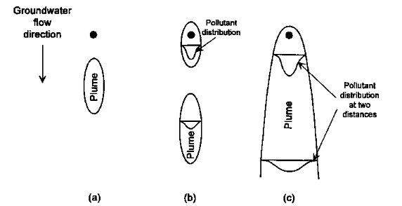

Fig.1 Plume of contaminant generated from a) a slug source or spill, b) an
intermittent source, and c) a continuous source

The type of potential pollution source has a direct influence on the resulting plume that may be created. In the case of a spill or slug source of pollution, discrete plumes may result. The size, shape, and rate of plume movements will be dependent on source characteristics, the hydrologic and geologic nature of the site in question, and the chemical reactivity and biological interaction of individual contaminants with the subsurface environment. Fig.1a illustrates this type of phenomenon. Intermittent releases of a pollutant may result in a series of discrete plumes that may or may not overlap depending on the relative frequency of the releases and the factors mentioned above. Fig.1b illustrates this type of phenomenon. Continuous sources of pollution Fig.1c result in the development of plumes that may approach steady state conditions for non reactive conservative chemical species.

2. Darcy’s Law and Subsurface Flow

The principle that governs how fluid moves in the subsurface is called Darcy's law. Darcy’s law is an equation that defines the ability of a fluid to flow through a porous media such as rock. It relies on the fact that the amount of flow between two points is directly related to the difference in pressure between the points, the distance between the points, and the interconnectivity of flow pathways in the rock between the points. The measurement of interconnectivity is called permeability.

In the subsurface, rock is deposited in layers. Fluid flow within and between the rock layers is governed by the permeability of the rocks. However, to account for permeability, it must be measured in both the vertical and horizontal directions. For example, shale typically has permeabilities that are much lower vertically than horizontally (assuming flat lying shale beds). This means that it is difficult for fluid to flow up and down through a shale bed but much easier for it to flow from side to side. A good example of this characteristic is shown in the picture at left; which clearly indicates that it would be much easier for water to flow along the horizontal bedding planes in the shale where there are natural flow pathways instead of vertically where there are few flow pathways.

Ultimately, if the pressure difference between a hydraulically fractured zone and a fresh water aquifer is not great, the distance between the zones is relatively large, and there are rocks with low vertical permeabilities in between the deeper and the shallower zones, flow between the zones is unlikely to occur. The exception to this is where there is a separate flow pathway such as an open borehole or a series of faults or joints that intersect both the fractured zone and the freshwater aquifer. Under either of these circumstances, the pressure difference and distance will be the determining factors as to whether fluid can migrate from the lower to the upper zone.

Darcy’s Law Application
Darcy’s law is the equation that defines the ability of a fluid to flow through a porous media such as rock. It relies on the principle that the amount of flow between two points is directly proportional to the difference in pressure between the points and the ability of the media through which it is flowing to impede the flow. Here pressure refers to the excess of local pressure over the normal hydrostatic fluid pressure which, due to gravity, increases with depth like in a standing column of water. This factor of flow impedance is referred to as permeability. Put another way, Darcy's law is a simple proportional relationship between the instantaneous discharge rate through a porous medium and the pressure drop over a given distance.

Darcy’s law is expressed as:

Q = -KA dh/dl
Wherein:
Q = rate of water flow (vol /time)
K = hydraulic conductivity
A = column cross section area
dh/dl = hydraulic gradient that is, the change in head over the length of interest.

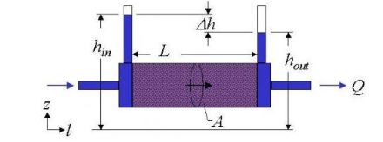
Darcy’s Law diagram is a s shown below in Fig.2:

Fig.2 Darcy’s Law diagram

Darcy’s refers to many unit systems. A medium that has a permeability of 1 Darcy allows a flow of 1 cm /s of a liquid with viscosity 1 cP ( 1 mPa.s) under 1 atm/cm pressure gradient acting across an area of 1 cm² .

Darcy’s law is critical when it comes to determining the possibility of flow from a hydraulically fractured to a freshwater zone because it creates a condition where the fluid flow from one zone to the other determines whether hydraulic fluids can reach fresh water zone or not.

The following assumptions are made in Darcy’s law:
- The soil is saturated
- The flow through soil is laminar
- The flow is continuous and steady
- The total cross-sectional area of soil mass is considered
- The temperature at the time of testing is 27⁰C

Note:

The hydraulic conductivity, K, is a constant for a given porous medium. A very porous medium with little resistance to flow will have a high value for K, while a tightly packed medium with high resistance to flow will have a low value for K. The approximate range of K values for several types of soil are given in the table at the left.

