Lec.4 & 5 Ground Water Pollution 4th class

Classification of Organic Compounds and Inorganic Compounds in Ground water

Organic Compounds in Ground water
In the past years, organic compounds in ground water have come to be recognized as one of the major threats to human health. The major classes and some of the most important compounds found in ground water are:
- Aromatic hydrocarbons
Aromatic hydrocarbons are compounds with a molecular structure based on that of the benzene ring, C₆H₆. When several of the benzene rings are joined together, polycyclic aromatic hydrocarbons (PAH), such as naphthalene (2 benzene rings), phenanthrene (3 benzene rings), and benzo-a-pyrene (5 benzene rings) are formed. These compounds are found in petroleum products, asphalt, coal tar, creosote and result from the incomplete combustion of fossil fuels.
If the benzene ring is joined to another group, it may be referred to as a functional group, phenyl, and in combination with chlorine these compounds are called polychlorinated biphenyls (PCBs). They are extremely resistant to chemical, thermal, or biological degradation and tend to persist in the environment. PCBs have been used as coolants and lubricants in transformers, capacitors, and other electrical equipment because they don't burn easily and are good insulators. The manufacture of PCBs was stopped in the U.S. in 1977 because of evidence they build up in the environment and can cause harmful health effects. Products made before 1977 that may contain PCBs include old fluorescent lighting fixtures and electrical devices containing PCB capacitors, and old microscope and hydraulic oils, but PCBs are still found in the environment. Health effects that have been associated with exposure to PCBs include acne-like skin conditions in adults and neurobehavioral and immunological changes in children.
Phenols are characterized by a benzene with one attached hydroxyl group. They originate in ground water mostly as contaminants from industrial wastes or biocides. Phenol is a common ground water contaminant due to its many industrial uses such as dyes, textiles, oil, gas, and explosive industries, and can also occur naturally with decomposing organic matter.
Benzene is a carcinogen and inhaled benzene is readily absorbed by blood and its strongly taken up by fatty tissues. Benzene can be converted to phenol by an oxidation reaction in the liver that is responsible for the unique toxicity of benzene, which involves damage to bone marrow, and is known to cause leukemia. Benzene is also a skin irritant and can affect the central nervous system.

- Alcohols
Alcohols have one or more OH groups, are miscible with water, and have the potential for significant mobility; however, they are readily biodegraded. Alcohols are considered the primary oxidation product of hydrocarbons. At many industrial sites, alcohols are discharged into ground water and can act as solvents for other organics. Common alcohols include methanol CH₃OH, ethanol C₂H₅OH, 1-propanol and isopropyl C₃H₇OH.

- Halogenated hydrocarbons
Halogenated hydrocarbons are one of the largest and most important groups of contaminants found in ground water. This group consists of both aliphatic and aromatic subclasses and its characterized by the presence of one or more halogen atoms (Cl, Br, F). Many of the halogenated ethenes have been found in large quantities in ground water, associated with industrial sited where solvents, cleansers and degreasers were used. Many halogenated hydrocarbons have moderate to high toxicity by inhalation. The brominated materials tend to be particularly toxic. Much of the toxicity is due to the fact that these substances are not metabolized, but persist and accumulate in fatty tissues (they tend to be fat-soluble). The combustion of chlorinated organic compounds may produce poisonous phosgene gas (COCl₂). Other materials formed by incomplete combustion are classes of chlorinated organic compounds, chlorodibenzodioxins and chlorodibenzofurans. These compounds cause cancer in laboratory tests

Inorganic Compounds in Ground water
The quality of water is a direct result of the reactions that occur between sources of contamination and other compounds that it may contact. In ground water, chemistry and chemical processes are important primarily because ground water is in contact with soil and rocks that contain a variety of minerals. In addition, the carbon and the nitrogen cycles contribute greatly to the quality of ground water. For instance, rainfall may come in contact with high levels of carbon dioxide in the atmosphere and become acidic. There is potential for this acidic water to infiltrate to ground water and dissolved minerals as it encounters them. Because of the processes that affect it, ground water naturally contains dissolved inorganic ions. A list of major and minor inorganic constituents and trace metals of ground water is presented in Table 1.
Table 1. Dissolved Constituents n ground water classified according to relative abundance
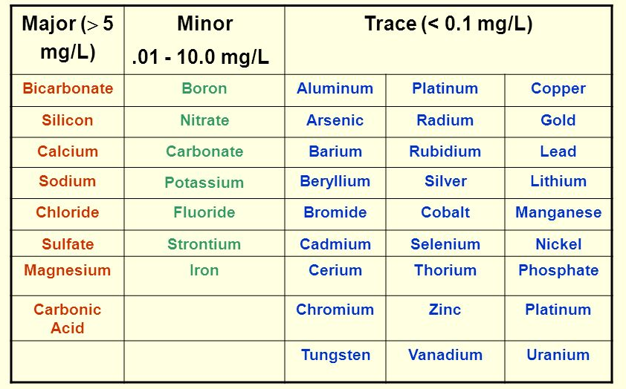

Of the inorganic contaminants in ground water, those of greatest concern are nitrates, ammonia, and trace metals. Nitrates in ground water originate from nitrate sources on land and are associated with fertilizers and the disposal of sewage waste, especially associated with faulty septic tanks. Feedlots are also a major source of nitrate in ground water, especially in rural areas.
Arsenic, cadmium, chromium, lead, zinc, and mercury are metal pollutants of major concern in ground water. Most of them arise from industrial practices and discharges from mining, metal plating, plumbing, coal, gasoline, and pesticides related industries. Many of these metals are very toxic to humans, especially cadmium, lead, and mercury. Cadmium and zinc are common water and sediment pollutants in areas associated with industrial installations. A major source of lead comes from leaded gasoline and lead piping. Mercury is associated with discarded batteries, laboratory products, and lawn fungicides. Arsenic is produced through phosphate mining and is a by-product of copper, gold, and lead refining.

