Transit Methodology
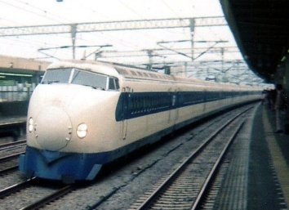
Introduction
This Lecture presents methodologies for calculating the vehicle and person capacities explained in previous lectures of transit modes that operate on street, namely:
- buses,
- streetcars,
- and light rail.
Procedures are presented for bus loading areas, bus stops, busways and freeway high occupancy- vehicle (HOV) lanes, exclusive arterial street bus lanes, mixed-traffic lanes used by buses, and rail lines.
Furthermore, this lecture presents procedures for the following:
- calculating bus and rail travel speeds and
- gives guidance on sizing passenger waiting areas at transit stations.
- In addition, procedures for calculating transit quality-of-service measures for transit service from the passenger’s point of view are presented for transit stops and route segments.

Methodology

This lecture presents transit quality-of-service measures for transit availability and comfort and convenience of transit stops and route segments, as well as other performance measures that analysts may want to consider for specific applications. These measures are presented to give all users of the HCM an understanding of the overall magnitude of and interrelationships within transit quality of service.
The four service measures related to transit facilities (transit stops and route segments) per the transit quality-of-service framework presented in previous lectures are service frequency, hours of service, passenger loads, and reliability.

Availability Measures

Transit service availability can be used as a measure of quality of service.
Availability measures for transit stops and route segments are described below:

1. Service Frequency at Transit Stop
From the transit user’s perspective, transit service frequency determines the number of times an hour a user has access to the transit mode, assuming that transit service is provided within acceptable walking distance (measured by service coverage) and at the times the user wishes to travel (measured by hours of service).
Service frequency also is a measure of the convenience of transit service to choice riders and is one component of overall transit trip time (helping to determine how long one waits for a transit vehicle).
Because of the different characteristics of urban scheduled transit service, paratransit service, and intercity scheduled transit service, these characteristics are used to define the LOS for each. Frequency LOS can vary by time of day or week: for example, a service may operate at LOS B during peak hours, LOS D at midday, and LOS F at night.
Similarly, paratransit service may operate at LOS D on weekdays but at LOS F on weekends if no service is offered.

2. Urban Scheduled Transit Service
Urban scheduled transit service includes all scheduled service within a city as well as service between cities within a larger metropolitan area. Deviated-route bus service is included in this category because the basic service is scheduled, even if specific stops are not. For the purpose of determining service frequency LOS, commuter rail is treated as intercity service.
The service frequency LOS measure for urban scheduled transit service is headway; however, for convenience, Table (1) shows LOS both by headway and by the corresponding number of vehicles per hour. It should be emphasized that although
headways are given as continuous ranges for the purposes of determining LOS, passengers find it easier to understand schedules when clock headways are used (headways that are evenly divisible into 60).

Table (1): Service Frequency LOS for Scheduled Urban Transit Service.

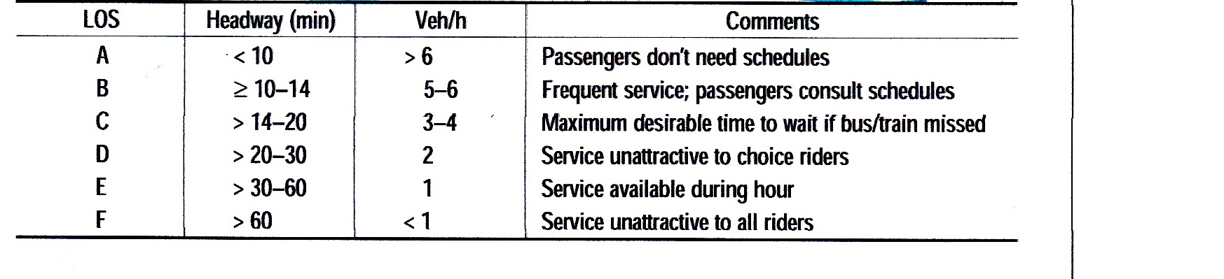

3. Paratransit Service
Paratransit includes all unscheduled transit service obtained by notifying the service provider that a pickup is desired. However, as noted above, deviated fixed-route service, which is scheduled, is evaluated using the urban scheduled transit service procedures.
The measure of service frequency for paratransit service is access time, the minimum amount of time from when a passenger requests service to the time a pickup can be guaranteed to occur. Service frequency LOS is measured by access time for paratransit operation.
Table (2) summarizes LOS thresholds for service frequency of paratransit service.

Table (2): Service Frequency LOS for Pratransit Service.

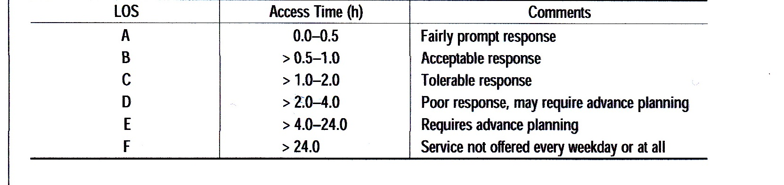

4. Intercity Scheduled Transit Servie
Transportation services between communities can be just as important as services within communities, especially for rural areas where medical, educational, and other services may not be readily available. Intercity transportation services, whether bus, train, or ferry, help to fill these mobility needs by linking smaller communities to larger communities and to other transportation modes.
The number of transit vehicles per day between one community and another establishes the LOS for intercity service. Table (3) summarizes LOS thresholds for service frequency of intercity scheduled transit service.

Table (3): Frequency LOS for Intercity Scheduled Transit Servie.
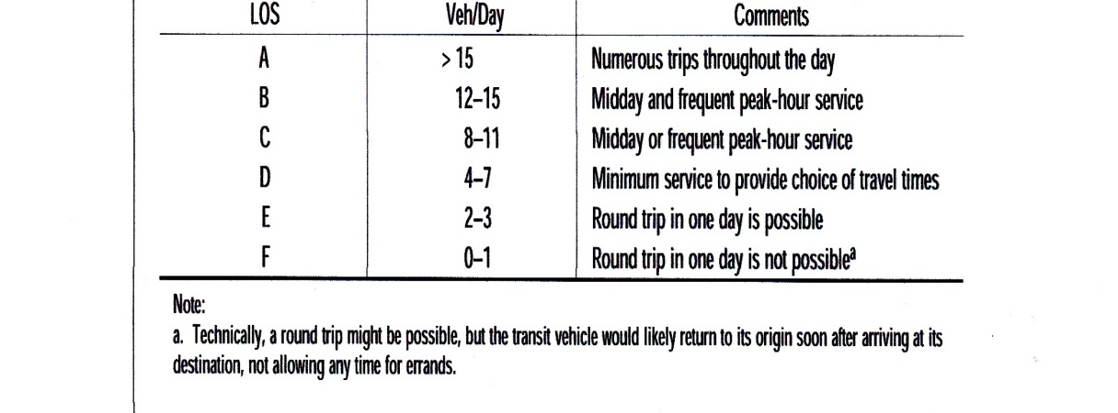

5. Accessibilty st Transit Stops
An evaluation of pedestrian accessibility should consider whether sidewalks are provided, the condition of the sidewalks, terrain, traffic volumes on streets that pedestrians must cross to access a transit stop and the kind of traffic control provided on those streets, and whether out-of-direction travel is required. Sidewalks are usually needed on arterial or collector routes used by buses, especially at the bus stop.
Assessment of bicycle access should consider the availability and condition of Bicycle accessibility bicycle facilities on the roadways leading to a transit stop, traffic volumes on the roadways leading to transit stops, the provision of bicycle racks on buses and whether demand exceeds rack capacity, the provision of bicycle storage lockers at high-volume boarding locations, and the ability to load bicycles onto rail vehicles during peak periods.
Assessment of automobile access should consider the capacity of park-and-ride or Automobile accessibility transit station parking lots relative to demand and the pedestrian environment within parking lots and between lots and the transit stop.

6. Pssenger Loadsat Transit Stops
Although passenger loads are generally more of a comfort and convenience factor than a transit availability factor, when a transit vehicle is full as it arrives at a stop, passengers waiting at the stop are unable to board and transit service is not available to those passengers at that time. Transit vehicle scheduling should provide sufficient frequency along routes to accommodate peak passenger demand volumes and avoid passing up waiting passengers. Special consideration should be given to providing sufficient transit vehicles to locations with strong peaking characteristics (such as airports, sports stadiums, or concert venues), when many people will want to board transit vehicles at the same time. Unusual weather conditions, can cause people who normally drive to use transit instead, resulting in overcrowded conditions.

7. Route Segment Hours of Service
Hours of service, also known as service span, is simply the number of hours during the day when transit service is provided along a route, a segment of a route, or between two ocations. It plays as important a role as frequency and service coverage in determining the availability of transit service to potential users.
Table (4) summarizes hours-of-service LOS thresholds for a transit route. Hours of-service LOS is measured similarly for fixed-route and paratransit services. For fixed route service, LOS is based on the number of hours per day when transit service is provided at least once an hour (corresponding to a minimum LOS E for service frequency and compatible with a typical 1-h analysis period). For paratransit service, LOS is based on the number of hours per day when service is offered.

Table (4): Hours - of - Service LOS.

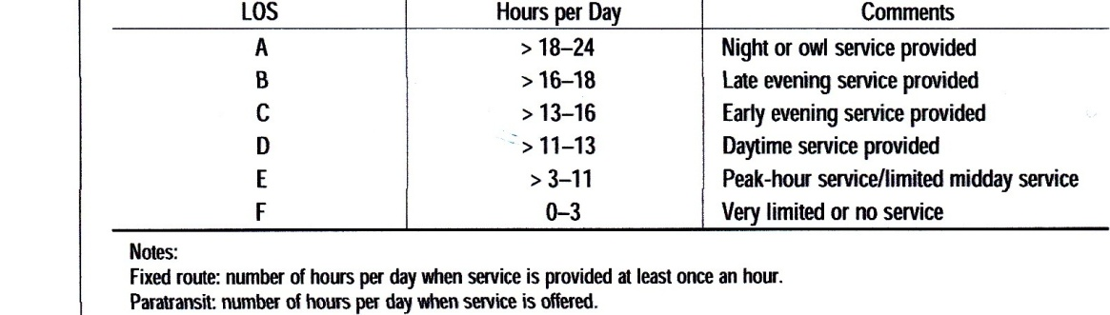

8. Route Segment Accessibility
The same accessibility considerations that apply to transit stops also apply to route segments.

Comfort and Convenince
Comfort and convience measures of transit service are described in the following:

1. Passenger Loads at Transit Stops
From the passenger’s perspective, passenger loads reflect the comfort level of the onboard vehicle portion of a transit trip both in terms of being able to find a seat and in terms of overall crowding levels within the vehicle. From a transit operator’s perspective, a poor LOS may indicate the need to increase service frequency or vehicle size in order to reduce crowding and to provide a more comfortable ride for passengers.
A poor passenger load LOS indicates that dwell times will be longer for a given passenger boarding and alighting demand at a transit stop and, as a result, travel times and service reliability will be negatively affected.
Passenger load LOS for bus and rail uses the same measure—square meters per passenger—but the ranges used to determine the LOS differ between the two modes because of differences in the level of crowding that passengers will tolerate and because most rail modes (with the notable exception of commuter rail) provide more standing area than do buses. Passenger load LOS can be measured by time of day (e.g., LOS D peak, LOS B off peak) or by the amount of time a certain condition occurs (e.g., some
passengers must stand for up to 10 min).
Alternatively, the load factors (passengers per seat) shown in Table (5) can be used to estimate LOS.
Table(5): Passenger Load LOS.
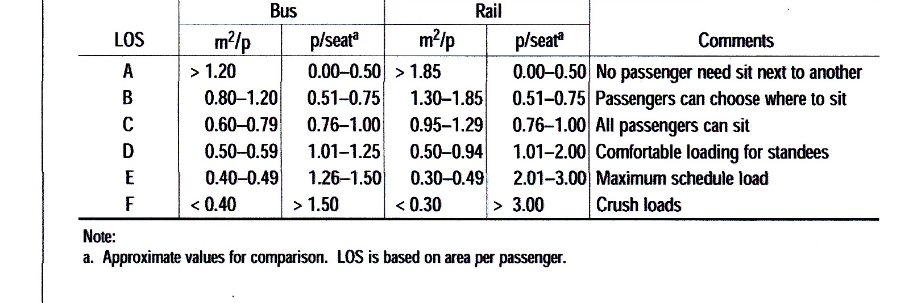

2. Amenties at Transit Stops
The amenities provided at transit stops are usually a matter of agency policy, based on the number of boarding riders that would benefit from a particular amenity as well as other factors. Table (6) lists typical amenities, daily boarding volumes, and other factors to consider.

Table (6): Typical Transit Stop Amenties.
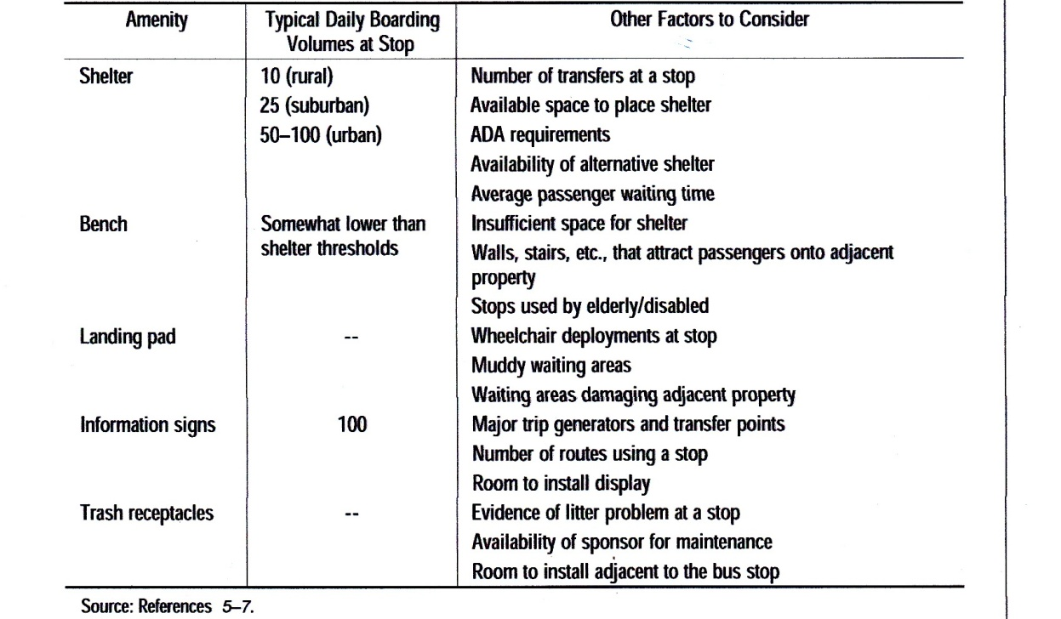

3. Route Segment Reliability
Several different measures of reliability are used by transit systems. The most common of these are:
• On-time performance,
• Headway adherence (the consistency or evenness of the interval between transit
vehicles),
• Missed trips, and
• Distance traveled between mechanical breakdowns.

Reliability LOS considers on-time performance for fixed-route service as a departure from a published time point 0 to 5 min after the scheduled time or an arrival at the end of the route no more than 5 min after the scheduled time. Early departures are not considered on time.
In the case of deviated fixed-route service, in which a bus travels to the rider rather than the riders traveling to meet a bus, early arrivals and departures are not as critical. Also, maintaining a consistent schedule from day to day is more difficult. Therefore, reliability LOS considers on-time performance for deviated fixed-route service as a pickup within 10 min of the scheduled time.
Table(7) lists reliability LOS grades for transit service operating with frequencies of fewer than six buses/h scheduled.

Table(7): Reliability LOS for On-Time Performance

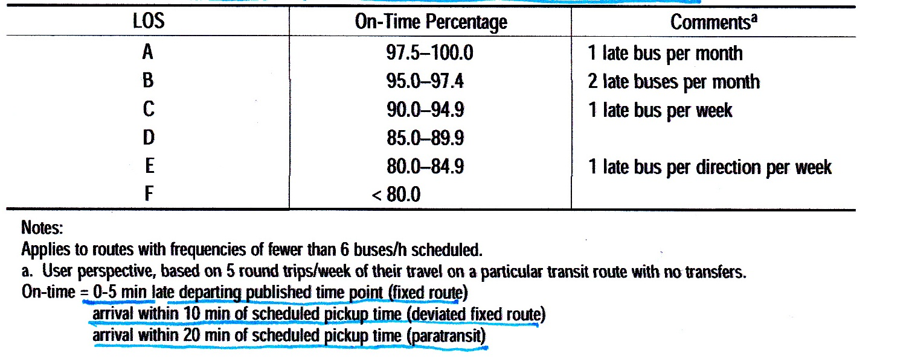

For transit service operating at frequencies of six buses/h scheduled or more, headway adherence is used to determine reliability. The measure is based on the coefficient of variation of headways of transit vehicles serving a particular route arriving at a stop, $c_{v}$, which is calculated by Equation (1):

$c_{v}=\frac{standard deviation of headways}{scheduled headway}$ ......................... (1)

Table (8): summarizes headway adherence LOS thresholds by coefficient of variation as shown below:

Table(8): Reliability LOS for Headway Adherenace.

4. Route Segment Travel Speed
Travel speed is a useful route segment performance measure because it reflects how long a trip may take without depending on how long a route segment might be. Transit priority measures, improvements to fare collection procedures, use of low-floor buses, and other similar actions implemented along a route segment will be reflected as improvements in travel speed.

