Classes and objects
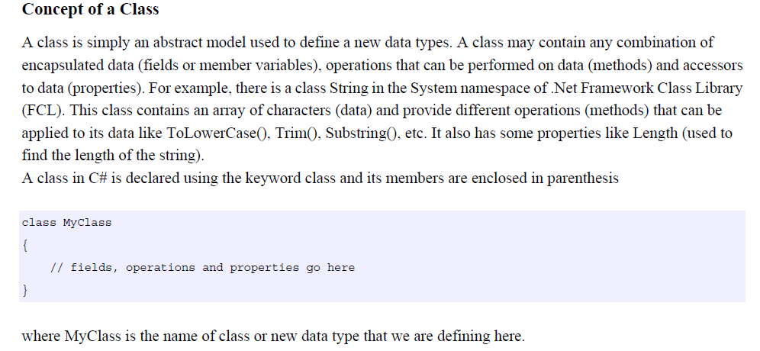
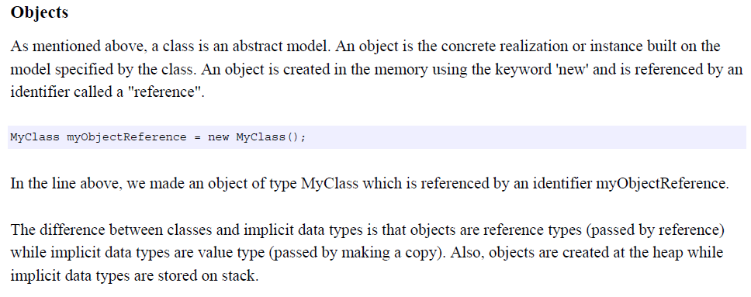
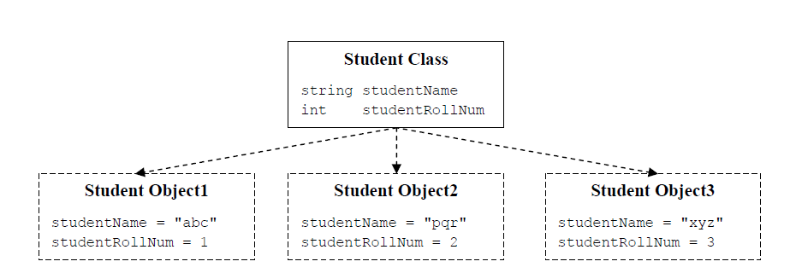
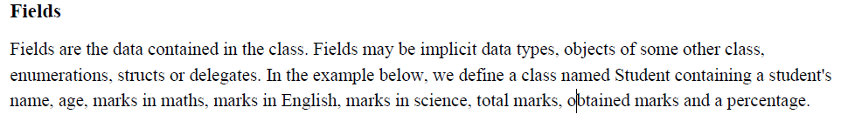

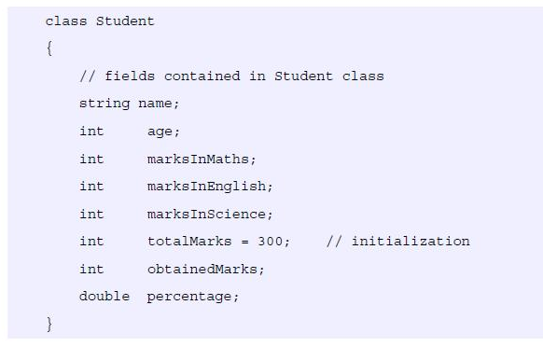
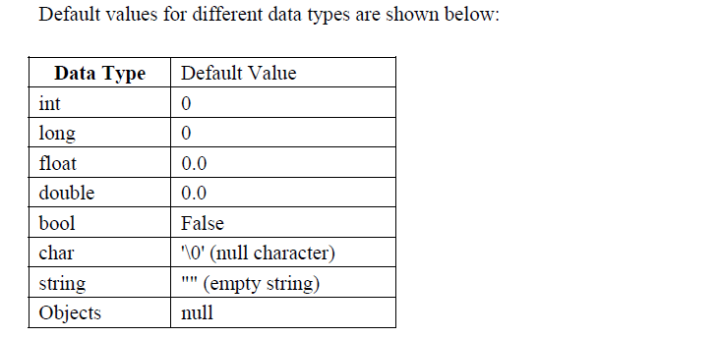
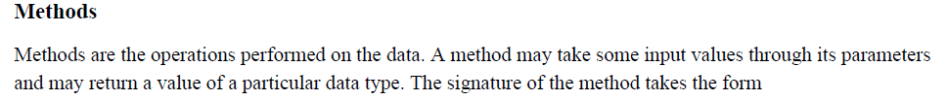
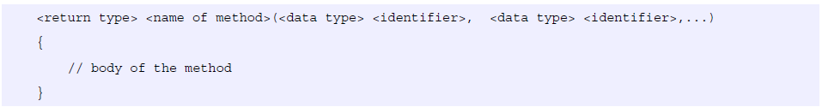
For example :
int Findsum ( int num1 , int num2 )
{
int sum = num1 + num2;
return sum ;
}
Here, we defined a method named Findsum which takes two parameters of int type (num1 and num2) and returns a value of type int using the keyword return. If a method does not return anything, its return type would be void. A method can also optionally take no parameter ( a parameterless method ).

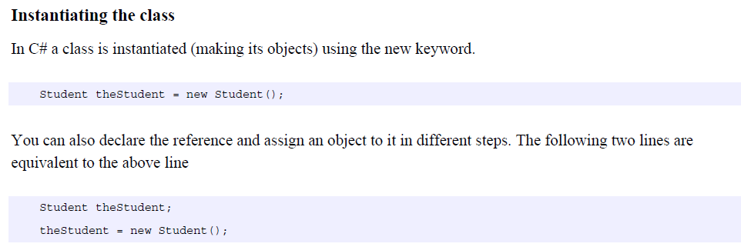
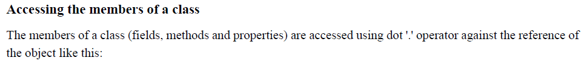
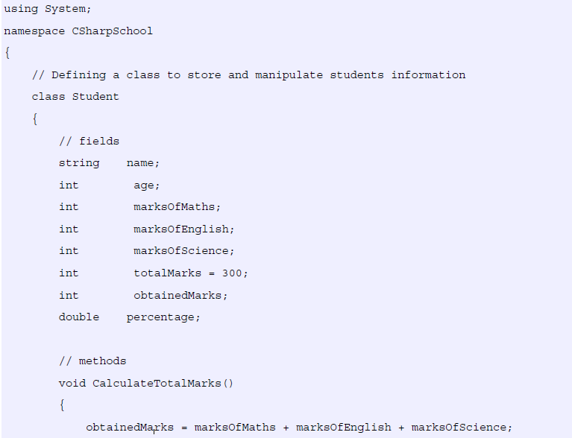
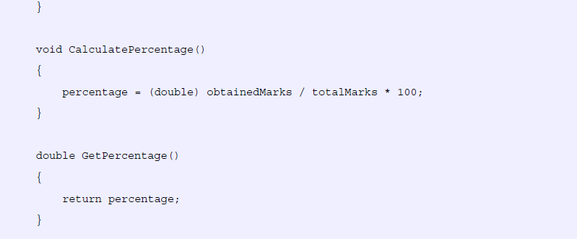
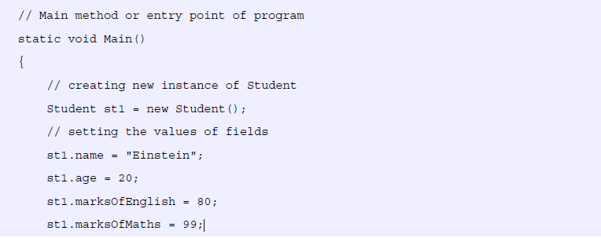
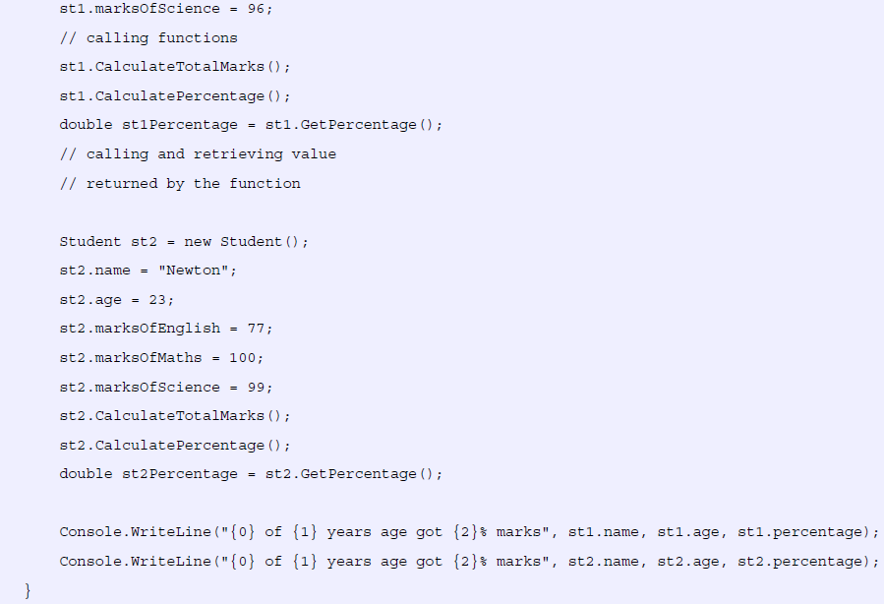
Constructors
A constructor initializes an object when it is created. It has the same name as its class and is syntactically similar to a method. However, constructors have no explicit return type. The general form of a constructor is shown here:

access class-name(param-list) {
// constructor code
}

Typically, you will use a constructor to give initial values to the instance variables defined by the class or to perform any other startup procedures required to create a fully formed object. Also, usually, access is public because constructors are normally called from outside their class. The param-list can be empty, or it can specify one or more parameters.
All classes have constructors, whether you define one or not, because C# automatically provides a default constructor that causes all member variables to be initialized to their default values. For most value types, the default value is zero. For bool, the default is false.
For reference types, the default is null. However, once you define your own constructor, the default constructor is no longer used.
Here is a simple example that uses a constructor:

Ex : Design and implement a class to find the area of Circle?

class Circle
{
private double radius;
public Circle(double r) // constructor
{
radius = r;
}
public double Area()
{
return radius * radius * 3.14;
}
}
class Program
{
static void Main(string[] args)
{
Circle obj1 = new Circle(3.5);
Circle obj2 = new Circle(10);
Console.WriteLine("the area of first circle is " + obj1.Area());
Console.WriteLine("the area of second circle is " + obj2.Area());
Console.ReadKey();
}
}
Ex2 Design and implement a class to read two integer numbers and find the largest number

namespace CollectionsApplication
{
class MaxNumber
{
private int number1;
private int number2;
public MaxNumber(int num1, int num2) // constructor
{
number1 = num1;
number2 = num2;
}

public int FindMax()
{
if (number1 > number2)
return number1;
else
return number2;
}
}
class Test
{
static void Main(string[] args)
{
MaxNumber Max1 = new MaxNumber(50, 100);
MaxNumber Max2 = new MaxNumber(80, 30);
Console.WriteLine("Max value is : " + Max1.FindMax());
Console.WriteLine("Max value is : " + Max2.FindMax());
Console.ReadLine();
}
}
}

Example 3: Design and implement a class to create array table of 9 real numbers , and search the value ele in array and print index of numbers?

namespace CollectionsApplication
{
class Search1
{
private double[] table;
private double element;
private int size;
public Search1(int n, double ele) // constructor
{
table = new double[n];
element = ele;
size = n;
}
public void ReadArr()
{
Console.WriteLine("input the " + size + "elements ");
for (int i = 0; i < size; i++)
{
Console.WriteLine("input element " + i);
table[i] = double.Parse(Console.ReadLine());
}
}
public void searchele()
{
int i;
for (i = 0; i < size; i++)
if (element == table[i]) break;
if (i == size)
Console.WriteLine("Value : " + element + "Not Found.");
else
Console.WriteLine("Value : " + element + " Order :" + i);
}
static void Main(string[] args)
{
Search1 obj1 = new Search1(10, 3.5);
Search1 obj2 = new Search1(5, 10);
obj1.ReadArr();
obj1.searchele();
obj2.ReadArr();
obj2.searchele();
Console.ReadKey();
}
}
}

