Electronic Spectra of Coordination Compounds

Selection rules : Transitions of electrons to be allowed should be occurred from
singlet to singlet, or triplet to triplet states and so on, but a change in spin
multiplicity is forbidden. Laporte selection rule: There must be a change in parity:
allowed transitions: g $ u forbidden transitions: g $g, u$ u, and, thus, allowed

transitions are s p, p d and d
f; forbidden transitions are s s, p

d
d, f
f , s
d, p
f …etc. Since these selection rules must be strictly

obeyed, why do many d-block metal complexes exhibit ‘d–d’ bands in their
electronic spectra? A spin-forbidden transition becomes ‘allowed’ if, for example,
a singlet state mixes to some extent with a triplet state. This is possible by spin–
orbit coupling but for first row metals, the degree of mixing is small and so
bands associated with ‘spin-forbidden’ transitions are very weak . Spin-allowed
‘d–d’ transitions remain Laporte-forbidden and their observation is explained by
a mechanism called ‘vibronic coupling’.
تكون الأنتقالات الألكترونية مسموحة عندما يحصل الأنتقال بين مستويات الكترونية لها نفس تعددية البرم مثلا من الأحادية الى الأحادية او من الثلاثية الى الثلاثية وتكون مسموحة برميا مثل الطيف الألكتروني لمعقدات العناصر الأنتقالية في المنطقة المرئية وتتميز بأن لها شدة واطئة وذات معامل أمتصاص مولاري قليل.
أما القاعدة الأخرى لقواعد الأختيار (لابورت) تنص أن الأنتقال الألكتروي يكون مسموحا بين المستويات المتماثلة ومحظورة أوربتاليا عندما يكون نقل الألكترون بين نفس النوع من الأوربتالات فمثلا أنتقالات
d-d.f-f و p-p تكون محظورة

An octahedral complex possesses a centre of symmetry, but molecular
vibrations result in its temporary loss. At an instant when the molecule does not
possess a centre of symmetry, mixing of d and p orbitals can occur. Since the
lifetime of the vibration (10_13 s) is longer than that of an electronic transition
(10_18 s), a ‘d–d’ transition involving an orbital of mixed pd character can occur
although the absorption is still relatively weak . In a molecule which is noncentro
symmetric (e.g. tetrahedral), p–d mixing can occur to a greater extent and so the
probability of ‘d–d’ transitions is greater than in a centro symmetric complex.
This leads to tetrahedral complexes being more intensely colored than octahedral
complexes.

p,

Absorption bands in electronic spectra are usually broad; the absorption of a
photon of light occurs in 10_18 s whereas molecular vibrations and rotations
occur more slowly. Therefore, an electronic transition is a ‘snapshot’ of a
molecule in a particular vibrational and rotational state, and it follows that the
electronic spectrum will record a range of energies corresponding to different
vibrational and rotational states.
Absorption bands are described in terms of λmax corresponding to the
absorption maximum Amax; the wavelength, Amax , is usually given in nm, but the
position of the absorption may also be described in terms of wave numbers,
(cm_1). The molar extinction coefficient (or molar absorptivity) "εmax of an
absorption must also be quoted; " εmax indicates how intense an absorption is
and is related to Amax by equation below where c is the concentration of the
solution and ‘ℓ is the path length (in cm) of the spectrometer cell ( Fig. 1 ). Values
of "εmax range from close to zero (a very weak absorption) to >10 000 dm_3 mol_1
cm_1 (an intense absorption). Table – 1

εmax = Amax

cx ℓ

Some important points shall be considered are that the electronic spectra of:
1- d 1, d 4 , d 6, and d 9 complexes consist of one absorption;
2- d 2, d 3, d 7 and d 8 complexes consist of three absorptions;
3- d 5 complexes consist of a series of very weak, relatively sharp absorptions.

Fig. 1 Absorption in the electronic spectrum of a
molecule or molecular ion
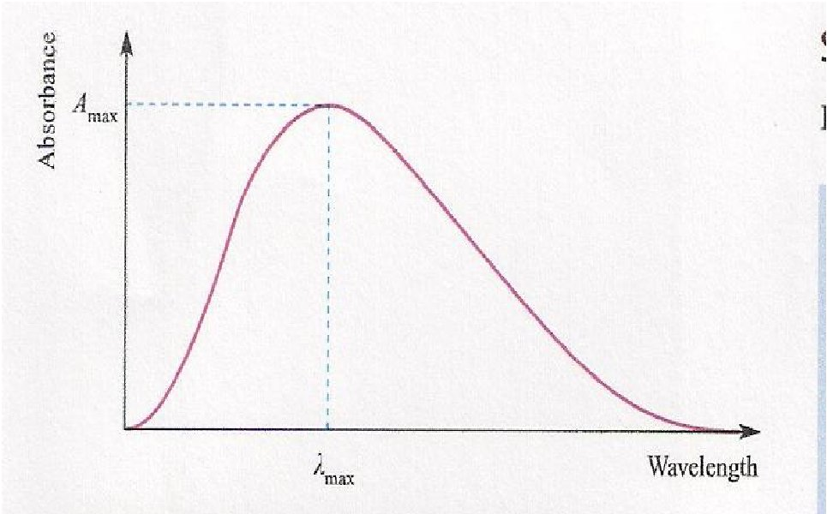

Table – 1 Some examples of electronic transitions with their values of εmax
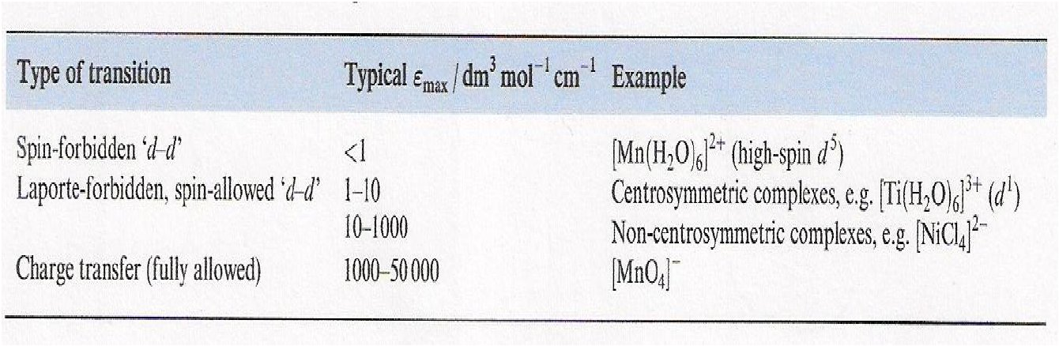

Charge Transfer Transitions: There is another important class of transition in
which the electron moves from a molecular orbital centered mainly on the ligand
to one centered mainly atom , or vice versa . In these the charge distribution is
considerably different in ground and excited states, and so they are called Charge
Transfer Transitions.
هناك نوع اخر ومهم للانتقالات الالكترونية يدعم التداخل بين الفلز واالليكند من خلال ظهور امتصاصات عالية الشدة في بداية المنطقة المرئية ونهاية الاشعة فوق البنفسجية وهي ثلاث انواع.
The metal on charge transfer (CT) gives rise to intense absorptions, whereas
‘d–d’ bands are much weaker. In some spectra, CT absorptions mask bands due
to ‘d–d’ transitions, although CT absorptions (as well as ligand-centred n – π*
and π – π* bands) often occur at higher energies than ‘d–d’ absorptions.

There are two classes of these bands ; ligand to metal ( L
M ) and metal

to ligand ( M
L ). In general , most of CT are of the first class. Charge transfer

transitions usually lie at the extreme blue end of the visible spectrum, or in the
ultraviolet region. Also, nearly all observed CT transitions are fully allowed,
hence the CT bands are strong, and the extinction coefficient are typically 103 to
104 , or more . There are of course many forbidden CT transition that give rise to
weak bands; these are seldom observed because they are covered up by the
strong CT bands, which lie between 400nm corresponds to 25 000 cm_1; 200nm
corresponds to 50 000 cm_1

Ligand to metal ( L

M ): Most of metal complexes had this type of transition

which can be expected to be divided to four types of transitions in octahedral
configuration. Fig. 2, shows a partial MO diagram for such complexes, and each of
transitions shown is a group of transitions, since the excited orbital configuration
gives rise to several different of similar but not identical energies.
Transition of the ν1 type will obviously be of lowest energy. Second since the
π and π* orbitals involved are both approximately non bonding , they will not vary
steeply with M – L distance as the ligand vibrate. The bands for these transitions
should be relatively narrow. A third factor that should assist in identifying the ν1 .
Set of bands is that they will be missing whenever the π*(t2g ) orbitals are filled (d 6
complexes). The energies for ν1 will be decrease in the sequence MCl6, MBr6 and
MI6 which is the order of decreasing the ionization potentials( easier oxidizability )
of the halogen atoms. As the oxidation state of the metal increase ( easier
oxidizability ) like RuCl6-3, RuCl6-2 ,its orbitals should be deeper , thus the transition
should go to lower energy.
Transition of the ν2 type should give the lowest energy CT bands in t2g6
complexes like those for PtX6-2 complexes. Since the transition is from a mainly the
nonbonding level to a distinctly antibonding one, the bands should be fairly broad.
The transition assigned to the ν2 sets all have half – widths of 2000 cm_1 to 4000
cm_1. The shift of energy in these bands with change of halogen and change of

metal oxidation state are again as expected for L
M transitions.

Transition of the ν3 set are all expected to be broad and weak and are not
observed. The ν4 transitions have been observed in a few cases, but in many cases
they must lie beyond the range of observation.

Fig. 2 Partial MO diagram for octahedral complex
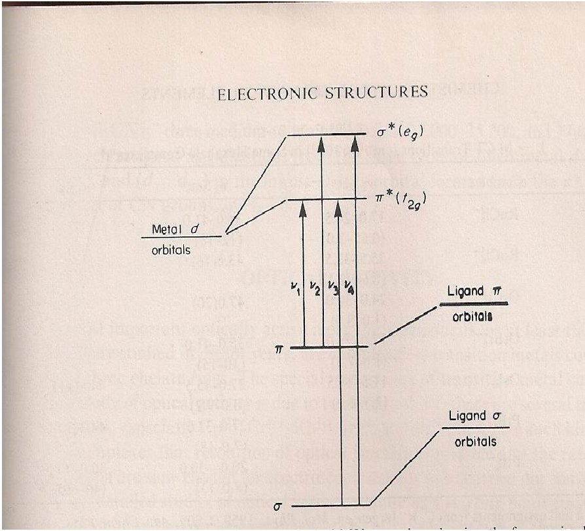

In tetrahedral complexes like NiX4-2, CoX4-2 and MnX4-2 a strong L M
spectra can be observed and assigned in much the same way as for octahedral
complexes. For d 8 complexes like HgCl 4-2, HgBr4-2 and HgI4-2 a strong CT for L
M transition and showed bands at 43,700 , 40,000 and 31,000 cm_1
In the previous lecture Fig. 2 showed the spectrum of [Cr(NH3)6]+3 ,when
one NH3 ligand replaced by one weaker ligand (Cl - ) moves the lower energy
band to lower energy than that for [CrCl(NH3)5]+2 . That arises because the Cl-
ligands have π lone pair electrons that are not directly involved in bonding. The
band is an example of an LMCT transition in which a lone pair electron of Cl- is
promoted into a predominantly metal orbital. The LMCT character of similar
bands in is [CrX(NH3)5]+2 confirmed by the decrease in energy in steps equivalent
to about 8000 cm_1 as X is varied from Cl to Br to I .
Metal to Ligand( M L ): A transfer of charge of electrons from metal to ligands
is most commonly observed in complexes with ligands that have low lying π*
orbitals, especially carbonyl ( CO ) , cyanide ( CN ) and aromatic ligands ( diimine,,
phenanthroline and dithiolene) Fig. 3. If the metal ion have a low oxidation
number, in which case the d orbitals will be relatively high in energy, the
transition will occur at low energy. A diimine ligand may also be easily
substituted into a complex with other ligands that favor a low oxidation state.
Two example are , [ W(CO)4(phen)] and [ Fe(CO)3(bipy )] .
In the case of octahedral metal carbonyl such as Cr(CO) 6 and Mo(CO)6 pair
of intense bands at 35,800 and 44,500cm_1 for the former and 35,000 and 43,000
cm_1 for the later which can be assigned to transition from bonding (mainly
metals) to the antibonding( mainly ligands)components of the metal ligands π
bonding interactions.

·

)

Fig. 3
