Sedimentary Rocks
Most of solid Earth consists of igneous and metamorphic rocks. Geologists estimate these two categories represent 90 to 95 percent of the outer 16 kilometers (10 miles) of the crust. Nevertheless, most of Earth’s solid surface consists of either sediment or sedimentary rock! Across the ocean floor, which represents about 70 percent of Earth’s solid surface, virtually everything is covered by sediment. Igneous rocks are exposed only at the crest of mid-ocean ridges and at some volcanic areas. Thus, while sediment and sedimentary rocks make up only a small percentage of Earth’s crust, they are concentrated at or near the surface—the interface among the geosphere, hydrosphere, atmosphere, and biosphere. Because of this unique position, sediments and the rock layers that they eventually form contain evidence of past conditions and events at the surface. Furthermore, it is sedimentary rocks that contain fossils, which are vital tools in the study of the geologic past. This group of rocks provides geologists with much of the basic information they need to reconstruct the details of Earth history.
Origins of Sedimentary Rock
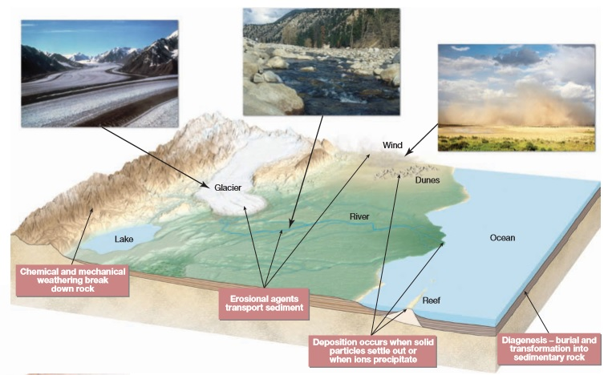
FIGURE below illustrates the portion of the rock cycle that occurs near Earth’s surface—the part that pertains to sediments and sedimentary rocks. A brief overview of these processes provides a useful perspective. • Weathering begins the process. It involves the physical disintegration and chemical decomposition of preexisting igneous, metamorphic, and sedimentary rocks. Weathering generates a variety of products, including various solid particles and ions in solution. These are the raw materials for sedimentary rocks. • Soluble constituents are carried away by runoff and groundwater. Solid particles are frequently moved downslope by gravity, a process termed mass wasting, before running water, groundwater, wind, and glacial ice remove them. Transportation moves these materials from the sites where they originated to locations where they accumulate. The transport of sediment is usually intermittent. For example, during a flood, a rapidly moving river moves large quantities of sand and gravel. As the flood waters recede, particles are temporarily deposited, only to be moved again by a subsequent flood. • Deposition of solid particles occurs when wind and water currents slow down and as glacial ice melts. The word sedimentary actually refers to this process.
• The deposition of material dissolved in water is not related to the strength of wind or water currents. Rather, ions in solution are removed when chemical or temperature changes cause material to crystallize and precipitate or when organisms remove dissolved material to build shells. • As deposition continues, older sediments are buried beneath younger layers and gradually converted to sedimentary rock (lithified) by compaction and cementation. This and other changes are referred to as diagenesis, a collective term for all of the changes (short of metamorphism) that take place in texture, composition, and other physical properties after sediments are deposited. Because there are a variety of ways that the products of weathering are transported, deposited, and transformed into solid rock, three categories of sedimentary rocks are recognized. As the overview reminded us, sediment has two principal sources. First, it may be an accumulation of material that genesis = origin dia = change originates and is transported as solid particles derived from both mechanical and chemical weathering. Deposits of this type are termed detrital, and the > rocks that they form are called detrital sedimentary rocks. The second major source of sediment is soluble material produced largely by chemical weathering. When these ions in solution are precipitated by either inorganic or biologic processes, the material is known as chemical sediment, and the rocks formed from it are called chemical sedimentary rocks. The third category is organic sedimentary rocks. The primary example is coal. This black combustible rock consists of organic carbon from the remains of plants that died and accumulated on the floor of a swamp. The bits and pieces of undecayed plant material that constitute the “sediments” in coal are quite unlike the weathering products that make up detrital and chemical sedimentary rocks.
Detrital Sedimentary Rocks
Sedimentary Rocks Types of Sedimentary Rocks Though a wide variety of minerals and rock fragments (clasts) may be found in detrital rocks, clay minerals and quartz are the chief constituents of most sedimentary rocks in this category. clay minerals are the most abundant product of the chemical weathering of silicate minerals, especially the feldspars. Clays are fine-grained minerals with sheetlike crystalline structures similar to the micas. The other common mineral, quartz, is abundant because it is extremely durable and very resistant to chemical weathering. Thus, when igneous rocks such as granite are attacked by weathering processes, individual quartz grains are freed. Other common minerals in detrital rocks are feldspars and micas. Because chemical weathering rapidly transforms these minerals into new substances, their presence in sedimentary rocks indicates that erosion and deposition were fast enough to preserve some of the primary minerals from the source rock before they could be decomposed. Particle size is the primary basis for distinguishing among various detrital sedimentary rocks. FIGURE below presents the size categories for particles making up detrital rocks. Particle size is not only a convenient method of dividing detrital rocks, but the sizes of the component grains also provide useful information about environments of deposition. Currents of water or air sort the particles by size—the stronger the current, the larger the particle size carried. Gravels, for example, are moved by swiftly flowing rivers as well as by landslides and glaciers. Less energy is required to transport sand; thus, it is common to such features as windblown dunes and some river deposits and beaches. Very little energy is needed to transport clay, so it settles very slowly. Accumulations of these tiny particles are generally associated with the quiet waters of a lake, lagoon, swamp, or certain marine environments. Common detrital sedimentary rocks, in order of increasing particle size, are shale, sandstone, and conglomerate or breccia. We will now look at each type and how it forms.
Sandstone
Sandstone is the name given rocks in which sand-sized grains predominate. After shale, sandstone is the most abundant sedimentary rock, accounting for approximately 20 percent of the entire group. Sandstones form in a variety of environments and often contain significant clues about their origin, including sorting, particle shape, and composition.
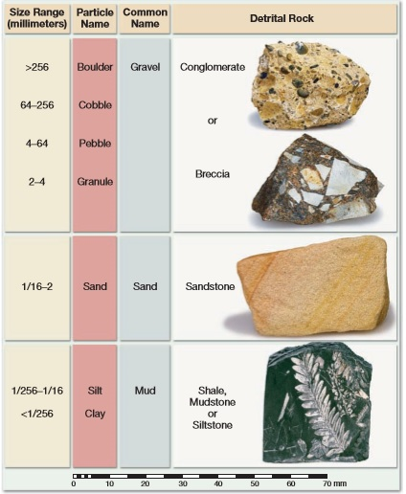

SORTING AND PARTICLE SHAPE.
Sorting is the degree of similarity in particle size in a sedimentary rock. For example, if all the grains in a sample of sandstone are about the same size, the sand is considered well sorted. Conversely, if the rock contains mixed large and small particles, the sand is said to be poorly sorted (FIGURE below). By studying the degree of sorting, we can learn much about the depositing current. Deposits of windblown sand are usually better sorted than deposits sorted by wave activity. Particles washed by waves are commonly better sorted than materials deposited by streams. Sediment accumulations that exhibit poor sorting usually result when particles are transported for only a relatively short time and then rapidly deposited. For example, when a turbulent stream reaches the gentler slopes at the base of a steep mountain, its velocity is quickly reduced, and poorly sorted sands and gravels are deposited. The shapes of sand grains can also help decipher the history of a sandstone. When streams, winds, or waves move sand and other larger sedimentary particles, the grains lose their sharp edges and corners and become more rounded as they collide with other particles during transport. Thus, rounded grains likely have been airborne or waterborne. Further, the degree of rounding indicates the distance or time involved in the transportation of sediment by currents of air or water. Highly rounded grains indicate that a great deal of abrasion and hence a great deal of transport has occurred. Very angular grains, on the other hand, imply two things: that the materials were transported only a short distance before they were deposited and that some other medium may have transported them. For example, when glaciers move sediment, the particles are usually made more irregular by the crushing and grinding action of the ice. In addition to affecting the degree of rounding and the amount of sorting that particles undergo, the length of transport by turbulent air and water currents also influences the mineral composition of a sedimentary deposit. Substantial weathering and long transport lead to the gradual destruction of weaker and less stable minerals, including the feldspars and ferromagnesians. Because quartz is very durable, it is usually the mineral that survives the long trip in a turbulent environment

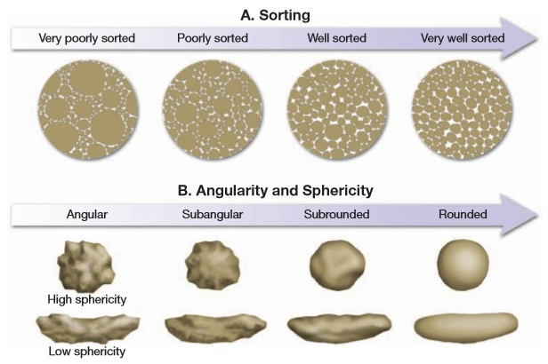

Conglomerate and Breccia
Conglomerate and Breccia Conglomerate consists largely of gravels. As Figure indicates, these particles may range in size from large boulders to particles as small as garden peas. The particles are commonly large enough to be identified as distinctive rock types; thus, they can be valuable in identifying the source areas of sediments. More often than not, conglomerates are poorly sorted because the openings between the large gravel particles contain sand or mud. Gravels accumulate in a variety of environments and usually indicate the existence of steep slopes or very turbulent currents. The coarse particles in a conglomerate may reflect the action of energetic mountain streams or result from strong wave activity along a rapidly eroding coast. Some glacial and landslide deposits also contain plentiful gravel. If the large particles are angular rather than rounded, the rock is called breccia . Because large particles abrade and become rounded very rapidly during transport, the pebbles and cobbles in a breccia indicate that they did not travel far from their source area before they were deposited. Thus, as with many other sedimentary rocks, conglomerates and breccias contain clues to their history. Their particle sizes reveal the strength of the currents that transported them, whereas the degree of rounding indicates how far the particles traveled.
Chemical Sedimentary Rocks
In contrast to detrital rocks, which form from the solid products of weathering, chemical sediments derive from ions that are carried in solution to lakes and seas. This material does not remain dissolved in the water indefinitely, however. Some of it precipitates to form chemical sediments. These become rocks such as limestone, chert, and rock salt. This precipitation of material occurs in two ways. Inorganic processes such as evaporation and chemical activity can produce chemical sediments. Organic (life) processes of waterdwelling organisms also form chemical sediments, said to be of biochemical origin. One example of a deposit resulting from inorganic chemical processes is the dripstone that decorates many caves (FIGURE 6.8). Another is the salt left behind as a body of seawater evaporates. In contrast, many water-dwelling animals and plants extract dissolved mineral matter to form shells and other hard parts. After the organisms die, their skeletons collect by the millions on the floor of a lake or ocean as biochemical sediment.

Limestone
Representing about 10 percent of the total volume of all sedimentary rocks, limestone is the most abundant chemical sedimentary rock. It is composed chiefly of the mineral calcite (CaCO3) and forms either by inorganic means or as the result of biochemical processes. Regardless of its origin, the mineral composition of all limestone is similar, yet many different types exist. This is true because limestones are produced under a variety of conditions. Those forms having a marine biochemical origin are by far the most common.
CARBONATE REEFS. Corals are one important example of organisms that are capable of creating large quantities of marine limestone. These relatively simple invertebrate animals secrete a calcareous (calcium carbonate) external skeleton. Although they are small, corals are capable of creating massive structures called reefs. Reefs consist of coral colonies made up of great numbers of individuals that live side by side on a calcite structure secreted by the animals. In addition, calcium carbonate-secreting algae live with the corals and help cement the entire structure into a solid mass. A wide variety of other organisms also live in and near reefs.
INORGANIC LIMESTONES. Limestones having an inorganic origin form when chemical changes or high water temperatures increase the concentration of calcium carbonate to the point that it precipitates. Travertine, the type of limestone commonly seen in caves, is an example. When travertine is deposited in caves, groundwater is the source of the calcium carbonate. As water droplets become exposed to the air in a cavern, some of the carbon dioxide dissolved in the water escapes, causing calcium carbonate to precipitate. Another variety of inorganic limestone is oolitic limestone. It is a rock composed of small spherical grains called ooids. Ooids form in shallow marine waters as tiny seed particles (commonly small shell fragments) and are moved back and forth by currents. As the grains are rolled about in the warm water, which is supersaturated with calcium carbonate, they become coated with layer upon layer of the chemical precipitate.
Dolostone
Dolostone Closely related to limestone is dolostone, a rock composed of the calcium-magnesium carbonate mineral dolomite [CaMg(CO3)2]. Although dolostone and limestone sometimes closely resemble one another, they can be easily distinguished by observing their reaction to dilute hydrochloric acid. When a drop of acid is placed on limestone, the reaction (fizzing) is obvious. However, unless dolostone is powdered, it will not visibly react to the acid. The origin of dolostone is not altogether clear and remains a subject of discussion among geologists. No marine organisms produce hard parts of dolomite, and the chemical precipitation of dolomite from seawater occurs only under conditions of unusual water chemistry in certain near-shore sites. Yet, dolostone is abundant in many ancient sedimentary rock successions.
Chert Chert is a name used for a number of very compact and hard rocks made of microcrystalline quartz (SiO2). One well-known form is flint, whose dark color results from the Precambrian time more than 2 billion years ago. From fossil remains, it is known that a variety of organisms have constructed reefs, including bivalves (clams and oysters), bryozoans (coral-like animals), and sponges. Corals have been found in fossil reefs as old as 500 million years, but corals similar to the modern colonial varieties have constructed reefs only during the last 60 million years. In the United States, reefs of Silurian age (416 to 444 million years ago) are prominent features in Wisconsin, Illinois, and Indiana. In west Texas and adjacent southeastern New Mexico, a massive reef complex formed during the Permian period (251 to 299 million years ago) is strikingly exposed in Guadalupe Mountains National Park.
COQUINA AND CHALK. Although much limestone is the product of biological processes, this origin is not always evident, because shells and skeletons may undergo considerable change before becoming lithified into rock. However, one easily identified biochemical limestone is coquina, a coarse rock composed of poorly cemented shells and shell fragments. Another less obvious but nevertheless familiar example is chalk, a soft, porous rock made up almost entirely of the hard parts of microscopic marine organisms smaller than the head of a pin. Among the most famous chalk deposits are those exposed along the southeast coast of England.
INORGANIC LIMESTONES. Limestones having an inorganic origin form when chemical changes or high water temperatures increase the concentration of calcium carbonate to the point that it precipitates. Travertine, the type of limestone commonly seen in caves, is an example. When travertine is deposited in caves, groundwater is the source of the calcium. organic matter it contains. Jasper, a red variety, gets its bright color from iron oxide. The banded form is usually referred to as agate. Like glass, most chert has a conchoidal fracture. Its hardness, ease of chipping, and ability to hold a sharp edge made chert a favorite of Native Americans for fashioning points for spears and arrows. Because of chert’s durability and extensive use, “arrowheads” are found in many parts of North America. Chert deposits are commonly found in one of two situations: as layered deposits referred to as bedded cherts and as nodules, somewhat spherical masses varying in diameter from a few millimeters (pea size) to a few centimeters. Most water-dwelling organisms that produce hard parts make them of calcium carbonate. But some, such as diatoms and radiolarians, produce glasslike silica skeletons. These tiny organisms are able to extract silica even though seawater contains only tiny quantities of the dissolved material. It is from their remains that most bedded cherts are believed to originate. Some bedded cherts occur in association with lava flows and layers of volcanic ash. For these occurrences it is probable that the silica was derived from the decomposition of the volcanic ash and not from biochemical sources. Chert nodules are sometimes referred to as secondary or replacement cherts and most often occur within beds of limestone. They form when silica originally deposited in one place dissolves, migrates, and then chemically precipitates elsewhere, replacing older material. Oolitic limestone consists of ooids, which are small spherical grains formed by the chemical precipitation of calcium carbonate around a tiny nucleus. The carbonate is added in concentric layers as the spheres are rolled back and forth by currents in a warm shallow marine setting.
Chert
is a name used for a number of dense, hard rocks made of microcrystalline quartz. Three examples are shown here. A. Agate is the banded variety. (Photo by Jeffrey A. Scovil) B. The dark color of flint results from organic matter. C. The red variety, called jasper, gets its color from iron oxide.
Evaporites Very often, evaporation is the mechanism triggering deposition of chemical precipitates. Minerals commonly precipitated in this fashion include halite (sodium chloride, NaCl), the chief component of rock salt, and gypsum (hydrous calcium sulfate, CaSO4 2H2O), the main ingredient of rock gypsum. Both have significant commercial importance. Halite is familiar to everyone as the common salt used in cooking and for seasoning foods. Of course, it has many other uses—from melting ice on roads to making hydrochloric acid— and has been considered important enough that people have sought, traded, and fought over it for much of human history. Gypsum is the basic ingredient of plaster of Paris. This material is used most extensively in the construction industry for wallboard and interior plaster
An organic Sedimentary rocks
Coal is quite different from other sedimentary rocks. Unlike limestone and chert, which are calcite or silica rich, coal is made mostly of organic matter. Close examination of a piece of coal under a microscope or magnifying glass often reveals plant structures such as leaves, bark, and wood that have been chemically altered but are still identifiable. This supports the conclusion that coal is the end product of large amounts of plant material buried for millions of years . The initial stage in coal formation is the accumulation of large quantities of plant remains. However, special conditions are required for such accumulations because dead plants normally decompose when exposed to the atmosphere or other oxygen-rich environments. One important environment that allows for the buildup of plant material is a swamp. Stagnant swamp water is oxygendeficient, so complete decay (oxidation) of the plant material is not possible. Instead, the plants are attacked by certain bacteria that partly decompose the organic material and liberate oxygen and hydrogen. As these elements escape, the percentage of carbon gradually increases. The bacteria are not able to finish the job of decomposition because they are destroyed by acids liberated from the plants. The partial decomposition of plants in an oxygen-poor swamp creates a layer of peat, a soft brown material in which plant structures are still easily recognized. With shallow burial, peat slowly changes to lignite, a soft brown coal. Burial increases the temperature of sediments as well as the pressure on them. The higher temperatures bring about chemical reactions within the plant materials and yield water and organic gases (volatiles). As the load increases from more sediment on top of the developing coal, the water and volatiles are pressed out and the proportion of fixed carbon (the remaining solid combustible material) increases. The greater the carbon content, the greater the coal’s energy ranking as a fuel. During burial the coal also becomes increasingly compact. For example, deeper burial transforms lignite into a harder, more compacted black rock called bituminous coal. Compared to the peat from which it formed, a bed of bituminous coal may be only 1/10 as thick. Lignite and bituminous coals are sedimentary rocks. However, when sedimentary layers are subjected to the folding and deformation associated with mountain building, the heat and pressure cause a further loss of volatiles and water, thus increasing the concentration of fixed carbon. This metamorphoses bituminous coal into anthracite, a very hard, shiny, black metamorphic rock. Although anthracite is a cleanburning fuel, only a relatively small amount is mined. Anthracite is not widespread and is more difficult and expensive to extract than the relatively flat-lying layers of bituminous coal.
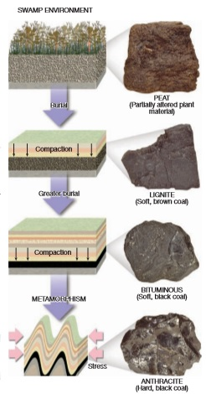

Turning Sediment into Sedimentary Rock: Diagenesis and Lithification
A great deal of change can occur to sediment from the time it is deposited until it becomes a sedimentary rock and is subsequently subjected to the temperatures and pressures that convert it to metamorphic rock. The term diagenesis is a collective term for all of the chemical, physical, and biological changes that take place after sediments are deposited and during and after lithification. Burial promotes diagenesis because as sediments are buried, they are subjected to increasingly higher temperatures and pressures. Diagenesis occurs within the upper few kilometers of Earth’s crust at temperatures that are generally less than 150° to 200 °C. Beyond this somewhat arbitrary threshold, metamorphism is said to occur. One example of diagenetic change is recrystallization, the development of more stable minerals from less stable ones. It is illustrated by the mineral aragonite, the less stable form of calcium carbonate (CaCO3). Aragonite is secreted by many marine organisms to form shells and other hard parts, such as the skeletal structures produced by corals. In some environments, large quantities of these solid materials accumulate as sediment. As burial takes place, aragonite recrystallizes to the more stable form of calcium carbonate, calcite, the main constituent in the sedimentary rock limestone. Another example of diagenesis was provided in the preceding discussion of coal. It involved the chemical alteration of organic matter in an oxygen-poor environment. Instead of completely decaying, as would occur in the presence of oxygen, the organic matter is slowly transformed to solid carbon. Diagenesis includes lithification , the processes by which unconsolidated sediments are transformed into solid sedimentary rocks. Basic lithification processes include compaction and cementation. The most common physical diagenetic change is compaction. As sediment accumulates, the weight of overlying material compresses the deeper sediments. The deeper a sediment is buried, the more it is compacted and the firmer it becomes. As the grains are pressed closer and closer, there is considerable reduction in pore space (the open space between particles). For example, when clays are buried beneath several thousand meters of material, the volume of clay may be reduced by as much as 40 percent. As pore space decreases, much of the water that was trapped in the sediments is driven out. Because sands and other coarse sediments are less compressible, compaction is most significant as a lithification process in finegrained sedimentary rocks. Cementation is the most important process by which sediments are converted to sedimentary rock. It is a diagenetic change that involves the crystallization of minerals among the individual sediment grains. Groundwater carries ions in solution. Gradually, the crystallization of new minerals from these ions takes place in the pore spaces, cementing the clasts together. Just as the amount of pore space is reduced during compaction, the addition of cement into a sedimentary deposit reduces its porosity as well. Calcite, silica, and iron oxide are the most common cements.
Classification of Sedimentary Rocks
The classification scheme in FIGURE Below divides sedimentary rocks into two major groups: detrital and chemical/organic. Further, we can see that the main criterion for subdividing the detrital rocks is particle size, whereas the primary basis for distinguishing among different rocks in the chemical group is their mineral composition. As is the case with many (perhaps most) classifications of natural phenomena, the categories presented in Figure are more rigid than the actual state of nature. In reality, many of the sedimentary rocks classified into the chemical group also contain at least small quantities of detrital sediment. Many limestones, for example, contain varying amounts of mud or sand, giving them a “sandy” or “shaly” quality. Conversely, because practically all detrital rocks are cemented with material that was originally dissolved in water, they too are far from being “pure.” As was the case with the igneous rocks examined in Chapter 3, texture is a part of sedimentary rock classification. Two major textures are used in the classification of sedimentary rocks: clastic and nonclastic. The term clastic is taken from a Greek word meaning “broken.” Rocks that display a clastic texture consist of discrete fragments and particles that are cemented and compacted together. Although cement is present in the spaces between particles, these openings are rarely filled completely. All detrital rocks have a clastic texture. In addition, some chemical sedimentary rocks exhibit this texture. For example, coquina, the limestone composed of shells and shell fragments, is obviously as clastic as conglomerate or sandstone. The same applies for some varieties of oolitic limestone. Some chemical sedimentary rocks have a nonclastic or crystalline texture in which the minerals form a pattern of interlocking crystals. The crystals may be microscopically small or large enough to be visible without magnification. Common examples of rocks with nonclastic textures are evaporites . The materials that make up many other nonclastic rocks may actually have originated as detrital deposits. In these instances, the particles probably consisted of shell fragments and other hard parts rich in calcium carbonate or silica. The clastic nature of the grains was subsequently obliterated or obscured because the particles recrystallized when they were consolidated into limestone or chert. Nonclastic rocks consist of intergrown crystals, and some may resemble igneous rocks, which are also crystalline. The two rock types are usually easy to distinguish because the minerals that make up nonclastic sedimentary rocks are different from those found in most igneous rocks. For example, rock salt, rock gypsum, and some forms of limestone consist of intergrown crystals, but the minerals contained within these rocks (halite, gypsum, and calcite) are seldom associated with igneous rocks.
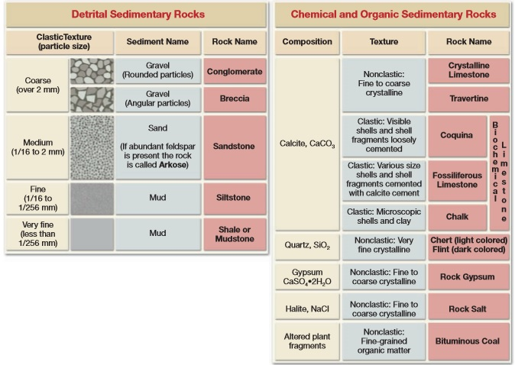

Sedimentary Structures In addition to variations in grain size, mineral composition, and texture, sediments exhibit a variety of structures. Some, such as graded beds, are created when sediments are accumulating and are a reflection of the transporting medium. Others, such as mud cracks, form after the materials have been deposited and result from processes occurring in the environment. When present, sedimentary structures provide additional information that can be useful in the interpretation of Earth history. Sedimentary rocks form as layer upon layer of sediment accumulates in various depositional environments. These layers, called strata or beds, are probably the single most common and characteristic feature of sedimentary rocks. Each stratum is unique. It may be a coarse sandstone, a fossil-rich limestone, a black shale, and so on. The variations in texture, composition, and thickness reflect the different conditions under which each layer was deposited. The thickness of beds ranges from microscopically thin to tens of meters thick. Separating the strata are bedding planes, flat surfaces along which rocks tend to separate or break. Changes in the grain size or in the composition of the sediment being deposited can create bedding planes. Pauses in deposition can also lead to layering because chances are slight that newly deposited material will be exactly the same as previously deposited sediment. Generally, each bedding plane marks the end of one episode of sedimentation and the beginning of another. Because sediments usually accumulate as particles that settle from a fluid, most strata are originally deposited as horizontal layers. There are circumstances, however, when sediments do not accumulate in horizontal beds. Sometimes when a bed of sedimentary rock is examined, we see layers within it that are inclined to the horizontal. When this occurs, it is called cross-bedding and is most characteristic of sand dunes, river deltas, and certain stream channel deposits (see Figure below). Graded beds represent another special type of bedding. In this case the particles within a single sedimentary layer gradually change from coarse at the bottom to fine at the top. Graded beds are most characteristic of rapid deposition from water containing sediment of varying sizes. When a current experiences a rapid energy loss, the largest particles settle first, followed by successively smaller grains. The deposition of a graded bed is most often associated with a turbidity current, a mass of sedimentchoked water that is denser than clear water and that moves downslope along the bottom of a lake or ocean.
Ripple marks are small waves of sand that develop on the surface of a sediment layer by the action of moving water or air. The ridges form at right angles to the direction of motion. If the ripple marks were formed by air or water moving in essentially one direction, their form will be asymmetrical. These current ripple marks will have steeper sides in the downcurrent direction and more gradual slopes on the upcurrent side. Ripple marks produced by a stream flowing across a sandy channel or by wind blowing over a sand dune are two common examples of current ripples. When present in solid rock, they may be used to determine the direction of movement of ancient wind or water currents. Other ripple marks have a symmetrical form. These features, called oscillation ripple marks, result from the back-and-forth movement of surface waves in a shallow nearshore environment.
Mud cracks indicate that the sediment in which they were formed was alternately wet and dry. When exposed to air, wet mud dries out and shrinks, producing cracks. Mud cracks are associated with such environments as tidal flats, shallow lakes, and desert basins. Fossils, the remains or traces of prehistoric life, are important inclusions in sediment and sedimentary rock. They are important tools for interpreting the geologic past. Knowing the nature of the life forms that existed at a particular time helps researchers decipher past environmental conditions. Further, fossils are important time indicators and play a key role in correlating rocks that are of similar ages but are from different places

Energy Resources from Sedimentary Rocks
Coal, petroleum, and natural gas are the primary fuels of our modern industrial economy. About 84 percent of the energy consumed in the United States today comes from these basic fossil fuels. Although major shortages of oil and gas will not occur for many years, proven reserves are declining. Despite new exploration, even in very remote regions and severe environments, new sources of oil are not keeping pace with consumption.
Coal, petroleum, and natural gas, the fossil fuels of our modern economy, are all associated with sedimentary rocks. Coal originates from large quantities of plant remains that accumulate in an oxygen-deficient environment, such as a swamp. More than 80 percent of present-day coal usage is for the generation of electricity. Air pollution from the sulfur-oxide gases that form from burning most types of coal is a significant environmental problem.
Oil and natural gas, which commonly occur together in the pore spaces of some sedimentary rocks, consist of various hydrocarbon compounds (compounds made of hydrogen and carbon) mixed together. Petroleum formation is associated with the accumulation of sediment in ocean areas rich in plant and animal remains that have become buried and isolated in an oxygendeficient environment. As the mobile petroleum and natural gas form, they migrate and accumulate in adjacent permeable beds such as sandstone. If the upward migration is halted by an impermeable rock layer, referred to as a cap rock, a geologic environment develops that allows for economically significant amounts of oil and gas to accumulate underground in what is termed an oil trap.

