Physiology is the study of processes and functions in living organisms. It is a broad field that encompasses many disciplines and has strong roots in physics, chemistry, and mathematics .The scope of physiology ranges from the activities or functions of individual molecules and cells to the interaction of our bodies with the external world.

The Basis of Physiological Regulation
Our bodies are made up of incredibly complex and delicate materials, and we are constantly subjected to all kinds of disturbances, yet we keep going for a lifetime. It is clear that conditions and processes in the body must be closely controlled and regulated, i.e., kept at appropriate values.

Extracellular Fluid “Internal Environment”

About 60 per cent of the adult human body is fluid, mainly a water solution of ions and other substances. Although most of this fluid is inside the cells and is called intracellular fluid, about one third is in the spaces outside the cells and is called extracellular fluid. This extracellular fluid is in constant motion throughout the body. It is transported rapidly in the circulating blood and then mixed between the blood and the tissue fluids by diffusion through the capillary walls.

In the extracellular fluid are the ions and nutrients needed by the cells to maintain cell life. Thus, all cells live in essentially the same environment the extracellular fluid. For this reason, the extracellular fluid is also called the internal environment of the body. For optimal cell, tissue, and organ function in animals, several conditions in the internal environment must be maintained within narrow limits. These include but are not limited to (1) oxygen and carbon dioxide tensions, (2) concentrations of glucose and other metabolites, (3) osmotic pressure, (4) concentrations of hydrogen, potassium, calcium, and magnesium ions, and (5) temperature. Departures from optimal conditions may result in disordered functions, disease, or death.

Differences between Extracellular and Intracellular fluids.
The extracellular fluid contains large amounts of sodium, chloride, and bicarbonate ions plus nutrients for the cells, such as oxygen, glucose, fatty acids, and amino acids. It also contains carbon dioxide that is being transported from the cells to the lungs to be excreted, plus other cellular waste products that are being transported to the kidneys for excretion. The intracellular fluid differs significantly from the extracellular fluid; specifically, it contains large amounts of potassium, magnesium, and phosphate ions instead of the sodium and chloride ions found in the extracellular fluid. Extracellular fluid is transported through all parts of the body in two stages. The first stage is movement of blood through the body in the blood vessels, and the second is movement of fluid between the blood capillaries and the intercellular spaces between the tissue cells.

Body-Fluid Compartments
To repeat, the internal environment can be equated with the extracellular fluid. It was not stated earlier that extracellular fluid exists in two locations surrounding cells and inside blood vessels. Approximately 80 percent of the extracellular fluid surrounds all the body’s cells except the blood cells. Because it lies “between cells,” this 80 percent of the extracellular fluid is known as interstitial fluid. The remaining 20 percent of the extracellular fluid is the fluid portion of the blood, the plasma, in which the various blood cells are suspended.

In essence, the fluids in the body are enclosed in “compartments.” The volumes of the body-fluid compartments are summarized in Figure )1( in terms of water, since water is by far the major component of the fluids. Water accounts for about 60 percent of normal body weight. Two-thirds of this water (28 L in a typical normal 70-kg person) is intracellular fluid. The remaining one-third (14 L) is extracellular and as described above, 80 percent of this extracellular fluid is interstitial fluid (11 L) and 20 percent (3 L) is plasma.

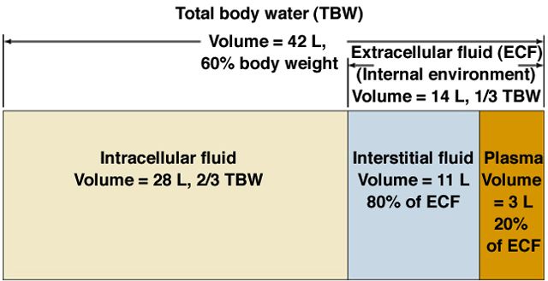

Figure 1: Fluid compartments of the body. Volumes are for an average 70-kg (154-lb) person. total body water (TBW) ; extracellular fluid (ECF).

Normal Ranges and Physical Characteristics of Important Extracellular Fluid Constituents

Table (1) lists the more important constituents and physical characteristics of extracellular fluid, along with their normal values, normal ranges, and maximum limits without causing death. Most important are the limits beyond which abnormalities can cause death. For example, an increase in the body temperature of only 11°F (7°C) above normal can lead to a vicious cycle of increasing cellular metabolism that destroys the cells. Note also the narrow range for acid-base balance in the body, with a normal pH value of 7.4 and lethal values only about 0.5 on either side of normal. Another important factor is the potassium ion concentration, because whenever it decreases to less than one third normal, a person is likely to be paralyzed as a result of the nerves’ inability to carry signals. Alternatively, if the potassium ion concentration increases to two or more times normal, the heart muscle is likely to be severely depressed. Also, when the calcium ion concentration falls below about one half of normal, a person is likely to experience tetanic contraction of muscles throughout the body because of the spontaneous generation of excess nerve impulses in the peripheral nerves. When the glucose concentration falls below one half of normal, a person frequently develops extreme mental irritability and sometimes even convulsions.

Table 1: Important Constituents and Physical Characteristics of Extracellular Fluid
 | Normal Value | Normal Range | Approximate Short Term Non lethal Limit | Unit
Oxygen | 40 | 35–45 | 10–1000 | mm Hg
Carbon dioxide | 40 | 35–45 | 5–80 | mm Hg
Sodium ion | 142 | 138–146 | 115–175 | mmol/L
Potassium ion | 4.2 | 3.8–5.0 | 1.5–9.0 | mmol/L
Calcium ion | 1.2 | 1.0–1.4 | 0.5–2.0 | mmol/L
Chloride ion | 108 | 103–112 | 70–130 | mmol/L
Bicarbonate ion | 28 | 24–32 | 8–45 | mmol/L
Glucose | 85 | 75–95 | 20–1500 | mg/dl
Acid-base | 7.4 | 7.3–7.5 | 6.9–8.0 | pH
Body temperature | 98.4 (37.0) | 98–98.8 (37.0) | 65–110 (18.3–43.3) | °F (°C)

“Homeostatic” Mechanisms of the Major Functional Systems

The term homeostasis is used by physiologists to mean maintenance of nearly constant conditions in the internal environment. Essentially all organs and tissues of the body perform functions that help maintain these constant conditions. For instance, the lungs provide oxygen to the extracellular fluid to replenish the oxygen used by the cells, the kidneys maintain constant ion concentrations, and the gastrointestinal system provides nutrients.

Homeostasis in a general sense refers to stability, balance or equilibrium. It is the body's attempt to maintain a constant internal environment. Maintaining a stable internal environment requires constant monitoring and adjustments as conditions change. This adjusting of physiological systems within the body is called homeostatic regulation. Homeostatic regulation involves three parts or mechanisms:
1) Receptor
2) Control center
3) Effector
The receptor receives information that something in the environment is changing. The control center or integration center receives and processes information from the receptor. And lastly, the effector responds to the commands of the control center by either opposing or enhancing the stimulus. This is an ongoing process that continually works to restore and maintain homeostasis. For example, in regulating body temperature there are temperature receptors in the skin, which communicate information to the brain, which is the control center, and the effector is our blood vessels and sweat glands in our skin.
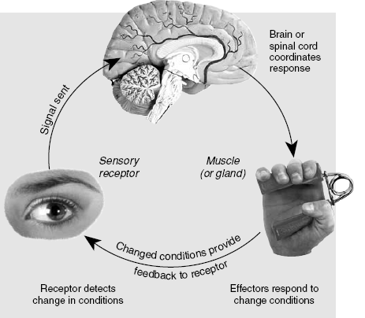
An organism is said to be in homeostasis when the internal environment contains:
  - The optimal concentration of gases
  - The optimal concentration of nutrients
  - The optimal concentration of ions and water
  - At the optimal temperature
Characteristics of Control Systems
The aforementioned examples of homeostatic control mechanisms are only a few of the many thousands in the body, all of which have certain characteristics in common. These characteristics are explained in this lecture.

1) Negative Feedback Nature of Most Control Systems

Most control systems of the body act by negative feedback, which can best be explained by reviewing some of the homeostatic control systems mentioned previously. In the regulation of carbon dioxide concentration, a high concentration of carbon dioxide in the extracellular fluid increases pulmonary ventilation. This, in turn, decreases the extracellular fluid carbon dioxide concentration because the lungs expire greater amounts of carbon dioxide from the body. In other words, the high concentration of carbon dioxide initiates events that decrease the concentration toward normal, which is negative to the initiating stimulus. Conversely, if the carbon dioxide concentration falls too low, this causes feedback to increase the concentration.
This response also is negative to the initiating stimulus.

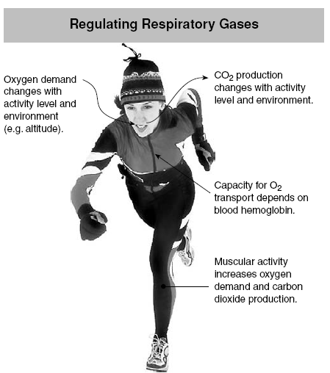

In the arterial pressure–regulating mechanisms, a high pressure causes a series of reactions that promote a lowered pressure, or a low pressure causes a series of reactions that promote an elevated pressure. In both instances, these effects are negative with respect to the initiating stimulus.

Average blood glucose concentrations of healthy individuals are graphed before and after a rapid intravenous injection of insulin. The “0” indicates the time of the injection. Notice that, following injection of insulin, the blood glucose is brought back up to the normal range. This occurs as a result of the action of hormones antagonistic to insulin, which cause the liver to secrete glucose into the blood. In this way, homeostasis is maintained.

Therefore, in general, if some factor becomes excessive or deficient, a control system initiates negative feedback, which consists of a series of changes that return the factor toward a certain mean value, thus maintaining homeostasis.
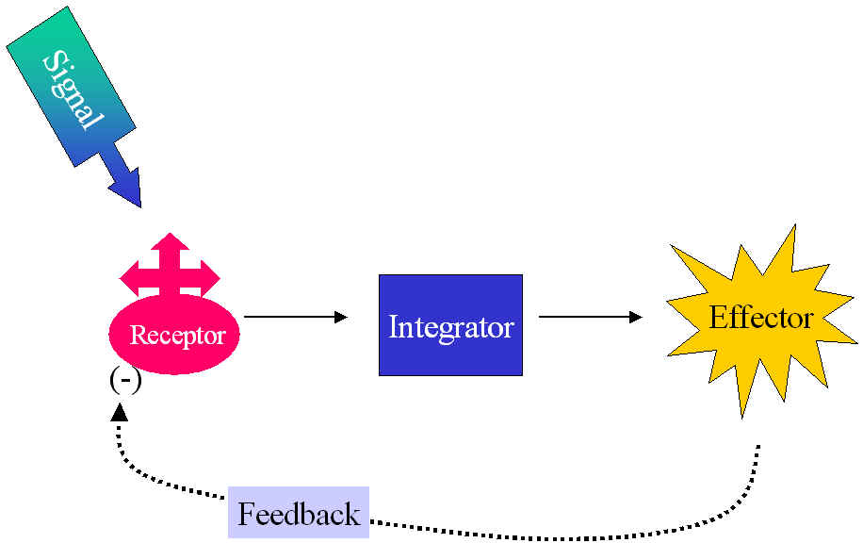 Negative feedback

2) Positive Feedback: a response is to amplify the change in the variable. This has a destabilizing effect, so does not result in homeostasis. Positive feedback is less common in naturally occurring systems than negative feedback, but it has its applications. For example, in nerves, a threshold electric potential triggers the generation of a much larger action potential. Blood clotting in which the platelets process mechanisms to transform blood liquid to solidify is an example of positive feedback loop. Another example is the secretion of oxytocin which provides a pathway for the uterus to contract, leading to child birth.
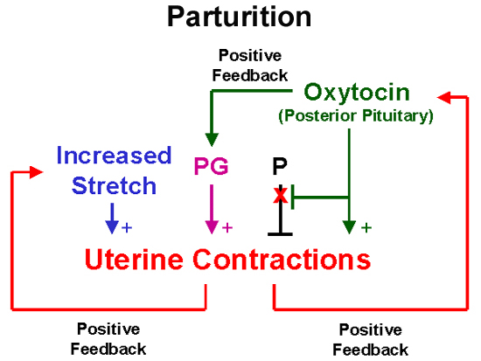Positive feedback

Regulation of Body Functions
- Nervous System. The nervous system is composed of three major parts: the sensory input portion, the central nervous system , and the motor output portion. Sensory receptors detect the state of the body or the state of the surroundings. For instance The eyes are sensory organs that give one a visual image of the surrounding area. The ears also are sensory organs. The central nervous system is composed of the brain and spinal cord. The brain can store information, generate thoughts, create ambition, and determine reactions that the body performs in response to the sensations. Appropriate signals are then transmitted through the motor output portion of the nervous system to carry out one’s desires.

- Hormonal System of Regulation. Located in the body are eight major endocrine glands that secrete chemical substances called hormones. Hormones are transported in the extracellular fluid to all parts of the body to help regulate cellular function. For instance Insulin controls glucose metabolism and parathyroid hormone controls bone calcium and phosphate. Thus, the hormones are a system of regulation that complements the nervous system. The nervous system regulates mainly muscular and secretary activities of the body, whereas the hormonal system regulates many metabolic functions.

