Ministry Of Higher Education and Scientific Research
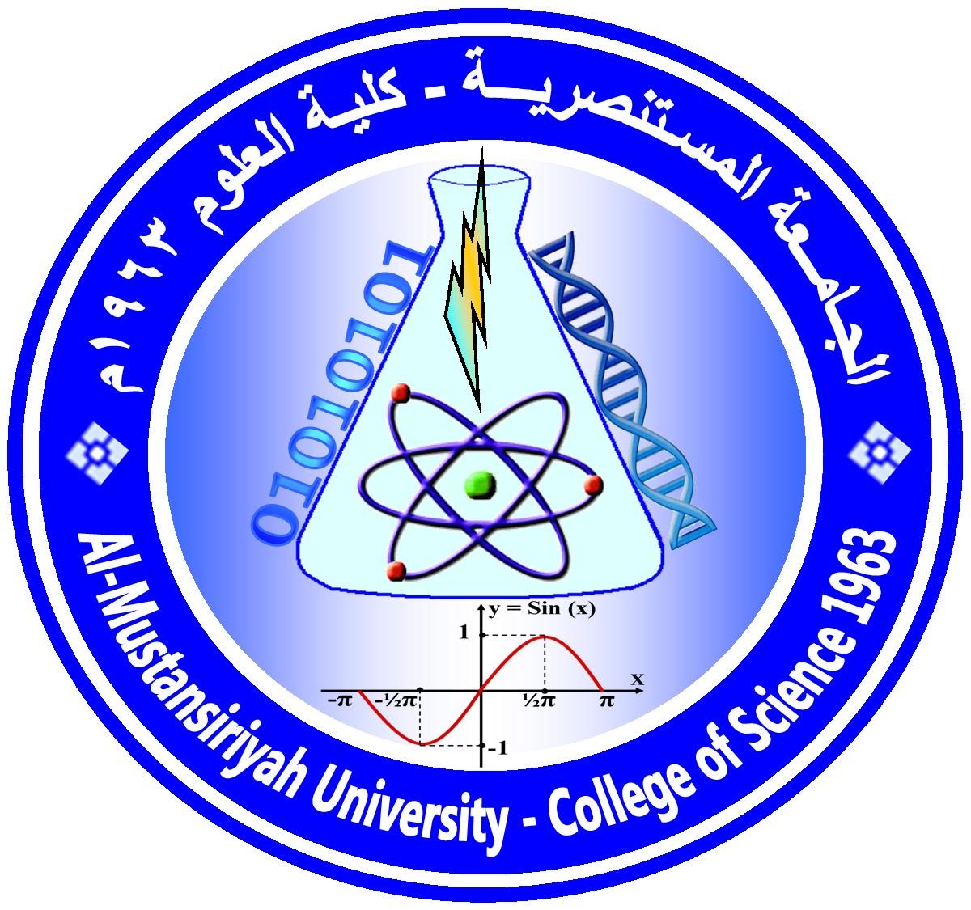
AL-Mustansiriya University/College of Science/Department of Computer Science
(ا)
Course Plan

Course No.: | Course Name: Open Source Software
Academic Year: Third /CS | Time Division: (3 theoretical+ 2 practical)
Course Description
( 3 credit hours)
Open Source Software is becoming an important resource for development, A working understanding of the economical and technical background of the Free / Open Source Software movement (FOSS) is essential for its effective use, active knowledge of the available FOSS resources, including hosting sites, projects, communities, legal frameworks, organizations etc.
The course takes students through the history and current status of the FOSS world, and starts them exploring it, by connecting their personal experiences with corresponding FOSS projects. Students will experience finding and using Open Source Software projects. And learn about open source license. They also learn how to initiate a new project, or join and extend an existing project. By completing the course, students will be ready to apply OSS methods and resources in their work.
Course Intended Outcomes:
At the end of the course, students are expected to learn:
(1). Can identify the licensing of open source systems and make decisions on their use, based on an
understanding of the legal, economical and technical issues.
(2). Can find open source projects related to a given development problem.
(3). Can install from source code an open source project and start using it.
(4). Can choose the correct license, development model, and development community for open source
projects, and can initiate a new project or join an existing project.
(5). Can use the major development platforms and tools that are common for open source projects.
(6). Experience participating in a public open source project.

Course Outline:
Week | Description depends on the Timing table(Theoretical) | practical
1 | Introduction to open source software. | Introduction to Linux and review the top10 Linux distributions depending on the last year chart.
2 | History, background, status of Open Source Software. | How to install Linux mint and its user guide, exploring the desktop of Linux mint and menus.
3 | Where are the projects?: review of open Source software repositories ,development organizations, and successful open source projects . | How to use Linux- using terminal command lines.
4 | Legal and social issues, Starting with the concepts of copyrights, patents, and licensing of software. | How to use Linux- using terminal command lines.
5 | licensing of open source software and Common licensing models | How to use Linux- How to upgrade Linux and using package manager.
6 | First exam | Installing and using another Linux distribution (Linux fedora and starting using it)
7 | Open source development model and methodologies. | Compare between Linux mint and fedora.
8 | Technical foundations of open source software: review some major development languages, libraries and frameworks that commonly used in Open Source software projects. | First exam
9 | Exploring Linux kernel. | PHP-introduction and PHP - Environment Setup
10 | Discussing Apache source code Android kernel. | PHP - Syntax Overview
11 | Discuss LibreOffice,and Firefox, other open source components. | PHP - Variable Types,  Constants Types, Operator Types
12 | Business models of open source software, How to make money out of free software? | PHP - Decision Making, Loop Types
13 | Reviewing and Selecting topics for open source software developing projects by a group of students. | PHP & MySQL
14 | Presentation of the students Developed open source project. | PHP & XML
15 | Second exam | Second exam

Textbooks:

-Fundamentals of open source software “by m. n. rao (author),2014 .

- Open source software: implementation and management by paul kavanag ,2004.

- g e t t i n g s t a r t e d w i t h open source development by rachna kapur, mario briggs, tapas saha, ulisses costa, pedro carvalho, raul f. chong, peter kohlmann,,2010.

Suggested references:
uses only material freely available on the Internet( references , software ) because it is open source.
Marking:
First course |  | Final Exam
1st exam 2nd exam Practical Activity  10 10 14 6 |  | 60

Assignments and/or Projects:
Assignment/Project | Description | Due Date | Marking
Writing Assignments | The student given during the course requiring individual work from students.( Linux kernel and android kernel) |  | 2
Group project | To be completed before the last day of class for the semester, group project will represent the culmination of students’ efforts during the course (design a web site for open source software that contains license designed by the students for a different subjects projects designed by the students) . |  | 3
Quizzes | Two quizzes | During the course | 1 Marks

Instructor information:
Lecture Room: [ lan2,lab5,room 402 ]

Instructor's Name: yasmin maki ( theoretical and practical( |  | Office No.:9
E-Mail:ymmiraq2009@yahoo.com
NOTES:
- Office Hours: Other office hours are available by appointment.
- The content of this syllabus not be changed during the current semester.
Lecturer Signature Chairman Signature

