Plasmid
In 1952, Joshua Lederberg coined the term plasmid, in reference to any extrachromosomal heritable determinant. Plasmids are fragments of double-stranded DNA that can replicate independently of chromosomal DNA, and usually carry genes. Although they can be found in Bacteria, Archaea and Eukaryotes, they play the most significant biological role in bacteria where they can be passed from one bacterium to another by horizontal gene transfer, usually providing a context-dependent selective advantage, such as antibiotic resistance.
Today, scientists can easily study and manipulate genes and other genetic elements using specifically engineered plasmids, commonly referred to as vectors, which have become possibly the most ubiquitous tools in the an extrachromosomal self-replicating structure found in bacterial cells that carries genes for a variety of functions not essential for cell growth.
Plasmids consist of cyclic double-stranded DNA molecules, replicating independently of the chromosomes and transmitting through successive cell divisions genes specifying such functions as antibiotic resistance (R plasmid); conjugation (F plasmid); the production of enzymes, toxins and antigens; and the metabolism of sugars and other organic compounds. Plasmids can be transferred from one cell to another by conjugation and by transduction. Some plasmids may also become integrated into the bacterial chromosome; these are known as episomes.

1. Extrachromosomal DNA, usually circular-parasite?
2. Usually encode ancillary functions for in vitro growth
3. Can be essential for specific environments: virulence, antibiotics resistance, use of unusual nutrients, production of bacteriocins (colicins)
4. Must be a replicon - self-replicating genetic unit
5. Plasmid DNA must replicate every time host cell divides or it will be lost
a. DNA replication
  - partitioning (making sure each progeny cells receives a plasmid)
6. High copy plasmids are usually small; low copy plasmids can be large
7. Partitioning is strictly controlled for low copy, but loose for high copy
- Plasmid replication requires host cell functions
- Copy number is regulated by initiation of plasmid replication
- Plasmids are incompatible when they cannot be stably maintained in the same cell because they interfere with each other’s replic

conjugative plasmid a plasmid that is transferred from one bacterial cell to another during conjugation.
F plasmid a conjugative plasmid found in F⁺ (male) bacterial cells that leads with high frequency to its transfer and much less often to transfer of the bacterial chromosome. A cell possessing the F plasmid (F⁺, male) can form a conjugation bridge (F pilus) to a cell lacking the F plasmid (F⁻, female), through which genetic material may pass from one cell to another.
F′ plasmid a hybrid F plasmid that contains also a segment of the host chromosome.
R plasmid a conjugative factor in bacterial cells that promotes resistance to agents such as antibiotics, metal ions, ultraviolet radiation, and bacteriophage.

The Fertility factor (first named F by one of its discoverers Esther Lederberg) allows genes to be transferred from one bacterium carrying the factor to another bacterium lacking the factor by conjugation. The F factor is carried on the F episome, the first episome to be discovered. Unlike other plasmids, F factor is constitutive for transfer proteins due to the gene traJ. The F plasmid belongs to a class of conjugative plasmids that control sexual functions of bacteria with a fertility inhibition (Fin) system.

Discovery of Fertility factor "F"
Esther M. Lederberg and Luigi L. Cavalli-Sforza discovered "F," subsequently publishing with Joshua Lederberg. Once her results were announced, two other labs joined the studies.

Structure
The most common functional segments constituting F factors are:
- OriT (Origin of Transfer): The sequence which marks the starting point of conjugative transfer.
- OriC (Origin of Replication): The sequence starting with which the plasmid-DNA will be replicated in the recipient cell.
- tra-region (transfer genes): Genes coding the F-Pilus and DNA transfer process.
- IS (Insertion Elements) composed of one copy of IS2, two copies of IS3, and one copy of IS1000: so-called "selfish genes" (sequence fragments which can integrate copies of themselves at different locations).

Relation to the genome
The episome that harbors the F factor can exist as an independent plasmid or integrate into the bacterial cell's genome. There are several names for the possible states:
- Hfr bacteria possess the entire F episome integrated into the bacterial genome.
- F⁺ bacteria possess F factor as a plasmid independent of the bacterial genome. The F plasmid contains only F factor DNA and no DNA from the bacterial genome.
- F' (F-prime) bacteria are formed by incorrect excision from the chromosome, resulting in F plasmid carrying bacterial sequences that are next to where the F episome has been inserted.
- F⁻ bacteria do not contain F factor and act as the recipients.

Function
When an F⁺ cell conjugates/mates with an F⁻ cell, the result is two F⁺ cells, both capable of transmitting the plasmid to other F⁻ cells by conjugation. The F-plasmid belongs to a class of conjugative plasmids that control sexual functions of bacteria with a fertility inhibition (Fin) system. In this system, a trans-acting factor, FinO, and antisense RNAs, FinP, combine to repress the expression of the activator gene TraJ. TraJ is a transcription factor that upregulates the tra operon. The tra operon includes genes required for conjugation and plasmid transfer. This means that an F⁺ bacteria can always act as a donor cell. The finO gene of the original F plasmid (in E. coli K12) is interrupted by an IS3 insertion, resulting in constitutive tra operon expression. F⁺ cells also have the surface exclusion proteins TraS and TraT on the bacterial surface. These proteins prevent secondary mating events involving plasmids belonging to the same incompatibility (Inc) group. Thus, each F⁺ bacterium can host only a single plasmid type of any given incompatibility group.
In the case of Hfr transfer, the resulting transconjugates are rarely Hfr. The result of Hfr/F⁻ conjugation is a F⁻ strain with a new genotype.When F-prime plasmids are transferred to a recipient bacterial cell, they carry pieces of the donor's DNA that can become important in recombination. Bioengineers have created F plasmids that can contain inserted foreign DNA; this is called a bacterial artificial chromosome.
Resistance transfer factor (shortened as R-factor or RTF) is an old name for a plasmid that codes for antibiotic resistance. R-factor was first demonstrated in Shigella. Often, R-factors code for more than one antibiotic resistance factor: genes that encode resistance to unrelated antibiotics may be carried on a single R-factor, sometimes up to 8 different resistances. Many R-factors can pass from one bacterium to another through bacterial conjugation and are a common means by which antibiotic resistance spreads between bacterial species, genera and even families. For example RP1, a plasmid that encodes resistance to ampicillin, tetracycline and kanamycin originated in a species of Pseudomonas, from the Family Pseudomonadaceae, but can also be maintained in bacteria belonging to the family Enterobacteriaceae, such as Escherichia coli.
the prototypical conjugative plasmid is the F-plasmid, or F-factor.^{[1]} The F-plasmid is an episome (a plasmid that can integrate itself into the bacterial chromosome by homologous recombination) with a length of about 100 kb. It carries its own origin of replication, the oriV, and an origin of transfer, or oriT.^{[4]} There can only be one copy of the F-plasmid in a given bacterium, either free or integrated, and bacteria that possess a copy are called F-positive or F-plus (denoted F⁺). Cells that lack F plasmids are called F-negative or F-minus (F⁻) and as such can function as recipient cells.
Among other genetic information the F-plasmid carries a tra and trb locus, which together are about 33 kb long and consist of about 40 genes. The tra locus includes the pilin gene and regulatory genes, which together form pili on the cell surface. The locus also includes the genes for the proteins that attach themselves to the surface of F⁻ bacteria and initiate conjugation. Though there is some debate on the exact mechanism of conjugation it seems that the pili are not the structures through which DNA exchange occurs. This has been shown in experiments where the pilus are allowed to make contact, but then are denatured with SDS and yet DNA transformation still proceeds. Several proteins coded for in the tra or trb locus seem to open a channel between the bacteria and it is thought that the traD enzyme, located at the base of the pilus, initiates membrane fusion.
If the F-plasmid that is transferred has previously been integrated into the donor’s genome (producing an Hfr strain ["High Frequency of Recombination"]) some of the donor’s chromosomal DNA may also be transferred with the plasmid DNA.^{[3]} The amount of chromosomal DNA that is transferred depends on how long the two conjugating bacteria remain in contact. In common laboratory strains of E. coli the transfer of the entire bacterial chromosome takes about 100 minutes. The transferred DNA can then be integrated into the recipient genome via homologous recombination.
A cell culture that contains in its population cells with non-integrated F-plasmids usually also contains a few cells that have accidentally integrated their plasmids. It is these cells that are responsible for the low-frequency chromosomal gene transfers that occur in such cultures. Some strains of bacteria with an integrated F-plasmid can be isolated and grown in pure culture. Because such strains transfer chromosomal genes very efficiently they are called Hfr (high frequency of recombination). The E. coli genome was originally mapped by interrupted mating experiments in which various Hfr cells in the process of conjugation were sheared from recipients after less than 100 minutes (initially using a Waring blender). The genes that were transferred were then investigated.
Since integration of the F-plasmid into the E. coli chromosome is a rare spontaneous occurrence, and since the numerous genes promoting DNA transfer are in the plasmid genome rather than in the bacterial genome, it has been argued that conjugative bacterial gene transfer is not an evolutionary adaptation of the bacterial host, nor is it likely ancestral to eukaryotic sex.^{[8]}
Plasmids in plant-associated bacteria

A different type of pathogenicity is seen with the plant pathogen Agrobacterium tumefaciens, which causes a tumour-like growth known as a crown gall in some plants. Again, it is only strains that carry a particular type of plasmid (known as a Ti plasmid, for Tumour Inducing) that are pathogenic; in this case however, pathogenicity is associated with the transfer of a specific part of the plasmid DNA itself into the plant cells. This phenomenon has additional importance because of its application to the genetic manipulation of plant cells .
Members of the genus Rhizobium also ‘infect’ plants, although in this case the relationship is symbiotic rather than pathogenic. These bacteria form nodules on the roots of leguminous plants. Under these conditions the bacteria are able to fix nitrogen and supply the plant with a usable source of reduced nitrogen, a process of considerable ecological and agricultural importance. The genes necessary for both nodulation and nitrogen fixation are carried by plasmids.

Metabolic activities

Plasmids are capable of expanding the host cell’s range of metabolic activities in a variety of other ways. For example, a plasmid that carries genes for the fermentation of lactose, if introduced into a lactose non-fermenting strain, will convert it to one that is able to utilize lactose. Such plasmids can cause problems in diagnostic laboratories where organisms are often identified on the basis of a limited set of biochemical characteristics. Commonly the potentially pathogenic Salmonella genus is differentiated from the (usually) non-pathogenic E. coli species primarily.

Plasmid replication and control

Many plasmids are replicated as double stranded circular molecules. The overall picture with such plasmids is basically similar to that of the chromosome, in that replication starts at a fixed point known as oriV (the vegetative origin, to distinguish it from the point at which conjugative transfer is initiated, oriT), and proceeds from this point, either in one direction or in both directions simultaneously until the whole circle is copied.
However there are some aspects of replication that differ from that of the chromosome, especially for the multicopy plasmids. Two examples that have been studied intensively are ColE1 and R100.

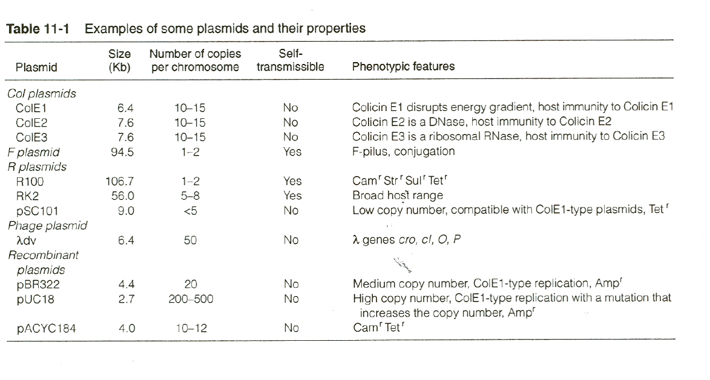

Plasmid replication
- Plasmid replication requires host DNA replication machinery.
- Most wild plasmids carry genes needed for transfer and copy number control.
- All self replication plasmids have a oriV: origin of replication
- Some plasmids carry and oriT: origin of transfer. These plasmids will also carry functions needed to be mobilized or mob genes.
- Plasmid segregation is maintained by a par locus-a partition locus that ensures each daughter cells gets on plasmid. Not all plasmids have such sequences.
- There are 5 main “incompatibility” groups of plasmid replication. Not all plasmids can live with each other.
- Agents that disrupt DNA replication destabilize or cure plasmids from cells.

Incompatibility Groups
- Not all plasmids can live together.
- Plasmids that are able to coexist in the same cell do not interfere with each other’s replication
- A single cell can have as many Inc group plasmids as it can tolerate and replicate!
Site-directed mutation: Suicide plasmds
- Plasmid must be unable to replicate without essential replication proteins provide in trans.
- It helps if the plasmid can be mobilized-oriT required
- Need a selectable marker
- Large or small region of homologous DNA cloned that will integrate into the chromosomal target.
- Need a counter selection method to kill the donor cells
- Screen for what you think is correct.
Also, merodiploid reporter strains can be constructed in this manner
- Make a lacZ fusion to your promoter of interest
- Clone into a suicide plasmid
- Mate into recipient.
- Resulting strain will harbor a duplication of the promoter region:lacZ and still have a functional copy of the gene.
Why would this be important?
F-plasmid
- large (100 kb)
- low copy (1-2 copies/cell)
- self transmissible
- requires protein synthesis (chloramphenicol-sensitive)
- repE gene encodes RepE protein
- RepE protein binds to origin of replication (oriS) and initiates DNA replication
- RepE binds to the repE promoter and activates transcription
- RepE binds to the copA/incC locus binding copies of F together via RepE – inhibiting replication (coupling)
Genetic organization of F
