Order: Diptera
Family: Calliphoridae
- Sub family: Calliphorinae
- Sub family: Luciliinae
The family Calliphoridae, also known as blowflies, is found in habitats such as forests, meadows, grasslands and even around homes. Blowflies resemble the size of houseflies, except they are metallic green, black, blue or copper-colored. Like many other species of insects, blowflies experience four steps of development during their life time
Female blowflies lay their eggs in masses of 40 to 1,000 eggs on or near surfaces that will provide the hatched eggs with their first food source. Some eggs are laid on animal carcasses, while others are deposited on wounds of living animals, where they eventually act as parasites and eat the flesh of their host. The blowfly eggs are white or pale yellow and sausage-shaped, measuring about 1.5 millimeters in length. These eggs incubate for four days and hatch into larvae when conditions are humid and warm.
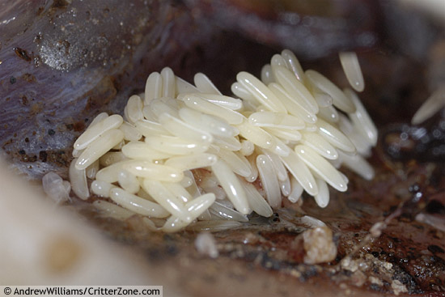
Larvae are typically maggot-shaped The larval period lasts about 5–8 days. Mature larvae bury in loose soil and pupate; the puparial period lasts about 6–15 days. The duration of the various life stages depends greatly on temperature and geographical area.

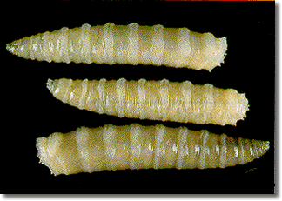

Adult flies frequently visit carrion, excreta, general refuse and decaying material, as well as sores and wounds. They are particularly common around unhygienic situations where meat or dead animals are present.
They are frequently abundant near slaughterhouses and piggeries. They commonly fly into houses, where they are particularly troublesome because of their noisy buzzing flight. The most common species infesting wounds of humans are Lucilia sericata and L. cuprina
.
Calliphora (Bluebottles)

Adults are robust flies, 8–14mm long, dull metallic-bluish or bluish-black .As in Lucilia, there are well-developed bristles on the thorax, but the squama of the wing is hairy on the dorsal surface ,whereas in Lucilia it lacks hairs. The abdomen is rather more shiny than the thorax.

Medical importance of greenbottles and bluebottles

The dirty habit of blowflies (greenbottles and bluebottles) of feeding on excreta, decaying material and virtually all foods makes them potential vectors of numerous pathogens. However, their medical importance is usually associated with facultative myiasis.
Larvae of both Lucilia and Calliphora often develop in foul-smelling wounds and ulcerations, especially those producing pus. Removal of maggots of Lucilia and Calliphora usually presents no problems, because they can be picked out of wounds with sterile forceps and antibiotic dressings applied

Adults may be vectors of pathogens of diseases such as dysentery. Flies, most commonly Calliphoridae, have frequently been associated with disease transmission in humans and animals, as well as myiasis. Studies and research have linked Calliphora and Lucilia to causal vectors of agents of bacterial infections. These larvae, commonly seen on decaying bodies, feed on carrion while the adults can be necrophagous or vegetative. During the process of decay, microorganisms (e.g. Mycobacterium) may be released through the body. Flies arrive at the scene and lay their eggs. The larvae begin eating and breaking down the corpse, simultaneously ingesting these organisms which is the first step of one transmission route

Forensic importance

Blow flies are usually the first insects to come in contact with carrion because they have the ability to smell dead animal matter from up to 1 mile (1.6 km) away . Upon reaching the carrion, females deposit eggs on it. Since development is highly predictable if the ambient temperature is known, blow flies are considered a valuable tool in forensic science. Traditional estimations of time since death are generally unreliable after 72 hours and often entomologists are the only officials capable of generating an accurate approximate time interval. The specialized discipline related to this practice is known as forensic entomology.

Myiasis:- is the invasion of organs and tissues of humans or other vertebrate animals by fly larvae, which at least for some time feed on the living or dead tissues .

