Lec. Five

**3- Sclerenchyma**

A tissue composed of cells with **secondary walls**, often **lignified**, whose principal function is **mechanical** or **support**. These cells are supposed to enable plant organs to withstand various strains, such as may result from stretching, bending, weight, and pressure without undue damage to the thin walled softer cells. Sclerenchyma cells may or may not retain their protoplasts at maturity. Sclerenchyma cells are usually divided into two categories: **fibers** and **sclereids.**

**1- Fibers**:

They are typically **long, spindle-shaped cells**, with more or less **thick secondary walls**, **not branched** and they usually occur in **strands**. Fibers serve as **supporting elements in plant parts** that are no longer elongating. The degree of lignification varies, and typically the simple or slightly bordered pits are relatively scarce and slit-like. Many fibers **retain their protoplasts at maturity**. Each fiber typically produced from new cell produced by mitosis, from meristem as this cell grows, it adds lignified cell wall and eventually dies leaving the cell wall skeleton to **strength plant part**, fibers have also **commercial uses**, for instance, **paper** is composed from **sclerenchyma fibers** and **xylem cells** from wood. Fibers found in various parts of plants, could be of **two** types depending on site where they are found:

1- **Extraxylary fibers**: fibers located outside xylem tissue

**Phloem fibers** (primary phloem fibers , secondary phloem fibers).

extraxylary fibers encountered in the **stems of eudicots** are the cortical fibers and the perivascular fibers.

A- **Cortical fibers**, as the name implies, originate in the cortex

B- **Perivascular fibers** (**pericyclic fibers**) are located on the periphery of the vascular cylinder inside the innermost cortical layer. They do not **originate as part of the phloem tissue but outside it**.

2- **Xylary fibers:** fibers located in xylem.

**2- Sclereids:**

They are typically **short cells** with **thick secondary walls**, strongly **lignified**, and provided with numerous **simple pits**. Some sclereids have relatively thin secondary walls. The secondary wall typically appears multilayered, reflecting its helicoidal construction. Many sclereids **retain**

**living protoplasts at maturity.**

**Classification of sclereids based on shape and size:**

The most commonly recognized categories of sclereids are :

1- **Brachysclereids**, or **stone cells**, roughly isodiametric or somewhat elongated cells, widely distributed in cortex, phloem, and pith of stems, and in the flesh of fruit.

2- **Macrosclereids**, elongated and columnar (rod-like) cells, exemplified by sclereids forming the palisade-like epidermal layer of leguminous seed coats.

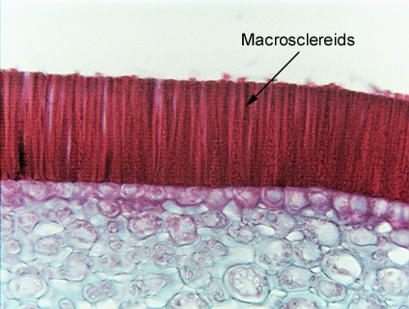

3- **Osteosclereids**, bone cells, also columnar but with enlarged ends as in the subepidermal layer of some seed coats.

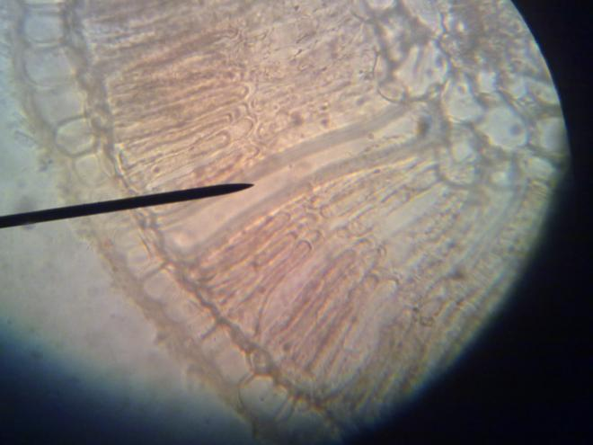

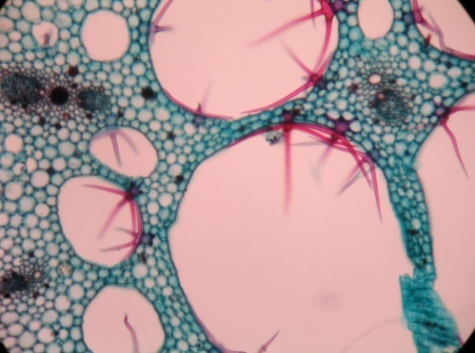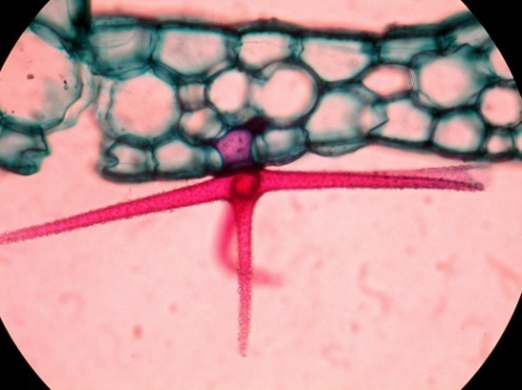4- **Astrosclereids**, star-cells, with lobes or arms diverging from a central body , often found in the leaves of eudicots.

**5- Trichosclereids**, thin-walled sclereids resembling hairs, with branches projecting.

**Epidermis**

It is a system of cells, variable in structure and function, usually the outermost layer on all parts of the **primary plant body**, including roots, stems, leaves, flowers, fruits, and seeds and compact with cuticle consisting of cutin (fatty material), **the cuticle effectively protects the plant from water loss and as barrier against pathogens**. Some investigators suggest that the surface layer of the root should have its own name, **rhizodermis**, or **epiblem*.*** Organs having little or no secondary growth usually retain their epidermis as long as they exist. A notable exception is found in long-lived monocots that have no secondary addition to the vascular system but replace the epidermis with a special kind of periderm.

**Composition of epidermis:**

The epidermis is a complex tissue composed of a wide variety of cell types, which reflect its multiplicity of functions. The groundmass of this tissue is composed of relatively:

**1- Unspecialized cells (the ordinary epidermal cells)**

They are ground cells, **tabular,** having little depth. Some, such as the palisade-like epidermal cells of many seeds, are much deeper than they are wide. In elongated plant parts, such as stems, petioles, vein ribs of leaves, and leaves of most monocots, the epidermal cells are elongated parallel with the long axis of the plant part. Epidermal cells have living protoplasts and may store various products of metabolism. They contain **plastids** that usually develop only **few grana** and are, therefore, **deficient in chlorophyll**. Photosynthetically active chloroplasts, however, occur in the epidermis of plants living in deep shade, as well as in the epidermis of

submerged water plants. Starch and protein crystals may be present in epidermal plastids, anthocyanins in vacuoles.

**2- Specialized epidermal cells:**

A diverse collection of plant epidermal cells can occur on the young stem and different foliar organs.

**1- Bulliform (like ballons) cells:**

They are **long, thin walled, highly vacuolated** cells usually present in **the stem of many monocots,** where are thought function **to rolling up or unrolling leaves** following the loss or uptake of water.

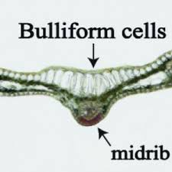

**2- Lithocysts**:

It is large cell produces a calcified body, the **cystolith**, composed largely of calcium carbonate attached to a silicified stalk, the stalk originates as a cylindrical ingrowth of the cell wall.

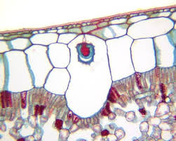

**3- Silica cells:** they are short cells, deposited in large quantities in the shoot system of grasses, when they are fully developed, their lumina are filled with isotropic bodies of silica. The shape of the silica bodies formed in the short cells over the veins can be used to identify the **subfamilies of**

**Gramineac** and also some of the tribes. The silicified cells can easily be **identified** by the **black cell wall** and **granular appearance** of **the lumen.** Beside above, there are other types of specializes cells like guard cells, subsidiary cells, trichomes will be discussed later in the next lecture.

**Classification of epidermis according to layers of cells:**

1- **Uniseriate epidermis:** The epidermis is usually one layer of cells in thickness.

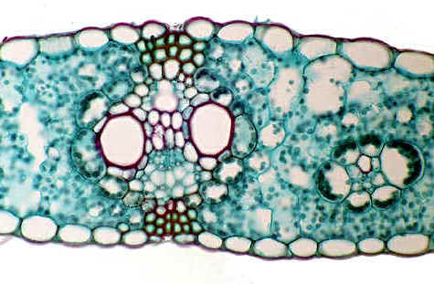

**2- Multiseriate or multiple epidermis:**

It is consisting of several layers of ontogenetically related cells, this is resulting from periclinally (parallel with the surface) division of protodermal cells in some leaves , their derivatives divide periclinally

, resulting in this type of epidermis tissue. In leaves the outermost layer of a multiple epidermis resembles an ordinary uniseriate epidermis in having a cuticle; the inner layers commonly contain few or no chloroplasts. One of the functions ascribed to the inner layers is storage of water.

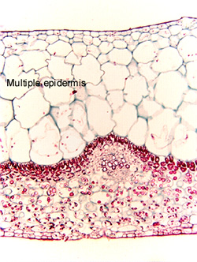

**Velamen:** multiple epidermis of dead hollow cells covering aerial roots in epiphytic plants like orchids, prevent plants from collapsing. **When wet, the velamen swells and gaps in it allow water uptake by the cortical cells beneath. When dry, it protects the cortex from drying out.**

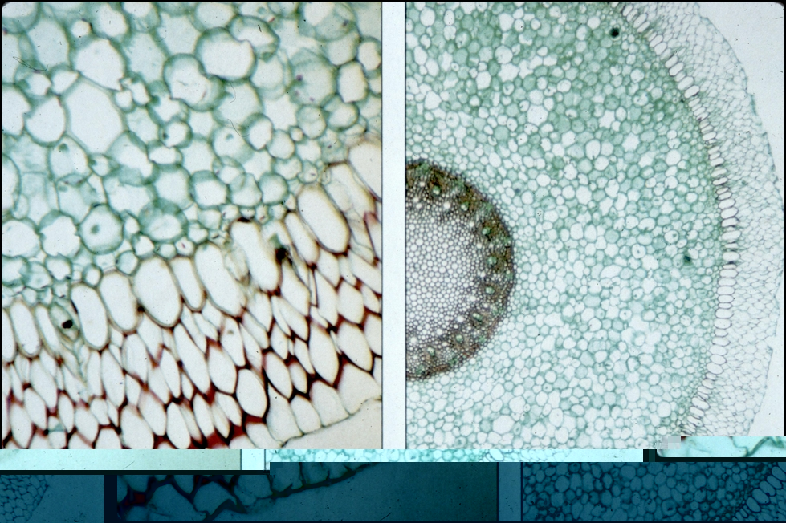

**Function of epidermis:**

1- Restricts transpiration (contains cutin(fatty material) within outer wall and on its surface (cuticle))

2- Gas exchange (presence of stomata)

3- Mechanical support (compact arrangement of cells and presence of tough cuticle layer)

4- Absorption ( thin walled and presence of root hairs)

5- Water storage (xerophyticplants)

6- Site of light perception involved in circadian leaf movement and photoperiodic induction