College of Science Al-Mustansiriyah University Dep.: Biology
Academic year: 2014-2015 Subject: Plant taxonomy Class: Third Grade
Lecturer:Dr.Hadeel R,Dr.Rana A, Dr. Aseel M,Dr.Zena K.
Lecture: 2
**Life span
Plants can be divided to many aspects according to their life cycle :-
1- Annual : A plant living and completing its life cycle in one growing season.
2- Biennial : A plant living for two seasons, growing vegetatively during the first and flowering during the second, like in Daucus carota.
3- Perennial : A plant living for more than 2 years and flowering several times during the life span. Perennials can be divided to :
A/ Herbaceous perennial :- the aerial shoot dies back each winter, and the annual shoots are produced from sub aerial stock every year.
B/ Woody perennial :- The woody aerial shoot live for number of years, a woody perennial may be tree, shrub.
**Plant habitat
It refers to the general environment where plant is growing, these include the following:
1/ Terrestial: Its growing on land like Bunium, it may be:-
A* Mesophyte : A plant growing in normal soil.
B* Xerophyte : A plant growing in dry habitats.
C* Halophyte : A salt –adapted plant.
D* Succulent : A plant with fleshy stem like cacti (الصبير) or leaf like members of Aizoaceae.
2/ Aquatic : A plant growing in water, it may be :-
A/ Floating : Its occurring on water surface as in Lema.
B/ Submerged or emersed :- Its wholly under water as in Ceratophyllum.
C/ Emergent :- Its anchored at the bottom but with shoots exposed above water as in Typha and Phragmites.
**There is another classification denoting nutritional physiology include :-
1.- Saprophyte :- A heterotrophic plant living off dead organic matter.
2- Holoparasites :- Plants lack photosynthesis /chlorophyll and must attach to a host to survive and reproduce as in Orobanche.
3- Insectivorous plants or Carnivorous :-
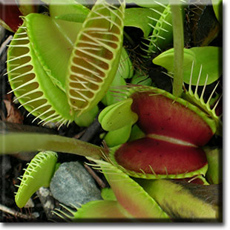
***Vegetative organs
*** Roots:
They are plant organs that function in anchorage and absorption of water and minerals. Roots are found in all of the vascular land plants except for Psilotales. The first root to develop in a vascular plant is the radicle of the embryo.
**Classification of roots according to origin:-
1/ Primary roots: They developed from radicle as continues after embryo growth. This system is widely found in dicot. There are different types of primary roots:
A- Tap roots: In this type the primary root becomes dominant as in Vicia faba .
B- Storage roots : Taproots has become greatly thickened accumulating high energy compounds ( usually starch) as in carots.
2/ Adventitious roots: Roots that arise from a nonroot organ (stem or leaf). They could be in different kinds as following:
A* Fibrous roots : In this system the primary root soon withers after its production and group of thin roots almost equal in size and thickness will appear instead. This type is widely distributed in monocots.
B* Prop roots: They grow from the base of stem and function to further support of plant as in Zea mays.
C* Tuberous roots : Swallowen roots as food accumulating growing from stem nodes as they could be either on clusters as in Dahlia and sweet potato or separated as in Bunium.
D* Haustoria : Specialized roots that penetrate the tissues of the plant host as in Cuscuta.
E* Pneumatophores or Aerating roots: Roots that grow upwardly from soil to air that function to obtain additional oxygen specially in plants growing in swamps and marshes as Avicennia.
F* Contractile roots : Roots that actually contract vertically functioning to pull the root stock further into soil as in plant with bulbs or corms.
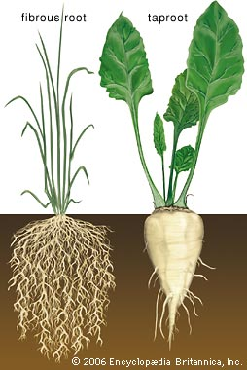
****Stems
They represent the main axes of plants, being distinguished into nodes and internodes, stem function both as supportive organs (supporting and bearing leaves and reproductive organs) and as conductive organs ( conducting both water /minerals and sugars through the vascular tissues.
Direction of stem growing or orientation of stem growing in higher plants living usually in land and their stem can be divided either:
1- Aerial stem:
Stem is growing above ground and could be in number of directions as following:-
A* Erect stems: stems pointing upwards as in date palm.
B* Ascending stems : directed upward, with a divergence angle of 15°-45°from upper axis( orientation) as in Nerium oleander.
C* Prostrate : the stem of these plants are adapted to lying flat on the ground but there is no rooting at nodes as in Tribulus and water melon.
D* Runner : a stem with long internode that runes on/or just below the surface of ground and terminating in new plantlet as in strawberry.
E* Climbers : growing upward by means of tendrils as in Vitis.
F* Twiners : a stem growing upward by helically twisting around supporting bodyas in Convolvulus.
2- Subterranean stems (underground): growing below the soil surface and specially modified :-
A* Rhizome: A horizontal fleshy underground stem with node and internodes, covering with scale leaves as in Ginger.
B* Stem tuber: they are swollen underground stems with reduced scale leaves and axillary buds as in potato.
C* Corm : thick fleshy shortened stems with storage function as in Crocus.
D* Bulb : a reduced stem surrounding by thick fleshy scale leaves. The leaves may be arranged in concentric manner surrounded by a thin membranous scale leaf as in tunicate bulb of onion(Allium cepa) .
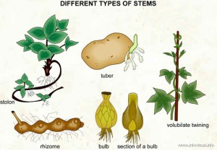
***Modification of Aerial stems
1- Phylloclades or cladodes: they are flattened structures that are green and photosynthetic and bear small scale leaves as in Phyllanthus (cultivated plant in Iraq) and Ruscus.
2- Spiny : pointed structure function as protection of plant against grazers as in Lycium.
3- Tendriller : a thin branch of stem twisted around supported body to help plant for climbing as Vitis.
***Stem habit
It’s a character describing the relative position of the stem :-
1/ Caulescent: A plant with an above-ground stem.
2/ Acaulescent: A plant that lack an above-ground stem, other than inflorescence axis, bearing major photosynthetic leaves only at ground level; often in basal rosette as in Carots.
***Leaves
They are the primary photosynthetic organs of plants, functioning also as the main site of transpiration. Leaves are usually arising from nodes. A leaf can be gametophytic as in the leafy liverworts and mosses or sporophytic, in the vascular plants.

***leaf parts:
Leaves may be divided into a number of leaf parts :-
1* Blade or lamina:- the expanded, flat portion of the leaf, which contains the bulk of the chloroplasts .
2* Petiole :- It’s a leaf stalk, which leaf is termed petiolate when its present and sessile when it lacks as in Malabaila.

***Modefication of petiole:-
A/ Phyllodes: flattened, blade like petiole found mainly in Australian Acacia, are derived from ancestrally compound leaves by loss of the rachis and leaflets.
B/ Tendril : It’s a coiled and twinning leaf.
C/ Spine : It’s a sharp- pointed leaf as in Cactus .
D/ Pulvinus: The swollen base of the petiole is sensitive to heat and agitation as in Mimosa.
3* Leaf sheath :- A leaf part typically at the base that partially or fully clasps the stem above the node as in the Poaceae(grasses) and many Apiaceae members.
4* Pseudo petiole :- It’s a petiole like structure arising between a leaf sheath and blade, found in several monocots, such as bananas and palms.
5* Stipules:- A pair of leaf like appendages at the either side of the base of a leaf. If stipules are present, the leaf are stipulate, and if the stipule is absent, then the leaf are exstipulate.
Stipules show a lot of structural modified diversity :
a/ Adnate: Attached to the base of petiole for some distant as in Rose.
b/ Ocrea: Tubular, scarious, specialized structures arising above the node in some members of Polygonaceae.
c/ Foliaceous or foliar:- Enlarged like leaves function in photosynthesis as in Pisum.
d/ Tendrillar:- Stipules modified to tendrils to help plants for climbing as in Smilax.
e/ Spiny:- Pointed, strong structures as in Ziziphus.
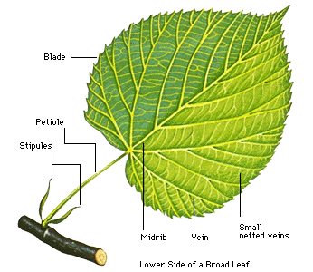

***Phyllotaxy:
It’s the pattern of arrangement of leaves on the stem, there are three main types of phyllotaxy:-
1* Alternate : In this type a single leaf arises at each node. The following leaves are produced in a spiral manner around the stem as in Hibiscus.
2* Opposite: In this type, the leaves are arranged in pairs at each node as in Verbena.
3* Whorled : Its more than two leaves occur at a node as in Nerium.

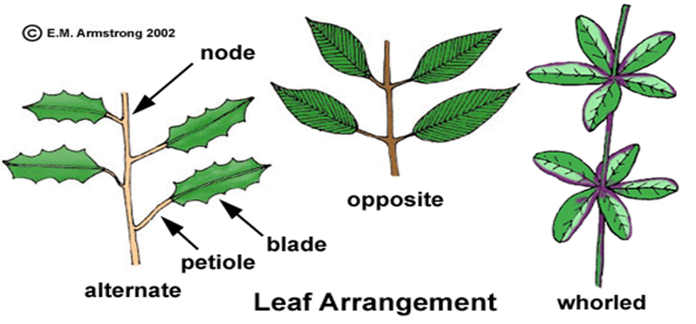

*** Leaf duration :
Leaves may stay and function for few days to many year, largely determined by the adaptation to climatic conditions:
A/ Ever green : leaves persistent through the year, falling regularly so that the tree is never leafless as in Citrus.
B/ Deciduous: Falling at the end of growing season so that the plant (tree or shrub) is leafless in winter as in Vitis.
C/ Caducuous: Falling off after their formation as in Opuntia.

