1
Igneous Rocks
Magma: The Parent Material of Igneous Rock
In our discussion of the rock cycle, it was noted that igneous rocks form as molten rock cools and solidifies. Considerable evidence supports the idea that the parent material for igneous rocks, called magma, is formed by melting that occurs at various levels within Earth’s crust and upper mantle to depths of perhaps 250 kilometers (about 150 miles). Once formed, a magma body buoyantly rises toward the surface because it is less dense than the surrounding rocks. (When rock melts it takes up more space and, hence, it becomes less dense than the surrounding solid rock.) Occasionally molten rock reaches Earth’s surface where it is called lava. Sometimes lava is emitted as fountains that are produced when escaping gases propel it from a magma chamber. On other occasions, magma is explosively ejected, producing dramatic steam and ash eruptions.
The Nature of Magma
Magma is completely or partly molten rock, which on cooling solidifies to form an igneous rock composed of silicate minerals. Most magmas consist of three distinct parts—a liquid component, a solid component, and a gaseous phase. The liquid portion, called melt, is composed mainly of mobile ions of the eight most common elements found in Earth’s crust—silicon and oxygen, along with lesser amounts of aluminum, potassium, calcium, sodium, iron, and magnesium. The solid components in magma are silicate minerals that have already crystallized from the melt. As a magma body cools, the size and number of crystals increase. During the last stage of cooling, a magma body is like a “crystalline mush” with only small amounts of melt. The gaseous components of magma, called volatiles, are materials that will vaporize (form a gas) at surface pressures. The most common volatiles found in magma are water vapor (H2O), carbon dioxide (CO2), and sulfur dioxide (SO2), which are confined by the immense pressure exerted by the overlying rocks. These gases tend to separate from the melt as it moves toward the surface (low-pressure environment). As the gases build up, they may eventually propel magma from the vent. When deeply buried magma bodies crystallize, the remaining volatiles collect as hot, water-rich fluids that migrate through the surrounding rocks.
Igneous Processes
Igneous rocks form in two basic settings. Magma may crystallize at depth or lava may solidify at Earth’s surface. When magma loses its mobility before reaching the surface it eventually crystallizes to form intrusive igneous rocks. They are also known as plutonic rocks—after Pluto. Intrusive igneous rocks are coarse-grained and consist of visible mineral crystals. These rocks are observed at the surface in locations where uplifting and erosion have stripped away the overlying rocks. Exposures of intrusive igneous rocks occur in many places Igneous rocks that form when molten rock solidifies at the surface are classified as extrusive igneous rocks. They are also called volcanic rocks—after the Roman fire god, Vulcan. Extrusive igneous rocks form when lava solidifies, in which case they tend to be fine-grained, or when volcanic debris falls to Earth’s surface
Igneous Compositions
Igneous rocks are composed mainly of silicate minerals. Chemical analyses show that silicon and oxygen are by far the most abundant constituents of igneous rocks. These two elements, plus ions of aluminum (Al), calcium (Ca), sodium (Na), potassium (K), magnesium (Mg), and iron (Fe), make up roughly 98 percent, by weight, of most magmas. In addition, magma contains small mounts of many other elements, including titanium and manganese, and trace amounts of much rarer elements such as gold, silver, and uranium. As magma cools and solidifies, these elements combine to form two major groups of silicate minerals. The dark (ferromagnesian) silicates are rich in iron and/or magnesium and comparatively low in silica. Olivine, pyroxene, amphibole, and biotite mica are the common dark silicate minerals of Earth’s crust. By contrast, the light (nonferromagnesian) silicates contain greater amounts of potassium, sodium, and calcium rather than iron and magnesium. As a group, nonferromagnesian minerals are richer in silica than the dark silicates. The light silicates include quartz, muscovite mica, and the most abundant mineral group, the feldspars. Feldspars make up at least 40 percent of most igneous rocks. Thus, in addition to feldspar, igneous rocks contain some combination of the other light and/or dark silicates listed above.

Granitic (Felsic) Versus Basaltic (Mafic) Compositions
Igneous rocks (and the magmas from which they form) can be divided into broad groups according to their proportions of light and dark minerals (FIGURE BELOW). Near one end of the continuum are rocks composed almost entirely of light-colored silicates—quartz and feldspar. Igneous rocks in which these are the dominant minerals have a granitic composition. Geologists also refer to granitic rocks as being felsic, a term derived from feldspar and silica (quartz). In addition to quartz and feldspar, most granitic rocks contain about 10 percent dark silicate minerals, usually biotite mica and amphibole. Granitic rocks are rich in silica (about 70 percent) and are major constituents of the continental crust Rocks that contain substantial dark silicate minerals and calcium-rich plagioclase feldspar (but no quartz) are said to have a basaltic composition (see Figure). Basaltic rocks contain a high percentage of ferromagnesian minerals, so geologists also refer to them as mafic (from magnesium and ferrum, the Latin name for iron). Because of their iron content, mafic rocks are typically darker and denser than granitic rocks. Basaltic rocks make up the ocean floor as well as many of the volcanic islands located within the ocean basins. Basalt also forms extensive lava flows on the continents.

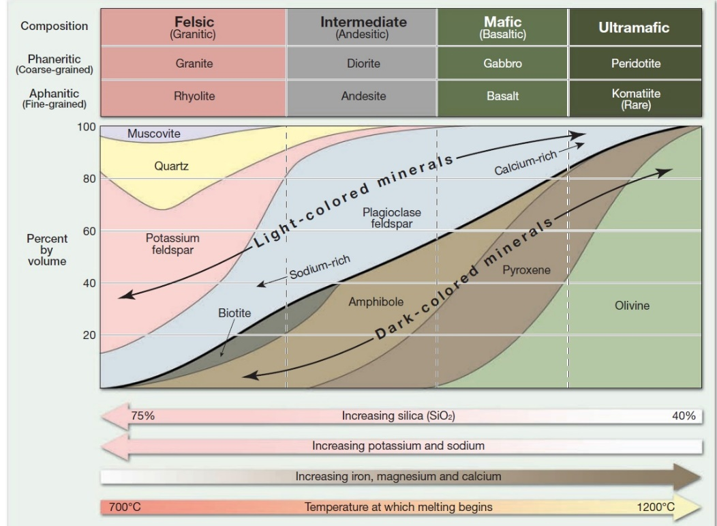

Figure: Mineralogy of common igneous rocks
Igneous Textures.
The term texture is used to describe the overall appearance of a rock based on the size, shape, and arrangement of its mineral grains. Texture is an important property because it reveals a great deal about the environment in which the rock formed. This fact allows geologists to make inferences about a rock’s origin based on careful observations of grain size and other characteristics of the rock.
Factors Affecting Crystal Size
Three factors influence the textures of igneous rocks: (1) the rate at which molten rock cools; (2) the amount of silica present; and (3) the amount of dissolved gases in the magma. Among these, the rate of cooling tends to be the dominant factor. A very large magma body located many kilometers beneath Earth’s surface will cool over a period of perhaps tens to hundreds of thousands of years. Initially, relatively few crystal nuclei form. Slow cooling permits ions to migrate freely until they eventually join one of the existing crystalline structures. and readily combine to form crystals. This results in the development of numerous embryonic nuclei, all of which compete for the available ions. The result is a solid mass of tiny intergrown crystals. When molten material is quenched quickly, there may not be sufficient time for the ions to arrange into an ordered crystalline network. Rocks that consist of unordered ions that are “frozen” randomly in place are referred to as glass.
Types of Igneous Textures
As you saw, the effect of cooling on rock textures is fairly straightforward. Slow cooling promotes the growth of large crystals, whereas rapid cooling tends to generate small crystals.
APHANITIC (FINE-GRAINED) TEXTURE.
Igneous rocks that form at the surface, or as small intrusive masses within the upper crust where cooling is relatively rapid, exhibit a fine-grained texture, also termed an aphanitic texture. The crystals that make up aphanitic rocks are so small that individual minerals can only be distinguished with visible the aid of a polarizing microscope or other sophisticated techniques. Therefore, we commonly characterize fine-grained rocks as being light, intermediate, or dark in color. Using this system of grouping, light-colored aphanitic rocks are those containing primarily light-colored nonferromagnesian silicate minerals and so on.
Common features of many extrusive rocks are the voids left by gas bubbles that escape as lava solidifies. These nearly spherical openings are called vesicles, and the rocks that contain them are said to have a vesicular texture. Rocks that exhibit a vesicular texture usually form in the upper zone of a lava flow, where cooling occurs rapidly enough to preserve the openings produced by the expanding gas bubbles (FIGURE BELOW).
PHANERITIC (COARSE-GRAINED) TEXTURE.
When large masses of magma slowly crystallize at great depth, they form igneous rocks that exhibit a coarse-grained texture also referred to as a phaneritic texture . Coarse-grained rocks consist of a mass of intergrown crystals that are roughly equal in size and large enough so that the individual minerals can be identified without the aid of a microscope. Geologists often use a small magnifying lens to aid in identifying minerals in a phaneritic rock.
PORPHYRITIC TEXTURE. A large mass of magma may require tens to hundreds of thousands of years to solidify. Because different minerals crystallize under different environmental conditions (temperatures and pressure), it is possible for crystals of one mineral to become quite large before others even begin to form. Should molten rock containing some large crystals move to a different environment—for example, by erupting at the surface—the remaining liquid portion of the lava would cool more quickly. The resulting rock, which has large crystals embedded in a matrix of smaller crystals, is said to have a porphyritic texture. The large crystals in such a rock are referred to as phenocrysts , whereas the matrix of smaller crystals is called groundmass. A rock with a porphyritic texture is termed a porphyry.
GLASSY TEXTURE. During some volcanic eruptions, molten rock is ejected into the atmosphere, where it is quenched quickly. Rapid cooling of this type may generate rocks having a glassy texture. Glass results when unordered ions are “frozen in place” before they are able to unite into an orderly crystalline structure. Obsidian, a common type of natural glass, is similar in appearance to a dark chunk of manufactured glass . Because of its excellent conchodial fracture and ability to hold a sharp, hard edge, obsidian was a prized material from which Native Americans chipped arrowheads and cutting tools
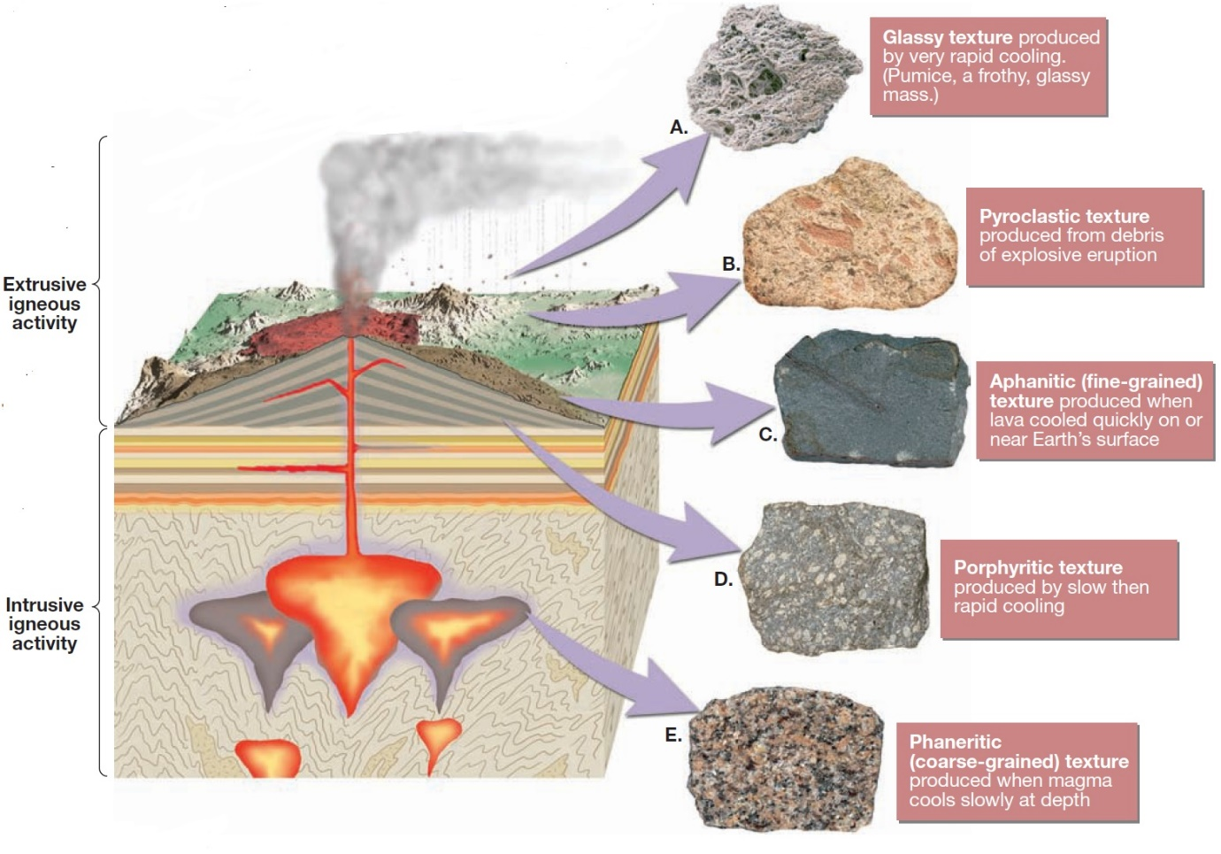
PYROCLASTIC (FRAGMENTAL) TEXTURE. Another group of igneous rocks is formed from the consolidation of individual rock fragments that are ejected during a violent volcanic eruption. The ejected particles might be very fine ash, molten blobs, or large angular blocks torn from the walls of the vent during the eruption. Igneous rocks composed of these rock fragments are said to have a pyroclastic texture or a fragmental texture. A common type of pyroclastic rock, called welded tuff, is composed of fine fragments of glass that remained hot enough during their flight to fuse together upon impact. Other pyroclastic rocks are composed of fragments that solidified before impact and became cemented together at some later time. Because pyroclastic rocks are made of individual particles or fragments rather than interlocking crystals, their textures often appear to be more similar to those exhibited by sedimentary rocks than to those associated with igneous rocks.
PEGMATITIC TEXTURE. Under special conditions, exceptionally coarse-grained igneous rocks, called pegmatites, may form. These rocks, which are composed of interlocking crystals all larger than a centimeter in diameter, are said to have a pegmatitic texture. Most pegmatites occur as small masses or thin veins situated around the margins of large intrusive bodies.
Naming Igneous Rocks
Igneous rocks are most often classified, or grouped, on the basis of their texture and mineral composition (FIGURE BELOW). The various igneous textures result mainly from different cooling histories, whereas the minerology of an igneous rock is the consequence of the chemical makeup of its parent magma. Because igneous rocks are classified on the basis of their mineral composition and texture, two rocks may have similar mineral constituents but have different textures and hence different names.
Felsic (Granitic) Igneous Rocks
GRANITE. Granite is perhaps the best known of all igneous rocks. This is partly because of its natural beauty, which is enhanced when it is polished, and partly because of its abundance in the Granite is a coarse-grained rock composed of about 25 percent quartz and roughly 65 percent feldspar, mostly potassium-and sodium-rich varieties. Quartz crystals, which are roughly spherical in shape, are often glassy and clear to light gray in color. By contrast, feldspar crystals are generally white to gray or salmon pink in color and exhibit a rectangular rather than spherical shape. Otherminor constituents of granite include muscovite and some dark silicates, particularly biotite and amphibole.
OBSIDIAN. Obsidian is a dark-colored glassy rock that usually forms when silica-rich lava is quenched quickly. In contrast to the orderly arrangement of ions characteristic of minerals, the ions in glass are unordered. Consequently, glassy rocks such as obsidian are not composed of minerals in the same sense as most other rocks. Although usually black or reddish-brown in color, obsidian has a composition that is more akin to light-colored igneous rocks such as granite, rather than to dark rocks such as basalt. Obsidian’s dark color results from small amounts of metallic ions in an otherwise relatively clear, glassy substance. If you examine a thin edge, obsidian will appear nearly transparent.
PUMICE. Pumice is a volcanic rock with a glassy texture that forms when large amounts of gas escape through silica-rich lava to generate a gray, frothy mass. In some samples, the voids are quite noticeable, whereas in others the pumice resembles fine shards of intertwined glass. Because of the large percentage of voids, many samples of pumice will float when placed in water. Oftentimes, flow lines are visible in pumice, indicating that some movement occurred before solidification was complete. Moreover, pumice and obsidian can often be found in the same rock mass, where they exist in alternating layers.
Intermediate (Andesitic) Igneous Rocks
ANDESITE. Andesite is a medium-gray, fine-grained rock of volcanic origin. many of the volcanic structures occupying the continental margins that surround the Pacific Ocean are of andesitic composition. Andesite commonly exhibits a porphyritic texture. When this is the case, the phenocrysts are often light, rectangular crystals of plagioclase feldspar or black, elongated amphibole crystals. Andesite often resembles rhyolite, so their identification usually requires microscopic examination to verify mineral make-up.
DIORITE. Diorite is the plutonic equivalent of andesite. It is a phaneritic rock that looks somewhat similar to gray granite. However, it can be distinguished from granite by the absence of visible quartz crystals and because it contains a higher percentage of dark silicate minerals. The mineral makeup of diorite is primarily sodium-rich plagioclase feldspar and amphibole, with lesser amounts of biotite. Because the light-colored feldspar grains and dark amphibole crystals appear to be roughly equal in
abundance, diorite has a salt-and-pepper appearance.
Mafic (Basaltic) Igneous Rocks
BASALT. Basalt is a very dark green to black, aphanitic rock composed primarily of pyroxene and calcium-rich plagioclase feldspar, with lesser amounts of olivine and amphibole. When porphyritic, basalt commonly contains small light-colored feldspar phenocrysts or green, glassy-appearing olivine phenocrysts embedded in a dark groundmass. Basalt is the most common extrusive igneous rock . the upper layers of the oceanic crust consist of basalt.
GABBRO. Gabbro is the intrusive equivalent of basalt. Like basalt, it tends to be dark green to black in color and composed primarily of pyroxene and calcium-rich plagioclase feldspar. Although gabbro is uncommon in the continental crust, it makes up a significant percentage of oceanic crust.
Pyroclastic Rocks
Pyroclastic rocks are composed of fragments ejected during a volcanic eruption. One of the most common pyroclastic rocks, called tuff, is composed mainly of tiny, ash-size fragments that were later cemented together.
Origin of Magma
Most magma originates in the uppermost mantle. The greatest quantities are produced at divergent plate boundaries in association with seafloor spreading. Lesser amounts form at subduction zones, where oceanic lithosphere descends into the mantle. In addition, magma can originate far from plate boundaries.
Generating Magma from Solid Rock
Based on evidence from the study of earthquake waves, Earth’s crust and mantle are composed primarily of solid, not molten, rock. Although the outer core is fluid, this iron rich material is very dense and remains deep within Earth. So, where does magma come from?
INCREASE IN TEMPERATURE. Most magma originates when essentially solid rock, located in the crust and upper mantle, melts. The most obvious way to generate magma from solid rock is to raise the temperature above the rock’s melting point. Workers in underground mines know that temperatures get higher as they go deeper. Although the rate of temperature change varies considerably from place to place, it averages about 25 °C per kilometre in the upper crust. This increase in temperature with depth, known as the geothermal gradient, is somewhat higher beneath the oceans than beneath the continents. As shown in FIGURE BELOW, when a typical geothermal gradient is compared to the melting point curve for the mantle rock peridotite, the temperature at which peridotite melts is everywhere higher than the geothermal gradient. Thus, under normal conditions, the mantle is solid. As you will see, tectonic processes exist that can increase the geothermal gradient sufficiently to trigger melting. In addition, other mechanisms exist that trigger melting by reducing the temperature at which peridotite begins to melt.
DECREASE IN PRESSURE: DECOMPRESSION MELTING. If temperature were the only factor that determined whether or not rock melts, our planet would be a molten ball covered with a thin, solid outer shell. Melting, which is accompanied by an increase in volume, occurs at higher temperatures at depth because of greater confining pressure. Consequently, an increase in confining pressure causes an increase in the rock’s melting temperature. Conversely, reducing confining pressure lowers a rock’s melting temperature. When confining pressure drops sufficiently, decompression melting is triggered. Decompression melting occurs where hot, solid mantle rock ascends in zones of convective upwelling, thereby moving intomregions of lower pressure. This process ismresponsible for generating magma along divergent plate boundaries (oceanic ridges) where plates are rifting apart
ADDITION OF VOLATILES. Anothermimportant factor affecting the melting temperaturemof rock is its water content. Watermand other volatiles act as salt does to meltmice. That is, volatiles cause rock to melt atmlower temperatures. Further, the effect of volatiles is magnified by increased pressure. Deeply buried “wet” rock has a much lower melting temperature than “dry” rock of the same composition.
Bowen’s Reaction Series and the Composition of Igneous Rocks
Recall that ice freezes at a single temperature, whereas basaltic magma crystallizes over a range of at least 200 °C of cooling. In a laboratory setting Bowen and his coworkers demonstrated that as a basaltic magma cools, minerals tend to crystallize in a systematic fashion based on their melting points. As shown in FIGURE below the first mineral to crystallize is the ferromagnesian mineral olivine. Further cooling generates calcium-rich plagioclase feldspar as well as pyroxene, and so forth down the diagram. During the crystallization process, the composition of the remaining liquid portion of the magma also continually changes. For example, at the stage when about a third of the magma has solidified, the melt will be nearly depleted of iron, magnesium, and calcium, because these elements are major constituents of the earliest-formed minerals. The removal of these elements causes the melt to become enriched in sodium and potassium. Further, because the original basaltic magma contained about 50 percent silica (SiO2), the crystallization of the earliest-formed mineral olivine, which is only about 40 percent silica, leaves the remaining melt richer in SiO2. Thus, the silica component of the melt becomes enriched as the magma evolves. Bowen also demonstrated that if the solid components of a magma remain in contact with the remaining melt, they will chemically react and change mineralogy as shown in Figure below. For this reason, this arrangement of minerals became known as Bowen’s reaction series. As you will see, in nature the earliest-formed minerals can be separated from the melt, thus halting any further chemical reaction. The diagram of Bowen’s reaction series in Figure depicts the sequence in which minerals crystallize from a magma of basaltic composition under laboratory conditions that this highly idealized crystallization model approximates what can happen in nature comes from the analysis of igneous rocks. In particular, we find that minerals that form in the same general temperature regime depicted on Bowen’s reaction series are found together in the same igneous rocks. For example, notice in Figure that the minerals quartz, potassium feldspar, and muscovite, which are located in the same region of Bowen’s diagram, are typically found together as major constituents of the plutonic igneous rock granite.

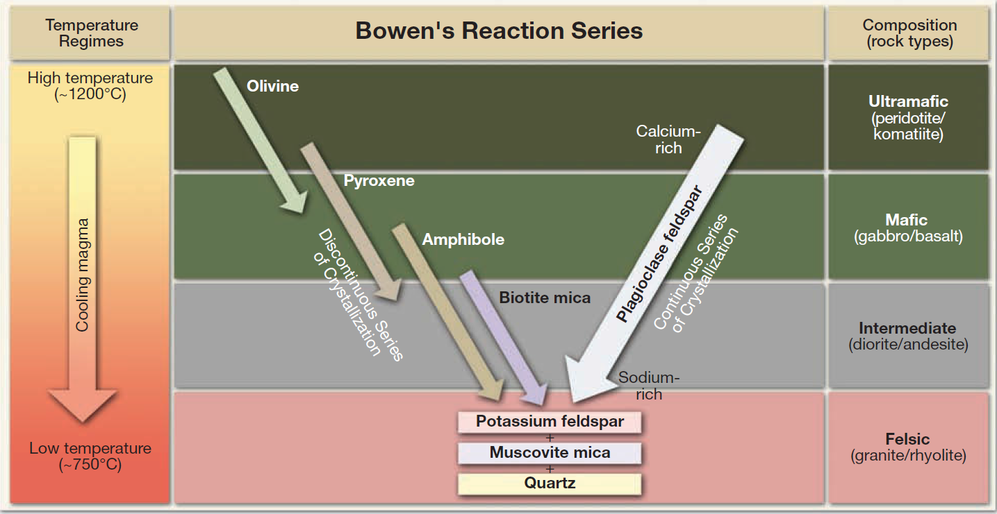
Intrusive Igneous Activity
Although volcanic eruptions can be violent and spectacular events, most magma is emplaced and crystallizes at depth, without fanfare. Therefore, understanding the igneous processes that occur deep underground is as important to geologists as the study of volcanic events. When magma rises through the crust, it forcefully displaces preexisting crustal rocks referred to as host or country rock. Invariably, some of the magma will not reach the surface but will instead crystallize or “freeze” at depth where it becomes an intrusive igneous rock. Much of what is known about intrusive igneous activity has come from the study of old, now solid, magma bodies exhumed by erosion.
Nature of Intrusive Bodies
The structures that result from the emplacement of magma into pre-existing rocks are called intrusions or plutons. Because all intrusions form out of view beneath Earth’s surface, they are studied primarily after uplifting and erosion have exposed them. The challenge lies in reconstructing the events that generated these structures millions or even hundreds of millions of years ago. Intrusions are known to occur in a great variety of sizes and shapes. Some of the most common types are illustrated in
Tablular Intrusive Bodies: Dikes and Sills
Tabular intrusive bodies are produced when magma is forcibly injected into a fracture or zone of weakness, such as a bedding surface (see Figure below). Dikes are discordant bodies that cut across bedding surfaces or other structures in the host rock. By contrast, sills are nearly horizontal, concordant bodies that form when magma exploits weaknesses between sedimentary beds. In general, dikes serve as tabular conduits that transport magma, whereas sills store magma. Dikes and sills are typically shallow features, occurring where the host rocks are sufficiently brittle to fracture. Although they can range in thickness from less than a millimeter to over a kilometer, most are in the 1- to 20-meter range. Dikes and sills can occur as solitary bodies, but dikes in particular tend to form in roughly parallel groups called dike swarms. These multiple structures reflect the tendency for fractures to form in sets when tensional forces stretch brittle country rock. Dikes can also occur radiating from an eroded volcanic neck, like spokes on a wheel. In these situations the active ascent of magma generated fissures in the volcanic cone out of which lava flowed.
Massive Intrusive Bodies: Batholiths, Stocks, and Laccoliths
BATHOLITHS. By far the largest intrusive igneous bodies are batholiths. Batholiths occur as mammoth linear structures several hundreds of kilometres long and up to 100 kilometers wide (FIGURE below). Although batholiths can cover a large area, recent gravitational studies indicate that most are less than 10 kilometers (6 miles) thick. Some are even thinner. Batholiths are almost always made up of felsic and intermediate rock types and are often referred to as “granite batholiths.” Large granite batholiths consist of hundreds of plutons that intimately crowd against or penetrate one another.
LACCOLITHS. Igneous intrusions can lift the sedimentary strata they penetrate. Gilbert named the igneous intrusions he observed laccoliths, which he envisioned as igneous rock forcibly injected between sedimentary strata, so as to arch the beds above, while leaving those below relatively flat.

