Physical Properties of Minerals
Minerals have definite crystalline structures and chemical compositions that give them unique sets of physical and chemical properties shared by all samples of that mineral. For example, all specimens of halite have the same hardness, the same density, and break in a similar manner. Because a mineral’s internal structure and chemical composition are difficult to determine without the aid of sophisticated tests and equipment, the more easily recognized physical properties are frequently used in identification.

Optical Properties
Of the many optical properties of minerals, their luster, their ability to transmit light, their color, and their streak are most frequently used for mineral identification.
LUSTER. The appearance or quality of light reflected from the surface of a mineral is as luster. Minerals that have the appearance of metals, regardless of color, are said to have a metallic luster . Some metallic minerals, such as native copper and galena, develop a dull coating or tarnish when exposed to the atmosphere. Because they are not as shiny as samples with freshly broken surfaces, these samples are often said to exhibit a submetallic luster. Most minerals have a nonmetallic luster and are described using various adjectives such as vitreous or glassy. Other nonmetallic minerals are described as having a dull or earthy luster (a dull appearance like soil) or a pearly luster (such as a pearl or the inside of a clamshell). Still others exhibit a silky luster (like satin cloth) or a greasy luster (as though coated in oil).
THE ABILITY TO TRANSMIT LIGHT. Another optical property used in the identification of minerals is the ability to transmit light. When no light is transmitted, the mineral is described as opaque; when light, but not an image, is transmitted through a mineral it is said to be translucent. When both light and an image are visible through the sample, the mineral is described as transparent.
COLOR. Although color is generally the most conspicuous characteristic of any mineral, it is considered a diagnostic property of only a few minerals. Slight impurities in the common mineral quartz, for example, give it a variety of tints including pink, purple, yellow, white, gray, and even black. Other minerals, such as tourmaline, also exhibit a variety of hues, with multiple colors sometimes occurring in the same sample.
STREAK. The color of the mineral in powdered form, called streak, is often useful in identification. A mineral’s streak is obtained by rubbing it across a streak plate (a piece of unglazed porcelain) and observing the color of the mark it leaves. Although the color of a mineral may vary from sample to sample, its streak is usually consistent in color. Streak can also help distinguish between minerals with metallic luster and those with nonmetallic luster. Metallic minerals generally have a dense, dark streak, whereas minerals with nonmetallic luster typically have a light colored streak. It should be noted that not all minerals produce a streak when rubbed across a streak plate. For example, the mineral quartz is harder than a porcelain streak plate. Therefore, no streak is observed using this method.

Crystal Shape or Habit
Mineralogists use the term crystal shape or habit to refer to the common or characteristic shape of a crystal or aggregate of crystals. A few minerals exhibit somewhat regular polygons that are helpful in their identification. For example, magnetite crystals sometimes occur as octahedrons, garnets often form dodecahedrons, and halite and fluorite crystals tend to grow as cubes or near cubes. While
most minerals have only one common habit, a few have two or more characteristic crystal shapes such as the pyrite.
Mineral Strength
How easily minerals break or deform under stress is determined by the type and strength of the chemical bonds that hold the crystals together. Mineralogists use terms including tenacity, hardness, cleavage, and fracture to describe mineral strength and how minerals break when stress is applied.
TENACITY. The term tenacity describes a mineral’s toughness, or its resistance to breaking or deforming. Minerals that are ionically bonded, such as fluorite and halite, tend to be brittle and shatter into small pieces when struck. By contrast, minerals with metallic bonds, such as native copper, are malleable, or easily hammered into different shapes. Minerals, including gypsum and talc, that can be cut into thin shavings are described as sectile. Still others, notably the micas, are elastic and will bend and snap back to their original shape after the stress is released.
HARDNESS. One of the most useful diagnostic properties is hardness, a measure of the resistance of a mineral to abrasion or scratching. This property is determined by rubbing a mineral of unknown hardness against one of known hardness, or vice versa. A numerical value of hardness can by obtained by using the Mohs scale of hardness, which consists of 10 minerals arranged in order from 1 (softest) to 10 (hardest), It should be noted that the Mohs scale is a relative ranking, and it does not imply that mineral number 2, gypsum, is twice as hard as mineral 1, talc. In fact, gypsum is only slightly harder than talc. In the laboratory, other common objects can be used to determine the
hardness of a mineral. These include a human fingernail, which has a hardness of about 2.5, a copper
penny (3.5), and a piece of glass (5.5). The mineral gypsum, which has ahardness of 2, can be easily scratched with a fingernail. On the other hand, the mineral calcite, which has a hardness of 3, will scratch a fingernail but will not scratch glass. Quartz, one of the hardest common minerals, will
easily scratch glass. Diamonds, hardest of all, scratch anything, including other diamonds.

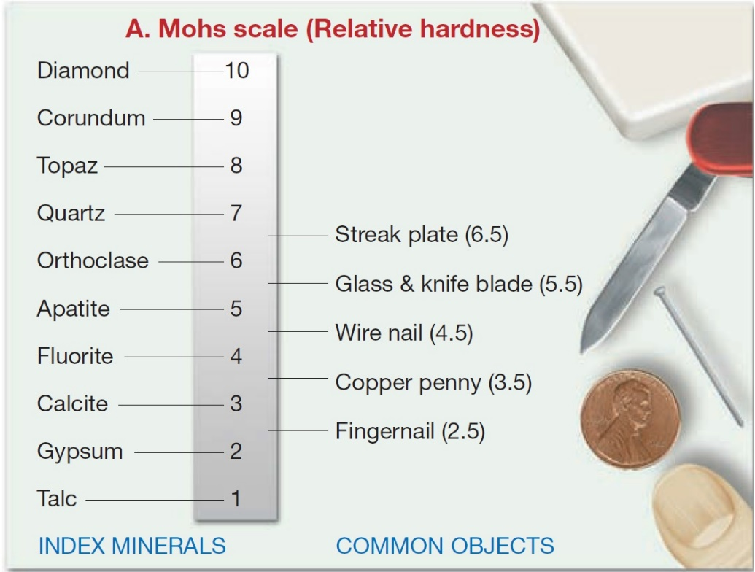

CLEAVAGE. In the crystal structure of many minerals, some atomic bonds are weaker than others. It is along these weak bonds that minerals tend to break when they are stressed. Cleavage is the tendency
of a mineral to break (cleave) along planes of weak bonding. Not all minerals have cleavage, but those that do can be identified by the relatively smooth, flat surfaces that are produced when the mineral is broken. The simplest type of cleavage is exhibited by the micas. Because these minerals have very weak bonds in one direction, they cleave to form thin, flat sheets. Some minerals have excellent cleavage in one, two, three, or more directions, whereas others exhibit fair or poor cleavage, and still
others have no cleavage at all. Whenminerals break evenly in more than one direction, cleavage is described by the number of cleavage directions and the angle(s) at which they meet. Each cleavage surface that has a different is counted as a different direction of cleavage.
FRACTURE. Minerals having chemical bonds that are equally, or nearly equally, strong in all directions exhibit a property called fracture. When minerals fracture, most produce uneven surfaces and are described as exhibiting irregular fracture. However, some minerals, such as quartz, break into smooth, curved surfaces resembling broken glass. Such breaks are called conchoidal fractures. Still other minerals exhibit fractures that produce splinters or fibers that are referred to as splintery and fibrous fracture, respectively.
Density and Specific Gravity
Density, an important property of matter, is defined as mass per unit volume. Mineralogists often use a related measure called specific gravity to describe the density of minerals. Specific gravity is a number representing the ratio of a mineral’s weight to the weight of an equal volume of water.
Other Properties of Minerals
In addition to the properties discussed thus far, some minerals can be recognized by other distinctive properties. For example, halite is ordinary salt, so it can be quickly identified through taste. Talc and graphite both have distinctive feels; talc feels soapy, and graphite feels greasy. Further, the streaks of many sulfur-bearing minerals emit odors like rotten eggs. A few minerals, such as magnetite, have a high iron content and can be picked up with a magnet, while some varieties (lodestone) are natural magnets and will pick up small iron-based objects such as pins and paper clips Moreover, some minerals exhibit special optical properties. For example, when a transparent piece of calcite is placed over printed text, the letters appear twice. This optical property is known asmdouble refraction. One very simple chemical test involves placing a drop of dilute hydrochloric acid from a dropper bottle onto a freshly broken mineral surface.

Estimated percentages (by volume) of the most common minerals in Earth’s crust.

