Plate Boundaries

Lithospheric plates move as coherent units relative to all other plates. Although the interiors of plates may experience some deformation, all major interactions among individual plates (and therefore most deformation) occur along their boundaries. In fact, the first attempts to outline plate boundaries were made using locations of earthquakes. Later work showed that plates are bounded by three distinct types of boundaries, which are differentiated by the type of relative movement they exhibit. These boundaries are briefly described here:
1. Divergent boundaries—where plates move apart, resulting in upwelling of material from the mantle to create new seafloor (Figure 1.30A).
2. Convergent boundaries—where plates move together, resulting in the subduction (consumption) of oceanic lithosphere into the mantle (Figure 1.30B). Convergence can also result in the collision of two continental margins to create a major mountain system.
3. Transform fault boundaries—where plates grind past each other without the production or destruction of lithosphere (Figure 1.30C).
If you examine Figure 1.30, you can see that each large plate is bounded by a combination of these boundaries. Movement along one boundary requires that adjustments be made at the others.

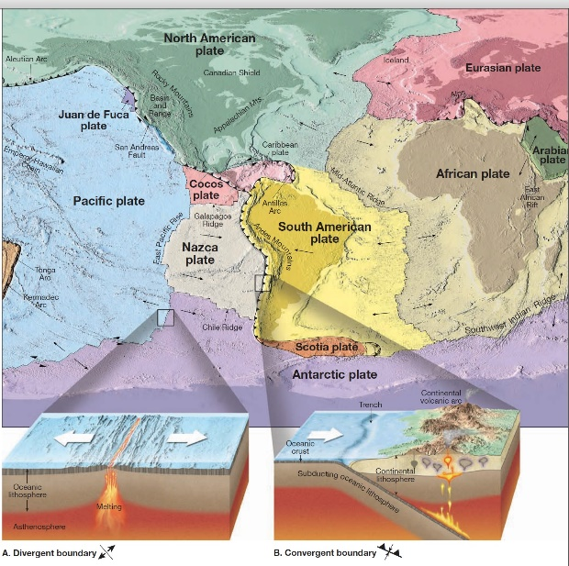

DIVERGENT BOUNDARIES. Plate spreading (divergence) occurs mainly along the oceanic ridge. As plates pull apart, the fractures created are immediately filled with molten rock that wells up from the
Asthenosphere below . This hot material slowly cools to become solid rock, producing new slivers of seafloor. This happens again and again over millions of years, adding thousands of square kilometers of new seafloor. This mechanism has created the floor of the Atlantic Ocean during the past 160 million years and is appropriately called seafloor spreading. Because seafloor spreading is the dominant process associated with divergent boundaries, these zones are sometimes referred to as spreading centers. The rate of seafloor spreading varies considerably from one spreading center to another. Spreading rates of only 2.5 centimeters (1 inch) per year are typical in the North Atlantic. Along divergent boundaries where molten rock emerges, the oceanic lithosphere is elevated, because it is hot and occupies more volume than do cooler rocks. Worldwide, this elevated zone (the oceanic ridge) extends for over 70,000 kilometers (43,000 miles) through all major ocean basins. As new lithosphere is formed along the oceanic ridge, it is slowly yet continually displaced from the zone of upwelling along the ridge axis. Thus, it begins to cool and contract, thereby increasing in density. This thermal contraction accounts for the greater ocean depths that exist away from the ridge. In addition, cooling causes the mantle rocks below the oceanic crust to strengthen, thereby adding to the plate’s thickness. Stated another way, the thickness of oceanic lithosphere is age dependent.

CONVERGENT BOUNDARIES. Although new lithosphere is constantly being added at the oceanic ridges, the planet is not growing in size—its total surface area remains constant. To accommodate the
newly created lithosphere, older oceanic plates return to the mantle along convergent boundaries. As two plates slowly converge, the leading edge of one slab is bent downward, allowing it to slide beneath the other. The surface expression produced by the descending plate is a deep-ocean trench. The simplest type of convergence occurs where one oceanic plate is thrust beneath another. At such sites subduction results in the production of magma in a manner similar to that in the Andes, except volcanoes grow from the floor of the ocean rather than on a continent. If this activity is sustained, it will eventually build a chain of volcanic structures that emerge from the sea as a volcanic island arc. Most volcanic island arcs are found in the Pacific Ocean, as we saw earlier, when an oceanic plate is subducted beneath continental lithosphere, an Andean-type mountain range develops along the margin of the continent. However, if the subducting plate also contains continental lithosphere, continued subduction eventually brings the two continents together.

TRANSFORM FAULT BOUNDARIES.
Transform fault boundaries are located where plates grind past each other without either generating new lithosphere or consuming old lithosphere. These faults form in the direction of plate movement and were first discovered in association with offsets in oceanic. Although most transform faults are located along oceanic ridges, some slice through the continents. Two examples are the earthquake-prone San Andreas Fault of California and the Alpine Fault of New Zealand. Along the San Andreas Fault the Pacific plate is moving toward the northwest, relative to the adjacent North American plate.
The movement along this boundary does not go unnoticed. As these plates pass, strain builds in the rocks on opposite sides of the fault. Occasionally the rocks adjust, releasing energy in the form of a great earthquake of the type that devastated San Francisco in 1906.

