Lectures on
Cloud Physics
For 4th Year Class

Edited by Dr Prof Monim Hakeem Khalaf
Dept. of Atmospheric Science, College of Science, Al-Mustansiriah University
Syllabus of Course
Clouds: Their definition, identification and classification of clouds and altitude, their composition, why are we interested in clouds?
Atmospheric thermodynamics: vapor pressure, Clauius-Clapeyron equation, saturation vapor pressure, ways for reaching saturation and mechanisms for cooling the air.
Fundamental concepts of cloud physics: Liquid water content, other parameters of macroscale cloud, cloud drop size distribution, actual drop size distribution.
Formation of cloud droplets: General aspects, saturation vapor pressure over a curved droplet, saturation vapor pressure over a solution, combining the curvature and solute effect, atmospheric aerosols, cloud condensation nuclei.
Droplet growth by diffusion: growth of an individual droplet by diffusion of water vapor, growth rate in term of mass or radius, other questions needed to solve for growth rate, evaporation of droplet, Bergeron process.
Droplet growth by collisions and coalescences: Droplet terminal fall speed, growth due to collection smaller, uniform droplet, collision efficiency, growth equation in terms of radius, growth due to collision with smaller droplets of non-uniform size.
growth of ice crystals: formation of ice crystals, diffusional growth of ice crystals branching versus faceting, collision-coalescence versus the Bergeron process.
Precipitation: types of precipitation, rainfall rate and drop-size distribution. The Marshall-Palmer drop-size distribution.
Weather modification: Examples of experiments, cloud seeding, methodology.
Cloud electrification; Lightning, electrical properties of the fair weather atmosphere, electrical properties of a thunderstorm, Benjamin Frianklin's famous kite experiment, cloud-to-ground lightning, Intra-cloud lightning, other forms of lightning, thunder, lightning rods, lightning safety.

References:
1. A Short Course in Cloud Physics; R. R. Rogers
2. The Physics of Clouds; B. J. Mason
3. Microphysics of Clouds and Precipitation; H. R. Fletcher and Klett
4. Lectures on atmospheric thermodynamics,

Cloud physics is the microscale study of processes that govern all cloud and precipitation processes,

1. Clouds
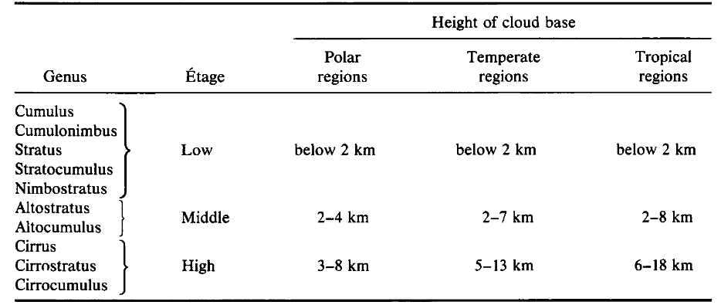
1.1 Its Definition: A cloud is aggregate of tiny water droplets or ice crystals suspended in the air. Some are found only at high elevations whereas others nearly touch the ground as shown in Table 1 the approximate base height of some cloud types. They can be thick or thin, big or little and exist in a seemingly endless variety of forms.

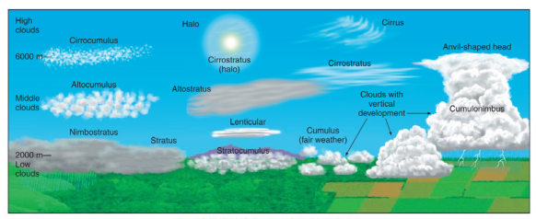

1.2 Cloud composition
Clouds consist of water droplets. When clouds become very cold, the water vapor condenses to form tiny six-sided crystals of ice, many of them like the snowflakes. Some clouds contain both water droplets and ice crystals. Water droplets do not freeze instantly when the temperature drops below freezing but supercool to varying extents first. Supercooled liquid water is water at a temperature below freezing but still in the liquid state. As the temperature continues to drop, the fraction of frozen droplets increases until they all freeze at –40 °C. The exact distribution of frozen to liquid droplets is not constant for all clouds but depends on the prevalence of trace atmospheric constituents called ice nuclei.
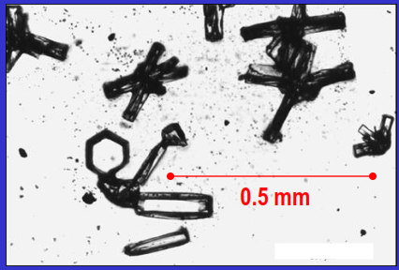

Cloud particles (microphysics)
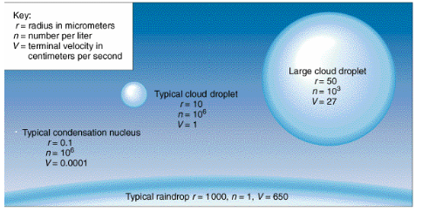

1.3 Why are we interested in clouds?
1. Clouds are a major factor in the earth‘s radiation budget because they interact strongly with both short and long-wave radiation. An interest in cloud physics is also inﬂuenced by a desire to artiﬁcially modify clouds so as to control the Earth’s radiation balance.
2. Clouds are a key step in the hydrological cycle
3. Clouds provide a medium for (heterogeneous) chemical reactions
4. Clouds affect significantly vertical transport and redistribution of species in the atmosphere
5. Clouds couple to the water cycle because they are the vessels in which precipitation develops.
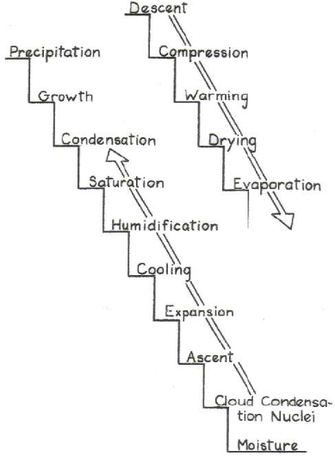

Prerequisites for cloud formation
Water vapor, low temperature, supersaturation, Cloud Condensation Nuclei (CCN) or Ice Nuclei (IN)

2.1 Atmospheric Thermodynamics
2.1 Vapor pressure: The partial pressure of water vapor in the atmosphere. The value of density of the water vapor is 4.77x10⁻³ kg/m³ at 0 °C.
2.2 Clausius-Clapeyron (C-C) equation
C-C equation describes the equilibrium concentration of a gas over its condensed phase (liquid or solid). It relates the equilibrium pressure between two phases to the temperature of the heterogeneous system (involves more than a single phase).
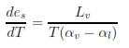
Atmospheric water vapor drives many important meteorological phenomena (notably precipitation), motivating interest in its dynamics. The C–C Eq. for water vapor under typical atmospheric conditions (near standard temperature and pressure) is

where e_{s} is saturation vapor pressure and T is temperature, L_{v} is the specific latent heat of evaporation (2400 kJ/kg {at 25 °C} to 2600 kJ/kg {at -40 °C}). α_{v} and α_{l} are specific volumes for water vapor and liquid water respectively.
2.3 Saturation vapor pressure (e_{s})
The saturation vapor pressure is the partial pressure of the water vapor in equilibrium with a plane surface of pure water. That means that the rate of condensation is equal to the rate of evaporation e_{s} is a function of temperature alone, it doesn’t depend on the vapor content of the air. e_{s}(T) is highly nonlinear as it increases rapidly with increasing temperature. This explains why the amount of atmospheric water vapor will likely increase with global warming caused by increasing concentration of greenhouse gases. There are approximate expressions for e_{s}, one of the most used is:
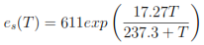

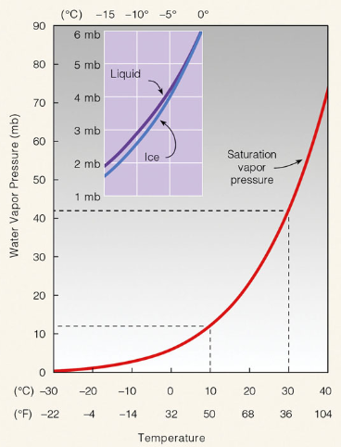
where T in °C.

2.4 Ways of reaching saturation
a. Dew point temperature: temperature at which saturation is reached if cooled isobarically.
b. Wet-bulb temperature: temperature at which saturation is reached if cooled by evaporating water into it at constant pressure
c. Equivalent temperature: temperature which moist air would attain
if all the moisture were condensed out at constant pressure.
d. Isentropic condensation temperature: temperature at which saturation is reached when moist air is cooled adiabatically with mixing ratio held constant.

2.5 Mechanisms for Cooling the Air
(1) Lifting – most clouds form when air is lifted.
a) Convergence – low pressure center – stratus
b) Mountains – lifting by terrain
c) Fronts – lifting over denser air.
d) Warm air relative to surroundings
i) Fires, volcanoes – cumulus
ii) Latent heat
(2) Mixing – seeing your breath on cold day
(3) Contact – with cold surface – advection fog
(4) Radiation – ground fog
Q1: Can raindrops grow from cloud droplets through condensation alone? Homework!!
Q2: If at 0 °C the density of dry air alone is 1.275 kg.m⁻³ and the density of water vapor alone is 4.770 x10⁻³ kg.m⁻³, what is the total pressure exerted by a mixture of the dry air and water vapor at 0 °C? Homework!!
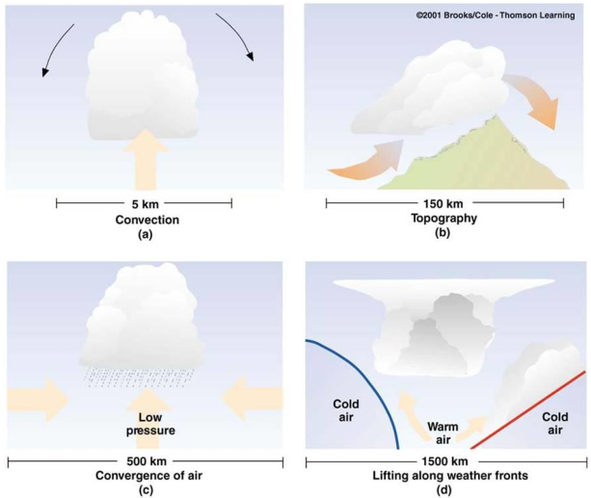
Equivalent temperature is the temperature of an air parcel from which all the water vapor has been extracted by an adiabatic process

3. Fundamental concepts of cloud physics
The following parameters vary with time as a cloud evolves and develops.
3.1 Liquid water content (LWC)
The LWC is the measure of the mass of the water in a cloud in a specified amount of dry air. It is typically measured per volume of air (g/m³) or mass of air (g/kg). This variable is important in figuring out which types of clouds are likely to form and is strongly linked to three other cloud microphysical variables: the cloud drop effective radius, the cloud drop number concentration, and the cloud drop size distribution. Being able to determine the cloud formations that are likely to occur is extremely useful for weather forecasting as cumulonimbus clouds are related to thunderstorms and heavy rain.
The liquid water content of a cloud varies significantly depending on the type of clouds present in the atmosphere at a given location. The classification of the cloud is highly related to the liquid water content as well as the origin of the cloud. The combination of these two allows a forecaster to more readily predict the types of conditions that will be in an area based on the types of clouds that are forming or have already formed. Both the precipitation formation and the cooling rates of clouds depend on LWC in a cloud for two reasons.
1) The LWC determines the ultimate potential for a cloud to produce precipitation. Generally speaking, unless a cloud generates a liquid-water content in excess of 0.5 g/m³, it is unlikely to precipitate.
2) The LWC is important because it determines the rates of shortwave or longwave radiational heating and cooling.
How does it calculate? Clouds that have low densities, such as cirrus clouds, contain very little water, thus resulting in relatively low liquid water content values of around 0.03 g/m³. Clouds that have high densities, like cumulonimbus clouds, have much higher liquid water content values that are around 1-3g/m. Below is a chart giving typical LWC values of various cloud types (Thompson, 2007).
Cloud type | Cirrus | Fog | Stratus | Cumulus | Stratocumulus | Cumulonimbus
LWC (g/m³) | 0.03 | 0.05 | 0.25-0.3 | 0.25-0.3 | 0.45 | 1.0-3.0
Various equations are useful in determining LWC and the effects that influence it. One of the most significant variables related to the LWC is the droplet concentration of a cloud, which is the number of water droplets in a volume of cloud, typically a cubic centimeter, and can be calculated by
LWC = m_{w} * n/N
where n the droplet concentration in a cloud, N is the total number of water droplets in the volume and m_{w} is the mass of the water in the air parcel.
3.2 Other parameters of macroscale cloud
1. Cloud temperature: The cloud-base temperature indicates the liquid-water-producing potential of the cloud. For example, a cloud with a base temperature of +20 °C has a cloud-base saturation mixing ratio of -15 g/kg, while a cloud with a base temperature of +4 °C has a cloud-base saturation mixing ratio of only 5 g/kg. Thus, if these two clouds have equal depths, the one with the warmer cloud base has a much greater potential for producing rainfall.
2. Cloud-top temperature is important because the greater the difference between the cloud-base temperature and cloud-top temperature, the greater the potential for rainfall. Furthermore, if the cloud-top temperature is below O °C, then ice is possible.
3. Turbulence is important because it mixes properties of the cloud and interacts closely with the other parameters. The level of turbulence also affects the precipitation processes, due to the formation of higher peak supersaturations and to increased interactions among cloud particles of different types and sizes.
Turbulence is also likely to affect the radiative properties of a cloud. In a turbulent cloud the fluctuations in liquid water will exist. As a consequence, the radiative emittance and absorptance will differ significantly from that found in a more homogeneous cloud.

3.3 Cloud drop size distribution
The number of droplets per unit volume is called the number density, and is denoted by N. The units of N are m⁻³. The number density of drops having diameters in the range between D₁ and D₂ is given by the integral
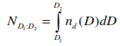
The function n_{d}(D) is called the drop-size distribution function. The units of n_{d} are m−4. The differential of number density is:
dN = nd (D)dD (1)
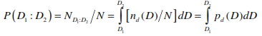
This Eq. is interpreted as the number density of droplets in the diameter range range between D and D+dD. The probability of randomly selecting a droplet that has a diameter between D₁ and D₂

so that n_{d}/N can be thought of as the probability density function for the drop diameter:
p(D) = nd /N (2)
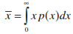
From probability theory we know that the mean or expected value of a variable x can be found from its probability density function, p(x) via

(3)
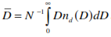
Using Eq. (2) and (3), that the mean diameter of the droplets in a distribution is

Liquid water content in terms of drop-size distribution
The mass of a droplet of diameter D is:
m = π/6 ρ_{L} D 3
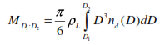
where ρ_{L} is the density of liquid water. The liquid water content of the droplets in this diameter range is just the volume of a drop of diameter D multiplied by Eq. (1)
(4)

Integrating (8) between diameters D₁ and D₂ gives the liquid water content contributed by droplets in this size range
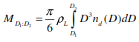

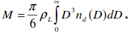
The total liquid water content for all drop sizes is

3.4 Actual drop size distributions
The drop size distributions of actual clouds can be quite complex, and varies from cloud to cloud. Some distributions have more than one peak, while others have a single peak. In general, maritime cumulus clouds have larger drops and broader distributions than do continental clouds. In many instances the drop-size distribution is represented very closely by a form of the gamma distribution, having the form:
n_{d}(D) = aD2 exp (−bD )
where a and b are constant
Distance between droplets
The mean distance between droplets in a population is given by
r = 0.554 N −1/3
Exercises
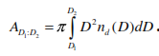
1. Show that the surface area density of all drops having diameters between D₁ and D₂ is given by

2. Assume a population of cloud droplets follows the gamma distribution with
a = 4.53×10 24 m−6 and b = 2.35×10 5 m−1.
a. What is the number density of the droplets (in cm−3)?
b. What is the liquid water content of the cloud (in g/m3)?
c. What is the surface area density of the drops (in cm2/m3) (i.e., what is the total surface area of all the drops contained in a cubic meter of air?)
d. What is the mean drop diameter (in µm)?
e. What is the mean distance between drops (in mm).

4. Formation of cloud droplets
4.1 General Aspects:
- Phase changes of water
vapor ↔ liquid
liquid ↔ solid
vapor ↔ solid
- Nucleation processes
1) Heterogeneous: Droplets form on nuclei
2) Homogeneous: Droplets form in a pure environment
- Supersaturation: The excess of relative humidity over the equilibrium value of 100%.
High supersaturation is required for very small droplets to be stable. Unstable drops will evaporate.
4.2 Saturation vapor pressure over a curved droplet (The curvature effect)
The saturation vapor pressure over a curved water surface, e_{r}, is greater than that over a flat surface, e_{s}(∞). This is expressed mathematically as
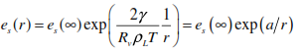

where γ is the surface tension of the water-air interface (~0.075 N/m), ρ_{L} is the density of liquid water (~1000 kg/m3), and r is the radius of curvature (or radius of the droplet).
For a droplet to be in equilibrium with the environment (meaning the droplet will neither grow nor evaporate), then the environmental vapor pressure e must be equal to es (r). If this is not true, the droplet will either grow or evaporate. This is summarized as:
Condition | The droplet will…
e < es (r ) | Evaporate
e = es (r ) | remain the same size
e > es (r ) | grow via condensation
For a droplet to be in equilibrium then
e = es(∞) exp ( a/r ) .
Dividing both sides of (2) by es(∞), we get
Seq = e / es(∞) = exp ( a/r )
where is the equilibrium saturation ratio.
The saturation ratio is just relative humidity expressed as a ratio rather than a percent. The equilibrium saturation ratio is the saturation ratio required for the droplet to be in equilibrium.
ο If the environmental saturation ratio is less than the equilibrium saturation ratio the droplet will evaporate.
ο If the environmental saturation ratio is greater than the equilibrium saturation ratio the droplet will grow.
For very small drops the equilibrium saturation ratio is extremely large.
The increase of equilibrium saturation ratio with decreasing radius is known as the curvature effect.
Homogeneous nucleation (condensation of pure water with no dust or aerosols present) requires a relative humidity of 400 – 500%! Though this can be achieved in a laboratory, such high relative humidity does not occur in the atmosphere. Therefore, homogeneous nucleation cannot explain the initial formation of cloud droplets.
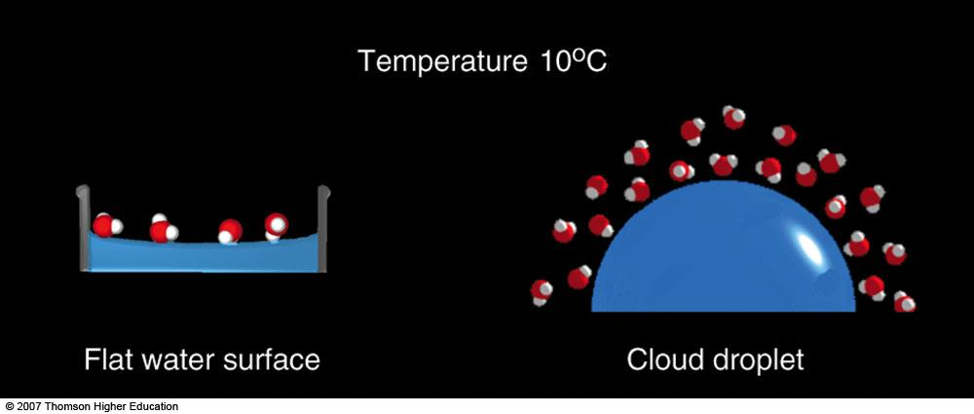

4.3 Saturation vapor pressure over a solution (the solute effect)
When a solute is added to a solvent, the vapor pressure of the solvent (above the resulting solution) is lower than the vapor pressure above the pure solvent.
A dissolved substance (solute) lowers the saturation vapor pressure of water. A formula expressing this for dilute solutions is given by Raoult’s Law:
e' = χ_{w} * e_{s}

where (X_{w}) is the mole fraction of the water.
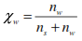

ns is the number of moles of solute and nw is the number of moles of water. For very dilute solutions we can approximate X_{w}

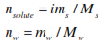
The number of moles of solute and water are given by

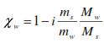
where m is mass, M is molecular weight, and i is the ion factor (the number of ions that one molecule of substance dissociates into). Therefore, we get

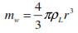
The mass of the water in the droplet is:

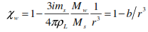
so that

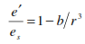
The ratio of the saturation vapor pressure of the mixture over that of pure water is then

The reduction of saturation vapor pressure by introducing a solute is known as the solute effect. For droplets of small radius, the saturation vapor pressure over the drop is much less than that over pure water. As radius increases the saturation vapor pressure of the solution approaches that of pure water.
4.3 Combining the curvature and solute effects
The curvature effect increases the saturation vapor pressure and has the greatest impact for small droplets.
The solute effect decreases the saturation vapor pressure and also has the greatest impact for small droplets.
Which effect “wins” depends on the droplet size and on the amount of solute present.
The combined effects are expressed by applying the correction from (11) to the equilibrium saturation ratio equation (3) to get
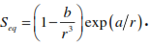

A plot of Seq for a solution containing three different amounts of solute (each curve differs in solute mass by a factor of 10) is shown below. The tallest curve is for the least amount of solute.
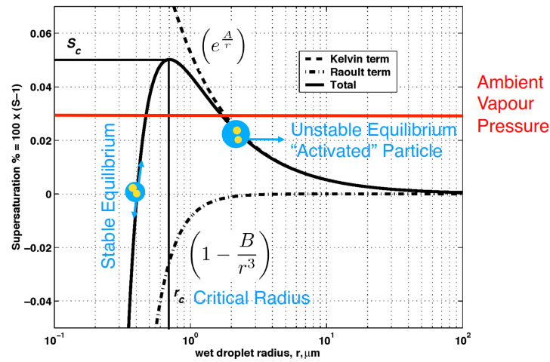

A plot like that shown above is referred to as a Kohler curve.
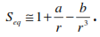
Making use of the approximation that for small x, ex ≈ 1 + x, we can write

The radius at which the Kohler curve is a maximum can be found by taking ∂S /∂r and setting it equal to zero. This radius is called the critical radius, r*, and the saturation ratio at this point is called the critical saturation ratio, S*. They have values of
The critical radius is of fundamental importance for cloud droplet growth.
At radii below the critical radius (r < r*) the droplets are in stable equilibrium.
If S increases the droplets will grow to a larger size and then stop. If S decreases the droplets will shrink to a smaller size and then stop. Droplets at radii below the critical radius are called haze particles.
At radii above the critical radius (r > r*) the equilibrium is unstable, and the droplets will spontaneously grow larger, even though S is not increasing. Droplets whose radius equals the critical radius (r = r*) are said to be activated.
Example 1: To the nearest 1000, about how many large cloud droplets have to combine to form one typical raindrop?
Answer: N = Mass of raindrop/mass of large droplet = 0.004 grams/5.2x10⁻⁷ grams = 7692 or about 8000 large droplets.

Example 2: Suppose that it takes about 2 minutes for a large cloud droplet to double in mass. How long does it take a large cloud droplet to grow into a raindrop and leave the cloud?
Answer: In Problem 3 we saw that about 8000 large cloud droplets equals a raindrop. Since 8000 is about 213, we need 13 doubling times to grow this large, which takes 13 x 2 minutes = 26 minutes.

4.5 Atmospheric aerosols
Aerosols are formed either directly by disintegration of liquids or solids (known as primary sources) or indirectly by condensation of gases (known as gas-to- particle conversion). Indirect sources are known as secondary sources. Examples of primary sources are:
wind-generated dust; sea spray; forest fires; combustion
The gases responsible for gas-to-particle conversion are:
Sulfur dioxide (SO₂); Nitrogen dioxide (NO₂); NH₃; certain hydrocarbon.
Aerosols are broken into three different groups based on size. These groups are
ο Aitkin nuclei – particle with r < 0.1µm
ο Large particles – 0.1µm < r < 1.0µm
ο Giant particles – r > 1.0µm
The size distribution of aerosol populations can be specified by a distribution function nd(D), where D is the equivalent diameter (the diameter of a spherical particle with the same volume as the actual particle).
In many instances the aerosol size distribution is given as:

This distribution is known as the Junge distribution.
Growth cloud droplet Depends upon:
- Type and mass of hygroscopic nuclei.
- surface tension.
- humidity of the surrounding air.
- rate of transfer of water vapor to the droplet.
- rate of transfer of latent heat of condensation away from the droplet.

4.6 Cloud condensation nuclei
Homogeneous nucleation does not occur in the atmosphere, since saturation ratio rarely exceeds 1.02. Therefore, the solute effect is extremely important!
The solute for the solute effect comes from aerosol particles in the air. There are two types of aerosols
ο Hygroscopic nuclei – nuclei that are attractive to water vapor molecules, and act as collection sites for condensation
ο Hydrophobic nuclei – nuclei that are repellent to water and therefore cannot act as sites for condensation
Not all hygroscopic nuclei are important for cloud droplet formation. Since saturation ratio rarely exceeds 1.01, only those nuclei that activate at S < 1.02 are available for forming cloud droplets. It is these nuclei that are known as cloud condensation nuclei (CCN).
Exercises
1. What is the relative humidity required to support pure water droplets of radius 8µm at a temperature of 0 °C? Is a relative humidity of this magnitude ever achieved in the atmosphere?
2. Using a graphing calculator or computer program, plot the Kohler curve for a droplet containing 2.5×10−18 grams of sodium chloride (NaCl). Also, plot the curve for a droplet containing one-tenth as much sodium chloride and compare the curves. Sodium chloride has a molecular weight of 58.44 g/mol, and has an ion factor of 2.

5. Droplet growth by diffusion
5.1 Growth of an individual droplet by diffusion of water vapor
The continued growth of a cloud droplet, once condensation has started, is initially governed by the diffusion of the water vapor molecules toward the droplet. Diffusion is the process of molecules moving from regions of higher concentrations to regions of lower concentrations. At the surface of a droplet, water vapor is simultaneously condensing and evaporating. When the concentration of water vapor molecules is higher some distance from the droplet than it is at the droplet surface, the water vapor in the air diffuses toward the droplet, condenses onto the droplet, and the net effect is droplet growth. The rate of growth of the droplet depends on two things
1. The gradient in vapor concentration from the surface of the droplet to the ambient environment the presence of supersaturation, i. e., a relative humidity H greater than the equilibrium relative humidity H of the droplet. Diffusional growth gives narrow size distribution.

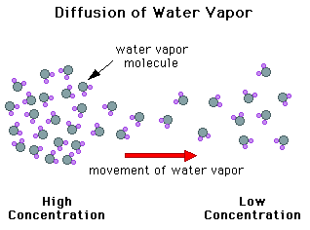
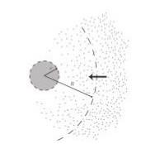

2. The surface area 4 π r²
From Fick’s law, the flux of water vapor at the surface of the drop is
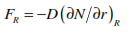
(1)

where D is the diffusivity of water vapor molecules (like a ﬂux: units cm²/s). After droplets initially form, they grow by diffusion of water vapor onto the droplet.
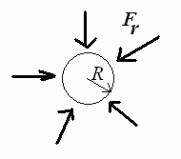

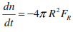
If the water vapor flux at the surface of the drop is denoted as F_{R}, and only depends on distance from the center of the droplet (r), then the growth rate of the droplet in terms of the number of water molecules that make up the droplet is just the radial flux at the surface of the droplet multiplied by the area of the droplet:

(2)
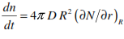
where R is the radius of the droplet. The negative sign is there because a flux toward the droplet is negative, which increases the droplet’s size. (1) in (2) we get:
(3)

the equation governing the change in number density with time at a fixed point in space (the same equation used for describing heat transfer) is
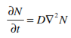

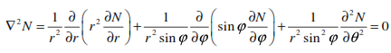
Written in spherical coordinates, the LaPlacian is

But if we assume that the vapor concentration doesn’t depend on angle, then this greatly simplifies to
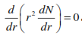

This Eq. can be integrated twice to get
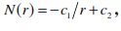
(4)
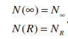
where c₁ and c₂ are constants of integration. We assume we know the water vapor concentration of the environment far away from the droplet. We denote the environmental water vapor number density as N. We also assume we know the water vapor number density at the surface of the droplet (r = R), which we call N. So, the boundary conditions for Eq. (4) are

If we substitute these boundary conditions into Eq. (4) we get
∞
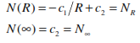

which when solved for c₁ and c₂ yields
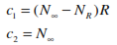

and so Eq. (1) becomes
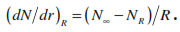
and so

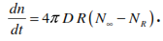
Put this Eq. into this into Eq. (3) and find our equation for the growth rate of the droplet,
(5)
This Eq. isn’t the most convenient form of the growth rate equation, because it predicts the number of molecules of water in the droplet which is a very large number.
Diffusional growth is certainly the way that small droplets initially grow into larger cloud droplets.
5.2 Growth rate in term of mass or radius
We’d like to modify an equation that gives the growth rate in terms of either mass or radius of the droplet.
The mass of the droplet is: (m = M *n/N_{A}) can substitute in Eq (5)
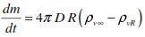
with multiply NM/N_{A} = n . M / N_{A} .V=m_{v}/V=ρ_{v} which becomes
(6)
Which is the growth rate in terms of mass of the droplet. The growth rate can also be given in terms of droplet radius as follows: The mass of a droplet is
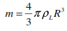
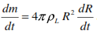
which differentiates to

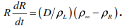
Combining this with Eq. (6) gives
(7)
Eq. (7) is the most useful formula for calculating the growth rate of the droplet because it is in terms of the radius of the droplet. We could, of course, reformulate it to an equation in terms of diameter, but we will stick with using the radius.
5.3 Other equations needed to solve for growth rate
In Eq. (7) we assume that we know everything except R and ρ_{R}, the absolute humidity at the surface of the drop. Thus, we have two unknowns, but only equation. This means we need another equation. We can safely assume that at the surface of the drop, the environment is saturated, so that
$$ρ_{R}=ρ_{s}=e_{s}/R_{V}T_{R}$$

where ρ_{s} is the saturation absolute humidity and T_{R} is the temperature at the surface of the drop. This is related to the saturation vapor pressure through the ideal gas law for water vapor. The saturation vapor pressure, e_{s}, is found from the C-C Eq. modified for the curvature and solute effects, and so we have
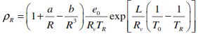

(8)

This Eq. introduces another unknown, T_{R}, so we still need another Eq. The additional equation is formed from looking at the balance of heat at the surface of the droplet.
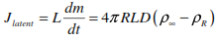
As water condenses on the droplet, the droplet will heat up due to the latent heat released during condensation, as follows.

where L is the latent heat of vaporization. But, the droplet will also be losing heat to the surrounding air via diffusion which is given by:

where K is the thermal conductivity of air and T∞ is the temperature of the environment.
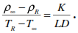
In the steady state, the above two heats must be equal: then

(9)

Eq. (9) gave us the final 3rd Eq. We now have three Eqs (6), (7) and (9), with three unknowns, R, T_{R}, and ρ_{R}. We can use these three equations to solve for the growth rate and find the radius of the droplet at some future time, t. The figure below shows droplet radius as a function of time calculated using these Eqs. for a droplet of initial size of 0.75 μm with NaCl as the solute.
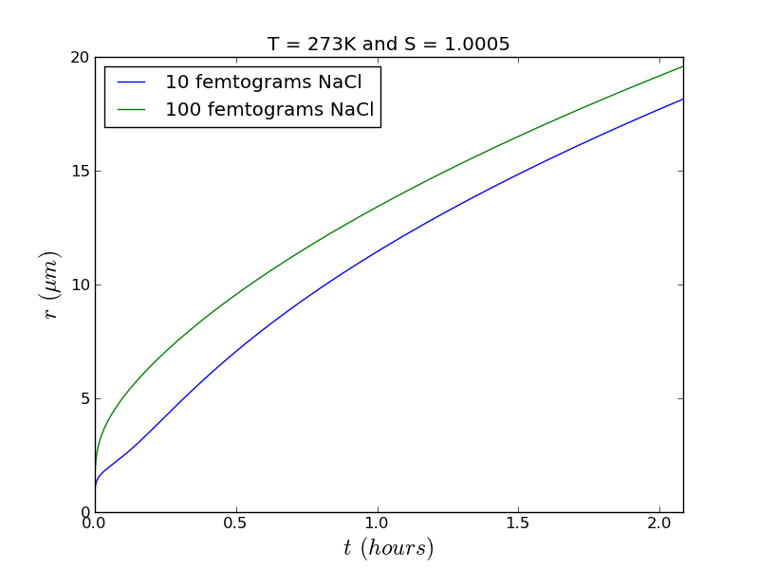

5.4 Evaporation of droplet
Once a droplet falls from a cloud it enters an unsaturated environment (S < 1). In this case, the droplet will begin to evaporate. The shrinking of the droplet is also governed by
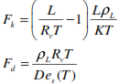
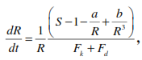

only now S is less than 1 so that dR/dt is negative
A small droplet will evaporate very quickly and disappear.
_ Larger droplets will last longer.
_ Droplets larger than 0.1 mm in radius have a good chance of reaching the ground, while those that are smaller will likely evaporate. Therefore, the cutoff between cloud droplets and precipitation is taken as r = 0.1 mm.

5.5 Bergeron process
liquid water droplets in clouds do not spontaneously freeze when they are lifted above the freezing level by updrafts. The freezing process is a gradual one, as some of the droplets encounter ice nuclei and freeze into ice crystals as a result. The Swedish meteorologist Tor Bergeron ﬁrst realized that a mixed environment of supercooled droplets and a few ice crystals promotes rapid diﬀusional growth of the ice crystals as a consequence of the saturation vapor pressure over ice being lower than that over liquid water.
The Bergeron Process is the in-cloud formation of ice particles from supercooled water droplets. Supercooled water evaporates, and is then deposited on the ice crystals.
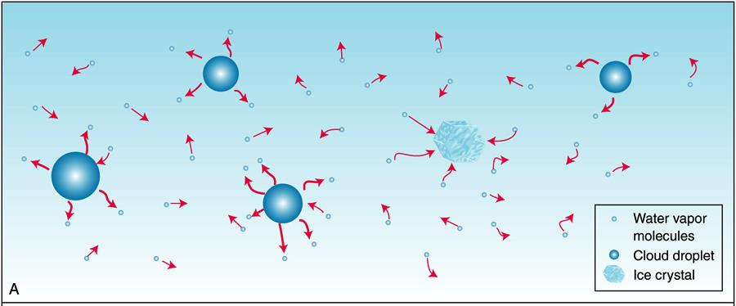
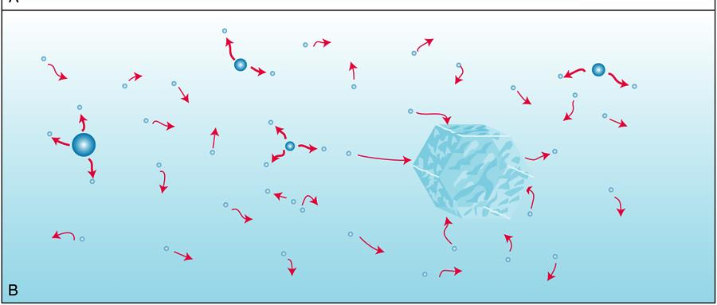
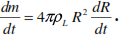
Exercises
1) For a spherical droplet show that
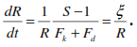
2) For radii greater than a few microns, the solute and curvature effects become negligible. In this case the growth equation becomes

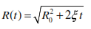
a) Integrate this equation to show that the radius as a function of time is
b) Use this equation to find how long it would take to grow a droplet from 5 to 50 microns. Use a saturation ratio of 1.0005 and a temperature of 273 K. Use K=0.024 m⁻¹s⁻¹K⁻¹, D= 2.21x10⁻⁵ m²/s, L = 2.5x10⁶ J/kg.

6. Droplet growth by collision and coalescence
Cloud droplets will be carried by air currents within the cloud, and if they bump into each other, it is called a collision. However, if they collide then stick together, that is called coalescence. Although this process is important, especially in the tropics, it falls short of being the primary mechanism for the formation of raindrops. Updrafts in a cloud can transport a droplet upward repeatedly allowing it many opportunities to fall back down through the cloud and collide and coalesce with other droplets. Initially by diffusion, and subsequently by collision and coalescence, tiny aerosol nuclei grow into large water droplets more than 10,000 times their initial size. The collision-coalescence process is often called the warm-rain process, since it is the only way to explain precipitation formation in clouds that remain above freezing. However, it can also occur in cold clouds.
Collisions are inﬂuenced by gravitational, electrical and aerodynamic forces. Gravitational effects dominate in clouds where large droplets capture small ones.
Collisions require different fall velocities between small and large droplets (ignoring turbulence and other non-gravitational forcing).
- this is a dominant process for precipitation formation in warm clouds (tops warmer than about -15°C)
- since the bigger drops fall faster than the smaller drops, they will "collect" the smaller drops - the bigger drop grows
- droplet fall speed is called its terminal velocity
- need droplets of different sizes for this process to really work
Q: what determines the droplets fall speed relative to the ground?

6.2 Droplet terminal fall speed
Because the steady settling velocity of a droplet as it falls under the influence of gravity through still air (called the terminal fall speed of the droplet) increases with the size of the droplet, those droplets in a cloud that are somewhat larger than average will have a higher than average terminal fall speed and will collide with smaller droplets lying in their paths.
_{FR}
_{FA}
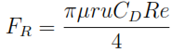
The drag force C_{D} on a sphere of radius r is:
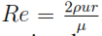
Where Reynolds number , ρ fluid density, μ dynamic viscosity.
The gravitational force minus buoyancy on a sphere of radius r is
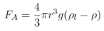

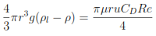
Terminal fall speed occurs when FA = FR.

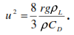
If ρ_{l}>>ρ

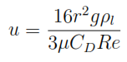

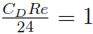
For very small Reynolds numbers
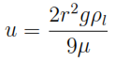
(1)
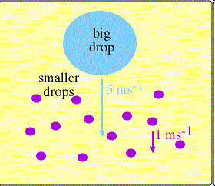
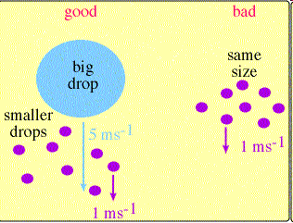
If we knew the drag coefficient, then we could find the terminal velocity. The drag coefficient is determined experimentally, with the following results obtained for the terminal velocity of droplets.
Droplet radius | Terminal velocity
r< 40 μm | u = (1.19 x 10⁶ cm⁻¹ s⁻¹) r²
40 μm < r < 0.6 mm | u = (8000 s⁻¹) r
r > 0.6 mm | u = (2200 cm^{1/2} s⁻¹ ) (ρ_{o}/ρ) r^{1/2}

where ρ_{o} is equal to 1.20 kg/m³

6.3 Growth due to collection with smaller, uniform droplets
As a droplet falls it may collide with other droplets. The volume swept out by a droplet of radius R falling through a distance of dh is π R² dh. However, if the droplet is falling through a population of smaller droplet each of radius r, then the ‘collection’ radius of the falling droplet is R because it will touch any smaller droplet whose center is within a distance of d = R + r from the center of the large droplet. So, the volume swept out by the droplet is (see figure
dV = π (R+r)² dh (2)

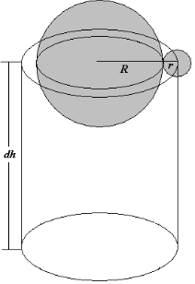

If the larger droplet is falling at its terminal velocity, u(R), then dh=u(R).dt and Eq. (2) becomes
dV = π (R+r)² u(R) dt
If we assume that as the large drop falls, any smaller droplets that are at least
partially within the volume dV will be ‘collected by’ or stick to the large drop. Therefore, its mass will increase by the liquid water content, M, of the smaller droplets, multiplied by the volume, dV. Thus,
dm = M dV = π (R+r)² M u(R) dt
But the smaller droplets are also falling at their terminal velocity, u(r). We have to correct for this, because if the small droplets were falling at the same speed of the larger droplet there would be no increase in mass since there would be no collisions. The greater the difference in the terminal velocities, the fewer collisions and the less mass will be collected. The corrected formula is
dm = M dV = π (R+r)² [u(R)-u(r)] dt
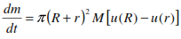
or, in terms of growth rate,
(3)
If all the smaller droplets within the volume coalesce (stick) to the falling
droplet, then Eq. (3) could be used to predict the rate of mass growth of the
falling droplet.
Q. Why is a warm, tropical cumulus cloud more likely to produce precipitation than a cold, stratus cloud?
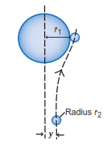
6.4 Collision efﬁciency
A drop of radius R overtaking a drop of radius r.
An object with zero inertia would be swept aside.
The collision efficiency E of a droplet of radius r with a drop of radius R is therefore defined as
E= y²/(R+r)²
If y< (r +R) not all drops in the geometrical collision cross section will collide with the collector drop. These calculations are mathematically involved.
- Collision efﬁciency is small for small r=R
- Increases as r=R increases up to 0.6
- At around 0.6, the radii are similar and relative velocities are small, the ﬂow ﬁelds interact strongly
- at r=R close to 1, there is a ”wake effect” and the efﬁciency can be greater than one.
In reality, not all the smaller droplets will collide with or stick (coalesce) to the larger droplet. One reason for this is that, the air flow around the larger drop may force the smaller droplet away as the drops pass. It is also possible for droplets that weren’t in the path of the larger droplet to be captured by the wake of the falling droplet. This is known as wake capture.
Even if two droplets collide, they may not actually stick, or coalesce. One reason for this is that there may be a microfilm of air between the droplets that prevents their surfaces from contacting.
All the above effects are taken into account by defining a collection efficiency, E, that is just the ratio of the number of small droplets that actually stick to the larger drop to the total number of small droplets within the volume.
The collection efficiency must be experimentally determined, and is going to depend on many physical factors such as the drop sizes involved, temperature, turbulence, wind shear, etc.
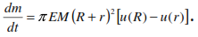
Usually E<1. With collection efficiency taken into account, Eq. (3) for the growth of droplet mass becomes
(4)
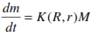
Equation (4) is often written as
where is called the gravitational collection kernel.
6.5 Growth equation in terms of radius
In terms of the change in radius of the larger drop, the growth-rate eq. is
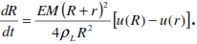
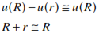
If we assume the smaller droplets have a negligible terminal velocity compared to the larger droplets, then we can use the approximations

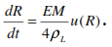
to write the growth equation in terms of radius as
(*)
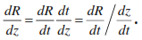
From the chain rule this can be written as

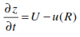
But dz∕dt is the rate at which the drop is actually falling, and is the difference of the speed of any updrafts and the terminal velocity of the drop,

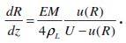
where U is the updraft velocity. Therefore, Eq. (*) becomes
(**)
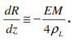
If the updraft velocity is negligible, then this becomes
(5)
Eq. (5) suggests that the droplet radius should decrease with height since as the droplet falls (z getting smaller) its radius should be increasing through the collision/coalescence process.

6.6 Growth due to collision with smaller droplets of non-uniform size
If there are two different sizes of smaller drops, r₁ and r₂, then the growth rate in terms of mass will have a separate term for each smaller droplet size present and will be
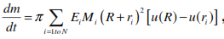
In general, if there are N different sizes of little drops, then we have

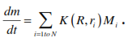
where each drop radius, r_{i}, has its own collection efficiency and liquid water content, E_{i} and M_{i}. Written in terms of the collection kernel, we have

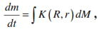
If the small droplets are distributed continuously then the summation becomes an integration,

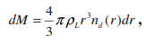
and we know that

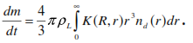
so that the growth equation for a continuous droplet spectrum is
(***)
This Eq. must be solved numerically, and is complicated by the fact that the collection kernel depends on radius of the small droplets, so it must remain within the integral. The collection kernel is usually determined empirically.
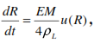
If we assume that R >>r and u(R) >> u(r) then we can show that

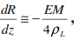
and

which are the same as Eqs. (*) and (**). Thus, regardless of whether or not our drop-size distribution is continuous, or if we just have one size of drops present, if we make the assumptions that R >> r and u(R) >> u(r) then Eqs. (*) and (**) are valid in either case.
Exercises
2. Clouds that form over water are usually more efficient in producing precipitation than clouds that form over land. Why?
Q1: a. Show that for a continuous spectrum of small drops that the growth equation in terms of the radius of the big drop is
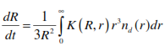

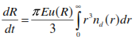
b) Show that if we assume that R >>r, and u(R) >> u(r), that the growth rate equation for a continuous small drop spectrum becomes

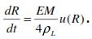
c) Show that the expression above is equal to

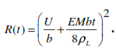
Q2: A droplet is at the very top of its trajectory in a cloud of liquid water content M and updraft speed U. The terminal velocity of the drop is given by . Integrate (*) to show that the droplet radius as a function of time is

7. Growth of Ice Crystals
7.1 Structure of water
Water molecules are bent at an angle of 104.5°. Water molecules have a dipole, due to the different electron affinities of hydrogen and oxygen.
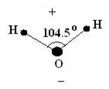

The oxygen side of the molecule is negatively charged, while the hydrogen
side is positively charged.
Because of this structure, the intermolecular (Van Der Waals) forces are
important, and leads to the interesting behavior of water compared to other
substances.
- The density of water does not monotonically increase as temperature
decreases. Instead, it reaches a maximum at about 4 °C (see diagram).
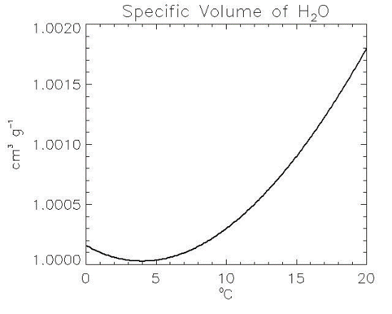

- The solid phase of water is actually less dense than the liquid phase, unlike most other substances (the specific volume of ice at 0 °C is 1.09 cm³/g).
Ice crystals have different shapes, or habits, depending on the conditions of temperature and super-saturation under which they form.
- The most common shapes are hexagonal plates, hexagonal columns, and Dendrites.

7.2 Formation of ice crystals
Ice crystals can form either by the freezing of super-cooled water droplets, or via deposition. Just as condensation requires a nucleus to provide a surface for the embryonic water droplet to form around, so to does deposition.
Ice crystals must form around some nuclei
- The exception is perhaps cirrus clouds, which form at temperatures cold enough that homogeneous nucleation of ice crystals may occur.
The nuclei for deposition are called ice nuclei. They are rare. Only one out of 10 million aerosols is an effective ice nuclei. Little is known about ice nuclei, but it appears that the primary ice nuclei in the atmosphere is the mineral kaolinite, which is found in many soils. Certain bacteria may also be ice nuclei.
Because ice nuclei are so rare, it is common to find clouds consisting of super-cooled liquid water droplets at temperatures as cold as –15 °C, and super-cooled liquid clouds have even been found at temperatures as low as - 40 °C.
- These super-cooled water droplets will freeze instantly upon impact with objects, and are a primary concern when aircraft fly through such clouds since they form ice on the wings, propellers, and engine intakes.
- The smaller the drop, the more likely it is to be super-cooled at very low temperatures. Once an ice crystal forms it can grow by diffusion, accretion, or aggregation.

7.3 Diffusional growth of ice crystals
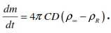
Diffusional growth of ice crystals is more rapid than that of liquid water droplets because the saturation vapor pressure over ice is less than that over water. The diffusional growth equation for ice crystals is very similar to that for water droplets, and is

where ρ_{R} is the saturation absolute humidity at the surface of the crystal, and C is a shape factor that depends on the shape of the crystal. This equation is really the same as that for water droplets, because for a sphere, C = R where R is the radius of the sphere.
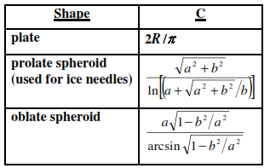
The approximate shape factors for various shapes are

where a and b are the semi-major and semi-minor axes.
As with water droplets, an equation for the balance of latent heat of sublimation added to the crystal, and that diffused away from the crystal, must also be used when discussing diffusional growth. This equation is
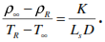

where L_{s} is the latent heat of sublimation.
A form of the C-C eq. is used to determine the saturation vapor pressure over ice at the surface of the crystal. The three equations can then be solved for the growth rate. The maximum growth rate occurs in the temperature range of −10 °C to −15 °C, so it is at these temperatures that ice crystals grow fastest by diffusion. Unlike for water droplets, diffusional growth of ice crystals is fast enough to explain how precipitation consisting of single crystals (snow grains) can form. When these melt, they become drizzle. For larger precipitation to form, the ice crystals must grow by either accretion (colliding with super-cooled water droplets) to form graupel, or aggregation (colliding with other ice crystals) to form snowflakes (which may then melt to become rain). The process of precipitation formation in cold clouds by ice crystal diffusional growth at the expense of liquid water droplets is known as the Bergeron process.

7.4 Branching versus faceting
Ice crystals grow through the competing processes of branching and faceting. Faceting refers to the tendency for the water molecules to form flat or crystalline surfaces as they collect on the crystal. Faceting drives the fact that ice crystals are hexagonal forms. Branching refers to the tendency for the water molecules to diffuse preferentially to jutting or irregular features the poke out from the surface. Branching drives the formation of tendrils and arms on ice crystals.
When crystals first form they are small, with noticeable, regular facets. As the crystal grows the tips grow preferentially due to branching. So, instead of having flat facets, they become concave. As the crystal grows bigger, the point begins growing into branches.
The humidity in the environment of the snowflake changes throughout its lifetime. This can lead to side branching:
In high super-saturation environments, the branches will grow rapidly and the tips will be more rounded. With lower super-saturation the growth is slower, which favors the formation of facets on the tip of the branch. The edges of these facets can further grow into sidebrances.

7.5 Collection-Coalescence versus the Bergeron process
In warm clouds (those whose tops are not appreciably colder than freezing), the collision-coalescence process is the only process that can explain the initiation and growth of precipitation. In cold clouds, either or both processes may be at work to explain initiation of precipitation.
The relative importance of either process depends on the type of cloud. In general: The Bergeron process is likely more important in stratiform clouds, whereas collision-coalescence is more important in convective clouds.
In stratiform clouds, ice crystals from the very cold upper levels fall into the cold lower levels where they grow rapidly. As they fall further, they continue to grow by accretion and aggregation. So, the precipitation is initiated in the upper levels, but grows in the lower levels.

8. Precipitation
It is any product of the condensation of atmospheric water vapor that falls under gravity. The main forms of precipitation include drizzle, rain, sleet, snow, graupel and hail. Precipitation occurs when a portion of the atmosphere becomes saturated with water vapor, so that the water condenses and "precipitates". Thus, fog and mist are not precipitation but suspensions, because the water vapor does not condense sufficiently to precipitate. Two processes, possibly acting together, can lead to air becoming saturated: cooling the air or adding water vapor to the air. Precipitation forms as smaller droplets coalesce via collision with other rain drops or ice crystals within a cloud. Short, intense periods of rain in scattered locations are called "showers". Precipitation is a major component of the water cycle, and is responsible for depositing most of the fresh water on the planet Mechanisms of producing precipitation include convective, stratiform, and orographic rainfall. Convective processes involve strong vertical motions that can cause the overturning of the atmosphere in that location within an hour and cause heavy precipitation, while stratiform processes involve weaker upward motions and less intense precipitation. Precipitation can be divided into three categories, based on whether it falls as liquid water, liquid water that freezes on contact with the surface, or ice. Mixtures of different types of precipitation, including types in different categories, can fall simultaneously. Liquid forms of precipitation include rain and drizzle. Rain or drizzle that freezes on contact within a subfreezing air mass is called "freezing rain" or "freezing drizzle". Frozen forms of precipitation include snow, ice needles, ice pellets, hail, and graupel. (some) drops need to grow to precipitable size mechanisms:
• water vapour condensation
• droplet coalescence• droplet coalescence
• ice processes
8.1 Types of precipitation
1 Rain – Drops of water falling from a cloud, and having a diameter of greater than 0.5 mm
2 Drizzle - Liquid water drops having a diameter of less than 0.5 mm. You can often tell the difference between rain and drizzle because drizzle usually doesn’t cause ripples in standing water puddles.
3 Snow – Ice crystals or aggregates of ice crystals. The shape of snowflakes varies with the temperature at which they are formed.
4 Snow grains – frozen equivalent of drizzle (from stratus clouds). Diameter < 1 mm.
5 Sleet (also called ice pellets) – Sleet is frozen raindrops. If greater than 5 mm in diameter, it is called hail (see note under hail).
6 Snow pellets (also called graupel) – larger than snow grain, but have diameter < 5 mm. Snow pellets are crunchy and break apart when squeezed. Usually fall in showers from cumulus congestus clouds. If greater than 5 mm they are called hail (see note under hail).
7 Hail – Hail begins as a snowflake that partially or completely melts, and then refreezes. But, instead of immediately falling to the ground, it gets caught in an updraft and can make several trips up and down through the cloud, each time accumulating more ice. Hail is only formed in very strong thunderstorms (cumulonimbus clouds). Hail has diameters > 5 mm. If smaller, it is either snow pellets or ice pellets, depending on its hardness and crunchiness.
NOTE: It is sometimes difficult to differentiate between hail, snow pellets,
and sleet. Here are some rules to follow:
_ If it has a diameter larger than 5 mm it is hail.
_ If it has a diameter less than 5 mm, and is transparent and solid it is sleet.
_ If it has a diameter less than 5 mm, is not transparent, and crunches
when squeezed, it is snow pellets.
8 Glaze – Also called freezing rain, glaze forms when supercooled raindrops strike an object and instantly freeze on impact.
9 Rime – Forms in a manner similar to glaze, only it is caused by the freezing of supercooled cloud droplets rather than supercooled raindrops. It often forms feathery ice crystals on trees.

8.2 Rainfall rate and drop-size distribution
The flux of water mass contained in droplets having diameters between D and dD is
dF=u . dM
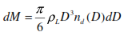
where u is the terminal velocity of the droplets of diameter D. If we know the size distribution of the droplets then

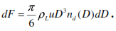
so that we have

The total mass flux from all the droplets is found by integrating over all
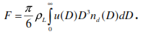
Diameters

F is the mass of liquid water falling through a unit horizontal area per unit time so it is a measure of how much precipitation is striking the ground. To convert this into a depth of water accumulated on the ground we use the following dimensional analysis:
so that we have the following relationship between rainfall rate (R, with units of accumulated depth per time) and flux,
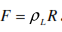
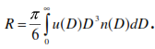
Thus, the rainfall rate is given by

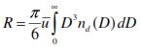
Using the mean-value theorem of calculus we can write this as

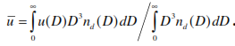
Where u is the volume-weighted mean terminal velocity for the population as a whole,

8.3 The Marshall-Palmer drop-size distribution
Raindrop size distribution are often given by the Marshall-Palmer distribution,
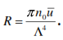
n₀ is called the intercept parameter, and Λ is called the slope factor. The intercept factor is a constant, and is often given a value of n₀ = 0.08 cm⁻⁴. For the Marshall-Palmer distribution the rainfall rate is

Empirically, the slope factor has been found to depend on rainfall rate via

where R has units of mm/hr and Λ has units of cm. This is very close to the theoretically derived equation.

Exercises
1. If a droplet population consists of droplets of a single size (D = 2 mm,
u = 6.49 m/s), and the droplet density is 26 drops per m³, what is the rainfall rate in mm/hr?
2. Show that for the Marshall-Palmer drop-size distribution the slope factor and the precipitation water content are related via
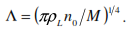

9. Weather modification
It is the act of intentionally manipulating or altering the weather. The most common form of weather modification is cloud seeding to increase rain or snow, usually for the purpose of increasing the local water supply. Inadvertent weather modification occurs when man’s activities seed clouds. There is evidence that this is occurring near industrial areas. Weather modification, commonly known as cloud seeding, is the application of scientific technology that can enhance a cloud's ability to produce precipitation. Weather Modification, is on the forefront of scientific technology to maximize water availability worldwide. cloud seeding increases the amount of precipitation.
Experiments in cloud modifications are usually undertaken with one of the following goals:
1) Weather modification can also have the goal of preventing damaging weather, such as hail or hurricanes, from occurring.
2) to stimulate precipitation
3) to dissipate cloud or fog
4) to suppress hail
Attempts have been made to “seed” cold clouds with dry ice or silver iodide crystals in order to enhance the Bergeron process. This is done to either enhance precipitation, or to disperse fog. It can be somewhat successful on a small scale (such as trying to clear fog at an airport). Warm clouds are seeded with salt particles in an effort to get a few large drops to form to initiate the collision-coalescence process.
9.1 Examples of experiments:
1) For the 2008 Olympics, China had plans to utilize 30 airplanes, 4,000 rocket launchers, and 7,000 anti-aircraft guns in an attempt to stop rain.
2) The United Arab Emirates, had created over 50 artificial rainstorms between July and August 2010 near Al Ain, a city which lies close to the country's border with Oman and is the second-largest city in the Abu Dhabi Emirate. The artificial rainstorms were said to have sometimes caused hail, gales and thunderstorms, baffling local residents.
3) An electronic mechanism was tested in 2010, when infrared laser pulses were directed to the air above Berlin by researchers from the University of Geneva. The experimenters posited that the pulses would encourage atmospheric sulfur dioxide and nitrogen dioxide to form particles that would then act as seeds.
Cloud seeding, a form of weather modification, and is a common technique to enhance precipitation.is the attempt to change the amount or type of precipitation that falls from clouds, by dispersing substances into the air that serve as cloud condensation or ice nuclei, which alter the microphysical processes within the cloud. The usual intent is to increase precipitation (rain or snow), but hail and fog suppression are also widely practiced in airports. Cloud seeding is a common technique to enhance precipitation. Cloud seeding entails spraying small particles, such as silver iodide onto clouds in order to affect their development, usually with the goal of increasing precipitation. Cloud seeding only works to the extent that there is already water vapor present in the air.

Types of cloud seeding: 1) Aerial Cloud Seeding 2) Ground-Based Cloud Seeding
Methodology: The most common chemicals used for cloud seeding include silver iodide, potassium iodide and dry ice (solid carbon dioxide). Liquid propane, which expands into a gas, has also been used. This can produce ice crystals at higher temperatures than silver iodide. After promising research, the use of hygroscopic materials, such as table salt, is becoming more popular. Cloud seeding to increase snowfall takes place when temperatures within the clouds are between 19 and −4 °F (−7 and −20 °C). Introduction of a substance such as silver iodide, which has a crystalline structure similar to that of ice, will induce freezing nucleation.
In mid-latitude clouds, the usual seeding strategy has been based on the fact that the equilibrium vapor pressure is lower over ice than over water. The formation of ice particles in super cooled clouds allows those particles to grow at the expense of liquid droplets. If sufficient growth takes place, the particles become heavy enough to fall as precipitation from clouds that otherwise would produce no precipitation. This process is known as "static" seeding.
Seeding of warm-season or tropical cumulonimbus (convective) clouds seeks to exploit the latent heat released by freezing. This strategy of "dynamic" seeding assumes that the additional latent heat adds buoyancy, strengthens updrafts, ensures more low-level convergence, and ultimately causes rapid growth of properly selected clouds.
Cloud seeding chemicals may be dispersed by aircraft or by dispersion devices located on the ground (generators or canisters fired from anti-aircraft guns or rockets). For release by aircraft, silver iodide flares are ignited and dispersed as an aircraft flies through the inflow of a cloud. When released by devices on the ground, the fine particles are carried downwind and upward by air currents after release.

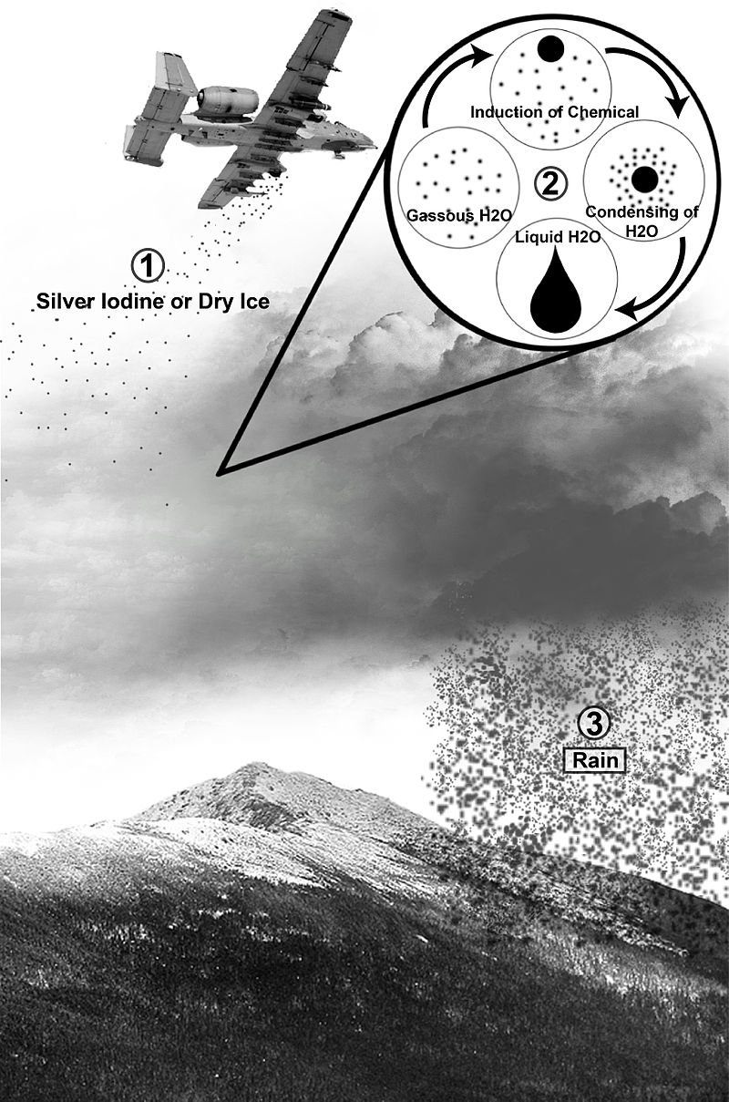

10. Cloud electrification
10.1 Lightning
Lightning is simply a discharge of electricity, a giant spark, which usually occurs in mature thunderstorms. Lightning is a discharge of electricity between the oppositely charged centers, either from the cloud to the ground, or within the cloud.
Lightning may take place within a cloud, from one cloud to another, from a cloud to the surrounding air, or from a cloud to the ground. For lightning to occur, separate regions containing opposite electrical charges must exist within a cumulonimbus cloud.

10.2 Electrical properties of the fair weather atmosphere
The upper atmosphere is a good conductor of electricity because there are a lot of ions present, while the troposphere is a poor conductor of electricity, because there are not many ions.
The earth normally has a negative charge, and the upper atmosphere normally has a positive charge.
Since air in the lower atmosphere is not a perfect isolator, there is a vertical current ﬂow from the positively charged ionosphere to the Earth’s surface. This current has been measured to be on average about 2.7 µA/km and is called the fair-weather current. Integrating over the Earth’s surface, this results in a current of ∼1500 A. Since measurements have never shown a complete absence of this fair-weather electric ﬁeld for any length of time, there must be a mechanism to replenish the lost charge back to the ionosphere. Otherwise, this fair-weather current would neutralize the charge on Earth and in the atmosphere on a time scale on the order of 10 minutes, depending on the amount of pollution in the air.
There must be some mechanism to continually put positive charges into the upper atmosphere. Thunderstorms provide this mechanism.
10.3 Electrical properties of a thunderstorm
The top of a thunderstorm (cumulonimbus) cloud becomes positively charged, while the bottom of the cloud becomes negatively charged.
The reason for this charge separation is not well understood, though it does have something to do with frozen vs. liquid hydrometeors. The frozen hydrometeors are positively charged, and are found at the top of the cloud. The liquid hydrometeors are negatively charged, and are found at the bottom of the cloud.
The negative charge at the bottom of the cloud induces a positive charge at the ground.
One theory proposes that clouds become electrified when graupel (small ice particles called soft hail) and hail stones fall through a region of supercooled liquid droplets and ice crystals. As liquid droplets collide with a hailstone, they freeze on contact 'tnd release latent heal. This process keeps the surface of the hailstone warmer than that of the surrounding ice crystals. When the warmer hailstone comes in contact with a colder ice crystal, an important phenomenon occurs: There is a net transfer rl positive ions (charged molecules)
from tlie wan11er object to the colder object. Hence, the hailstone (larger, warmer particle) becomes negatively charged and the ice crystal (smaller. cooler particle) positively charged, as the positively ions are incorporated into the ice crystal.
The same effect occurs when colder, supercooled liquid droplets freeze on contact with a warmer hailstone and tiny splinters of positively charged ice break off. These lighter, positively charged particles are then carried to the upper part of the cloud by updrafts. The larger hailstones (or graupel), left with a negative charge, either remain suspended in an updraft or fall toward the bottom of the cloud. By this mechanism, the cold upper part of the cloud becomes positively charged, while the middle of the cloud becomes negatively charged The lower part of the cloud is generally of negative and mixed charge except for an occasional positive region located in the falling precipitation near the melting level.
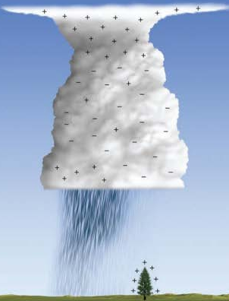

Another school of thought that during the formation of precipitation, regions of separate charge exist within tiny cloud droplets and larger precipitation particles. In the upper part of these particles we find negative charge, while in the lower part we find positive charge. When falling precipitation collides with smaller particles, the larger precipitation particles become negatively charged and the smaller particle, positively charged. Updrafts within the cloud then sweep the smaller positively charged particles into the upper reaches of the cloud, while the larger negatively charged particles either settle toward the lower part of the cloud or updrafts keep them suspended near the middle of the cloud.
There are roughly 50 to 100 lightning flashes around the globe every second!
10.4 Benjamin Frianklin's famous kite experiment
Benjamin Franklin designed an experiment to prove that lightning is electricity. Franklin’s experiment used a kite with a conducting wire between the kite and a metal key. The kite was flown in the vicinity of a thunderstorm.
His experiment was not designed so that the kite would be directly struck by lightning, nor was his kite ever directly struck by lightning! Instead, his experiment was designed only to observe a small spark from the key to his hand.
10.5 Cloud-to-ground (CG) lightning
Cloud-to-ground (CG) lightning is a lighting discharge from the cloud to the ground. CG lightning proceeds in a distinct sequence
ο Stepped leader – The stepped leader is an ionized path that forms from the cloud to the ground. It has many short segments, and is highly branched. Usually it is not even visible.
ο Return stroke – Once the stepped leader reaches to within 50 meters or so above the ground, a positive charge flow is initiated from the ground back toward the cloud. This is the return stroke, and it is the brightest and most energetic part of the lightning flash.
ο Dart leader – After the return stroke subsides, another leader progressesback down the lightning channel. This leader is similar to the stepped leader, but is not branched.
ο Return stroke – As the dart leader approaches the ground another return stroke is initiated from the ground back to the cloud.
The dart leader-return stroke sequence continues until enough charge is neutralized that the atmosphere is able to once again act as an insulator.
On average there are 3 or 4 return strokes per CG flash, though there may be more.
The entire sequence of a CG flash lasts for only a few-tenths of a second.
Note that the return stroke travels from the ground upward to the cloud.
The peak electrical current in a CG flash is typically 30 to 40 KAmps.
The lightning channel is only a few centimeters in diameter.
The air in the lightning channel is heated to temperatures as high as 60,000 °F.
CG lightning normally lowers negative charge to the ground.
A very small percent of CG lightning lowers positive charge to the ground. These positive discharges are usually much more energetic than the normal, negative discharges.
10.6 Intra-cloud (IC) lightning
Intra-cloud (IC) lightning is a lightning discharge between charge centers within the cloud, or between clouds, and doesn’t reach the ground.
The vast majority (60 to 80 percent) of lightning is IC lightning
Less is known about IC lightning than CG lightning, because it is much harder to observe and measure.
10.7 Other forms of lightning
Heat lightning – Heat lightning is just lightning seen at night from a very distant thunderstorm. It is so far away that the thunder is not heard. It is called heat lightning because it usually occurs on hot summer nights.
Sheet lightning – Sheet lightning is just IC lightning that illuminates a large section of the sky seemingly all at once.
Ribbon Lightning – Ribbon Lightning is caused by the wind blowing the air so that each return stroke occurs in a different location, giving the effect of a ribbon.
Ball lightning – Ball lightning is a rarely reported phenomenon of a ball of light or electricity that occurs during a thunderstorm. It may move through buildings or even airplanes.
ο The balls are reported to be about the size of a grapefruit, and last for only a few second.
ο Not much is known about ball lightning other than anecdotal accounts from persons encountering it.
ο Many occurrences have been associated with CG lightning strikes.

10.8 Thunder
Thunder is the sound caused by the rapid expansion of the heated air in the lightning channel. The sound travels at around 750 mph, or about 1/5 of a mile per second. Light travels at about 186,000 miles per second.
The difference between the speed of light and the speed of sound can be used to estimate how far away a lightning flash was.
ο Each second of time between when you see the flash and when you hear the thunder is 1/5 (0.2) miles. Therefore, every five seconds equals one mile.
ο So, if there is 14 seconds between the flash and the thunder, the lightning was 14 X 0.2 = 2.8 miles away.
Sound rays usually bend upward in the atmosphere. Therefore, if lightning is more than about 15 miles away the sound passes over your head and you do not hear it.
Thunder rumbles because the sound generated by different parts of the lightning channel reaches you at different times. The closer you are to the lightning, the sharper and shorter the thunder will sound.
10.9 Lightning rods
A lightning rod is a long, metal rod designed to attract the lightning bolt and direct its current harmlessly through a wire to the ground. Lightning rods do not slowly discharge the electricity from the cloud!
A rod of height H will protect a cone around it having a base of 2H.
The lightning rod must be well grounded. Otherwise the lightning may jump from the rod to building it is designed to protect.
10.10 Lightning safety
The key to lightning safety is to not let yourself be a lightning rod during a thunderstorm you should:
1. Get inside and enclosed building or vehicle (nit a convertible).
2. Stay away from metal from windows and doors.
3. Stay away from metal or other conducting surfaces.
4. Do not use the telephone or plumbing (lightning can travel through the phone wiring, electric wiring, cable TV wiring, or plumbing pipes).
5. If outdoors, do not stand in exposed fields, or under tall objects such as isolated trees.

