Lec(6) Immunology Dr. Ekhlass Noori

Biotechnology

Antigens and Receptors
Introduction:
Immune responses are initiated by the interaction between a receptor and a ligand (a molecule that interacts with a receptor). These interactions are what trigger the activation of leukocytes or white blood cells. The shapes of the ligand and its receptor are critical. The effectiveness of interaction often increases with the affinity or strength of interaction between ligand and receptor (Fig1). Receptors may be displayed on cell surfaces (e.g., cell -surface receptors) or may be soluble molecules (e.g., secreted products of leukocytes). Ligands may be expressed by cells as cell -surface molecules (e.g., on microbes) or as soluble molecules (e.g., the secreted products of cells).
Several factors influence the binding of a ligand to a cell -surface receptor: The shape and charge affect binding affinity, the collective affinities where multiple receptors may be involved (avidity), the intracellular signals that are triggered, and the presence of other receptors that may also influence the action in question. The context in which cells receive signals can influence whether they respond to those signals (Fig. 2). Cells must often correlate information from multiple activated receptors, some providing positive signals and others providing negative signals, to determine what action they will ultimately take. A grouping of ligands that may be recognized by cells of both the innate and adaptive immune systems is collectively known as antigens. The smallest individually identifiable part of an antigen that is bound by a receptor is known as an epitope.
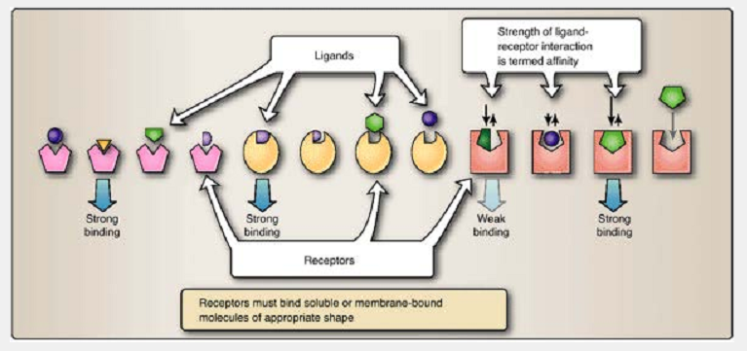
Figure 1 Receptor-ligand interactions. Receptors bind molecules or ligands that may be either soluble or bound to membranes. If the binding is sufficient, the receptor is able to provide a signal to the cell.
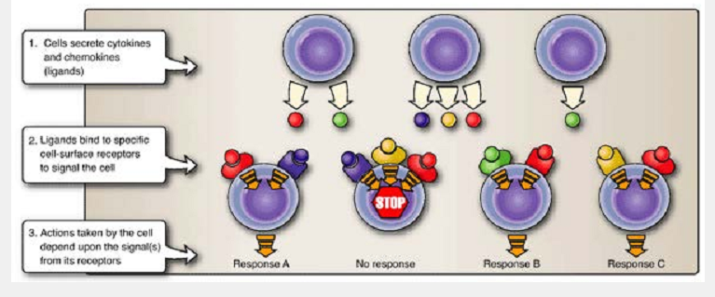Figure 2 Receptor-ligand context influences outcome. A cell integrates messages coming from multiple receptors to determine what action it ultimately takes.

The innate immune system employs a limited set of receptors to recognize epitopes expressed by a wide range of microorganisms. The adaptive immune system, on the other hand, generates a vast number of epitope-specific lymphocyte receptors that are expressed only by bone marrow-derived lymphocytes (B lymphocytes or B cells) and thymus-derived lymphocytes (T lymphocytes or T cells). Different receptors on B cells and T cells precisely recognize molecular features of epitopes as an important initial step in generating an immune response. As with receptors in general, both the molecular nature of the antigen and how it interacts with leukocyte receptors greatly influence the immune response that will be generated through the binding of these highly specialized receptors.
Antigens:
Classically, an antigen is defined as an organism, a molecule, or part of a molecule that is recognized by the immune system. Antigens may be simple or complex, protein, carbohydrate, or synthetic in origin. Often, the term is associated primarily with those molecules recognized by the extremely diverse receptors found on T and B lymphocytes. We will follow this usage and reserve the terms “antigen” and “epitope” for the substances that are recognized and bound by these somatically generated B and T cell receptors. It must be noted, however, that molecules designated as antigens in this context may also be bound by other types of receptors on other cells.
A. Epitopes: the basic recognition unit
Antigen receptors recognize discrete regions of molecules called antigenic determinants or epitopes, the smallest part of an antigen that is “seen” by somatically generated B and T cell receptors (Fig3). Different lymphocytes, each with a unique set of receptors, may recognize different epitopes on the same antigen. Some receptors (e.g., those of B cells) can recognize their specific epitopes whether they are part of free soluble molecules, surface-bound molecules, or even degraded (proteolytic) fragments of antigens. Other receptors (e.g., T cell receptors) can bind only to epitopes that are on small fragments affixed to specialized host cell surface molecules that display them to the T cells. Depending upon the nature of the immune responses they trigger, antigens/epitopes are divided into three broad functional types: immunogens, haptens, and tolerogens.

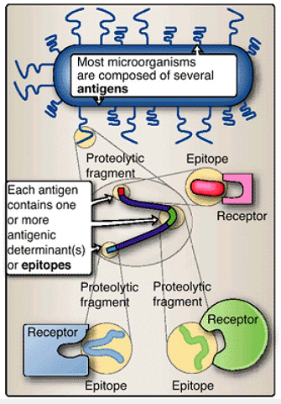
Figure 2.3 Epitopes and antigens: degrees of complexity. Complex antigens may contain large numbers of different epitopes.

B. Immunogens
Immunogens contain epitopes that both induce an immune response and are the targets of that response (Table 1). The strength of the immune response by the innate system is the same no matter how many times it encounters the same immunogen. In contrast, re exposure of the adaptive immune system to the same immunogen usually increases the intensity of the epitope-specific immune response. Although epitopes on antigens may bind to soluble or cell -surface receptors, not all antigens are immunogens. Unfortunately, the terms “antigen” and “immunogen” are often used interchangeably. we use the term “immunogen” to mean a substance or antigen that evokes a specific, positive immune response and the term “antigen” to mean a molecule or cell recognized by the immune system. Some non immunogenic molecules (e.g., haptens) can be bound to an immunogen. the immunogen is referred to as a carrier.
C. Haptens
Haptens are small, normally non immunogenic, molecules, usually of non biologic origin, that behave like synthetic epitopes. Haptens are antigens and can bind to immune receptors but cannot by themselves induce a specific immune response and hence are not immunogenic. However, when a hapten is chemically bound to an immunogen (also called a carrier), immune responses may be generated against both the hapten and the epitopes on the immunogen (Table 1).

D. Tolerogens
During development of the immune repertoire (the sum of all of the epitopes for which a given individual has generated immunologic receptors), tolerance to self molecules and cells develops first. Therefore a lack of immune response to self antigens exists in the normal, healthy state. Nonself antigens are subsequently recognized as foreign. Tolerance can also develop later in life, for example to antigens that are administered orally. Tolerogens induce adaptive immune unresponsiveness. However, unlike immunogens, exposure to a tolerogen results in a diminished response rather than an enhanced one (Table 1).
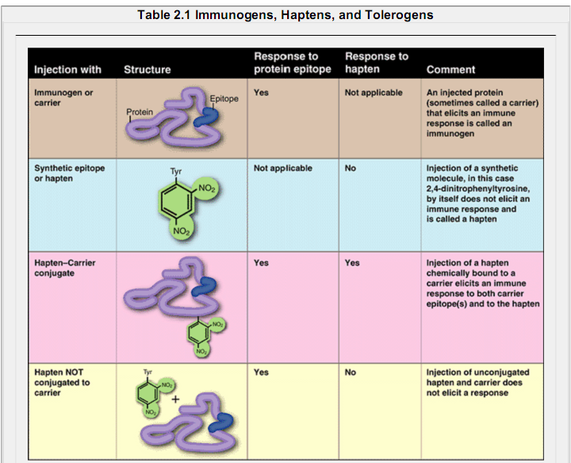
E. Immunogenicity
Although there are no firm rules for predicting whether a substance is an immunogen prior to exposure to the immune system, there are several guidelines:
Size: Proteins greater than 10 kDa are usually more immunogenic.
Complexity: Complex proteins with numerous, diverse epitopes are more likely to induce an immune response than are simple peptides that contain only one or a few epitopes.
Conformation and accessibility: Epitopes must be “seen by” and be accessible to the immune system.
Chemical properties: A protein immunogen has to be enzymatically cleavable by phagocytes. For example, L-amino acid-containing polypeptides are generally good immunogens, while D-amino acid-containing polypeptides are poor immunogens, because proteolytic enzymes are able to cleave only the L-forms of amino acids. Many carbohydrates, steroids, and lipids tend to be poor immunogens. Amino acids and haptens are, by themselves, not immunogenic (Fig4).

Receptors:
The immune system depends upon receptors, and the ligands that are bound by them, for its function. The engagement of receptors provides the initiating event that can lead to a wide variety of activities, depending upon the particular receptor and ligand and upon the type of cell or molecules that the receptor is associated with. Some receptors are designed to bind molecules that then generate signals between cells. Others sample the environment to detect the presence of intruders. Yet others examine their neighbors to be sure that they belong to self and do not present a threat.

A. Preformed receptors
The initial defense to an infectious agent comes from elements of the innate immune system that contain preformed receptors that allow a quick response. This response confers some protection while the adaptive immune system prepares to respond.

1. Pattern recognition receptors
Receptors of the innate immune system recognize broad structural motifs (similarities in design) that are generally not present within the host but are instead found on microbes. These receptors, pattern recognition receptors (PRRs), are present in soluble forms (e.g., complement proteins, which comprise a particular kind of immune defense system) or on host cell surfaces. They recognize pathogen-associated molecular patterns (PAMPs), which include combinations of sugars, some proteins, lipids, and nucleic acids broadly associated with microbes (Fig5). PRR binding to PAMPs triggers various forms of inflammation intended to destroy the pathogens.
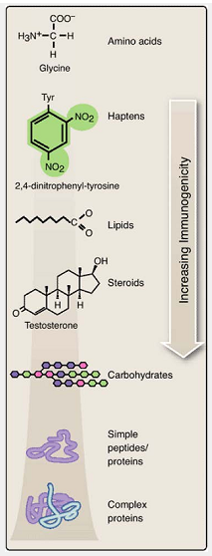
Figure 4 Factors governing immunogenicity. In general, the greater the size and complexity of the antigen, the greater the variety of possible epitopes and the greater the immunogenicity.

2. Toll-like receptors
In humans, PRRs also include toll-like receptors (TLRs) that are present on a variety of host cells (Table 2). When triggered by binding to a PAMP on an infectious organism, TLRs mediate the generation of defensive responses that include transcriptional activation, synthesis and secretion of cytokines (immune chemicals secreted by immune cells) to promote inflammation, and the attraction of macrophages, neutrophils, natural killer (NK) cells, and dendritic cells to the site of infection.

3. Killer activation receptors
NK cells are part of the lymphocyte lineage that do not express the extremely variable types of antigen-specific receptors found on B cells and T cells. Nevertheless, they do bear receptors that are able to detect alterations in host cells that have been infected by pathogens, particularly viruses. Killer activation receptors (KARs) on NK cells allow them to recognize the presence of stress-related molecules (called MICA and MICB molecules in humans) expressed by host cells that are unhealthy or abnormal for various reasons, including being infected. Binding of MICA or MICB molecules by the NK cell's KARs induces the NK cell to attach and destroy the targeted (e.g., infected) host cell (Fig. 2). This process, and its important role in innate immunity.

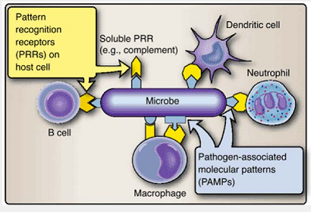
Figure 5 Pattern-recognition receptors (PRRs). Pattern recognition receptors detect and bind pathogen-associated molecular patterns (PAMPs).
4. Killer inhibition receptors
Another set of receptors, the killer inhibition receptors (KIRs), is used by NK cells to monitor major histocompatibility complex (MHC) class I molecules normally displayed on the cell surfaces of all nucleated cells in the body (see Fig. 2-6). By scrutinizing MHC class I molecules, NK cells have a second means to determine the normality of host cells. Many processes, including some cancers and some types of viral infection, decrease the number of MHC class I molecules displayed on the surface of the affected cell. Once bound to a target cell via its KARs, the NK cells use their KIRs to assess the expression of MHC class I molecules on that cell. If NK cells determine that the level is subnormal, they proceed to kill the target cell. If they determine that normal levels are present, the killing process is terminated and the target cell is released unharmed.
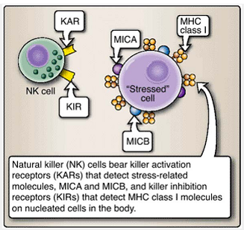
Figure 6 Killer-cell activation receptors (KARs) and killer-cell inhibition receptors (KIRs).

5. Complement receptors
The complement system is a complex set of soluble molecules that generate a variety of reactions that attract immune cells to the site of infection and lead to destruction of microbes. Some of these activities are accomplished by the binding of certain complement components or their fragments to microbial surfaces and “tagging” that microbe for destruction by other elements of the immune system. Cell-surface-bound complement receptors on phagocytic cells and B cells recognize these bound complement fragments and facilitate the binding, ingestion, and internal degradation of the tagged microbes (Fig.7).
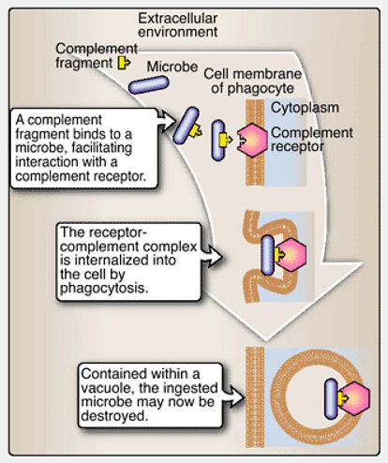
Figure 7 Complement receptors. Binding by complement receptors on phagocytic cells facilitates binding, ingestion, and destruction of microbes.

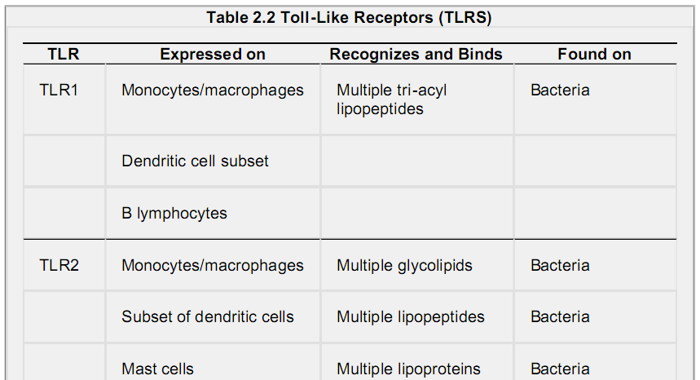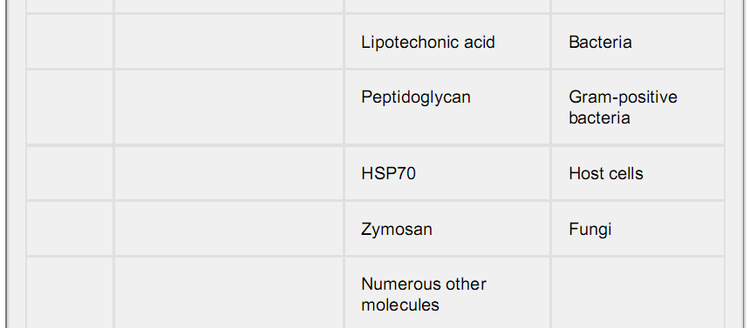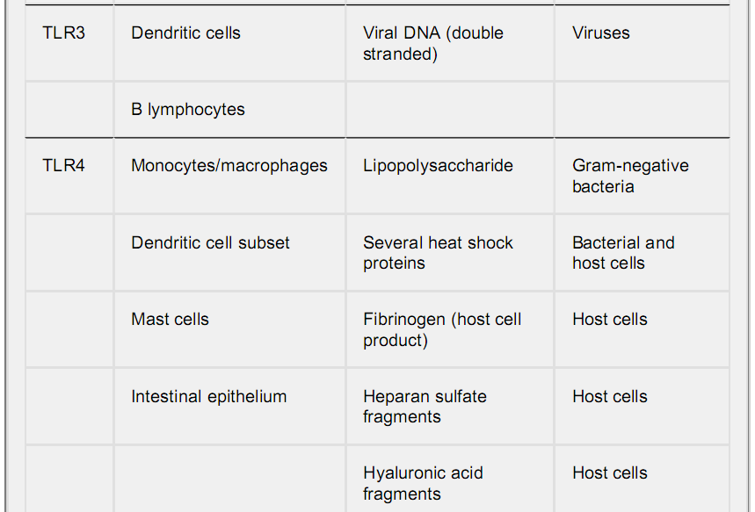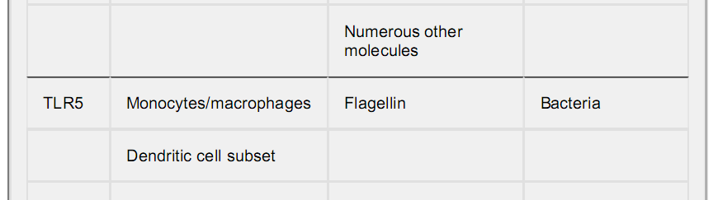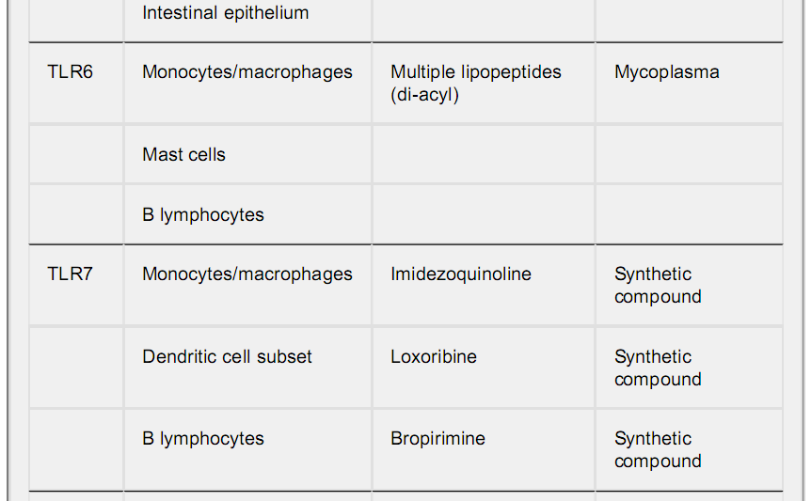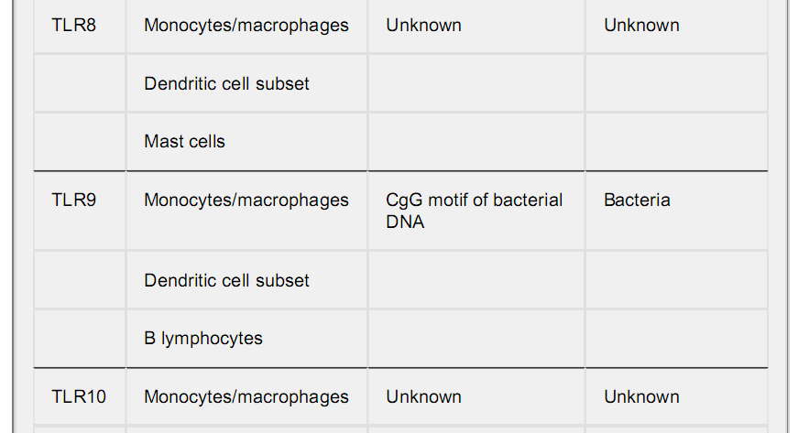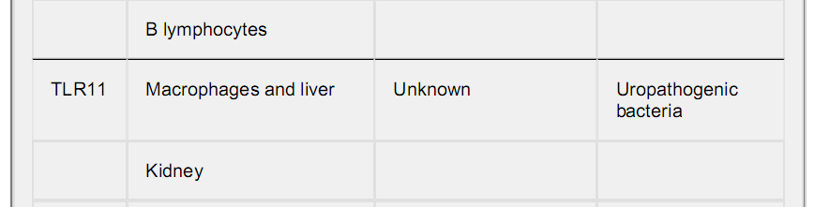

6. Fc receptors
Immunoglobulin (including those epitope-binding immunoglobulins termed antibodies) are classified as IgA (immunoglobulin A), IgD, IgE, IgG, and IgM based upon their structure. Although the structural the important point for our purposes here is that epitope binding by IgA, IgG, or IgM antibodies triggers a conformational change in the “tail” or Fc portion of the antibody. Fc receptors (FcRs) are expressed on the surfaces of phagocytic cells (see Fig8). Phagocytic cells recognize and bind epitope-engaged antibodies (recognizable by the altered conformation of the Fc region), which leads to the phagocytosis of the epitope-antibody-FcR complex. Antibodies that have not bound one or more epitopes do not bind to FcRs, and in this way, an antibody that has not bound to an epitope remains in circulation. The Fc receptor that binds IgE is the exception, which binds IgE molecules that have not yet encountered their epitopes; intracellular signaling does not occur until the IgE antibody binds the appropriate antigen.

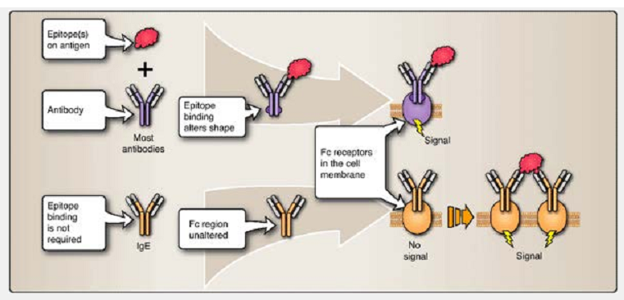
Figure 8 Fc Receptors. Like complement receptors, Fc receptors permit phagocytes to identify and ingest microbes and molecules that antibodies have previously “tagged” for destruction. The receptor for IgE is an exception, however. It binds free IgE and no cellular signalling occurs prior to the binding of antigen to the IgE.

B. Somatically generated receptors
The preformed receptors of the innate immune system (e.g., PRRs, TLRs, and complement) are encoded in the germline and passed on intact from one generation to the next. In contrast, the specialized receptors of B cells and T cells of the adaptive immune system are regenerated anew in the lymphocytes of each individual through random somatic chromosomal rearrangements and mutations. The result is a vast array of receptors specific for precise molecular details found in unique epitopes that may be encountered in the future.
1. B cell receptors
B cell receptors (BCRs) are composed of monomeric immunoglobulin associated with disulfide-linked heterodimers called Igα and Igβ (Fig. 9). When a BCR binds an epitope, the specialized cytoplasmic tails of Igα and Igβ initiate an intracellular signaling cascade that may lead to B cell activation. In addition, some activated B cells terminally differentiate into plasma cells, which secrete immunoglobulins that have the same epitope-binding specificity as their BCR.

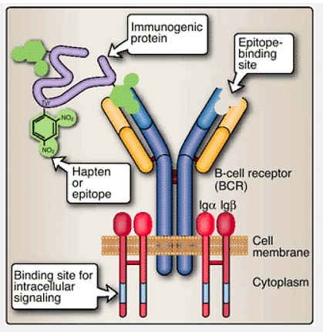
Figure:9 Immunoglobulins serve as B-cell receptors (BCRs). B cells bear receptors that are composed of two identical large (heavy) chains and two identical smaller (light) chains. Molecules such as Igα and Igβ are associated with BCRs and help provide a signal to the cell when the BCR binds an epitope.

2. T cell receptors
Structurally similar to immunoglobulin molecules, T cell receptors (TCRs) are heterodimers, consisting of either an αβ or a γσ chain pair (an αβ receptor is shown in Figure10; γσ receptors have similar structures). TCRs are always membrane bound and recognize antigen combined with MHC molecules. They are associated with the cluster of differentiation 3 or CD3 complex of transmembrane surface molecules. The CD3 complex functions much like the Igα and Igβ of BCRs in that it links the TCR with intracellular signaling molecules. An additional accessory molecule (CD4 or CD8) is also present to serve as a type of co receptor for the TCR.

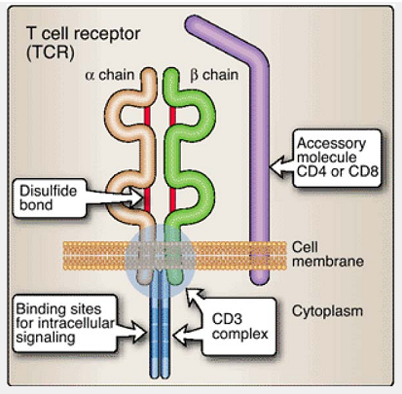
Figure 10: αβ T cell receptors (TCRs). T cells bear receptors that are composed of two chains, either an α-β combination (shown) or a γ-σ combination. The CD3 complex is associated with the TCR and facilitates cell signalling .

