**Lec(1) Immunology**

**Syllabus:**

1. Historical Background,Innate immunity (Barriers)
2. Immune cells & recognition Receptor.
3. Complement component,Cellular innate immunity(Inflamation I.R &Phagocytosis)
4. The Adaptive Immune System (Immunoglobulins)
5. Cells and Organs
6. Major Histocompatibility Complex (Molecules of cellular interaction).
7. Antigens and Receptors.
8. Lymphocyte Activation& Lymphocyte Effector functions
9. Humeral Immunity &Cell- Mediated Immunity.
10. Tolerance
11. Hypersensitivity Reaction.

**References:**

**Lippincotts Illustrated Reviews Immunology (2013) 2nd**

**Edition,Harvey, R.A *et al***

**Suggested References:**

* Immunology 2003( Goldsby,R.A.Kuby.J *et. al,*)
* Essential of Clinical Immunology 5th ed 2006. Snowden, N. *et .al,*)
* Medical Immunology 10th ed 2001.( Stites,D. P.)
* Basic Immunology 2nd ed 2007( Abbas, A. K.; Lichtman, A. H.)

**Historical Background**

The concept of immunity from disease dates back at least to Greece in the 5th century BC. Thucydides wrote of individuals who recovered from the plague, which was raging in Athens atthe time. These individuals, who had already contracted the disease, recovered and became “immune” or “exempt.” However, the earliest recognized attempt to intentionally induce immunity to an infectious disease was in the 10th century in China, where smallpox wasendemic. The process of “variolation” involved exposing healthy people to material from the lesions caused by the disease, either by putting it under the skin, or, more often, inserting powdered scabs from smallpox pustules into the nose. Variolation was known and practiced frequently in the Ottoman Empire, where it had been introduced by Circassian traders around 1670. Unfortunately, because there was no standardization of the inoculum, the variolation occasionally resulted in death or disfigurement from smallpox, thus limiting its acceptance.Variolation later became popular in England, mainly due to the efforts of Lady Mary WortleyMontague who survived smallpox but who lost a brother to it. Lady Montague was married toLord Edward Wortley Montague, the ambassador to the Sublime Porte of the Ottomans inIstanbul. While in Istanbul, Lady Montague observed the practice of variolation. Determined not

to have her family suffer as she had, she directed the surgeon of the Embassy to learn thetechnique and, in March 1718, to variolate her five year-old son. After her return to England, shepromoted the technique, and had her surgeon variolate her four-year old daughter in the presence

of the king’s physician. The surgeon, Charles Maitland, was given leave to perform what came tobe known as the Royal Experiment, in which he variolated six condemned prisoners who latersurvived. By these and other experiments, the safety of the procedure was established, and two of the king’s grandchildren were variolated on April 17, 1722. After this, the practice of variolation

spread rapidly throughout England in the 1740s and then to the American colonies.

**Edward Jenner and the development of the first safe vaccine for smallpox**

Although Jenner is rightly celebrated for his development of cowpox as a safe vaccine for smallpox, he was not the first to make use of a relatively non-pathogenic virus to induce immunity. In 1774, Benjamin Jesty, a farmer, inoculated his wife with the vaccinia virusobtained from “farmer Elford of Chittenhall, near Yetminster.” In 1796, Jenner inoculated James Phipps with material obtained from a cowpox lesion that appeared on the hand of a dairymaid

(Fig. 1). Six weeks later, he inoculated the experimental subject with smallpox without producing disease. Although this experiment justifiably lacked an appropriate control, further studies by Jenner established the efficacy of his vaccination procedure. For this feat, Jenner received a cash prize of 30,000 pounds and election to nearly all of the learned societies

throughout Europe.

** Fig. 1.** Jenner’s drawing of cowpox lesion from which he created his vaccine.

**Koch, Pasteur, and the germ theory of disease**

In 1875, Robert Koch, a country physician with no formal scientific training, inoculated the earof a rabbit with the blood of an animal that had died of anthrax. The rabbit died the next day. He isolated infected lymph nodes from the rabbit and was able to show that the bacteria contained within them could transfer disease to other animals. He developed and refined techniques

necessary for the cultivation of bacteria, including the development of agar growth medium. He was appointed to the Institute of Hygiene in Berlin, where his ultimate goal was to identify the organism responsible for the “White Death”--tuberculosis.

Quite independently, Louis Pasteur began his studies of the “chicken cholera bacillus.” In aserendipitous discovery, Pasteur inadvertently left a flask of the bacillus on the bench over the summer and inoculated 8 chickens with this “old but viable” stock of chicken cholera bacillus.

He found that not only did the chickens not die, but they did not even appear ill! Pasteur said that the virulent chicken cholera bacillus had become attenuated by sitting on the bench over the summer **months. The similarity** between these results and those of and Jenner using vaccinia virus was immediately apparent to him. In honor of Jenner, Pasteur called his treatment

vaccination. Pasteur later worked on anthrax and rabies and developed the first viable vaccine foranthrax and rabies.Although Koch and Pasteur were contemporaries, they were intensely competitive and actually

bitter enemies--of course, the outbreak of the Franco-Prussian war (1870) did nothing to cement their relationship. In a trenchant example of how not to behave toward a colleague at a scientific meeting, Koch made his way to the podium following Pasteur’s lecture and said: “When I saw in the program that Monsieur Pasteur was to speak today...I attended the meeting eagerly, hoping to

learn something new...I must confess that I have been disappointed, as there is nothing new in the speech which Monsieur Pasteur has just made...”

Although many consider Pasteur the “father of immunology” (?parent of immunology) it is due to both his and Koch’s efforts that firmly established the germ theory of disease. Prior to thistime, although the practical benefits of variolation were apparent, there was no known biological basis for either the cause of diseases or the efficacy of vaccination.

**The emerging distinction between cellular and humoral immunity**

Metchnikoff was the first to recognize the contribution of *phagocytosis* to the generation of immunity. In Italy, while studying the origin of digestive organs in starfish larvae, he observed that certain cells unconnected with digestion surrounded and engulfed carmine dye particles and splinters that he had introduced into the bodies of the larvae. He called these cells phagocytes

(from Greek words meaning “devouring cells”). Working first at the Bacteriological Institute in Odessa (1886-87), and later at the Pasteur Institute in Paris, Metchnikoff established that the phagocyte is the first line of defense against infection. He became a leading proponent of the

“Cellularists” who believed that phagocytes, rather than antibodies, played the leading role in immunity.

Supporters of the alternative theory, the “Humoralists,” believed that a soluble substance in the body was mainly responsible for mediating immunity. Building upon the demonstration by Von Behring and Kitasato of the transfer of mmunity against Diphtheria by a soluble “anti-toxin” inthe blood, Paul Ehrlich predicted the existence of immune bodies (antibodies) and side-chainsfrom which they arise (receptors). Ehrlich suggested that antigens interact with receptors borne

by cells, resulting in the secretion of excess receptors (antibodies). Ehrlich surmised that erythrocytes would not have this capacity and speculated that this immune function might be aspecialized characteristic or “haemopoietic tissue” (Fig. 2).

Ehrlich was probably the first scientist to introduce the concept of munological self/not-self discrimination, a mechanism “...which prevents the production within the organism of amboceptors (antibodies) directed against its own tissues. In this *horror autoxicus*, we are dealing with a well-adapted regulatory contrivance.”

**Summary of the state of immunology at the end of the 19th century**

By the turn of the century, several paradigms had been established that laid the groundwork forfuture studies in immunology. The first was based on the “germ theory” of disease (Koch andPasteur) which held that disease was caused by bacteria. The second paradigm was that



**Fig. 2.** Ehrlich’s drawing of a “haemopoietic” cell bearing “side chains” (receptors) and releasing “immune bodies”**(antibodies)**

**History of Immunology Time Line**

**Innate immunity**

**Barriers to Infection**

**Introduction**

We live in a microbial world. Our bodies are constantly surrounded by astronomical numbers of microbes (Table 3.1). In addition to the microbes themselves, the molecules they produce and some molecules from other environmental sources (e.g.,venoms) can also injure body cells and tissues. The body has several mechanical, chemical, and biologic **barriers** that provide the first line of defense against the entry of microbes into the aseptic, nutrient-rich environment of our tissues. These barriers can be thought of as the moats and thick walls that provided the initial protection to the inhabitants of castles under

enemy attack.

**1. Physical Barriers**

The initial mechanical barriers that protect the body against invasive microbes include the epidermis and keratinocytes of the skin; the epithelium of the mucous membranes of the gastrointestinal, respiratory, and urogenital tracts; and the cilia in the respiratory tract (Fig. 1.1). These mechanical barriers also incorporate a number of chemical and biologic barriers that minimize or prevent entry of potential pathogenic organisms into the body.

***A. Skin***

The epidermis or outer layer of skin varies in thickness from 0.05 to 1.5 mm depending upon location (Fig. 13.2). The outermost of the five layers of the epidermis, or *stratum corneum*, is composed of dead, tightly layered, and cornified squamous cells.Produced by **keratinocytes** of the lower four layers, cells of the stratum corneum provide a water-tight barrier that both

prevents our dehydration and provides a microbe-inhospitable dry environment on the surface of our skin. Continuously dividing keratinocytes and constant sloughing of the superficial epidermal layer removes microbes attached to cutaneoussurfaces.

***B. Mucous membranes***

The epithelium of mucous membranes lines all of the body's cavities that come into contact with the environment, such as the respiratory, gastrointestinal, and urogenital tracts (Fig. 1.3). This epithelium contains goblet cells that secrete mucus. It isestimated that 4 liters of mucus are secreted within the astrointestinal tract alone on a daily basis (although much of it isresorbed in the large intestine). In the respiratory tract, the mucus traps inhaled bacteria, fungi, and other particles. In the gastrointestinal tract, the mucus and mucous membranes help to protect the epithelial cells and underlying tissues from damage by digestive enzymes and to propel ingested matter through the tract. Mucosal surfaces of the moist epithelium facilitate the exchange of molecules with the

environment while also resisting microbial invasion. Additionally, the sloughing of the intestinal epithelial cells has a protective effect similar to that from the sloughing of keratinocytes in the skin.

**Table 3.1 Our Microbial Environment**

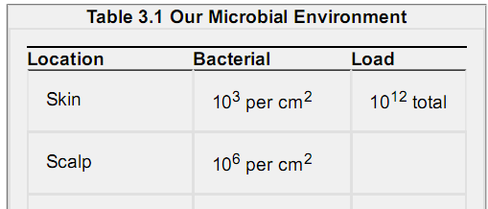

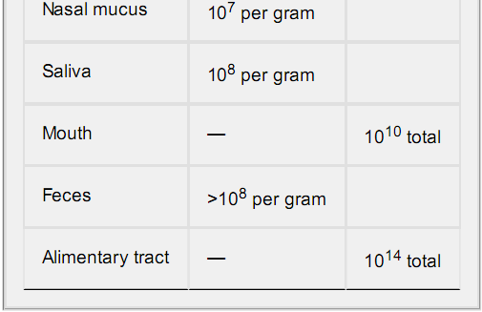

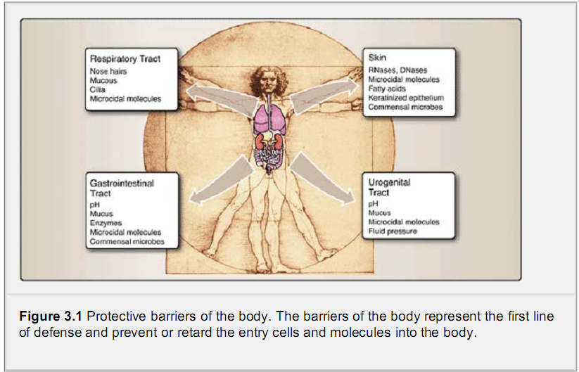

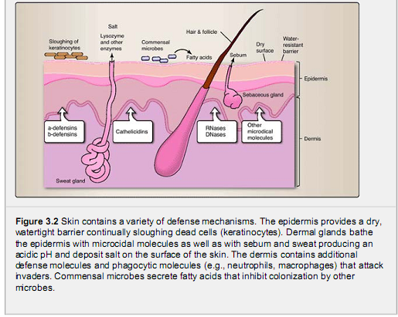

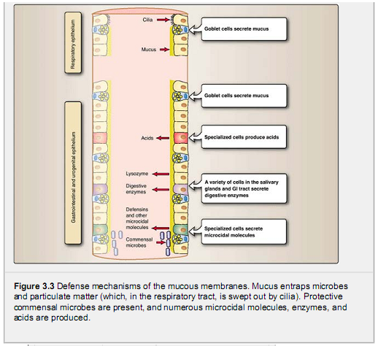

***C. Respiratory tract***

Air turbulence caused by hairs within the nostrils deposits particles larger than 10 μm in the nasal mucosa. The hairlike **cilia** of the epithelia lining the respiratory tract passages help the tract clean by moving the secretions ontaining trapped microbes andparticles outward for expulsion by coughing and sneezing. The rhythmically beating cilia of the respiratory epithelium is commonly disrupted by chronic smoking and chronic alcohol consumption, leading to an increased risk of respiratory infections.

***D. Urinary tract***

Similar to the outward movement of secretions of the respiratory tract, urination helps to inhibit movement of microbes from the environment up into the bladder and kidneys. The periodic voiding of sterile urine provides an externally directed fluid pressurethat inhibits the inward movement of microbes along the urinary tract. This simple protective mechanism can be disrupted bythe therapeutic insertion of a catheter, which increases the risk of urinary tract infections by facilitating entry of microbes intothe urinary tract. Urinary tract infections due to catheterization account for nearly half of all hospital nosocomial infections. The

female urogenital tract is also protected by the acidic secretions of the vagina and the presence of microcidal moleculessecreted by the mucous membranes.

**2.. Chemical and Environmental Barriers**

The acidic pH of the skin, stomach, and vagina serves as a chemical barrier against microbes. Microcidal molecules, such asα-defensins, β-defensins, cathelicidin, RNases, DNases, and lysozyme, which are secreted by a variety of cell types, alsoprovide protective environment barriers.

***A. pH***

Most pathogens are very sensitive to an acidic environment, where an acid pH (less than 6) inhibits the growth of potential pathogens.

1. **Skin**: The skin contains oil and sweat glands (sebaceous and sudoriferous glands, respectively), some of whose products are slightly acidic. In general, the skin has a pH of about 5.5. **Sebum** is a mix of lipids produced by the sebaceous glands. Excessive sebum secretion is often associated with oily skin and acne, particularly in adolescents,as it can clog skin pores (entrapping and retaining microbes) and create less favorable pH levels.

2. **Stomach**: Compared to the colon, the stomach has very few bacteria because of the highly acidic environment (normal pH of 1.0 to 3.0). The acidic environment of the stomach prevents the colonization of the intestines by ingested microbes.

3. **Vagina**: The acidic environment of the vagina and cervical os in healthy women is normally pH 4.4 to 4.6. This acidic environment is the result of lactic acid production by the commensal bacteria *Lactobacilli* spp. (see Section IV).

***B. B. Microcidal action of secreted molecules***

Several tissues that are in contact with the environment synthesize and secrete a variety of **microcidal molecules** that act to inhibit or kill microbes that are attempting to colonize. A few of the primary microcidal molecules are discussed here.

1. **Skin**: The skin is protected in part by several antimicrobial peptides secreted by a variety of cell types found within the skin. Among these are α-defensins, β-defensins, and cathelicidin. All are able to inhibit microbial growth by direct

action upon the microbes, perhaps by damaging the microbial membranes and causing lysis. They can also act aschemoattractants for cells of the **i**nnate immune system and facilitate the ingestion and destruction of microbes by

phagocytes. Fatty acids released by some of the commensal microbes that are present on the skin also act to inhibit growth by some other bacteria.

Other molecules with enzymatic activity are present in the skin as well. Sweat contains **lysozyme**, an enzyme that breaks down peptidoglycan (a constituent of most bacterial cell walls). Also present in the skin are molecules that act

on the RNA and DNA of a wide range of microbes. **RNases** and **DNases**, in fact, are powerful enough to require the wearing of protective gloves while performing molecular biology procedures—not to protect the hands, but to protect the material that is being manipulated from destruction by the enzymes on the skin. Finally, the evaporation of sweat creates a slightly salty nvironment that inhibits growth of many bacteria.

2. **Respiratory tract**: To protect the mucosal surfaces of the lungs, some cells of the respiratory epithelium secrete microcidal molecules such as β-defensins. These and other molecules in the respiratory tract can attach to microbes

and make them more susceptible to ingestion and destruction by phagocytic cells.

3. **Gastrointestinal tract**: The gastrointestinal tract defends against pathogens in many ways. In addition to the low pH of the stomach, some epithelial cells secrete microcidal molecules such as α-defensins and cryptidin that help to destroy many potential pathogens. Approximately 22 different digestive enzymes are released from the salivary glands,stomach, and small intestine. Among these is lysozyme found in saliva. These enzymes help the digestive process but are also effective in killing and degrading many potential pathogens that may be ingested.

4. **Lacrimal secretions**: Lacrimal glands are small almond-shaped structures, located above the outer corner of the eye,that produce tears. As part of protecting the eyes, the secretions of lacrimal glands contain lysozyme.

**IV. Biologic Barriers: Commensal Microbes**

**Commensal microbes** are those that exist in a symbiotic relationship with the body. The skin and the gastrointestinal tract are colonized by over 500 commensal bacterial and other microbial species that are estimated to make up over 95% of the cells present in a normal human body (Table 3.2). Commensal microbes colonizing the skin and gastrointestinal tracts “defend” their

territory and inhibit the establishment of other potentially pathogenic microbes. In the gastrointestinal tract, these microbes also assist in the digestive process.

Commensal microbes are not pathogenic (disease-causing) except under special circumstances. For example, commensal microbes can cause disease in people who are immunocompromised (i.e., their immune systems do not function effectively).The introduction of medical devices, such as catheters, into the body can also cause commensal bacteria from the skin toenter areas of the body that are normally sterile. Any disruption of the normal flora of the body may lead to disease.Pseudomembranous colitis is a condition caused by *Clostridium difficile*, a pathogenic bacterium that produces a toxin that damages the gastrointestinal tract and causes watery diarrhea, abdominal cramps, and fever. The condition may occur after a course of broad-spectrum antibiotic therapy. One explanation for the condition is that use of antibiotics reduces the levels of normal ommensal bacteria of the gastrointestinal tract, thus permitting the establishment and overgrowth by *Clostridium**difficile*.

**Chapter Summary**

The body has several mechanical, chemical, and biologic **barriers** that provide the first line of defense against the entry of microbes and toxic molecules.

The initial mechanical barriers that protect the body against invasive microbes include the epidermis and keratinocytes of the skin; the epithelium of mucous membranes of the gastrointestinal, respiratory, and urogenital tracts; and the cilia in respiratory tract.The slightly acidic **pH** of the skin and vagina is inhibitory to microbial growth. The high acidity of the stomach is highly inhibitory.

**Microcidal molecules** inhibit microbial growth. Present in the skin are molecules such as RNases and

DNases, defensins, and cathelicidin. Some cells of the respiratory epithelium secrete β-defensins; some epithelial cells secrete α-defensins and cryptidins.

**Commensal microbes** are those that exist in a symbiotic relationship with the body. Commensal microbes colonizing the skin and gastrointestinal tracts inhibit the establishment of other potentiallypathogenic microbes



