Histology
Histology is the study of the tissues of the body and how these tissues are arranged to constitute organs. Histology involves all aspects of tissue biology, with the focus on how cells’ structure and arrangement optimize functions specific to each organ.
Tissues have two interacting components: cells and extracellular matrix (ECM). The ECM consists of many kinds of macromolecules, most of which form complex structures, such as collagen fibrils and basement membranes. The ECM supports the cells and the fluid that transports nutrients to the cells, and carries away their catabolites and secretory products. The cells produce the ECM and are also influenced and sometimes controlled by matrix molecules. Cells and matrix interact extensively, with many components of the matrix recognized by and attaching to cell surface receptors.
The human body is composed of only four basic types of tissue:
- Epithelial tissue
- Connective tissue
- Muscular tissue
- Nervous tissue
These tissues, which all contain cells and molecules of the extracellular matrix (ECM), exist in association with one another and in variable proportions and morphologies, forming the different organs of the body.

Epithelial Tissue
Epithelial tissues are composed of closely aggregated polyhedral cells with strong adhesion to one another and attached to a thin layer of ECM. Epithelia are cellular sheets that line the cavities of organs and cover the body surface.
The principal functions of epithelial tissues include the following:
- Protection for the underlying tissues from radiation, desiccation, toxins, and physical trauma.
- Absorption of substances in the digestive tract lining with distinct modifications.
- Regulation and excretion of chemicals between the underlying tissues and the body cavity.
- Secretion of hormones into the blood vascular system. The secretion of sweat, mucus, enzymes, and other products that are delivered by ducts come from the glandular epithelium.

Because epithelial cells line all external and internal surfaces of the body, all substances that enter or leave tissues and organs must cross an epithelium.

Characteristics of epithelium
1- Cellularity: epithelia are composed mostly of cells. They have very little extracellular material between the cells.
2- Avascular: the tissue is avascular, meaning without blood vessels. Nutrient and waste exchange occurs through neighboring connective tissues by diffusion.
3- Attachment: the upper surface of epithelium is free, or exposed to the outside of the body or to an internal body cavity. The basal surface rests on connective tissue. A thin, extracellular layer called the basement membrane forms between the epithelial and connective tissue.
4- Polarity: epithelial cells generally show polarity, with organelles and membrane proteins distributed unevenly within the cell.
5- Regeneration: Cells are rapidly replaced when they are damaged, abraded, or die.

Basement Membranes
The membranes are always attached to an underlying connective tissue layer at a thin region called the basement membrane. The basement membrane is noncellular and consists of materials produced by the epithelial cells and the adjacent connective tissue.

Epithelium: Cell Junctions
Several membrane-associated structures provide adhesion and communication between cells. Some are present in other tissues but all are particularly numerous and prominent in epithelia. Epithelial cells adhere strongly to neighboring cells and basal laminae, particularly in epithelia subject to friction or other mechanical forces.
There are four main types of cell-cell junctions:
- Tight junctions or Occluding junctions
The tight junctions also called (Occluding junctions) between epithelial cells are thought to have both of these roles:
- First, they function as barriers to the diffusion of some membrane proteins (and lipids) between apical and basolateral domains of the plasma membrane. Mixing of such proteins and lipids occurs if tight junctions are disrupted, for example, by removing the extracellular Ca2+ that is required for tight junction integrity.
- Second, tight junctions seal neighboring cells together so that, if a low-molecular-weight tracer is added to one side of an epithelium, it will generally not pass beyond the tight junction. This seal is not absolute, however.
Although all tight junctions are impermeable to macromolecules, their permeability to small molecules varies greatly in different epithelia. Tight junctions in the epithelium lining the small intestine, for example, are 10,000 times more permeable to inorganic ions, such as Na+, than the tight junctions in the epithelium lining the urinary bladder. These differences reflect differences in tight junction proteins that form the junctions.
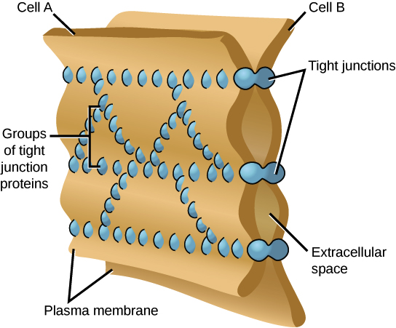

- Adhering junctions (zonula adherens)

Adherens junctions occur in epithelia, where they often form a continuous adhesion belt (or zonula adherens) just below the tight junctions, encircling each of the interacting cells in the sheet. The adhesion belts are directly apposed in adjacent epithelial cells, with the interacting plasma membranes held together by the cadherins that serve here as transmembrane adhesion proteins.
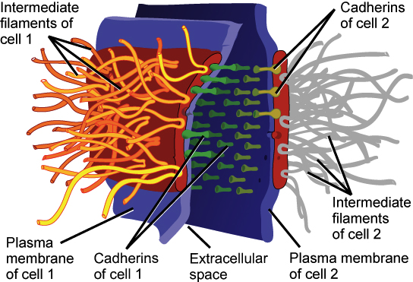

- Desmosomes (macula adherens) and Hemidesmosomes
Desmosomes: connect two cells together. A desmosome is also known as a spot desmosome or macula adherens, because it is circular or spot like in outline, and not belt- or band shaped like adherens junctions. Desmosomes are particularly common in epithelia that need to withstand abrasion. Desmosomes are also found in cardiac cells, but the intermediate filament in this case is desmin, not keratin (which is found in epithelial cells).

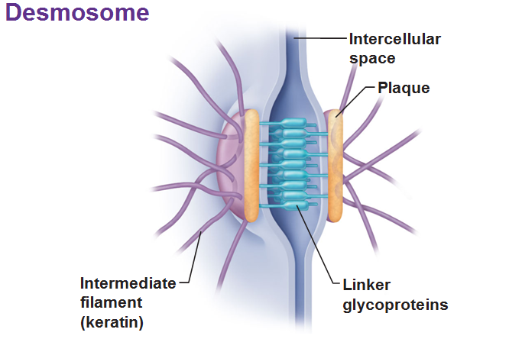

Hemidesmosomes: These look similar to desmosomes, but are different functionally, and in their content. They connect the basal surface of epithelial cells via intermediate filaments to the underlying basal lamina. The transmembrane proteins of hemidesmosomes are not cadherins, but another type of protein called integrin.

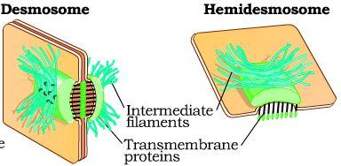

- Gap junctions.
mediate communication rather than adhesion or occlusion between cells. Abundant in many epithelia, gap junctions are also functionally important in nearly all mammalian tissues. Cryofracture preparations show that gap junctions consist of aggregated transmembrane protein complexes that form circular patches in the plasma membrane. The gap junction proteins, called connexins, form hexameric complexes called connexons, each of which has a central hydrophilic pore about 1.5 nm in diameter. When two cells attach, connexins in
the adjacent cell membranes move laterally and align to form connexons between the two cells, with each junction having dozens or hundreds of aligned
connexon pairs. Gap junctions permit intercellular exchange of molecules with small (<1.5 nm) diameters. Some molecules mediating signal transduction, such as cyclic nucleotides and ions, move rapidly through gap junctions, allowing cells in many tissues to act in a coordinated manner rather than as independent
units. For example, in heart and visceral muscles gap junctions help produce rhythmic contractions.

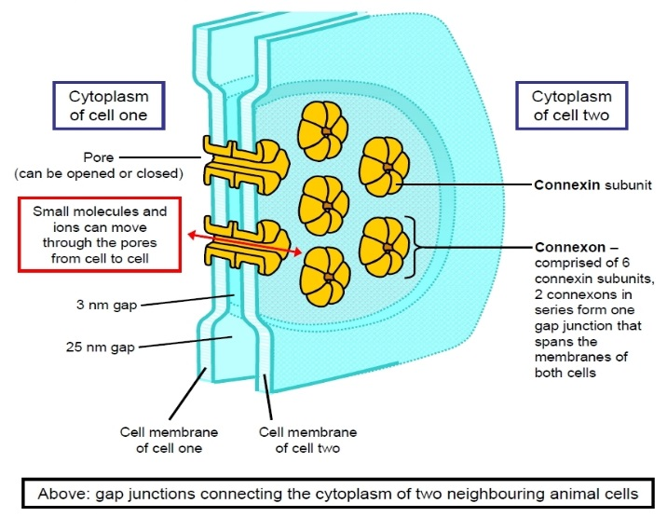
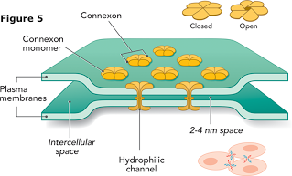

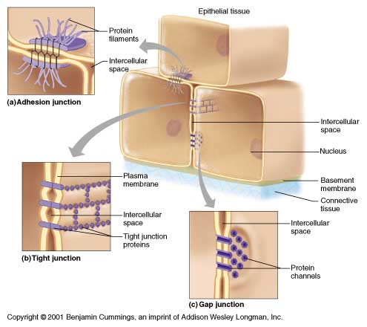

Specializations of the apical cell surface
The apical ends of many tall or cuboidal epithelial cells face an organ’s lumen and often have specialized projecting structures. These function either to increase the apical surface area for absorption or to move substances along the epithelial surface.

1- Cilia
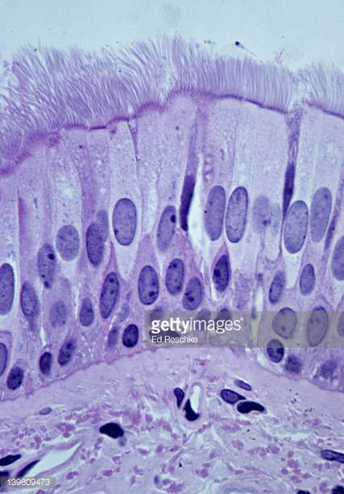
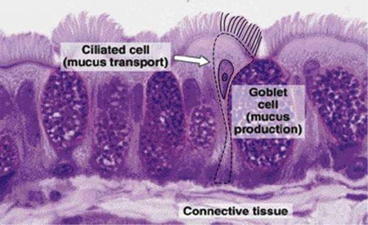
Cilia are long projecting structures, larger than microvilli, which contain internal arrays of microtubules. Most (if not all) cell types have at least one cilium of variable length, usually called a primary cilium, which is not motile but is enriched with receptors and signal transduction complexes for detection of light, odors, motion, and flow of liquid past the cells. For example, in the oviducts, cilia help to transport ova and fluid toward the uterus.
2- Stereocilia
Stereocilia are a much less common type of apical process, restricted to absorptive epithelial cells lining the epididymis and the proximal part of ductus deferens in the male reproductive system. Like microvilli, stereocilia increase the cells’ surface area, facilitating absorption. More specialized stereocilia with a motion-detecting function are important components of inner ear sensory cells.
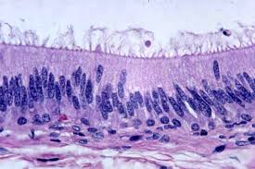
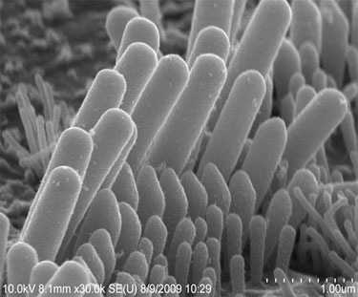
FIGURE
3- Microvilli
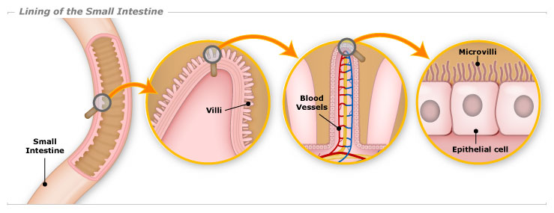
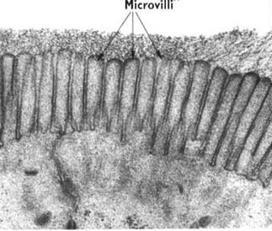
Microvilli, fingerlike cytoplasmic projections on the apical surface of most epithelial cells. Such extensions usually reflect cytoplasmic movements and activity of actin filaments and are both temporary and variable in their length, shape, and number. However, in epithelial cells specialized for absorption, the apical surfaces present an array of projections called microvilli. In cells such as those lining the small intestine, apical surfaces are densely covered with uniform microvilli, which are visible as a brush or striated border on these cells.
Types of Epithelia
Epithelia can be divided into two main groups:
- Covering (or lining) epithelia.
- Secretory (glandular) epithelia.

- Covering or Lining Epithelia
Cells of covering epithelia are organized into one or more layers that cover the external surface or line the cavities of an organ. Such epithelia are classified according to the number of cell layers and the cell morphology in the surface layer. Simple epithelia contain one cell layer and stratified epithelia contain two or more layers.

Simple epithelial tissues
Based on cell shape, simple epithelia are classified as:
1. Simple squamous is a single layer of flat cells (fusiform) in contact with the basement membrane. This type of epithelium is often permeable and occurs where small molecules pass quickly through membranes via filtration or diffusion. They are

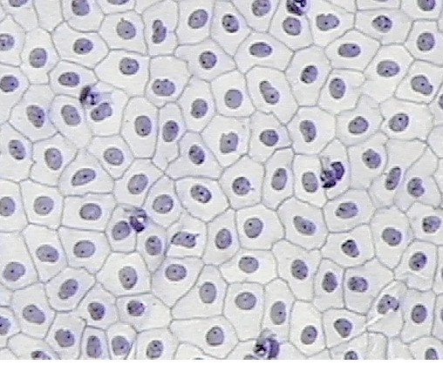
found in the Bowman’s capsule in kidney, Respiratory spaces in lung. They line the blood and lymphatic vessels (called Endothelium), ventricles and atria of the heart (called Endocardium), and line the walls and covers the contents of the closed cavities of the body (called mesothelium).

2. Simple cuboidal is a single layer of cube-like cells which have large, spherical and central nuclei. They are found on the surface of ovary, the wall of exocrine gland, kidney tubules and thyroid follicles. These cells perform secretion and absorption.
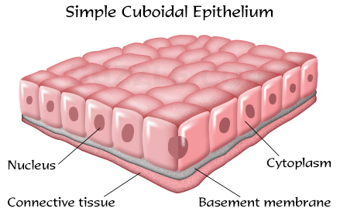

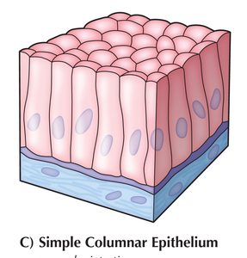
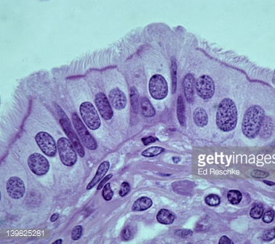
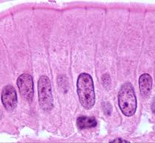
3. Simple columnar is a single layer of columnar cells. These cells have oviform and basal nuclei. Their major functions are absorption and secretion. Noncilicted Line of small intestine and colon, stomach, gastric gland, and gallbladder. Ciliated line the uterus.

4. Pseudo stratified columnar is a single layer of three cell shapes; fusiform, columnar, and basal. Some of these cells do not reach the free surface but all rest on the basement membrane. Thus, it is actually a simple epithelium. They are limited in the body such as in respiratory tract, ductus deferens and efferent ductules of epididymis. Their function is secretion and absorption.
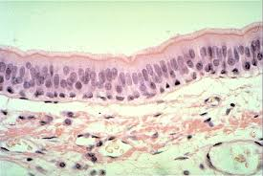
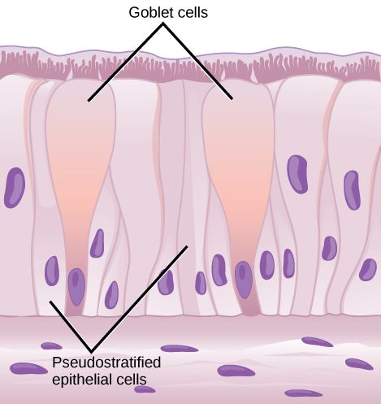
Stratified epithelial tissues
- Stratified squamous consists of squamous (flattened) epithelial cells arranged in layers upon a basal membrane. Only one layer is in contact with the basement membrane; the other layers adhere to one another to maintain structural integrity. Although this epithelium is referred to as squamous, many cells within the layers may not be flattened; this is due to the convention of naming epithelia according to the cell type at the surface. In the deeper layers, the cells may be columnar or cuboidal. There are no Inter Cellular Spaces. This type of epithelium is well suited to areas in the body subject to constant abrasion, as it is the thickest and layers can be sequentially sloughed off and replaced before the basement membrane is exposed.
- Non-keratinized Stratified squamous forms the inner lining of the mouth, esophagus, and vagina.
- Keratinized Stratified squamous surfaces are protected from abrasion by keratin and kept hydrated and protected from dehydration by glycolipids produced in the surface layer. It forms the outermost layer of the skin.

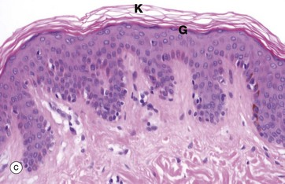
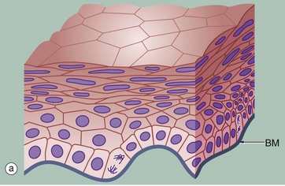
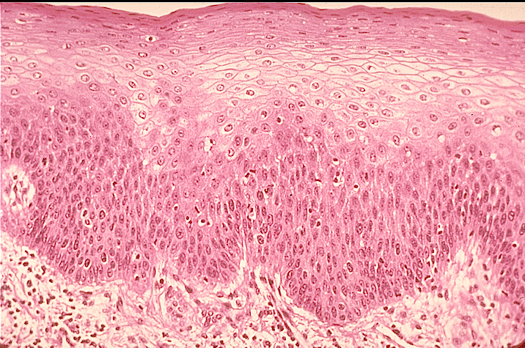

- Stratified cuboidal composed of multiple layers of cube-shaped cells. They protect areas such as the ducts of sweat, mammary, and salivary glands.
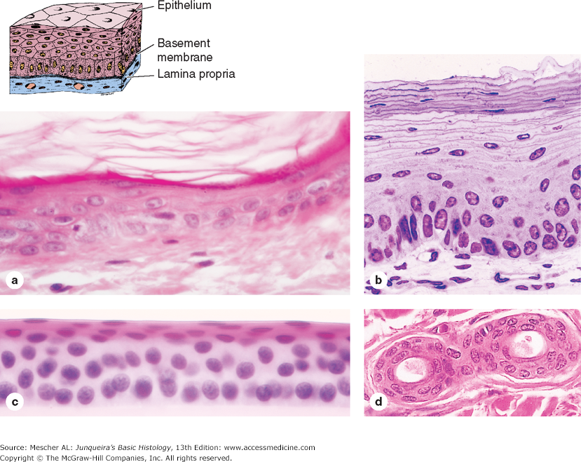

- Stratified columnar is a rare type of epithelial tissue composed of column shaped cells arranged in multiple layers. They are the ocular conjunctive of the eye. In parts of the pharynx and anus, the female’s utethra and vas deferens. Also

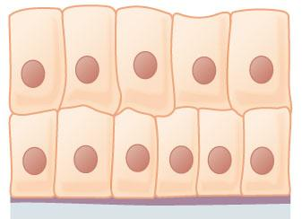
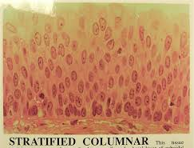
found in intralobular ducts in salivary glands. The cells function in secretion and protection.

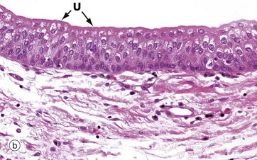
4. Transitional or urothelium is a type of tissue consisting of multiple layers of epithelial cells which can contract and expend. These cells are found in the urinary bladder, ureters, and superior urethra and gland ducts of the prostate. These cells appear to be cuboidal with a domed apex when the organ or the tube in which they reside is not stretched. When the bladder fills, the tissue actually compresses and the cells become stretched, and they appear to be flat, irregular, and squamous.
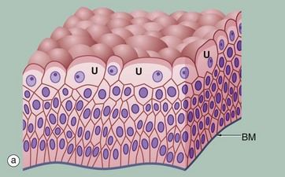

- Secretory (glandular) epithelia
Glandular epithelia are formed by cells specialized to produce secretion. The molecules to be secreted are generally stored in the cells in small membrane-bound vesicles called secretory granules. Glandular epithelial cells may synthesize, store, and secrete proteins (e.g., pancreas), lipids (e.g., adrenal, sebaceous glands), or complexes of carbohydrates and proteins (e.g., salivary glands). The mammary glands

secrete all three substances. Less common are the cells of glands that have low synthesizing activity (e.g., sweat glands) and that secrete mostly substances transferred from the blood to the lumen of the gland.

Types of Glandular Epithelia
The epithelia that form the glands of the body can be classified according to various criteria:
- Unicellular glands consist of isolated glandular cells. An example of a unicellular gland is the goblet cell of the lining of the small intestine or of the respiratory tract.
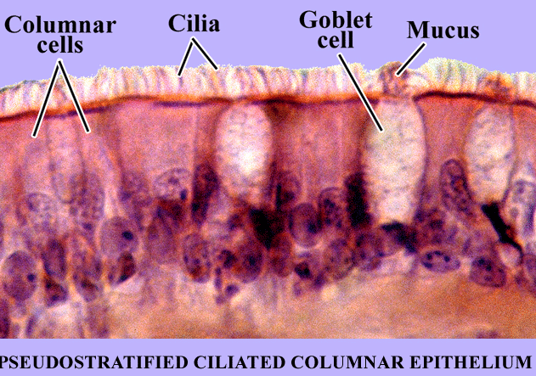

- multicellular glands are composed of clusters of cells.

According to the mechanism of secretion glans are subdivided into:
- Endocrine glands that lost their connection with the surface they originated from. These glands are therefore ductless, and their secretions are picked up and transported to their site of action by the bloodstream.
- Exocrine glands which produce secret onto the surface of the epithelium from which they originated. This connection is transformed into tubular ducts lined with epithelial cells through which the glandular secretions pass to reach the surface. Exocrine glands have a secretory portion, which contains the cells responsible for the secretory process, and ducts, which transport the secretions:
- Simple (ducts not branched) or compound (ducts with two or more branches).
Secretory portions: can be tubular (either short or long and coiled) or acinar (rounded and saclike); either type of secretory unit may be branched, even if the duct is not branched.
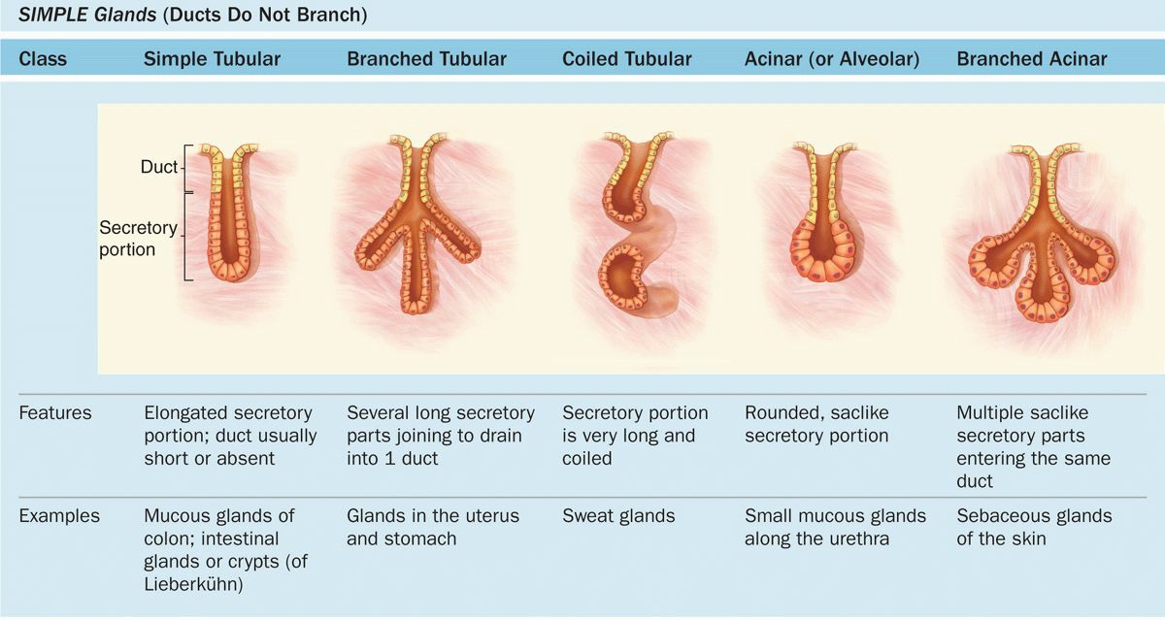

- Compound glands can have branching ducts and can have multiple tubular, acinar, or tubuloacinar secretory portions.
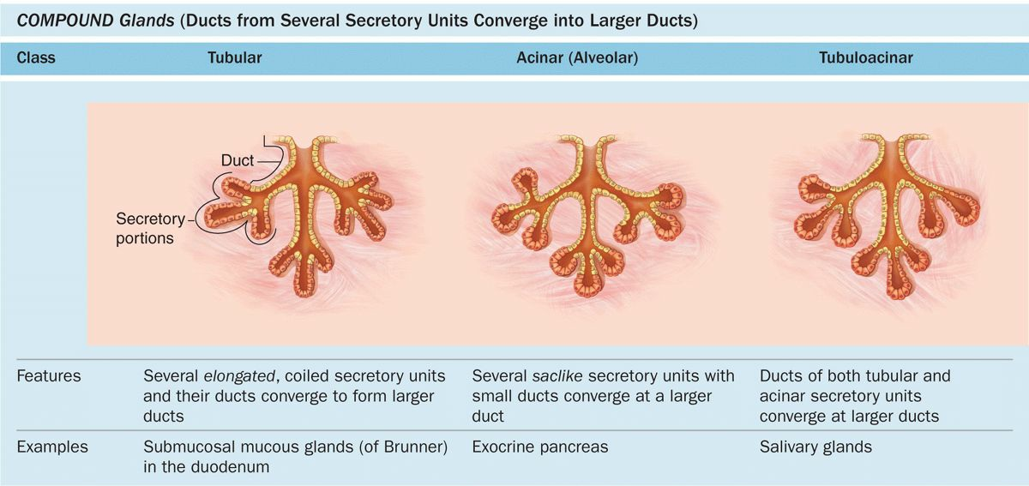

Epithelial cells in multicellular glands have three basic mechanisms for releasing their product, and cells involved in each type of secretion are easily recognized histologically:
- Merocrine secretion: This is the most common method of protein secretion and involves typical exocytosis of proteins or glycoproteins from membrane-bound vesicles.
- Holocrine secretion: In this process cells accumulate product as they mature and undergo terminal cell differentiation, culminating in complete cell disruption with release of the product and cell debris into the gland’s lumen. This is best seen in the sebaceous glands of skin.

- Apocrine secretion: Here product accumulates at the cells’ apical ends, portions of which are then extruded to release the product together with a bit of cytoplasm
and plasma membrane. This is the mechanism by which droplets of lipid are secreted in the mammary gland.
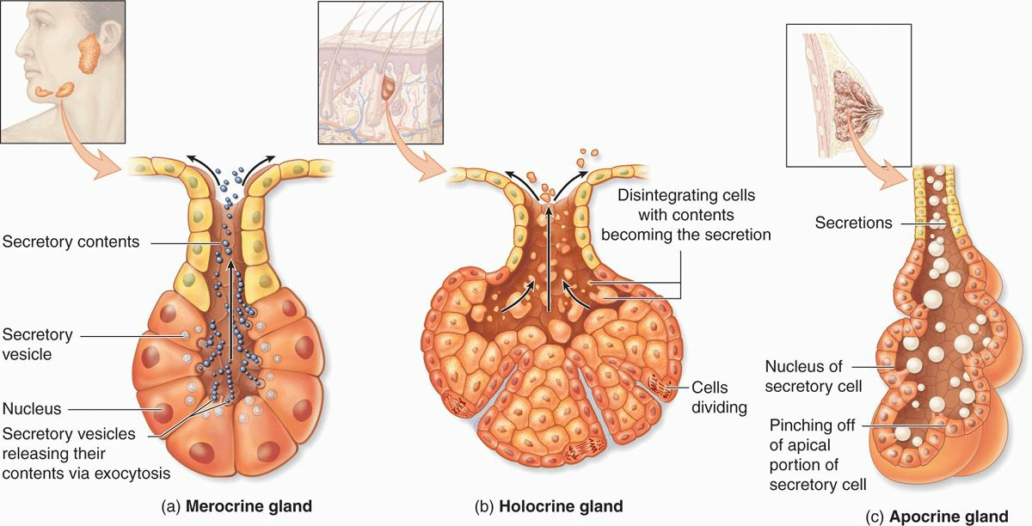

The type of secretory product of exocrine glands may also be one of three categories:
- Mucous secretion glands: the mucus are viscous and slimy. The mucus cells are pyramid like shape. Their nucli are flattened against the base of the cell by accumulated secretory products. Their cytoplasms have mucinogen granules which are water soluble and lost during routine tissue preparation. For this reason, the cytoplasm of mucus cells appears to empty in H&E-stained paraffin sections. For example, sublingual salivary glands.

- Serous secretions gland: the serous are watery. The serous cells are pyramid like shape. Their nucli are round or oval. Their cytoplasms have secretory granules which are often intensely stained with eosin. The perinuclear cytoplasm often appears basophilic because of an extensive rough endoplasmic reticulum, a characteristic of protein synthesizing cells. For example, the parotid gland and pancreas.

- Seromucous secretions gland: a gland in which some secretory cells are serous and some mucous. The serous cells surround the mucous cells which called serous demilune. The cells secrete a fluid intermediate varying between a watery and a more viscous mucoid substance. For example, submaxillary salivary glands.
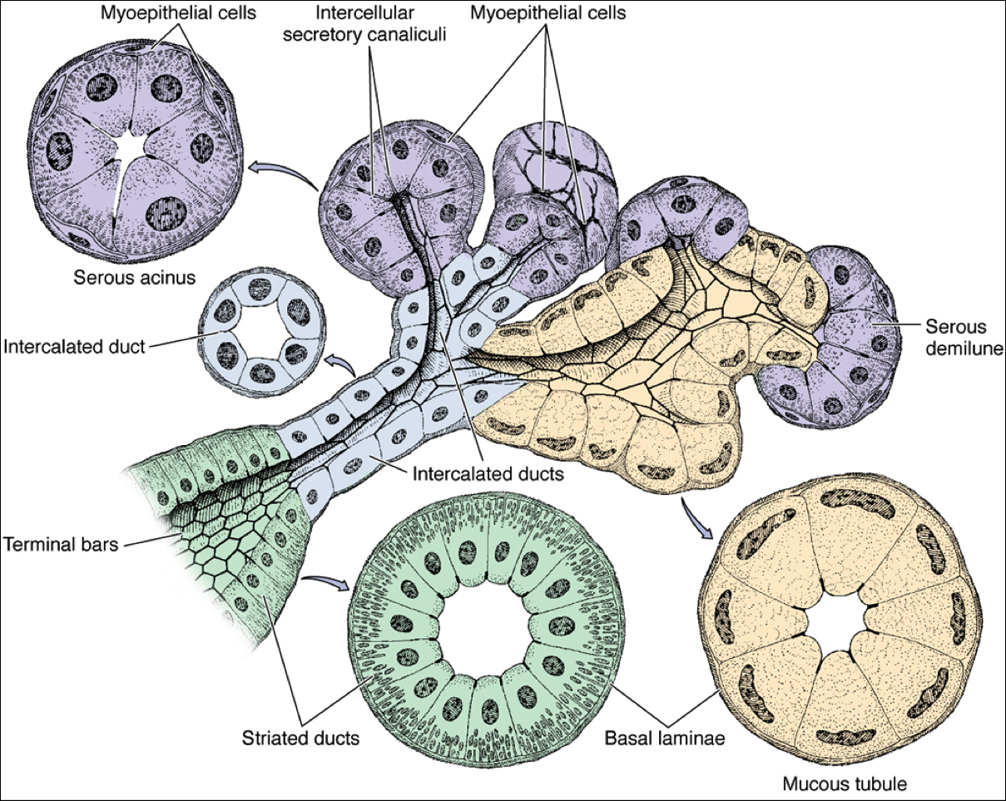

Renewal of epithelial cells
Epithelial tissues are relatively labile structures whose cells are renewed continuously by mitotic activity and stem cell populations. The rate of renewal varies widely; it can be fast in tissues such as the intestinal epithelium, which is replaced every week, or slow, as in the large glands. In stratified epithelial tissues, stem cells and mitosis occur only within the basal layer in contact with the basal lamina. In some functionally complex epithelia, stem cells are located only in restricted niches some distance from the transit amplifying cells and differentiating cells. For example, the epithelium lining the small intestine is derived completely from stem cells found in the simple glands between the intestinal villi. In the epidermis, stem cells are located at a characteristic position along the wall of hair follicles.

