Lect 4 volatile oils dr.Saba hadi
They evaporate when exposed to the air at ordinary temperatures so they are called volatile oils, ethereal oils or essential oils ,They are called essential oil because volatile oil represent the essences of plants.
Essential oils are volatile fragrant compounds obtained from plants through the process of extraction. Plant materials from seeds, roots, flowers, leaves, stems, bark, and resin can be used to extract the essential oil of the plant. Extraction can be done with fresh or dried plant material.

- How volatile oils consist
Oils consist by secondary product bio processes and collects in special vascular structures such as:
- Glandular hairs الشعيرات الغدية F. Labiateaceae العائلة الشفوية .
Ex. Mint النعناع
- Oil glands الغدد الزيتية F . Rutaceae عائلة السذبية
Ex. Citrus ( Lemon, orange).
- Oil ducts القنوات الزيتية F. Umbelliferaceae العائلة الخيمية Ex. Anise اليانسون

- PROPERTIES OF VOLATILE OILS

- High refractive index معامل الانكسار عالية
- Optically active نشط بصريا
- Immiscible with water امتزاج مع الماء
- Soluble in ethers, alcohol and most organic operties of volatile oils

- The presence of volatile oils in the plant

All are located in the part of plant or in some of its parts, such as Menthol oil resides in the leave and clove oil resides in the flowers and oil anise زيت اليانسون in seeds either cinnamon oil زيت الدارسين resides in the bark.

- Physiological functions of the volatile oils for plant
1. attract insects, which helps to pollinate the flowers and increase production.

- Some volatile oils works to repel insects for the defense plant, some plants have volatile oils unpleasant smell.

- The removal of products biological processes and put out tissue plant.
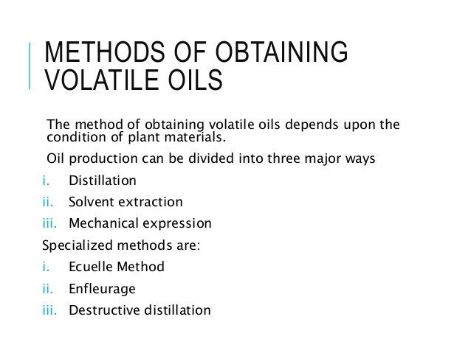
ECUELLE METHOD : It is used to obtain citrus oils
ENFLEURAGE : In this method, an odorless fixed oil or fat is spread in a thin layer on glass plates
DESTRUCTIVE DISTILLATION : Organic substances such as wood or resin
- Medical use
- used medically expelling the gases eliminates the pain of colic and bloating in children تستعمل طبيا كطاردة للغازات فيزيل الآم المغص والانتفاخ عند الاطفال
- used in some medicines kids and give taste and smell acceptable such as anise, peperment oil تستعمل في بعض ادوية . الاطفال لاعطائها طعما ورائحة مقبولة لديهم مثل زيت اليانسون والنعناع - 3- used as a spice for foods such as oil cumin and cardamom, nutmeg and other تستخدم كتوابل للاطعمة مثل زيت الكمون والهيل وجوزة الطيب وغيرها
- . Some of the volatile oils are used as a disinfectant, such as thyme بعض الزيوت الطيارة تستخدم كمواد مطهرة مثل الزعتر
- Some volatile oils have anti fungi and bacteria.

- Some volatile oils used to remove dental pain and gums such as clove oil,Eugenol one of the most important compound clove oil بعض الزيوت الطيارة تستخدم لازالة الام الاسنان واللثة مثل زيت القرنفل احد اهم مركبات زيت القرنفل

- Some of volatile oils used as a repellent expectorant such as eucalyptus oil تستخدم بعض الزيوت الطيارة كمادة طاردة للبلغم مثل زيت اليوكاليبتوس

- Some considered laxative such as anise oil بعضها تعتبر ملينة مثل زيت اليانسون

- CHEMISTRY of volatile oils

Chemical constituents of volatile oil may be classified into two groups. a. Terpenes b. Phenylpropanoids
- TERPENES

- Natural products whose structures may be divided into isoprene units.
- These units arise from acetate via mevalonic acid.
- These are branched chain 5 carbon units containing 2 unsaturated bonds.
- Made up of head to tail condensation of isoprene units. If i. 1 isoprene unit present= hemiterpene (C5H8) . 2 isoprene unit present= monoterpenes (C10H16) . 3 isoprene unit present= sesquiterpene (C15H24) . 4 isoprene unit present= diterpene (C20H32) . 5 isoprene unit present= triterpene (C25H48) Majority of the terpenes are monoterpenes in volatile oils.

B . PHENYLPROPANOIDS
- They are formed via shikimic acid phenylpropanoid route These compounds contain phenyl ring with an attached propane side chain.
- Many of the Phenyl propanoids found in volatile oils are phenols or phenol ethers.

- CLASSIFICATION OF VOLATILE OILS

1. Hydrocarbon volatile oils
2. Alcoholic volatile oils
3. Aldehydic volatile oils
4. Ketonic volatile oils
5. Phenolic volatile oils
6. Phenolic ether volatile oils
7. Oxide volatile oils
8. Ester volatile oils
9. Miscellaneous volatile oils زيوت طيارة اخرى

- DIFFERENCE BETWEEN VOLATILE OIL AND FIXED OIL Volatile oils

