- Flavonoid lect 5
Flavonoids (or bioflavonoids) (from the Latin word flavus meaning yellow, their color in nature) are secondary metabolite products from the phenyl propanoid biosynthetic pathway found in all plants they are a diverse group of phytochemicals non – nitrogenous plant pigments, exceeding four thousand in number Examples of flavonoids are beta carotene ( luteolin, zeaxanthin, crypto xanthin, quercetin). Alpha –carotene (capsanthin, Anthocyanins, Hesperidin). Lycopene (catechins, Rutin, and Reseratrol).
Example of dietary flavonoid sources include:
Tea: Green, white or black tea are a rich source of flavonoids, especially flavonols (catechin, epicatechin, epigallocatechin, epicatechin gallate). Tea is a good source of quecertin.
Onions: The major flavonoid in onions is quercetin. Other flavonoids in onion are kaempferol and myricertin.
Honey: Depending on the flower type the bees feed on, honey contains myricertin, and quercetin.
Other dietary flavonoid sources are beans, spinach, buckwheat, strawberry, blueberry, rooibos plant. The concentration and composition of flavonoids in plants may vary depending on the growing condition, maturity, plant part, and variety.
- Classification of flavonoids
Flavonoids belong to a large group of phenolic plant constituents they are presented
as derivatives of 2-phenyl-benzo-γ-pyrone.
Due to the differences in the structure of flavonoid compounds, flavonoids are classified:
- Flavanols.
- Flavanones.
- Flavonols.
- isoflavones,
- flavones and anthocyanins.
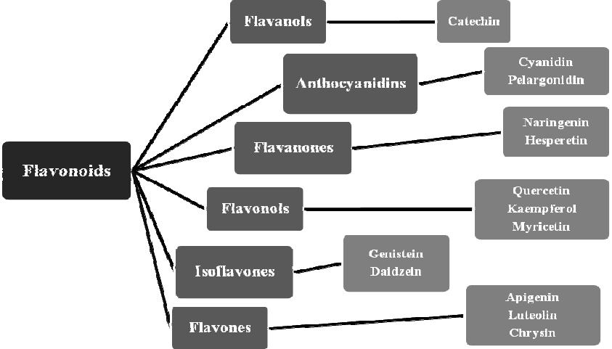 Distribution of flavonoids commonly occurring in plants.

- Use flavonoids
Beneficial effects of flavonoids on human health are partly explained by their antioxidant activity. because of the antioxidative property, it is suggested that flavonoids may delay or prevent the onset of diseases (such as cancer) induced by free radicals.
They also inhibit low density lipoprotein (LDL) oxidation by free radicals. Flavonoids have been reported to have negative correlation with incidence of coronary heart disease. Furthermore, flavonoids have anti-bacterial, anti-viral, anti-tumor, anti-inflammatory, antiallergenic, and vasodilatory effect. They also inhibit platelet aggregation.

- Flavonoids properties

- Flavonoids are crystallic substances with certain melting point.
- Many varieties of color in flower depend on the medium example :Acidic conditions provides strong red colours , alkalaine medium blue colour, natural environment provides the violet.
- Flavonoid glycosides are soluble in diluted alcohols and hot water. Aglycones are, for the most part, soluble in apolar organic solvents: when they have at least one free phenolic group, they dissolve in alkaline hydroxide solutions. Flavonoid aglycones soluble in diethylaether, acetone, alcohols, almost are insoluble in water.

- Function of Flavonoids in plants
Flavonoids play a variety of roles in plants. Below are some of their important functions:
Plant-microorganism interactions : Flavonoids play roles as signal molecules, phytoalexins, detoxifying agents, and stimulants for germination of spores. Flavonoids may have defensive or stimulant role depending on the microorganisms role in the plant.
Pigments : Anthocyanins give the colors of flowers, fruits, and leaves of plants.
Flavor : Flavonoids are among an array of the chemicals in plants that give the rich taste of plant products. The flavor may act as repellant or attractant to microorganisms or pests or pollinators.
Flavonoids are powerful antioxidants and scanvengers of free radicals. Free radicals cause cellular, and DNA damage in our body and consequently induce age-related diseases suchs as dementia and cancer.

