Aquatic Invertebrate
LAB (1)
Phylum: protozoa (protista)
1-Sub phylum: Sarcomastiqophora
Class: Cryptophyceae
Order: Cryptomonadina
Genus: Chilomonas
2-Sub phylum: Ciliophora
A-Class: Gymnostomatea
Order: Pleurostomatida
Genus: Litonotus
B-Class:Heterotrichea
Order: Heterotrichida
Genus: stentor
3- Sub phylum: Ochrophyta
A-Class: Antinochrysophceae
Order: Actinophryida
Genus: Actinosphaerium
B-Class:Granuloreticulosea
Order:Foramlniferida
Genus: Globigerina

4-Sub phylum: Bryozoa
Class: Gymnolaemata
Order: Cheilostomata
Genus: Bugula

Genus: Chilomonas

-Unicellular organism
-The apex is shifted to the left side
-Two equal flagella for locomotion
- One nuclus in the posterior part
- Cytoplasm includes pyrenoid and starch
- One contractile vacuole is found in the apex of the cell
(for regulation of osmotic pressure)

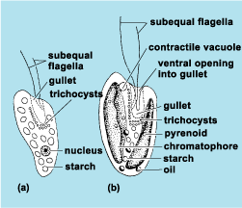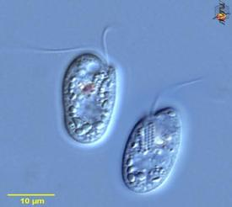
Chilomonas
Genus: Litonotus

-Predatory ciliate
-Highly elongated body with anterior neck
- Mouth located alongthe anterior margin
-Macronucleus commonly in two spherical parts with single micronucleus between the two
-One to several contractile vacuoles in the posterior part

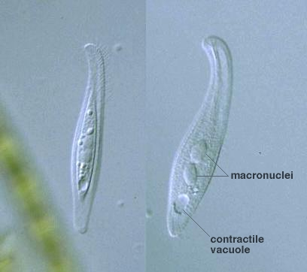

Litonotus

Genus: stentor

-Rapid contractile body with trumpet shaped
-Pristome wide with adomed central area
-Macronucleus moniliform with 10-20 beads
-Multiple ciliary membranelles spiraling around the regin that leads to the mouth ,it uses these cilia to sweep food particles into its cytostom.
-Usually attach to substrates by posterior thin stalk

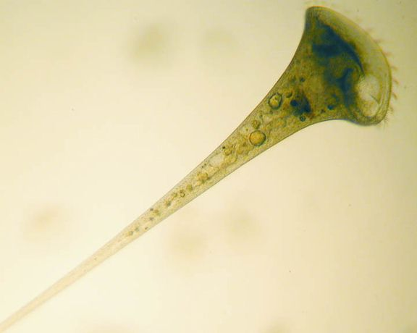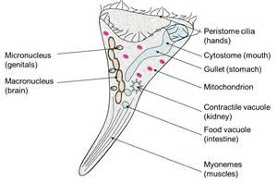

stentor

Genus: Actinosphaerium

- Spherical body with many pseudopods called axopodia
(to capturing prey and protection from predators)
-Axopodia end in the inner zone of ectoplasm
-Ectoplasm consists large vacuoles in one or several layers for floatting
- Endoplasm with numerous small vacuoles and nuclei

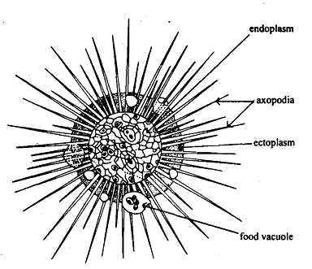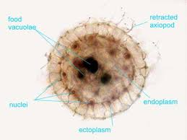

Actinosphaerium

Genus: Globigerina

- Globose chambers
- Having rounded shell with pores
- Shell made of calcareous with numerous spiny process

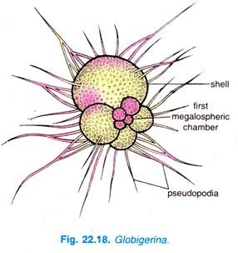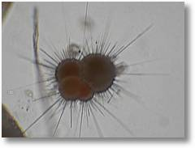

Globigerina

Genus: Bugula

- Flexible bushy branching colonies reddish or brown in colour
- The individuals in colony are called zooids (white and globular)
- Zooids consist of soft parts called the polypide enclosed in a rigid box called the zooecium

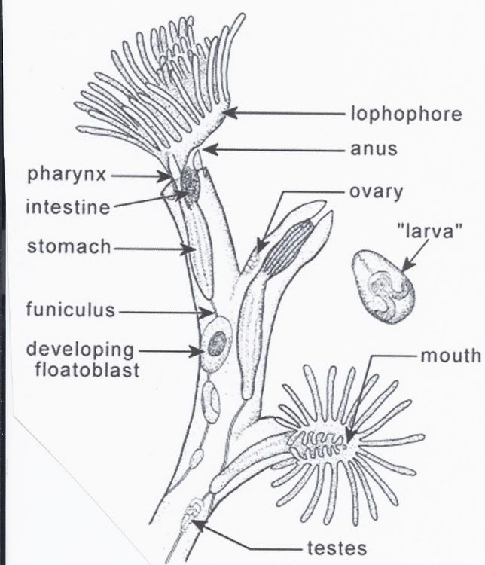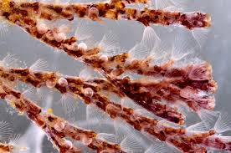

Bugula

