Aquatic Invertebrate
LAB (2)
Super phylum: Aschelminthes
Phylum : Rotifera (rota :wheel , fera :to bear)
A-Class:Digononta
Order: Bdelloidea
Family: Philonidinidae
e.x. Philodina sp.
B-Class:Monogononta
1-Order: Ploima
Family: Brachionidae
e.x. Brachionus sp.
2- Order: Flosculariacea
Family: Filiniidae
e.x. Filinia longiseta
3- Order: collothecacea
Family: collothecidae
e.x. Collotheca sp.

General characteristics of Rotifera
-Triploblastic ( ectoderm , mesoderm , endoderm )
- Bilateral symmetrical ( both sides of the body are the same )
- Pseudocoelomate (has a body cavity but it is not lined by mesoderm)
- Unsegmented body consist of three part head,trunk and foot
- The head carries the rotator ciliated organ called corona ( for locomotion and feeding) and Posterior end with toes
- Complete digestive system (with mouth and anus)
- Pharynx equipped with movable chitinous jaws (mastax)to grind ingested food particles in to smaller
- body covering with an external flexible thick cuticle layer called (lorica) for protection
- Osmoregulation through Protonephridia
- Parthenogenesis common – reproduction from unfertilized eggs
- Respiratory and circulatory system are absent
- Nervous system has circular brain and paired of longitudinal nerve cords
A-Class:Digononta
- Free swimming
- Paired ovaries in female
- Foot with two toes (forked tail)
- Corona with two circular lobes with cilia
- Mastax ramate
- No lorica
- Parthenogenetic only
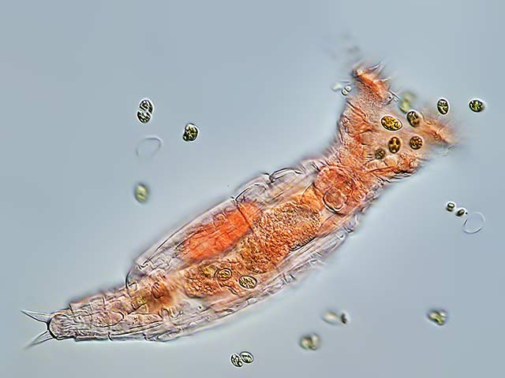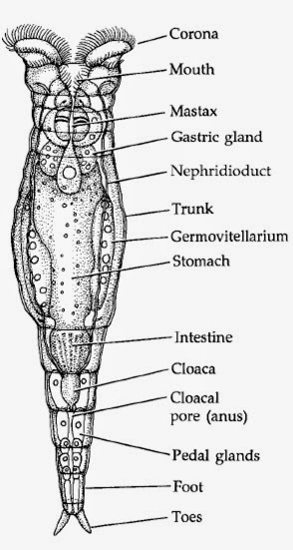
Philodina sp.
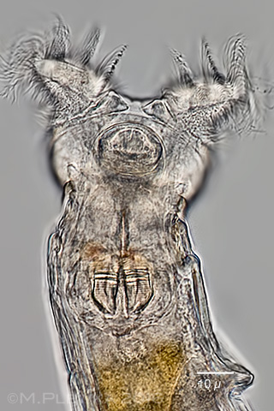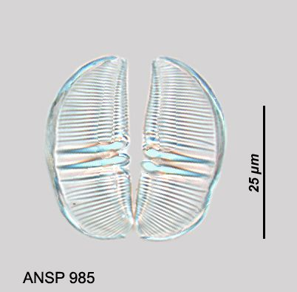
Philodina sp.(head ) mastax
B-Class:Monogononta
- Free swimming or sessil
- Single ovary in female
- Foot present or absent – toes variable
- Corona usually a single ciliated disk
- Mastax not ramate
- Lorica present or absent
- Mostly dioecious males are usually small

e.x. Brachionus sp.
-Free swimming
- Short and broad shape
-corona bear spines surrounding anterior end to captured prey

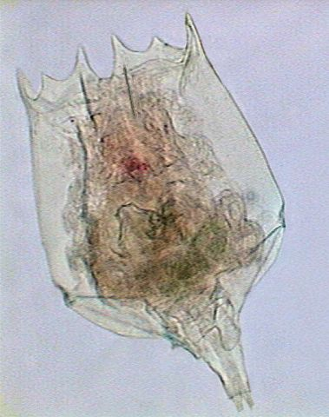
Brachionus sp.
e.x. Collotheca sp.
- sessil singly or colonies to substrate
- long with funnel shape
- Very large corona with cilia

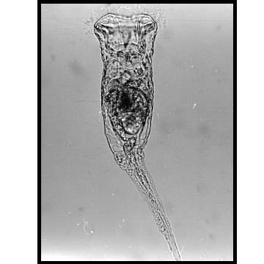
Collotheca sp.

e.x. Filinia longiseta
- Free swimming
- lack foot and toes
- Bears two lateral bristles and caudal bristle for swimming

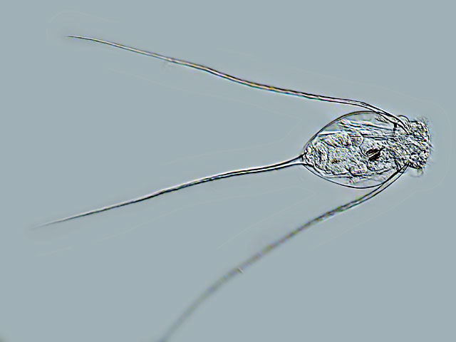
Filinia longiseta

