Aquatic Invertebrate
LAB(4)
Phylum : Mollusca
1- Class : Polyplacophora Order : Chitonida
Genus : Acanthochitona
2- Class : Aplacophora Order :Neomeniamorpha
Genus : Neomenia
3- Class : Monoplacophora Order : Tryblidiida
Genus : Neopilina
4-Class : Gastropoda Order : Pulmonata
Genus : Helix
5- Class : Bivalvia Order : Eulamella branchia
Genus : Anodonta
6- Class : Scaphopoda Order : Dentaliida
Genus : Dentalium
7- Class : Cephalopoda Order : Dibranchiata
Genus : Octopus

Genus : Acanthochitona
- Dorsoventral flattened body
-Dorsal surface bears eight articulating plates
-The mantle forms a girdle around the margen of the plates
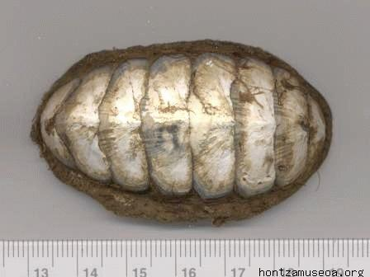
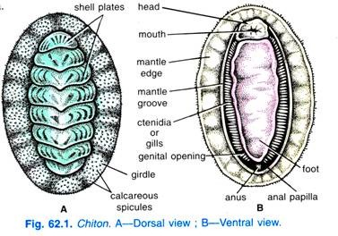
Acanthochitona
Genus : Neomenia
The body worm shaped bears numerous calcareous scales embedded in cuticle , there is no true shell

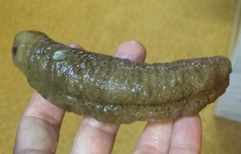
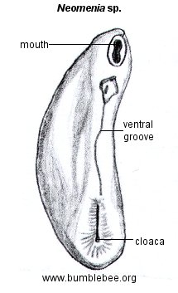
Neomenia

Genus : Neopilina
-Single round shell and a creeping foot
-Five pairs of gills in ventral surface

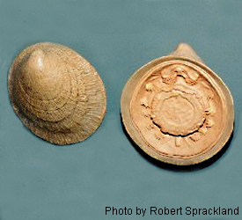
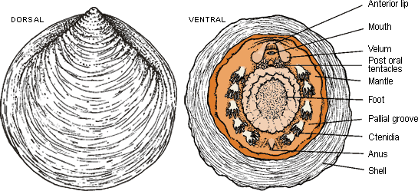
Neopilina

Genus : Helix
-Univalve coiled shell
-Head with two pairs of tenticales , the upper and larger pair contain the eyes and the lower pair used for feeling
-Mouth have scraping tongue called radula that is composed of many fine chitinous teeth for rasping and catting food
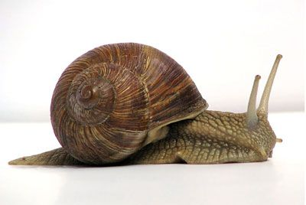
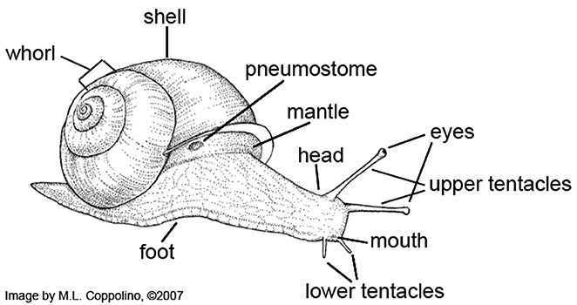
Helix
Genus : Anodonta
-Shell with two valves held together dorsally by a hinge ligament
-Umbo is the oldest part of the shell and growth occurs in concentric lines around it
-Posterior margen forming siphons for respiration
- No head and radula
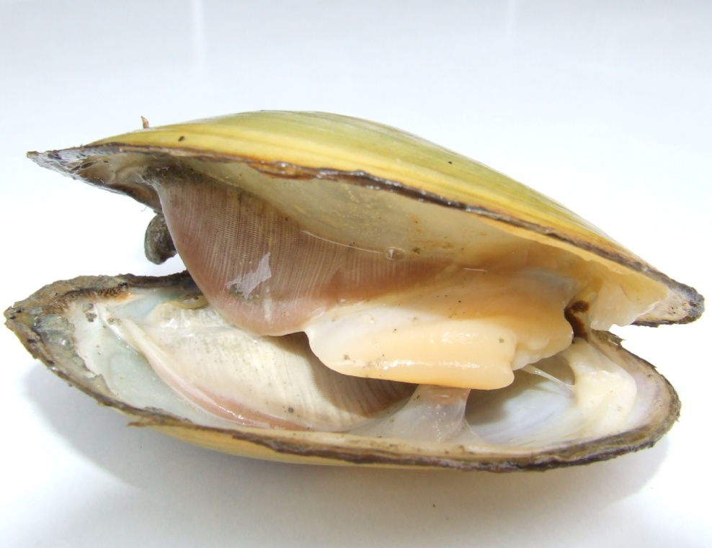
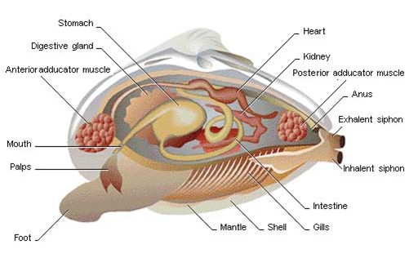
Anodonta
Genus :Dentalium
- Conical and curved white shell like elephant’s tusk . they are hollow and open at both ends
-The foot extends from the larger end of the shell used to burrow through the mud or sand, while leaving the small end exposed to the water above
-Long tentacles extending from the head near the mouth for feeding

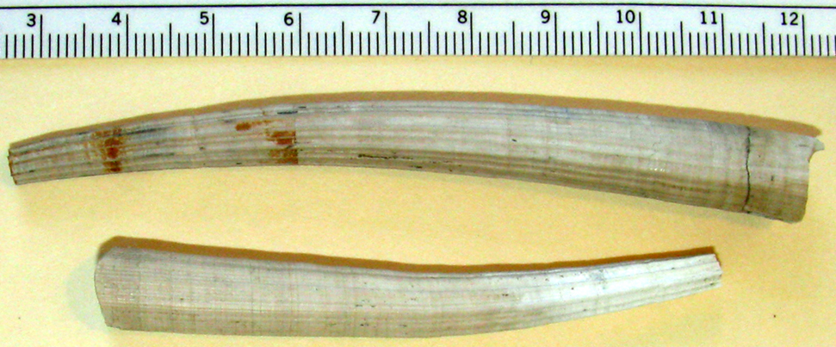
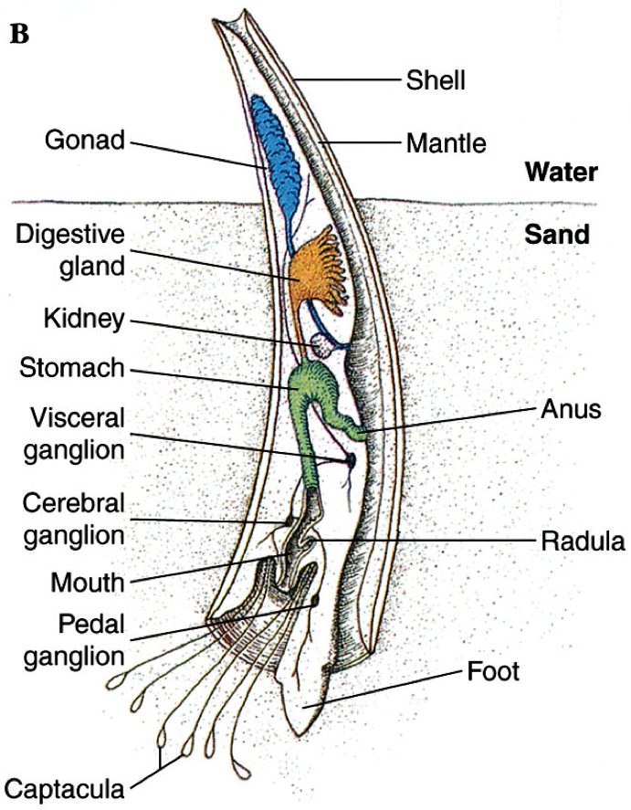
Dentalium
Genus : octopus
- Globe shaped head with two eyes and four pairs of arms
-Has a sharp peak with its mouth at the center point of the arms
-Two rows of suckers line there tentacles
-No internal or external skeleton
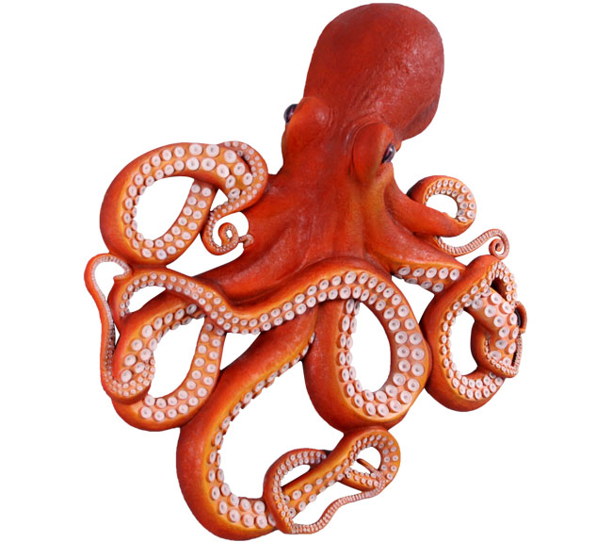
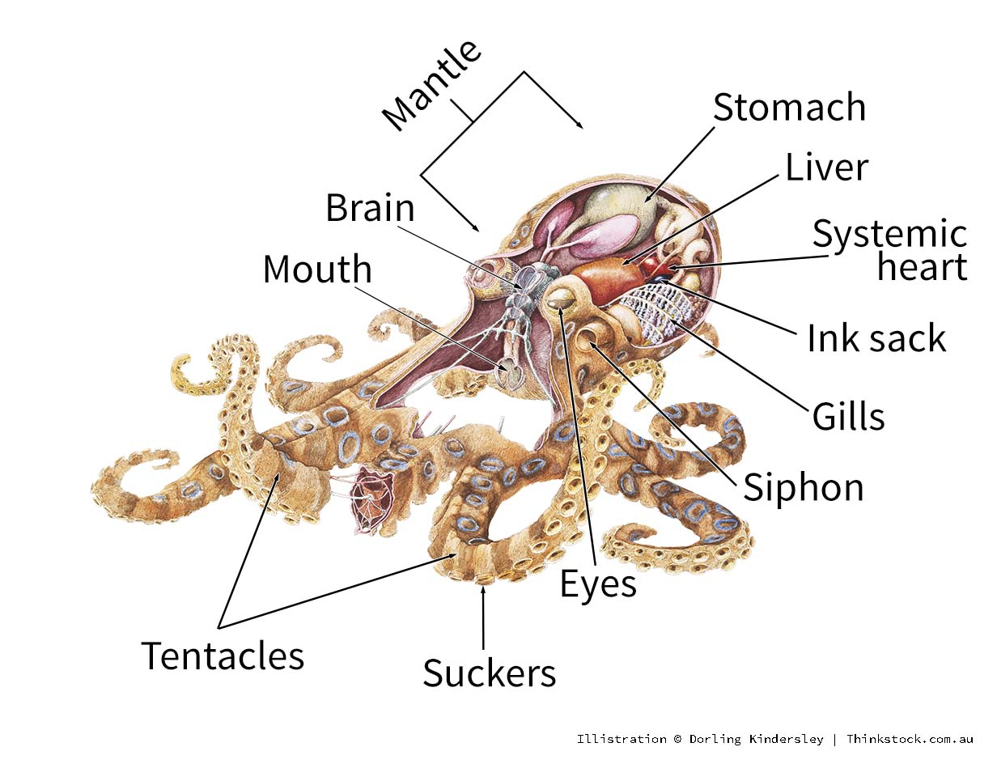
octopus

