Aquatic Invertebrate
LAB(5)
Phylum: Arthropoda
Subphylum: Crustacea
1-Class: Branchiopoda
Order: Cladocera
Genus: Daphnia
2-Class: Maxillopoda
Order: Cyclopoida
Genus: Cyclops
3-Class: Malacostraca
Order: Decapoda
Genus: Cambarus

Genus: Daphnia (water fleas)
-Jerky swimming movements
- Transparent and kidney shaped body enclosed by carapace made of chitin and polysaccharide
- Head have a single large compound eye and two pairs of slightly branched antennae
-Body including (4-6)pairs of thoracic appendages for feeding and respiration
-Abdomen have two large claws used for cleaning
-Males smaller size than female , larger antennules and first legs which are armed with hook used in clasping
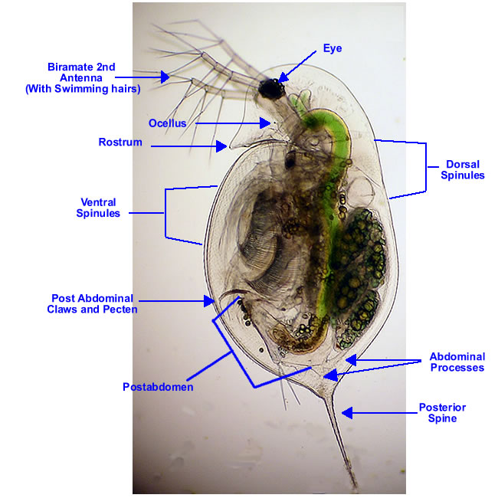
Daphnia
Genus: Cyclops
- Single eye in the middle of its head with two pairs of antennae
-The brodly oval front section comprises the head and the first five thoracic segment with five pairs of legs
-The hind part is slimmer and made up of the sixth thoracic segment and four legless pleonic segment
-Two caudal appendages project from the rear called furca
-Males used the long two first legs for gripping the females during mating
-The females carries the eggs in two small sacs on her body

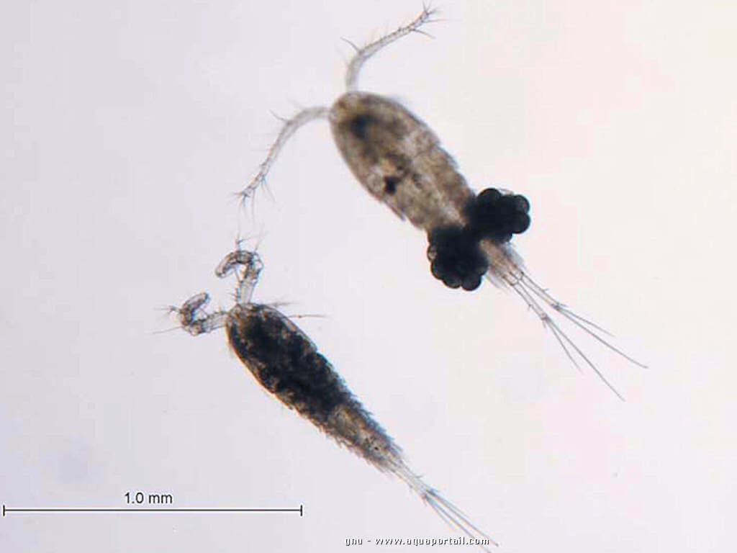
Cyclops
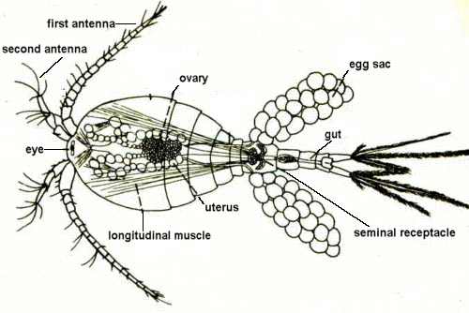

Genus: Cambarus (crayfish)
- Body is divided into three regions: head,thorax and abdomen
-Head and thorax covered by a carapace
- Head bears large stalked compound eyes , two pairs of antennae for sensory and three pairs of smaller appendages for feeding or respiration
-Thoracic segments bears five pairs of walking legs called (pereopods) the first three pairs claw bearing for feeding and defense
- Abdominal segments bears six pairs of appendages .the first five pairs called (pleopods) for swimming or respiration . the last pair flat appendages called (uropods) forming a tail

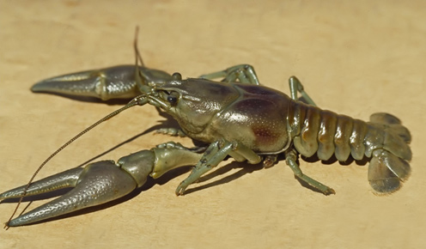
Cambarus

