Aquatic Invertebrate
LAB (6)
Phylum : Arthropoda
Sub phylum : Chelicerata
1-Class : Merostomata
Order : Xiphosura
Genus : Limulus sp.
2-Class : Pycnogonida
Order : pantopoda
Genus : Nymphon sp.

Sub phylum : Chelicerata
- head lack antennae and mandibles
-the body is divided into two region : ananterior cephalothorax (prosoma) and a posterior abdomen (opisthosoma)
- prosoma have two anterior appendages before the mouth called chelicerae and pedipalp for feeding and four pairs of walking legs
Subphylum: Crustacea
- head with two pairs of antennae and one pair of mandibles
- Body is divided into three regions: head,thorax and abdomen
- Thoracic segments bears five pairs of walking legs
Genus : Limulus (horseshoe crab)
-The body is divided into an anterior cephalothorax protected by a hard dorsal carapace and posterior abdomen with long straight tail called telson
-It has two compound lateral eyes and seven secondary simple eyes , five eyes on top of its shell and two eyes on the underside
-The mouth is located in the center of the second pair of legs
-Has five pairs of legs for walking , swimming and moving food in to the mouth, each with a claw at the tip except for the last pair
-Underside of the abdomen have six pairs of gill book for respiration

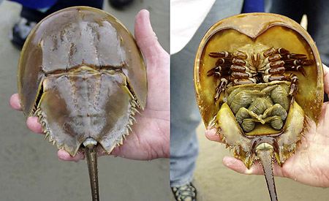

Limulus

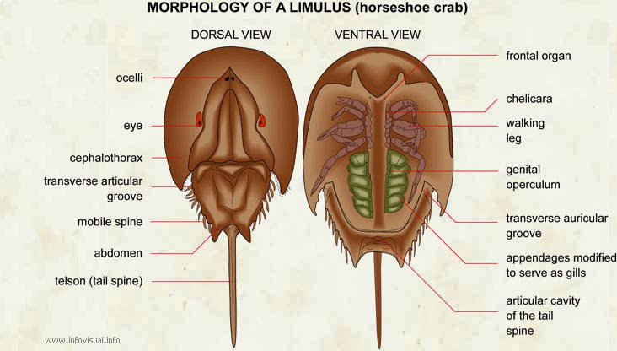

Genus : Nymphon sp. (sea spider)
-small and thin bodies with four pairs of long walking legs posterior to the pair of chelicerae and pair of palps
-the head bears a posterior pair of ovigers used by male to carry fertilized eggs
-head with sucking mouth that opens at the tip of elongated proboscis and four simple eyes
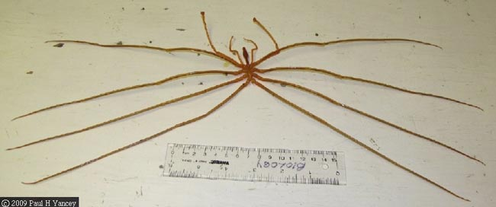

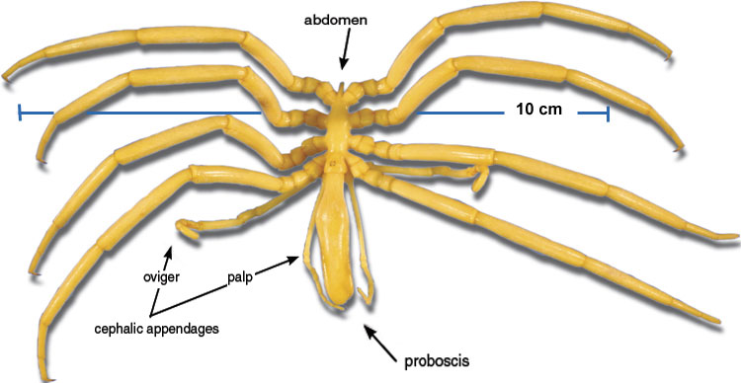
Nymphon sp.

