Aquatic invertebrate
LAB (7)
Phylum : Tardigrade
1-Class : Eutardigrada
2-Class : Heterotardigrada
3-Class : Mesotardigrada

General Charectors
-Slow walking animals commenly called (water bears)
-Barrel and unsegmented body range from (0.5 -1) mm in length
- Trunk bears four pairs of short unjointed legs with four to eight claws
- Body covered by cuticle
-Tubular sucking mouth armed with sharp stylets
-No circulatory or respiratory systems, gas exchange occurring through the body surface
-Nervous system with brain and double ventral nerve cord

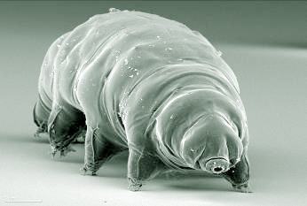

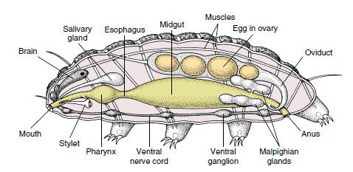

Phylum : Ectoprocta ( Bryozoa )
1-Class : Gymnolaemata (marine bryozoa)
2-Class : Phylactolaemata (fresh water bryozoa)

General Charectors :
- Commonly called moss animals
-Sessile colonies have individuals branching called zooids
-Gut is u shapped with mouth inside the crown of tentacles (lophophore ) and the anus outside it
-Body enclosed by calcareous or chitinous box
-Zooids are hermaphrodites
-Have avicularia a beak like structure for protective function
