Aquatic invertebrate
LAB(8)
Phylum : Hemichordata
Class : Enteropneusta
Genus : Saccoglossus
Phylum : Chordata
1-Subhylum : Urochordata
Class : Ascidiacea
Order : phlebobranchia
Genus : Ascidia
2-Subhylum : Cephalochordata
Class : Leptocardii
Order : Amphioxiformes
Genus : Branchiostoma

Saccoglossus ( corn worm )
-the body divided into an anterior proboscis , an intermediate collar and posterior trunk .
-the mouth is located between the proboscis and the collar
- proboscis is muscular organ used in locomotion and collection food particles
-trunk is longest part contains the pharynx which is perforated with gill slits
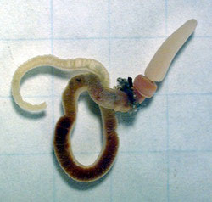

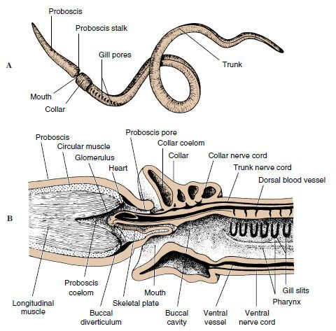
Ascidia (Sea squirt)
- sac like body structure with two tubular opining (incurrent siphon and excurrent siphon )
-body wall is covered by a smoth thick tunic consists of cellulose

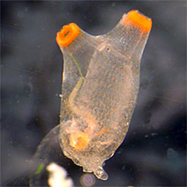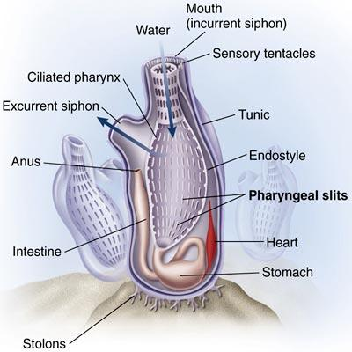

Branchiostoma
