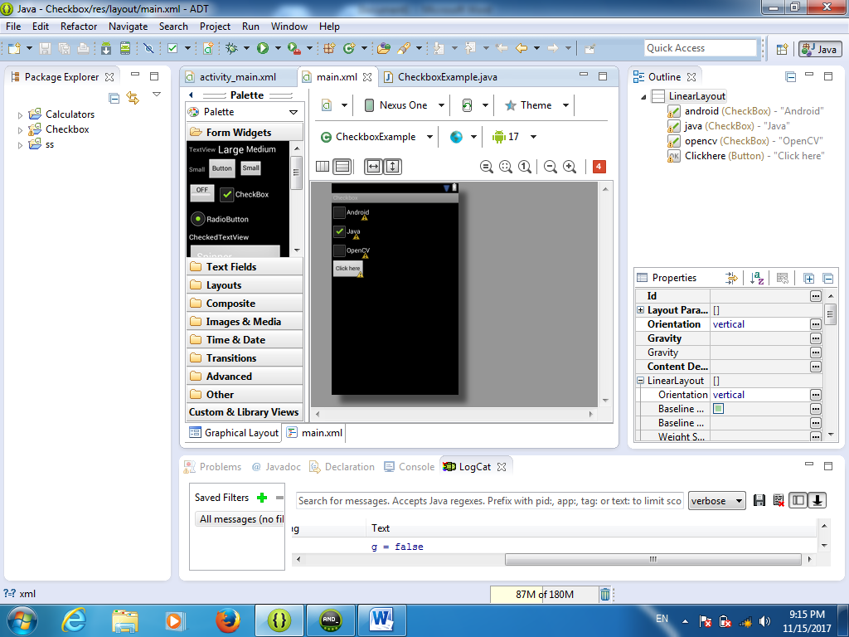

<?xml version="1.0" encoding="utf-8"?>
<LinearLayout xmlns:android="http://schemas.android.com/apk/res/android"
android:layout_width="fill_parent"
android:layout_height="fill_parent"
android:orientation="vertical" >

<CheckBox
android:id="@+id/android"
android:layout_width="wrap_content"
android:layout_height="wrap_content"
android:text="Android" />

<CheckBox
android:id="@+id/java"
android:layout_width="wrap_content"
android:layout_height="wrap_content"
android:text="Java"
android:checked="true" />

<CheckBox
android:id="@+id/opencv"
android:layout_width="wrap_content"
android:layout_height="wrap_content"
android:text="OpenCV" />

<Button
android:id="@+id/Clickhere"
android:layout_width="wrap_content"
android:layout_height="wrap_content"
android:text="Click here" />

</LinearLayout>
Code of java
package com.androidexample.checkbox;

import android.app.Activity;
import android.os.Bundle;
import android.view.View;
import android.view.View.OnClickListener;
import android.widget.Button;
import android.widget.CheckBox;
import android.widget.Toast;

public class CheckboxExample extends Activity {
private CheckBox android, java, opencv;
private Button Clickhere;
@Override
public void onCreate(Bundle savedInstanceState) {
super.onCreate(savedInstanceState);
setContentView(R.layout.main);
android = (CheckBox) findViewById(R.id.android);
java = (CheckBox) findViewById(R.id.java);
opencv = (CheckBox) findViewById(R.id.opencv);
Clickhere = (Button) findViewById(R.id.Clickhere);
Clickhere.setOnClickListener(new OnClickListener() {
@Override
public void onClick(View v) {
// Create string buffer to
StringBuffer OUTPUT = new StringBuffer();
OUTPUT.append("Android : ").append(android.isChecked());
OUTPUT.append("\nJava : ").append(java.isChecked());
OUTPUT.append("\nOpenCV :").append(opencv.isChecked());

Toast.makeText(CheckboxExample.this,OUTPUT.toString(),
Toast.LENGTH_LONG).show();
}});}}

