Industrial microbiology:-
is a branch of applied microbiology which processing of materials by microorganisms (such as fungi, bacteria, algae) or plant and animal cells are used in industrial processes; for example, in the production of various useful end products such as drugs, baking, production of alcohol for beverages, and in fuel production (gasohol). Additional groups of microorganisms form products that range from organic acids to enzymes used to create various sugars, amino acids, and detergents. For example, the sweetener aspartame is derived from amino acids produced by microorganisms.
Areas of industrial microbiology include :- the foods, pharmaceutical, and chemical industries.
- First microorganism is used in the industry :
- Yeasts are :-1) eukaryotic unicellular microorganisms. 2) classified as members of the fungus kingdom . 3) Yeasts are connected budding cells known as pseudohyphae or false hyphae. 4) its largest of the bacteria and youngest from the fungi Yeast sizes. :-typically measuring 3–4 µm in diameter. Most yeasts reproduce asexually by mitosis known as budding.
- yeast species either require oxygen for aerobic cellular respiration or are anaerobic.
- Yeast needs moisture , food & warmth to grow. A carbohydrate food source such as molasses is required for reproductive yeast growth .
- Yeast will be appear as large oval or round cells dark blue or violet by crystal violet .
Molasses is a byproduct of sugar beet & sugar cane , supplies the least expensive source of sucrose , glucose & fructose , in addition to (nitrogen , phosphate , sodium carbonate ) small amounts of minerals .
Nitrogen is supplemented using ammonia or ammonium salts
Sodium carbonate as processing aids for PH control.
Oxygen to enhance yeast growth.
Examples of Commercial yeasts:

1. Saccharomyces cerevisiae = Baker's yeast & Nutritional supplements(B-complex vitamins).

2-Saccharomyces pastorianus=Saccharomyces carlsbergensis to production of beer( Alcoholic beverages).

3- Saccharomyces bayanus & Saccharomyces uvarum are used in winemaking and cider fermentation.

4- Saccharomyces boulardii as Probiotic.

5-Candida utilis =Torula to used as a flavouring in processed foods .
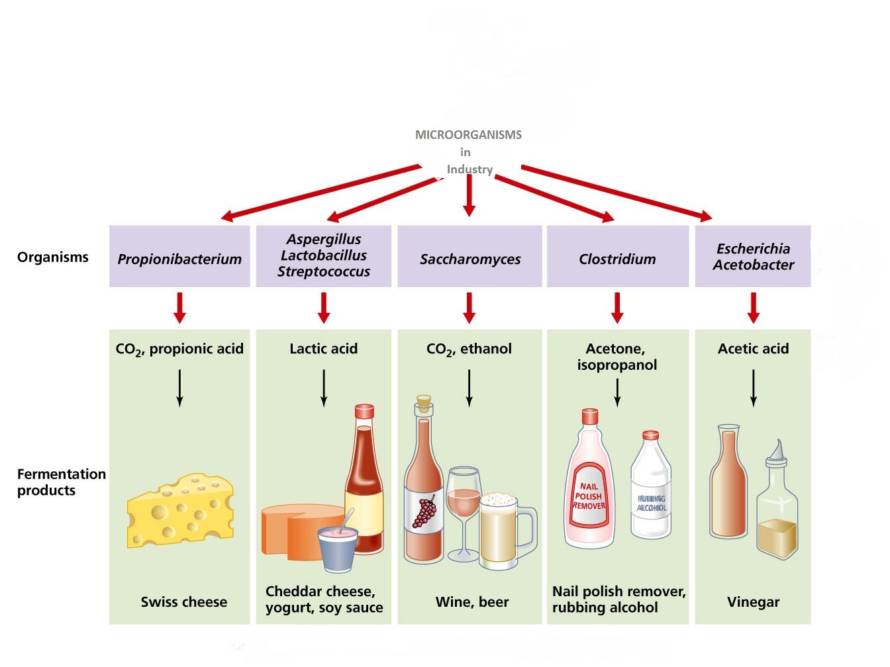
Figure 1 : Uses the microorganisms in industry .
Special media for the growth of yeasts:-
1-malt extract agar.
2-dextrose potato agar.
3-Yeast extract agar.

4-Czapek Dox Agar.
5-Sabourad agar.
- Second microorganism :
      - Acetic acid bacteria are: a group of gram-negative bacteria which oxidize sugars or ethanol and produce acetic acid during fermentation. The acetic acid bacteria consist of 10 genera in the family Acetobacteraceae. Several species of acetic acid bacteria are used in industry for production of certain foods and chemicals.

- All acetic acid bacteria are rod-shaped and obligate aerobes & motility active .
Acetic acid bacteria are airborne in nature. They are actively present in environments where ethanol is being formed as a result of fermentation of sugars, have ability a convert ethanol to acetic acid in the presence of oxygen.
*Vinegar is produced when acetic acid bacteria act on alcoholic beverages such as wine.
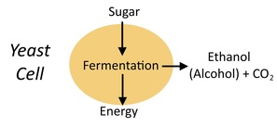

Production of alcohol & acetic acid :
the yeasts are produced vinegar / alcohol used aerobic or anaerobic fermentation processes , the dates and molasses are the essential materials for these processes.
The Percentage of sugar for alcohol or vinegar should be between 10-25%.
Alcohol was produced from the distillation of fermented plant materials, the yeasts ( like: saccharomyces cerevisiae ) are the first microorganisms used to production ethanol by converting waste cellulose to alcohol.
The concentration of basic sugary material to Preparation alcohol or vinegar is 68-70% . Molasses ( waste of sugar industry), dates & debbis are the most important commercial production media for ethanol production .
Next phase after the formation of alcohol from sugary solution , the second microorganisms (Acetobacter aceti ) is added to production of vinegar.
Acetobacter aceti species is used for the mass production of Acetic Acid, the main component in vinegar.
used in the fermentation industry in order to produce acetic acid from alcohol.
Experimental method:
1. TO PREPARATION OF ETHANOL (date extract medium) :-mix 100 gm from date with 100 ml tap water , heat at 80 C^{O} for 30 min.
2. by Gauze filter the mixture or the Soaked .
3. inoculate the medium (date extract medium) with 1% saccharomyces cerevisiae culture grown in malt extract broth & incubate at 30 co for 48 hrs in flask incubator has air pump to convert the condition to anaerobic which is suitable for ethanol production .

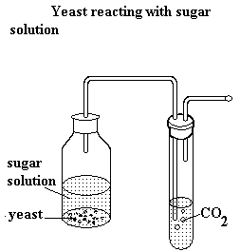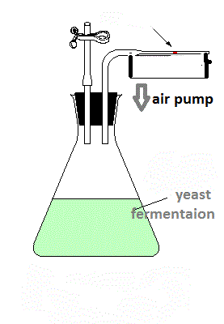

Detection of ethanol by chemical methods :
1. Ceric ammonium nitrate (CAN) method:-
a) take 0.5 ml of CAN , add 3ml of D.W to it (dilution).
b) add 3-5 drops from the sample (yeast fermented medium) to diluted CAN the appearance of red color indicate to a presence of ethanol .

2. potassium dichromate method :-
a) add 5 ml of K₂Cr₂O₇ solution to 1 ml of concentrated sulfuric acid & heat the mixture.
b) add 1 ml of the sample (yeast fermented medium) to the mixture . the positive result : is appearance of green color with acetaldehyde odor.
Preparation alcohol in laboratories and factories :
In this method , use a person square to determine the proportion of sugary substance in the preparator solution .
We need to:
1-water
2- raw sugary substance
3-yeast culture or vinegar mother
4- salts
5- glass of bottle, Gauze
There are four experiments performed per week:
1- Total soluble solid (TSS %)
2-pH
3- Titrable acidity T.A %
4- Ethanol concentration EOH %
Tools and equipments that used to produce the vinegar and alcohol in experiences are:
1.Refractometer.
2.pH meter or pH paper.
3.titration process.

4. Distillation Process.

*TSS% :
To prepare the alcoholic solutions from sugary solid substances have concentration less than 100% or 100% use a person square method, Then use refractometer apparatus to check of the concentration .

20 gm 70%
debbis debbis
20%

50 water 0% water

70 gm

For example of the application the Person square To prepare the sugary solution its concentration =20% & its quantity =3000 grams :
We need water and a sugary substance
Total Weight Dibbis
70 gm 20 gm
3000 gm x

X= 3000 × 20 = 857 gm / dibbis
70

3000 – 857 = 2143 ml (water)

If wanted the solution its concentration 20% of sugar but after examination found its concentration 18%, must be Corrected this Wrong concentration As follows:-

by Person square
Total w. Dibbis
2 gm 70% 52 2
Dibbis Dibbis 3000 x
20%
X= 2× 3000 =
52
50 gm
water 18% 115 gm dibbis
52 gm Dibbis
So, The Correction must increase the concentration to 20 by adding 115 gm of dibbis

But in the case the concentration of sugar in solution was Higher than required e.g. 22% ,
must be Corrected this Wrong concentration As follows:-

20 22%
dibbis dibbis
20%
total w water
22 2
2 0% 3000 x
water water
x= 3000× 2
22
=273 ml water

So, The Correction must decrease the concentration to 20 by adding 273 ml of water.

*pH measure:
pH paper is a simple & easy but limited accuracy and is not suitable for colored solutions therefore prefer to use measuring devices.

*titrable acidity :
To measure percentage of ionized & non-ionized acids ,unlike the pH reading which expresses the percentage of ionized acids only.

Procedure :
1. put 1ml of sugary solution in flask.
2.add to flask 19 ml of D.W
3. add 12 drop of phenolphthalein Reagent.
Calibration with a mixture of NaOH until pink appears; Here, we must stop the titration process and read the volume then calculate the percentage of T.A % as following:

T.A. % = ml NaOH × Normality of NaOH ×m.equivalent w.t of acetic acid × 100 w.t of sample ×total titrable volume

The volume of the base that used=mk naoh
Normality of naoh
m. equivalent w.t.of acetic acid=0.06005
w.t. of sample = 1 gm
total titrable volume= (1 gm + 19 ml D.W+12 drop)

T.A%= ?× 0.1 × 0.06005
1 × 20

*Ethanol concentration (EOH %) :
Detection of ethanol by physical methods such as : (boiling point Distillation method estimation of ethanol by pycnometer ).

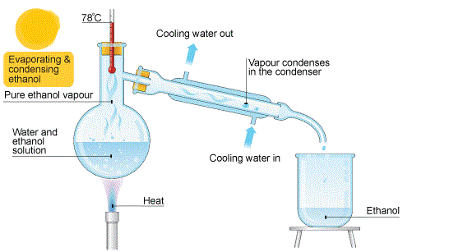
Procedure:
1- put such as 50 ml from sample ( sugary solution) in distillation flask .
2- Connect the rest of glass tools with Flask for the completion the distillation process by boiling .
3- The resulting From the distillation process collected in pycnometer (its volume ranges between 15-25 ml) .
4- determine the specific gravity of ethanol concentration at every-time after distillation process of the sample, calculate the specific gravity by the following formula :

Specific gravity =weight of pycnometer with the sample- its weight without sample (empty)
Weight of pycnometer with water - its weight without water(empty)

W= wt. of pycnometer empty.
W1= wt of pycnometer with D.W
W2= wt. of pycnometer with sample .

5- compare the results of specific gravity each week in Lab. With the previous concentrations of sugary solution sample.
Shake the bottles a week before taking the sample and recording the readings.

week | TSS% | PH | T.A % | EOH %
0
1 Type of fermentation
2 …………………
3
4
5 Type of fermentation
6 …………………….

Other requirements are added to the mixture solution:
1- salts for example : Potassium chloride , ammonium phosphate, ammonium sulfate ( 0.1-0.5 %).

