Shape of Bacteria

Bacteria are prokaryotic single-celled, microscopic organisms (Exceptions have been discovered that can reach sizes just visible to the naked eye. They include Epulopiscium fishelsoni, a bacillus-shaped bacterium that is typically 80 micrometers (µm) in diameter and 200-600 µm long, and Thiomargarita namibiensis, a spherical bacterium between 100 and 750 µm in diameter.)
generally much smaller than eukaryotic cells.
very complex despite their small size. Even though bacteria are single-celled organisms, they are able to communicate with one another through a process called quorum sensing. In this way they can function as a multicellular population rather than as individual bacteria.
Bacterial cell shape is determined primarily by a protein called MreB. MreB forms a spiral band – a simple cytoskeleton – around the interior of the cell just under the cytoplasmic membrane. It is thought to define shape by recruiting additional proteins that then direct the specific pattern of bacterial cell growth. For example, bacillus-shaped bacteria that have an inactivated MreB gene become coccoid shaped, and coccus-shaped bacteria naturally lack the MreB gene. Most bacteria come in one of three basic shapes: coccus, rod or bacillus, and spiral.

1. Coccus
The cocci are spherical or oval bacteria having one of several distinct arrangements based on their planes of division.

a. Division in one plane produces either a diplococcus or streptococcus arrangement.

diplococcus: cocci arranged in pairs .

Streptococcus pneumoniae, Neisseria a diplococcus

streptococcus: cocci arranged in chains

- Streptococcus pyogenes, a streptococcus
- Enterococcus

b. Division in two planes produces a tetrad arrangement.

tetrad: cocci arranged in squares of 4

- Micrococcus luteus showing several tetrads

c. Division in three planes produces a sarcina arrangement.

sarcina: cocci in arranged cubes of 8

d. Division in random planes produces a staphylococcus arrangement.

staphylococcus: cocci arranged in irregular, often grape-like clusters

- Staphylococcus aureus

An average coccus is about 0.5-1.0 micrometer (µm) in diameter. (A micrometer equals 1/1,000,000 of a meter.)

2. The rod or bacillus
Bacilli are rod-shaped bacteria. Bacilli all divide in one plane producing a bacillus, streptobacillus, or coccobacillus arrangement.

a. bacillus: single bacilli
- Escherichia coli

b. streptobacillus: bacilli arranged in chains

c. coccobacillus: oval and similar to a coccus

An average bacillus is 0.5-1.0 µm wide by 1.0-4.0 µm long.

3. The spiral
Spirals come in one of three forms, a vibrio, a spirillum, or a spirochete.

a. vibrio: a curved or comma-shaped rod

- Vibrio cholerae

b. spirillum: a thick, rigid spiral

c. spirochete: a thin, flexible spiral

- spirochete Leptospira
- spirochete Treponema pallidum

Spirals range in size from 1 µm to over 100 µm in length.

4. Exceptions to the above shapes
There are exceptions to the three basic shapes of coccus, bacillus, and spiral. They include sheathed, stalked, filamentous, square, star-shaped, spindle-shaped, lobed, trichome-forming, and pleomorphic (def) bacteria.

5. Ultrasmall Bacteria
Ultrasmall bacteria (150 could fit in a single Escherichia coli) have been discovered in groundwater that was passed through a filter with a pore size of 0.2 micrometers µm). They showed an average length of only 323 nanometers (def) (nm) and an average width of 242 nm. They contain DNA, an average of 42 ribosomes per bacterium, and possessed pili (def). It is thought that they use these pili to attach to other bacteria from which they scavenge nutrients. Because the surface to volume ratio is even greater than in more traditional sized bacteria, they might be better designed to take up scarce nutrients from more nutrient-poor environments.

Summary
There are three basic shapes of bacteria: coccus, bacillus, and spiral.
Based on planes of division, the coccus shape can appear in several distinct arrangements: diplococcus, streptococcus, tetrad, sarcina, and staphylococcus.
The bacillus shape can appear as a single bacillus, a streptobacillus, or a coccobacillus.
The spiral shape can appear in several forms: vibrio, spirillum, and spirochete.
The metric unit micrometer (1/1,000,000 or 10-6 of a meter) is used to measure bacterial size.

Bacteria display three basic shapes:

round‐ cocci, (from the Greek kokkos ‐ aberry),

rod shaped – bacilli (from the Latin bacillus ‐ astick orrod), spiral(quelled).

Coccus

Staphylococcus species

Streptococcus species

Bacillus

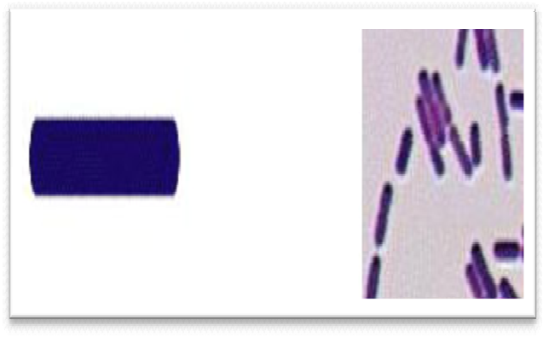

Clostridiumspp. Listeriaspp.

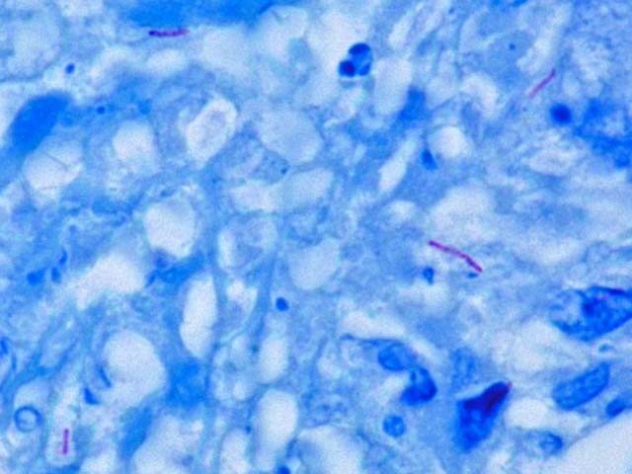

Mycobacterium tuberculosis

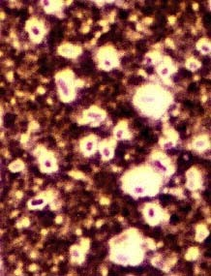

Klebsiella pneomonae

Spirochetes

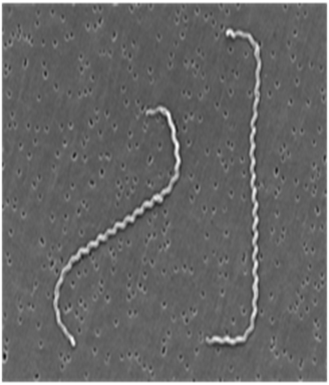
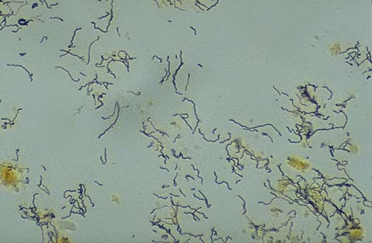
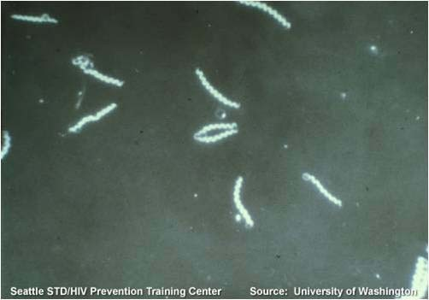

Spirochetes Treponema pallidum Leptospira

