|  |  |  |
| --- | --- | --- |
| **Al-Mustansiriyah University**  **College of Science**  **Physics Department** |  | **Fourth Grade**  **Nuclear Structure**  **Dr. Ali Abdulwahab Ridha** |

**Semester-1 (Nuclear structure syllabus)**

**Chapter One (Nuclear Concepts)**

1. Introduction (Definitions and Units)
2. Stability and Abundance
3. Nuclear Mass, Charge, Size and Density
4. Quantum theory of angular momentum

**Chapter Two (Binding Energy)**

1. Nuclear Binding Energy & Separation energy
2. Nuclear Forces, Spins and Dipole Moments

**Chapter Three (Nuclear Models)**

1. Liquid-Drop Model
2. Semi-empirical mass formula & Mass parabolas
3. Nuclear Shell Model, Single-particle shell model & Spin-Orbit coupling shell model
4. Other Models (Fermi Gas Model, Collective Model, Optical Model & Cluster Model)

**Chapter Four (Nuclear Radiation)**

1. Alpha Decay (α), Beta Decay (β) & Gamma Emission (γ)
2. Electron Capture (EC, K-capture), Internal Conversion, Isomeric Transition & Spontaneous Fission
3. Decay Schemes & Decay Chains

**Chapter Five (Interaction of Radiation with Matter)**

1. Alpha Interactions, Beta-Minus Interactions & Positron Interactions
2. Bremsstrahlung, Neutron Interactions, Electromagnetic (Gamma) Interactions & Shielding

|  |  |  |
| --- | --- | --- |
| **Al-Mustansiriyah University**  **College of Science**  **Physics Department** |  | **Fourth Grade**  **Nuclear Structure**  **Dr. Ali Abdulwahab Ridha** |

**Chapter One**

**(Nuclear Concepts)**

* 1. **History**

**The main stages of the nuclear physics are the following:**

• 1868 Mendeleev’s periodic classification of the elements.

• 1895 Discovery of X-rays by Roentgen.

• 1896 Discovery of radioactivity by Becquerel.

• 1897 Identification of the electron by J.J. Thomson.

• 1898 Separation of the elements polonium and radium by Pierre and Marie Curie.

• 1908 Measurement of the charge +2 of α particle by Geiger and Rutherford.

• 1911 Discovery of the nucleus by Rutherford; “planetary” model of the atom.

• 1913 Theory of atomic spectra by Niels Bohr.

• 1914 Measurement of the mass of α particle by Robinson and Rutherford.

• 1924–1928 Quantum theory (de Broglie, Schrodinger, Heisenberg, Born, Dirac).

• 1928 Theory of barrier penetration by quantum tunneling, application to α radioactivity, by Gamow, Gurney and Condon.

• 1929–1932 First nuclear reactions with the electrostatic accelerator of Cockcroft and Walton and the cyclotron of Lawrence.

• 1930–1933 Neutrino proposed by Pauli and named by Fermi in his theory of beta decay.

• 1932 Identification of the neutron by Chadwick.

• 1934 Discovery of artificial radioactivity by Joliot-Curie.

• 1934 Discovery of neutron capture by Fermi.

• 1935 Liquid-drop model and compound nucleus model of N. Bohr.

• 1935 Semi-empirical mass formula of Bethe and Weizsacker.

• 1938 Discovery of fission by Hahn and Strassman.

• 1939 Theoretical interpretation of fission by Meitner, Bohr and Wheeler.

To these fundamental discoveries we should add the practical applications of nuclear physics. Apart from nuclear energy production beginning with Fermi’s construction of the first fission reactor in 1942, the most important are astrophysical and cosmological. Among them are:

• 1938 Bethe and Weizsacker propose that stellar energy comes from thermonuclear fusion reactions.

• 1946 Gamow develops the theory of cosmological nucleosynthesis.

• 1953 Salpeter discovers the fundamental solar fusion reaction of two protons into deuteron.

• 1957 Theory of stellar nucleosynthesis by Burbidge, Fowler and Hoyle.

• 1960 Detection of solar neutrinos

• 1987 Detection of neutrinos and γ-rays from the supernova.

* 1. **Introduction**

Nuclei sit at the center of any atoms. Therefore, understanding them is of central importance to any discussions of microscopic physics. As you know, nuclei are composed of protons and neutrons. The number of protons is the atomic number (Z), and the mass number (A) is equal to the total number of nucleons (a collective name for protons and neutrons), Therefore, A = N + Z where (N) is the number of neutrons. Isotopes are denoted by  or more often by or just, where X is the chemical symbol and A is the mass number, for example.

* 1. **Definitions and Units**

Nuclide = nucleus with a specific N and Z (e.g. )

Isotope = two nuclei with same Z and different N. (e.g. , )

Isotone = two nuclei with same N and different Z (e.g. , )

Isobar = two nuclei with same A, different Z and N (e.g. , )

Isomer = same isotope but with excited state (usually long-lived)

(e.g. 189Au, stable; 189mAu, half-life = 4 minutes)

Mirror nuclei are isobars (same A) with opposite numbers of protons and neutrons.

For example, 14C (Z=6, N=8) and 14O (Z=8, N=6) are mirror nuclei.

Abundance = relative percentage (by number) of isotope.

Photon is quantity of electromagnetic energy with a specific linear momentum.

The equations which applied to each particle moving with light speed, as follow:

E=mc2  (photon as a particle "Einstein equation")

E=hν=hc/λ (photon as a wave "plank equation")

P=mc (photon as a particle)

P=h/λ=hν/c (photon as a wave "Compton assumption")

**Units:**

Length: 1 angstrom = 10-10m = 1Å

1 fermi (or femtometer) = 10-15m = 1fm.

Energy: 1 electron volt (eV) = energy of electron accelerated through 1 volt electrical potential = 1.6 x 10-19J.

1u (atomic mass unit) = 931.502MeV/c2 (where 12C has mass = 12.00000u)

mp = 938.280MeV/c2 mn= 939.573MeV/c2 me = 0.511MeV/c2

Speed of light, c = 3x108m/s, Electron charge, e = 1.6x10−19C,

Planck constant, h = 6.63x10−34J.s, Avogadro’s number, Na = 6.022x1023mol−1

* 1. **Stability and Abundance**

When we examine the characteristics of stable nuclei, we find that for A<40 the number of protons equals the number of neutrons (N=Z). But for A≥40, stable nuclei have N=1.7Z; i.e., the number of neutrons is greater than the number of protons, see figure (1-1). This can be understood from the fact that, in larger nuclei, the charge density, and therefore the destabilizing effect of Coulomb repulsion, is smaller when there is a neutron excess. Furthermore, a survey of the stable nuclei reveals that even-even nuclei are the ones most abundant in nature. This again lends support to the strong-pairing hypothesis, namely that pairing of nucleons leads to nuclear stability. The most stability of nuclei has a magic numbers (2, 8, 20, 28, 50, 82, 126 and 184) of protons or neutrons to making a closed shell.

The numbers of stable nuclei in nature are:

For even-even = 156, even-odd = 48, odd-even = 50 and odd-odd = 5 (1H, 6Li, 10B and 14N).

The most important stability parameters:

1. Magic numbers
2. Pairing of nucleons
3. Equality and percentage between protons & neutrons
4. Mass number (A)

From these parameter, we can predict the stability and which of radiation may be emitting from the nucleus.

**Example**: How many atoms of 10B are there in 5 grams of boron?

**Sol.**: From tables; the atomic weight of elemental boron W(B) = 10.811gm/mol. The 5gm sample of boron equals m/W(B) moles of boron, and since each mole contains Na atoms, the number of boron atoms is:



From tables, the isotopic abundance of 10B in elemental boron is found to be 19.9%. The number N(10B) of 10B atoms in the sample is therefore,

N(10B) = (0.199)(2.785x1023) = 5.542x1022 atoms

Or, where 

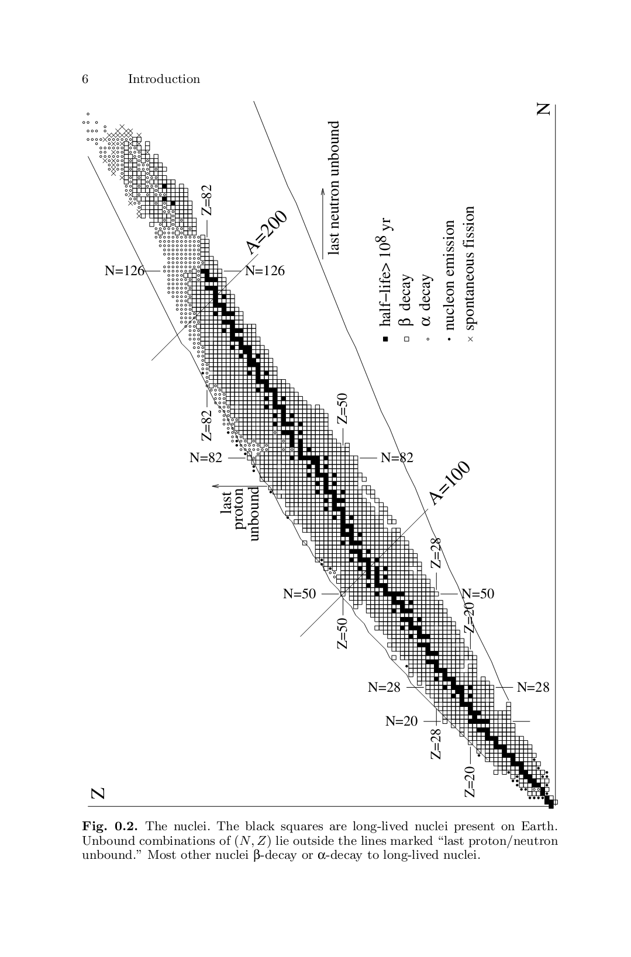

**Figure (1-1)**: the nuclei, the black squares are long-lived nuclei present on earth. Unbound combinations of (N,Z) lie outside the line marked "last proton/neutron unbound", most other nuclei β-decay or α-decay to long-lived nuclei.

* 1. **Nuclear Mass and Charge**

Nuclear masses are measured in terms of the atomic mass unit : 1amu or 1u= 1.66x10-27kg. One u is equivalent to 1/12 of the mass of a neutral ground-state atom of 12C. Since electrons are much lighter than protons and neutrons (protons and neutrons have approximately similar mass), one nucleon has mass of about 1amu. Because of the mass-energy equivalence, we will often express masses in terms of energy units. To convert between energy (in MeV) and mass (in u) the conversion factor is of course the speed of light square (since E = mc2). In these units we have: 1u = 931.502MeV/c2.

- Proton mass: mp = 1.007276u = 938.280MeV/c2

- Neutron mass: mn = 1.008665u = 939.573MeV/c2

- Electron mass: me = 0.000549u = 0.511MeV/c2

Mass difference between proton and neutron of order one part per thousand of u or, (mn − mp)c2 =1.29 MeV

For nuclear physics, the mass difference is much more important than the masses themselves. Also of great phenomenological importance is the fact that this mass difference is of the same order as the electron mass.

mec2 = 0.511 MeV

We would expect the mass of the nucleus to be:

MN(A,Z) ≈ Zmp + Nmn

For atoms, MA(A,Z) ≈ Zmp + Zme + Nmn

However, the measured values of nuclear masses revel that the mass of a nucleus is smaller than the sum of the masses of its constituents. Namely,

MN(A,Z)= Zmp + Nmn – B

Where B=B.E. is the nuclear binding energy=mass difference (ΔM)

This explains why an isolated nucleus cannot just fall apart into its constituents, because that would violate the principle of conservation of energy.

The mass difference comes from the energy gained in bringing the nucleons into their mutual potentials, is the mass defect (Δ) which written as:

Δ = [M(A,Z) - A]c2

mass excess = [M(A,Z)-A]



Which is negative, and can be thought of as being proportional to the nuclear binding energy (B.E.); the absolute value of Δ is related to the minimum energy required to break up the nucleus into its components.

Example: for 16O (Z=8, N=8)

From tables, Atomic mass= 15.994915 u =15.994915 x 931.502 = 14899.295 MeV/c2

Δ=[M(A,Z)-A]c2

=(15.994915 - 16)c2 =-0.005085 c2x931.502MeV/c2=-4.737MeV

Atomic mass= 8mp+8me+8mn=15026.912 MeV/c2

ΔM= [Zmp + Zme + Nmn - M(A,Z)]c2

ΔM=15026.912-14899.295=127.617 MeV

127.617/16=7.976 MeVper nucleon

Atomic nuclei are quantum bound states of particles called nucleons of which there are two types, the positively charged proton and the uncharged neutron. As far as we know, leptons are elementary particles that cannot be considered as bound states of constituent particles. Nucleons, on the other hand, are believed to be bound states of three spin 1/2 fermions called quarks. Two species of quarks, the up-quark u (charge 2/3) and the down quark d (charge -1/3) are needed to construct the nucleons:

proton = uud , neutron = udd .

qp= -e = +1.6x10-19C, nuclear charge QN=Zqp

Besides protons and neutrons, there exist many other particles that are bound states of quarks and antiquarks. Such particles are called hadrons. For nuclear physics, the most important are the three pions: (π+, π0, π-), that strong interactions between nucleons result from the exchange of pions and other hadrons just like the electromagnetic interactions which results from the exchange of photons.

* 1. **Nuclear Size and Density**

The existence of the nucleus as the small central part of an atom was first proposed by Rutherford in 1911. Later, in 1920, the radii of a few heavy nuclei were measured by Chadwick and were found to be of the order of 10-14m, much smaller than the order of 10-10m for atomic radii.

R = roA1/3 = 1.2A1/3 fm



The density of nuclei is approximately constant, and those nucleons are tightly packed inside the nucleus.



The experiments have been performed and analyzed for a great many nuclei and at several incident electron energies. All the result can be approximately explained by a charge distribution given by:



Where the physical significance of the various parameters are illustrated in figure (1-2).

ρo ≈1.65x1044 nucleons/m3 =0.165 nucleons/fm3

R≈1.07A1/3 fm, a≈0.55fm, t is the surface region

ρ

ρo

0.9ρo

.5ρo0

.1ρo0

0

r0.9 R r0.1 r

t=r0.1-r0.9=4.4a=2.4fm

**Figure (1-2)**: plot of nuclear density equation ρ(r) Vs. r, the meaning of ρo, R and a are illustrated.

From the distribution of the α-particle’s scattering angles, Rutherford concluded that the structure of an atom most likely mimics the solar planetary system. The size of the nucleus at the center of the atom was estimated based on the kinetic energy (T) of the incident α-particle and its potential energy at the point of closest approach (d). The closest approach occurs in the case of a head-on collision in which the α-particle comes to rest before it bounces back at an angle of 180 degrees, see figure (1-3). At that point the kinetic energy is zero, and the potential energy equals the initial kinetic energy.





Where k is the Coulomb force constant = 1 / (4πεo) = 8.99x109 Nm2/C2.

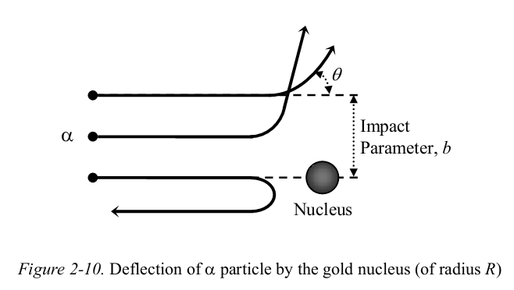

**Figure (1-3):** deflection of α particle by gold nucleus (of radius R).

**Example:** In Rutherford's experiment the kinetic energy of the incident α particles was 7.7MeV. Estimate the upper limit size of the gold nucleus and comment on the effect of increased energy of the incident particles in the experiment.

**Sol.:** the point of closest approach will determine the size of the nucleus. For the head-on collision it follows as:



This implies that the gold nucleus has radius smaller than 30fm (the actual measurement is about 8fm).

If the incident energy of α particles in Rutherford's experiment is increased, some of the particles would penetrate the nucleus; first in the head-on collisions and then for smaller angles as the energy is further increased. The limiting kinetic energy for the incident particle above which the Rutherford experiment would not agree with theoretical explanation.



Where R represents the radius of the gold nucleus.

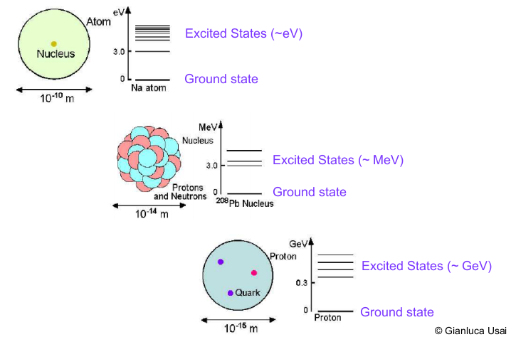

* 1. **Quantum theory of angular momentum**

Orbital angular momentum (from relative motion) is quantized in units of ћ, where ћ=h/2π, h is Planck's constant, L = 0 ћ, 1 ћ, 2 ћ, ...

Spin (intrinsic angular momentum) denoted by s for single particle and I for nucleus (nuclear spin), can be either integral or half-integral:

Fermions have half-integral spin s= 1/2 ћ, 3/2 ћ, 5/2 ћ, ...

Typical fermions include electrons, protons, neutrons, quarks, neutrinos...

Bosons have integral spin s = 0 ћ, 1 ћ, 2 ћ, ...

Typical bosons include pions, photons, W- and Z-bosons, gluons, (gravitons).

Since angular momentum is a vector, the total angular momentum of a nucleus is the vector sum of the angular momentum of its constituents, we find experimentally that complex nuclei have intrinsic angular momentum equal to I ћ, where:

For even-A nuclei: I is an integer (including zero)

For odd-A nuclei: I is an integer (including zero) plus one-half

For even-even nuclei: I=0

For example, the nucleus of deuterium 2H has I=1 and the nucleus of 7Li has I=3/2.

In QM we can only discuss the total angular momentum J and one component, usually Jz (The other components are in determinate), Jz can take on the values

Jz = -J, -J+1, -J+2, ... J-1, J i.e. (-J→J), sometimes for Jz we write m. So the angular momentum for a particle (or system of particles) is denoted by (J,Jz) or (J,m).



Adding angular momentum: The Rules; Suppose we start with (J1,m1) and (J2,m2) and “add” them together. What is final (J,m)?

(1) z-component is added: m = m1+ m2.

(2) | J1-J2| ≤ J ≤ J1+J2.

**Parity**:

Wave functions Ψ such that Ψ(-r) =Ψ (r) have even parity; wave functions such that Ψ (-r) = -Ψ (r) have odd parity. Parity is a quantum number and usually denoted by π. The parity of a single nucleon is: π= (-1), the intrinsic parities of free nucleons are: πp= πn=+1

The Pauli Exclusion Principle: no two identical fermions can be in exactly the same quantum mechanical state.

|  |  |  |
| --- | --- | --- |
| **Al-Mustansiriyah University**  **College of Science**  **Physics Department** |  | **Fourth Grade**  **Nuclear Structure**  **Dr. Ali Abdulwahab Ridha** |

**Chapter Two**

**(Binding Energy)**

**(2-1) Nuclear Binding Energy**

Since an atom contains Z positively charged particles (protons) and N=A-Z neutral particles (neutrons), the total charge of a nucleus is +Ze, where e represents the charge of one electron. Thus, the mass of a neutral atom, Matom, can be expressed in terms of the mass of its nucleus, Mnuc and its electrons me.



where mp is the proton mass, me the mass of an electron and mn the mass of a neutron. For example the mass of the rubidium nucleus, 87Rb, which contains 37 protons and 50 neutrons, can be calculated as:



The atomic mass, indicated on most tables of the elements, is the sum of the nuclear mass and the total mass of the electrons present in a neutral atom. In the case of 87Rb, 37 electrons are present to balance the charge of the 37 protons. The atomic mass of 87Rb is then:

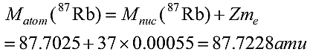

From the periodic table, the measured mass of a 87Rb atom is found to be MAmeasured(87Rb) = 86.909187 amu. These two masses are not equal and the difference is given by:



Expanding the terms in this equation, shows that the difference in mass corresponds to a difference in the mass of the nucleus

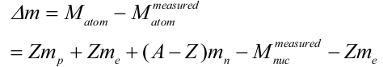

which reduces to

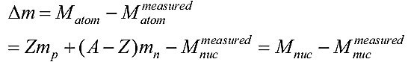

Thus, when using atomic mass values given by the periodic table, the mass difference between the measured and calculated is given by



Notice also that



Where mH is a mass of the hydrogen atom.

From this and other examples it can be concluded that the actual mass of an atomic nucleus is always smaller than the sum of the rest masses of all its nucleons (protons and neutrons). This is because some of the mass of the nucleons is converted into the energy that is needed to form that nucleus and hold it together. This converted mass, Δm, is called the “mass defect” and the corresponding energy is called the “binding energy” and is related to the stability of the nucleus; the greater binding energy leads to the more stable the nucleus. This energy also represents the minimum energy required to separate a nucleus into protons and neutrons. The mass defect and binding energy can be directly related, as shown below:



Since the total binding energy of the nucleus depends on the number of nucleons, a more useful measure of the cohesiveness is the average binding energy Bave.



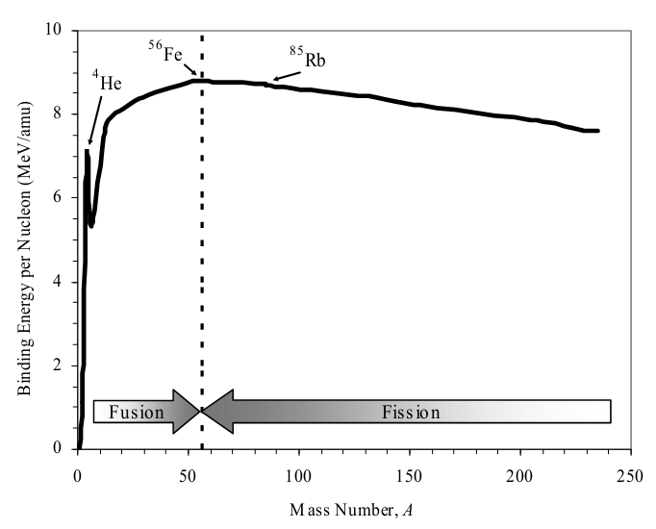

Figure (2-1): Variation of binding energy per nucleon with the atomic mass number

The binding energy per nucleon varies with the atomic mass number A, as shown in figure (2-1). For example, the binding energy per nucleon in a rubidium nucleus is 8.7MeV, while in helium it is 7.3MeV. The curve indicates three characteristic regions:

* Region of stability: A flat region between (A) equal to approximately 35 and 70 where the binding energy per nucleon is nearly constant. This region exhibits a peak near A = 60. These nuclei are near iron and are called the iron peak nuclei representing the most stable elements.
* Region of fission reactions: From the curve it can be seen that the heaviest nuclei are less stable than the nuclei near A = 60, which suggests that energy can be released if heavy nuclei split apart into smaller nuclei having masses nearer the iron peak. This process is called fission (the basic nuclear reaction used in atomic bombs as uncontrolled reactions and in nuclear power and research reactors as controlled chain reactions). Each fission event generates nuclei commonly referred to as fission fragments with mass numbers ranging from 80 to 160.
* Region of fusion reactions: The curve of binding energy suggests a second way in which energy could be released in nuclear reactions. The lightest elements (like hydrogen and helium) have nuclei that are less stable than heavier elements up to the iron peak. If two light nuclei can form a heavier nucleus a significant energy could be released. This process is called fusion, and represents the basic nuclear reaction in hydrogen (thermonuclear) weapons.

**(2-2) Separation energy**

Are the analogous of the ionization energies in atomic physics, reflecting the energies of the valence nucleons. The separation energy of any particle is defined as the amount of energy needed to remove a particle from the nucleus. For a given N,Z; Sn , Sp is larger for nuclei with even N or Z than with odd one, this due to the pair effect of nuclear force which increase the binding energy and separation energy.

There are two equations to determine the separation energy using the mass or the binding energy. For neutron as follow:

Sn=931.5[M(A-1,Z)+mn-M(A,Z)]

Sn=B(A,Z)-B(A-1,Z)

For proton:

Sp=931.5[M(A-1,Z-1)+mH-M(A,Z)]

Sp=B(A,Z)-B(A-1,Z-1)

For alpha particle:

Sα=931.5[M(A-4,Z-2)+mα-M(A,Z)]

Sα=B(A,Z)-B(A-4,Z-2)-B(α≡)

The fact, that each pair of these equations represents two equivalent equations.

Example: calculate the separation energy of neutron for 209Pb by using the two methods, where M(${}_{82}^{209}{Pb}$)=209.05398u, M(${}_{82}^{208}{Pb}$)=208.04754u.

Sol.:

1- Sn=931.5[M(A-1,Z)+mn-M(A,Z)]= 931.5[M(${}_{82}^{208}{Pb}$)+mn-M(${}_{82}^{209}{Pb}$)]

=931.5[208.04754+1.008665-209.05398]=2.07259MeV

2- 

B(${}_{82}^{209}{Pb}$)=931.5(82x1.007276+82x0.000549+127x1.008665-209.05398]

=1572.48844MeV

B(${}_{82}^{208}{Pb}$)=931.5(82x1.007276+82x0.000549+126x1.008665-208.04754]

=1570.41585MeV

Sn=B(A,Z)-B(A-1,Z)=1572.48844-1570.41585=2.07259MeV

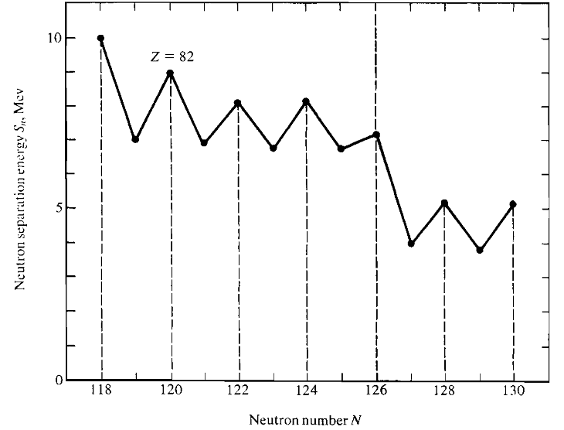

**Figure (2-2): Neutron separation energy of lead isotopes as a function of neutron number.**

**(2-3) Nuclear Forces**

Protons and neutrons are bound inside nuclei, despite the Coulomb repulsion among protons. Therefore there must be different and much stronger force acting among nucleons to bind them together. This force is called nuclear force, nuclear binding force, or in more modern settings, the strong interaction. There are notable properties of the nuclear binding force.

1. It is much stronger than the electromagnetic force (the force is charge independent, i.e. Fpp=Fnn=Fpn, we can see that from the equality of energy level, binding energy and total angular momentum of mirror nuclei). As shown in the empirical mass formula [see section (2-5-1)], the coefficient of the Coulomb term is more than an order of magnitude smaller than the other terms in the binding energy.

2. It is short-ranged, acts only up to 1–2 fm.

3. It has the saturation property, giving nearly constant B/A= Bave ≈ 8.5 MeV.

This is in stark contrast to the electromagnetic force.

4. The force depends on spin and states of the nucleon.

i.e. the nuclear force between two nucleons of the same type (p and p) or (n and n) could be the biggest whenever the total angular momentum for the first has the maximum value and equal with opposite direction to the other, i.e. the angular momentum for both is equal to zero.

For example, let are the spin to the two protons, the orbital momentum, therefore the total angular momentum for the first is equal , and for the second proton 

For the maximum nuclear force between the two nucleons, must be 

Put the two protons in s-state, then:



For maximum Fpp,

for two protons in p-state, then:





For maximum Fpp,

This phenomenon is called the pairing effect.

5. It is exchange forces. Like of the photon exchange between the electric charges, there are medium mass particles (mesons) were exchange between nucleons.

6. Even though the nuclear force is attractive to bind nucleons, there is a repulsive core when they approach too closely, around 0.5fm. They basically cannot go closer.

i.e. 2fm>r>0.5fm leads to attractive nuclear force, while r<0.5fm repulsive force.

**(2-4) Nuclear Spins and Dipole Moments**

Both the proton and the neutron have spin angular momentum of . Furthermore, just as electrons in an atom can have orbital angular momentum, so also can nucleons inside a nucleus. We know from quantum mechanics that orbital angular momentum can take on only integral values. The total angular momentum of the constituents-namely, the vector sum of the orbital and intrinsic spin angular momenta-defines the spin of the nucleus.

Thus, the nuclei with even mass number have integral nuclear spin whereas nuclei with odd mass number have half-integral nuclear spin. However, the nuclei with an even number of protons and an even number of neutrons (even-even nuclei) have zero nuclear spin. These facts lend credence to the hypothesis that spins of nucleons inside a nucleus are very strongly paired so as to cancel their overall effect.

To explain the fine structure of the spectral lines, suppose that each of the electron, proton and neutron has spin momentum result from rotation on its axis and therefore they has a magnetic moment due to this rotation, the interaction of magnetic moment of the electron with the magnetic moment of the nucleus leads to increase or decrease the tension between them and then will increase or decrease energy of electron, i.e. split the energy levels of the electron and thus will be divided every line of spectral lines into several lines. Every charged particle has a magnetic dipole moment associated with its spin, given by:



where e, m and s are the charge, mass and the intrinsic spin of the charged particle. The constant g is known as the Lande factor (Gyromagnetic ratio), which for a point particle, such as the electron, is expected to have the value g = 2.

When g ≠ 2 the particle is said to possess an anomalous magnetic moment, which is usually ascribed to the particle having a substructure like proton and neutron:

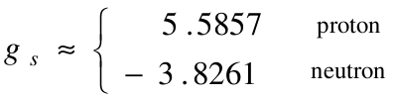

Relate to orbital angular momentum





For the electron (with ) , the dipole moment μe≈μB, where μB is the Bohr magneton, defined as:



Where a magnetic field of 1 tesla (T) corresponds to 104 gauss (G), the magnetic dipole moment for nucleons is measured in terms of the nuclear magneton, defined using the proton mass:



From the ratio of mp/me , we deduce that the Bohr magneton is about 2000 times larger than the nuclear magneton due to mp=1837me≈2000me , i.e.

atomic moment >> nuclear moment.

The magnetic moments of the proton and the neutron are:



Thus, the electrons cannot be present inside nuclei because it would then be particularly hard to explain the small values of nuclear moments, since even one electron would produce a moment a thousand times that observed for nuclei.

**The most important Radionuclides:**

1. **Hydrogen (Deuterium & Tritium) ${}_{1}^{2}H$& ${}_{1}^{3}H$**
2. **Helium (Alpha particle) ${}_{2}^{4}He$**
3. **Carbon ${}_{6}^{14}C$**
4. **Sodium ${}_{11}^{22}{Na}$**
5. **Potassium ${}_{19}^{40}K$**
6. **Cobalt ${}_{27}^{60}{Co}$**
7. **Strontium ${}_{38}^{90}{Sr}$**
8. **Iodine ${}_{53}^{131}I$**
9. **Cesium 55Cs**
10. **Barium ${}_{56}^{133}{Ba}$**
11. **Europium ${}_{63}^{152}{Eu}$**
12. **Lead ${}_{82}^{214}{Pb}$**
13. **Bismuth ${}_{83}^{214}{Bi}$**
14. **Polonium ${}_{84}^{210}{Po}$**
15. **Radon ${}_{86}^{222}{Rn}$**
16. **Radium ${}_{88}^{226}{Ra}$**
17. **Thorium ${}_{90}^{232}{Th}$**
18. **Uranium ${}_{92}^{238}U$& ${}_{92}^{235}U$**
19. **Neptunium ${}_{93}^{237}{Np}$**
20. **Plutonium ${}_{94}^{239}{Pu}$**
21. **Americium ${}_{95}^{241}{Am}$**

|  |  |  |
| --- | --- | --- |
| **Al-Mustansiriyah University**  **College of Science**  **Physics Department** |  | **Fourth Grade**  **Nuclear Structure**  **Dr. Ali Abdulwahab Ridha** |

**Chapter Three**

**(Nuclear Models)**

**(3-5) Nuclear Models**

The aim of nuclear models is to understand how certain combinations of N neutrons and Z protons form bound states and to understand the masses, spins and parities of those states. The great majorities of nuclear species contain excess neutrons or protons and are therefore β-unstable. Many heavy nuclei decay by α-particle emission or by other forms of spontaneous fission into lighter elements. Another aim of this chapter is to understand why certain nuclei are stable against these decays and what determines the dominant decay modes of unstable nuclei. The problem of calculating the energies, spins and parities of nuclei is one of the most difficult problems of theoretical physics.

**(3-5-1) Liquid-Drop Model**

The liquid drop model of the nucleus, proposed by Bohr and derived by Von Weizsacker in 1935, was one of the earliest phenomenological successes constructed to account for the binding energy of a nucleus. Experiments revealed that nuclei were essentially spherical objects, with sizes that could be characterized by radii proportional to A1/3, which suggested that nuclear densities were almost independent of nucleon number. This leads quite naturally to a model that envisions the nucleus as an incompressible liquid droplet, with nucleons playing the role analogous to molecules in a drop of normal liquid. In this picture, known as the liquid drop model, the individual quantum properties of nucleons are completely ignored. As in the case of a liquid drop, the nucleus is imagined as composed of a stable central core of nucleons for which the nuclear force is completely saturated (is based on the short range of nuclear forces), and a surface layer of nucleons that is not bound as tightly (forces not saturated). This weaker binding at the surface decreases the effective binding energy per nucleon (B/A), and provides a "surface tension", or an attraction of the surface nucleons towards the center. Nucleons interact strongly with their nearest neighbors, just as molecules do in a drop of water. Therefore, one can attempt to describe their properties by the corresponding quantities, i.e. the radius, the density, the surface tension and the volume energy, (see figure 3-1).

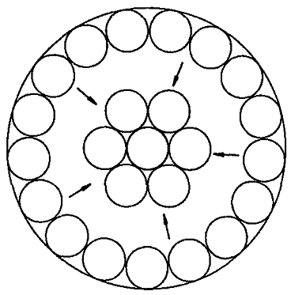

**Figure (3-1): Surface layer and core of nucleus in the liquid drop model.**

The essential assumptions are:

1. The nucleus consists of incompressible matter so that R~A1/3.
2. The nuclear force is identical for every nucleon and in particular does not depend on whether it is a neutron or a proton.
3. The nuclear force saturates.

**Semi-empirical mass formula**

An excellent parameterization of the binding energies of nuclei in their ground state was proposed in 1935 by Bethe and Weizsacker. This formula relies on the liquid-drop analogy but also incorporates two quantum ingredients; one is an asymmetry energy which tends to favor equal numbers of protons and neutrons. The other is a pairing energy which favors configurations where two identical fermions are paired. The semi-empirical mass formula (SEMF) or Bethe-Weizsacker mass formula is:



or B(A,Z)=Tv+ Ts+ Tc+ Ta+ Tp+ Tsh

The coefficients ai are chosen so as to give a good approximation to the observed binding energies. A good combination is the following:

Volume Term av = 15.5 MeV

Surface Term as = 16.8 MeV

Coulomb Term ac = 0.72 MeV

Asymmetry Term aa = 23 MeV

Pairing Term ap = 34 MeV

Shell Term Tsh = η = 1→3MeV

We will now study each term in the SEMF:

**1- Volume term (Tv):**

The first term is the volume term (avA), that describes how the binding energy is mostly proportional to A i.e. to the volume of nucleus, remember that the binding energy is a measure of the interaction among nucleons. Since nucleons are closely packed in the nucleus and the nuclear force has a very short range, each nucleon ends up interacting only with a few neighbors. This means that independently of the total number of nucleons, each one of them contribute in the same way. Thus the force is not proportional to the total number of nucleons one nucleon can interact with, but it’s simply proportional to A.



The constant of proportionality is a fitting parameter that is found experimentally to be av = 15.5MeV

This value is smaller than the binding energy of the nucleons to their neighbors as determined by the strength of the nuclear (strong) interaction. The total binding energy is instead the difference between the interaction of a nucleon to its neighbor and the kinetic energy of the nucleon itself. As for electrons in an atom, the nucleons are fermions, thus they cannot all be in the same state with zero kinetic energy, but they will fill up all the kinetic energy levels according to Pauli’s exclusion principle. This model, which takes into account the nuclear binding energy and the kinetic energy due to the filling of shells, indeed gives an accurate estimate for av.

For example Tv (8Be) = 15.5x8=124MeV

**2- Surface term (Ts):**

The surface term (-asA2/3), also based on the strong force, is a correction to the volume term. We explained the volume term as arising from the fact that each nucleon interacts with a constant number of nucleons, independent of A. While this is valid for nucleons deep within the nucleus, those nucleons on the surface of the nucleus have fewer nearest neighbors. This term is similar to surface forces that arise for example in droplets of liquids, a mechanism that creates surface tension in liquids. We can say that; whenever increasing of the nuclear surface area, the binding energy will decrease.



Where 4πR2 is the surface of the sphere, R=RoA1/3

Also the term must be subtracted from the volume term and we expect the coefficient as to have a similar order of magnitude as av. In fact as = 16.8MeV.

Ts for 8Be=-16.8x82/3 =-67.2MeV

**3- Coulomb term (Tc):**

The third term -ac Z(Z−1)A−1/3 derives from the Coulomb interaction among protons, and of course is proportional to Z. This term is subtracted from the volume term since the Coulomb repulsion makes a nucleus containing many protons less favorable (more energetic). To find the form of the term and estimate the coefficient ac, the nucleus is modeled as a uniformly charged sphere.



We assume that we have a sphere of radius r when collected the nucleon to get the nucleus with volume.



The potential energy (Vp) of such a charge distribution at the surface is:



We add a charge sample dq to the sphere to get a shell of thickness dr



The required work to add this layer is



To find the total work to forming the nucleus



We know that the proton is not repulsion with itself but with the other protons around it i.e. repulsion with Z-1 protons, then we can write:



Using the empirical radius formula R = RoA1/3 , Ro=1.2x10-15m , e=1.6x10-19C and K=9x109Nm2/C2



This gives the shape of the Coulomb term. Then the constant ac can be estimated from  with Ro=1.2fm, to be ac=0.72MeV which is agreement with the experimental value.

Tc for 

**4- Asymmetry term (Ta):**

The Coulomb term seems to indicated that it would be favorable to have less protons in a nucleus and more neutrons. However, this is not the case of the liquid-drop model in order to explain the fact that we have roughly the same number of neutrons and protons in stable nuclei. There is a correction term in the SEMF which tries to take into account the symmetry in protons and neutrons, i.e. the equality between them. This correction (and the following one) can only be explained by a more complex model of the nucleus, the shell model, together with the quantum-mechanical exclusion principle. If we were to add more neutrons, they will have to be more energetic, thus increasing the total energy of the nucleus. This increase more than the Coulomb repulsion, so that it is more favorable to have an approximately equal number of protons and neutrons. (A−2Z)2 The shape of the symmetry term is . It can be more easily understood by considering the fact that this term goes to zero for A = 2Z and its effect is smaller for larger A (while for smaller nuclei the symmetry effect is more important). i.e. for isobars of Z=N=A/2 (symmetry) has been more stability than isobars of Z≠N (Anti symmetry or Asymmetry) which reduce of the binding energy.

Asymmetry define as the difference between binding energy for two isobar, one have Z=N and the other Z≠N.

│Ta│=B(A,Z=N)-B(A,Z≠N)

The coefficient is aa = 23MeV



**5- Pairing term (Tp):**

This term is linked to the physical evidence that like-nucleons tend to pair off. Then it means that the binding energy is greater (δ > 0) if we have an even-even nucleus, where all the neutrons and all the protons are paired-off. If we have a nucleus with both an odd number of neutrons and of protons, it is thus favorable to convert one of the protons into a neutrons or vice-versa. Thus, with all other factor constant, we have to subtract (δ<0) a term from the binding energy for odd-odd configurations. Finally, for even-odd configurations we do not expect any influence from this pairing energy (δ = 0). The pairing term is then:



with ap = 34MeV

Assume that A is the mass number for even-odd nucleus, then A+1 represent an even-even nucleus and A-1 for odd-odd, the pairing term is written as:





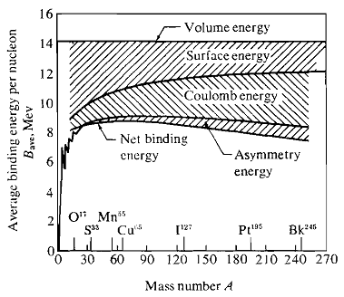

Figure (3-2): summary of liquid-drop model treatment of average binding energy.

**6- Shell term (Tv):**

There is found experimentally that for N=Z nuclei which has a double magic number (2,8,20,28,50,82,…) has been a very stability, very high nuclear binding energy and high abundance, then for one magic number N or Z, then for nearest of magic number which due to increases in binding energy.

Tsh=1→3MeV

Tsh=3 for double magic number (N and Z = magic number) like 

Tsh=2 for single magic number (N or Z = magic number and the other is near of magic number) like 

Tsh=1 for single magic number (N or Z = magic number and the other is far from magic number) like 

Tsh=0 for no magic number of N and Z, like 

H.W.: find the binding energy for ,  . Using:

a) mass formula, b) Weizsacker formula. Were the atomic mass of 6Li=6.015124u, 8Be=8.02502u, 17O=17.00453u and 208Pb=208.04754u

**Mass parabolas**

With a little rearrangement of SEMF Eq.:



From the formula of binding energy depending on the mass:

MN(A,Z)=Zmp+Nmn-B(A,Z)

we can write the mass of a nucleus in the following way:

 It’s clear that for any value of A (A = constant), this equation represent of a parabola equation as M(A,Z)c2=xA+yZ+zZ2±δ.

The minimum mass occurs for Z = Zo (usually not an integer). The plot of Z versus A or N gives the line of greatest nuclear stability. Setting ∂(Mc2)/∂Z = 0 yields:



For odd-A isobars, δ = 0. and therefore the equation gives a single parabola, which is shown in Fig. (3-3) for a typical case.

It is clear from Fig. (3-3a) that for odd-A nuclides there can be only one (stable) isobar for which both these conditions do not occur. Note that:

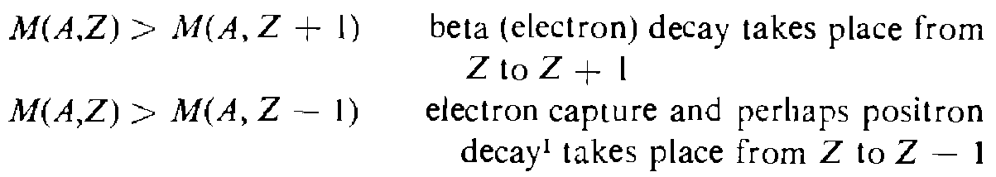

For even-A isobars, two parabolas are generated by above equation, differing in mass by 26. A typical case is given in Fig. (3-3b). Depending on the curvature of the parabolas and the separation 26, there can be several stable even-even isobars. Three is the largest number found in nature. There should be no stable odd-odd nuclides. The exceptional cases H2, Li6, B10, and N14 are caused by rapid variations of the nuclear binding energy for very light nuclides, because of nuclear structure effects which are not included in the liquid-drop model. Figure (3-3b) shows that for certain odd-odd nuclides both conditions are met so that electron and positron decay from the identical nuclide are possible and do indeed occur.

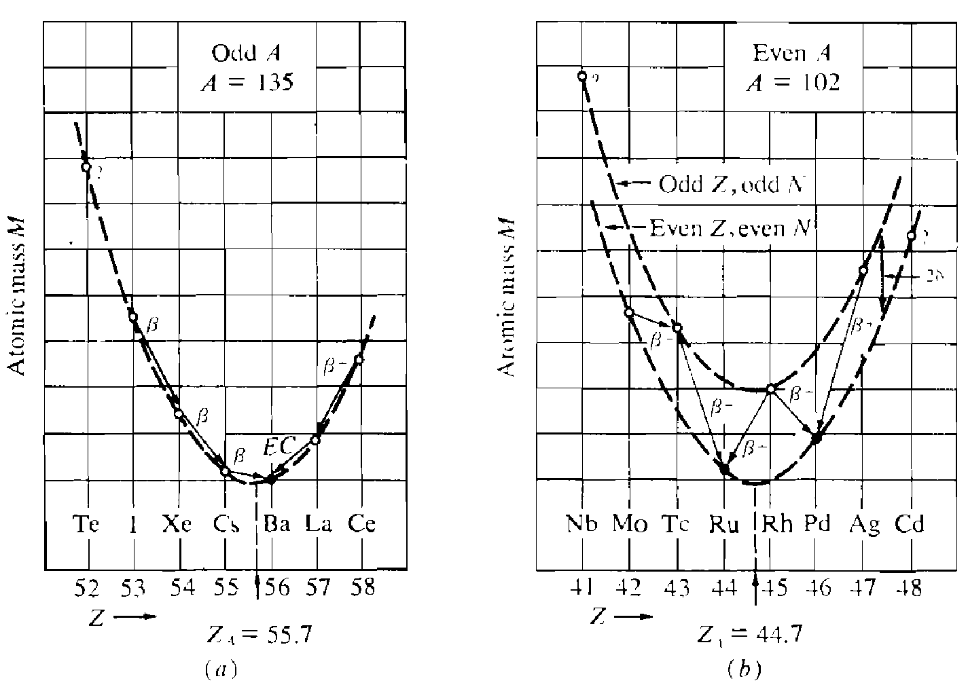

Figure (3-3): mass parabola for isobars. (a) odd A nuclei. (b) even A nuclei. Full circles represent stable nuclides and open circles radioactive nuclides.

**(3-5-2) Nuclear Shell Model**

The nuclear shell model is based on the analogous model for the orbital structure of atomic electrons in atoms. Although the liquid drop model of the nucleus has proved to be quite successful for predicting subtle variations in the mass of nuclides with slightly different mass and atomic numbers, it avoids any mention of the internal arrangement of the nucleons in the nucleus. We have observed that:

1- There are an abnormally high number of stable nuclides whose proton and/or neutron numbers equals the magic numbers 2,8,20,28,50,82,126.

2- Further evidence for such magic numbers is provided by the very high binding energy of nuclei with both Z and N being magic.

3- The abnormally high or low alpha and beta particle energies emitted by radioactive nuclei according to whether the daughter or parent nucleus has a magic number of neutrons. Similarly.

4- Nuclides with a magic number of neutrons are observed to have a relatively low probability of absorbing an extra neutron, i.e. they have lowest of absorption cross sections for neutrons (neutron-capture cross sections).

To explain such nuclear systematics and the internal structure of the nucleus, a shell model of the nucleus has been developed. This model uses Schrodinger’s wave equation or quantum mechanics to describe the energetics of the nucleons in a nucleus in a manner analogous to that used to describe the discrete energy states of electrons around the nucleus. This model assumes:

1. Each nucleon moves independently in the nucleus uninfluenced by the motion of the other nucleons.

2. Each nucleon moves in a potential well which is constant from the center of the nucleus to its edge where it increases rapidly by several tens of MeV.

When the model's quantum-mechanical wave equation is solved numerically, the nucleons are found to distribute themselves into a number of energy levels. There is a set of energy levels for protons and an independent set of levels for neutrons. Filled shells are indicated by large gaps between adjacent energy levels and are computed to occur at the experimentally observed values of 2, 8, 20, 28, 50, 82, and 126 neutrons or protons. Such closed shells are analogous to the closed shells of orbital electrons. However, the shell model has been useful to obtain such results that predicts the magic numbers and particularly useful in predicting several properties of the nucleus, including (1) the total angular momentum of a nucleus, (2) characteristics of isomeric transitions, which are governed by large changes in nuclear angular momentum, (3) the characteristics of beta decay and gamma decay, and (4) the magnetic moments of nuclei.

**Single-particle shell model**

The basic assumption of any shell model is that despite the strong overall attraction between nucleons which provides the binding energy considered in previous section, the motion of each nucleon is practically independent of that of any other nucleon. This apparent contradiction is resolved by effects of the Pauli Exclusion Principle. If all inter-nucleon couplings (called residual interactions) are ignored, we call the model the single-particle shell model. In terms of Schrodinger's equation, each nucleon is then assumed to move in the same potential. The potential is spherical in the simplest case, but there is good evidence that for nucleon numbers far from closed shells the potential should have an ellipsoidal shape. This condition will be considered later.

This model depends on two quantum numbers, the radial (total) quantum number n and the orbital quantum number. In nuclear physics each state is specified by n and . Also for  = 0, 1, 2, 3, 4, 5, we use the spectroscopic letters s, p, d, f, g, h, respectively. A state denoted by 2p therefore means that n = 2, = 1.

The simplest useful potentials are an infinite square well potential of radius R

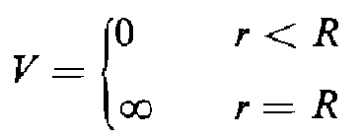

or a harmonic oscillator potential



where ω is the frequency of oscillation of the particle of mass mo. More realistic potentials are a finite square well potential as:

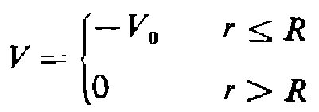

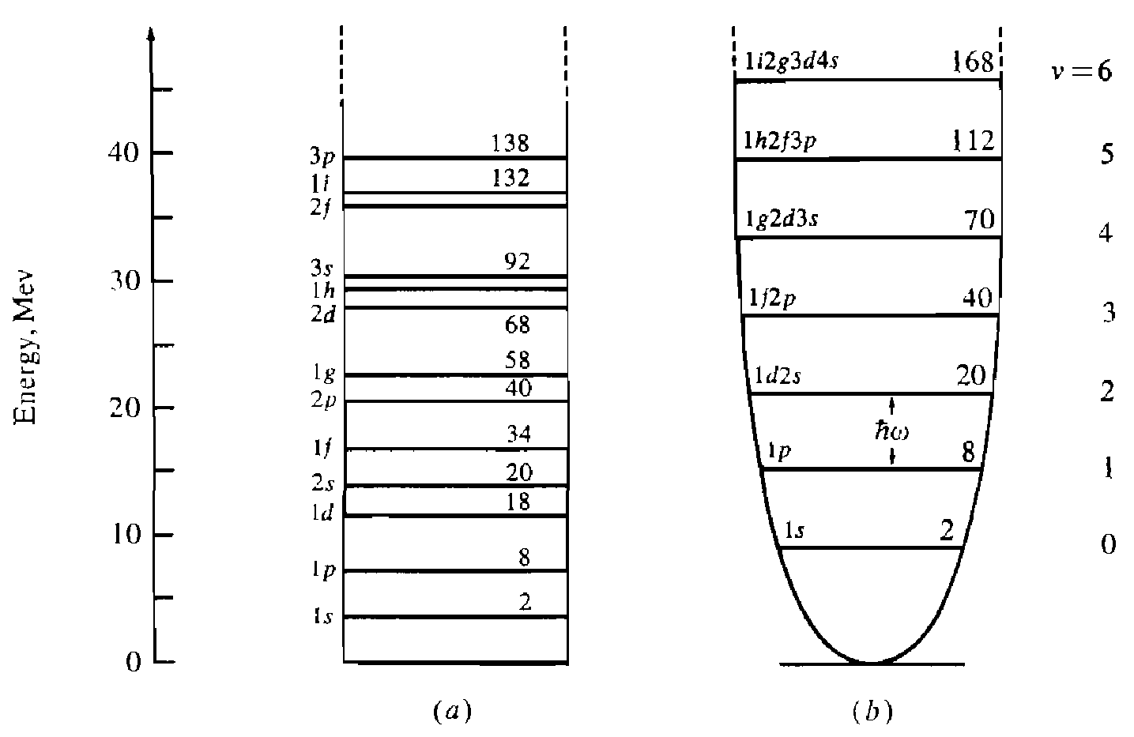

Figure (3-4): Energy levels of nucleons. (a) in an infinite spherical square-well potential. (b) in a harmonic oscillator potential. The spectroscopic notation (n,) and the total occupation number up to any particular level are given.

**Spin-Orbit coupling shell model**

A simple Coulomb potential is clearly not appropriate and we need some form that describes the effective potential of all the other nucleons. Since the strong nuclear force is short-ranged we would expect the potential to follow the form of the density distribution of nucleons in the nucleus. For medium and heavy nuclei, the Fermi distribution fits the data and the corresponding potential is called the Woods-Saxon form: 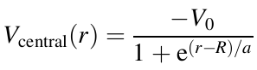

However, although these potentials can be shown to offer an explanation for the lowest magic numbers, they do not work for the higher ones. This is true of all purely central potentials.

The crucial step in understanding the origin of the magic numbers was suggested that by analogy with atomic physics there should also be a spin–orbit part, so that the total potential is:



Where L and S are the orbital and spin angular momentum operators for a single nucleon and  is an arbitrary function of the radial coordinate. This form for the total potential is the same as that used in atomic physics except for the presence of the function. Once we have coupling between L and S then  are no longer ‘good’ quantum numbers and we have to work with eigenstates of the total angular momentum vector J, defined by J=L+S. Squaring this, we have:



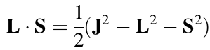

and hence the expectation value of L.S, which we write as , is:



(We are always dealing with a single nucleon, so that s=1/2) The splitting between the two levels is thus:

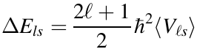

Experimentally, it is found that  is negative, which means that the state with  has a lower energy than the state with. This is the opposite of the situation in atoms. Also, the splitting are substantial and increase linearly with. Hence for higher, crossings between levels can occur. Namely, for large, the splitting of any two neighboring degenerate levels can shift the  state of the initial lower level to lie above the  level of the previously higher level.

An example of the resulting splitting up to the 1G state is shown in Figure (3-5), where the usual atomic spectroscopic notation has been used, i.e. levels are written (nj) with S, P, D, F, G, ... : used for = 0, 1, 2, 3, 4, .. . . Magic numbers occur when there are particularly large gaps between groups of levels. Note that there is no restriction on the values of  for a given n because, unlike in the atomic case, the strong nuclear potential is not Coulomb-like.

The configuration of a real nuclide (which of course has both neutrons and protons) describes the filling of its energy levels (sub-shells), for protons and for neutrons, in order, with the notation (nj)k for each sub-shell, where k is the occupancy of the given sub-shell. Sometimes, for brevity, the completely filled sub-shells are not listed, and if the highest sub-shell is nearly filled, k can be given as a negative number, indicating how far from being filled that sub-shell is.

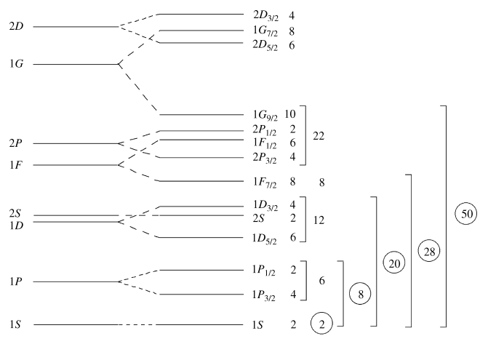

Figure (3-5): low-lying energy levels in a single-particle shell model using a Woods-Saxon potential plus spin-orbit term.

Using the ordering diagram above, and remembering that the maximum occupancy of each sub-shell is 2j+1, we predict, for example, the configuration for  to be:





Notice that all the proton sub-shells are filled, and that all the neutrons are in filled sub-shells except for the last one, which is in a sub-shell on its own. Most of the ground state properties of  can therefore be found from just stating the neutron configuration as .

Although the spin-orbit shell model had one of the most stimulating effects on nuclear structure physics, the simple form given above cannot be sufficient. For example, the model cannot explain why even-even nuclei always have a zero ground-state spin, or more generally, why any even number of identical nucleons couples to zero ground-state spin. Evidently there is a (residual) nucleon-nucleon interaction which favors the pairing of nucleons with opposing angular momenta.

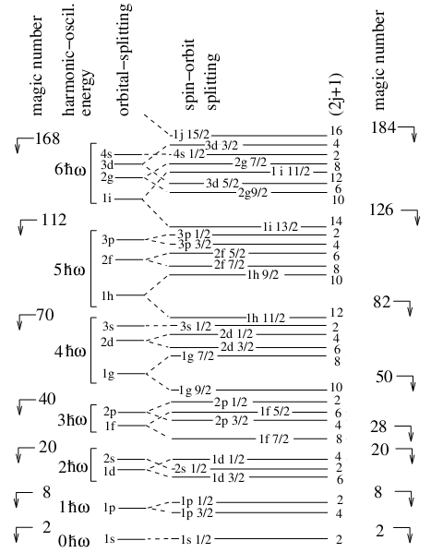

Figure (3-6): Nucleon orbitals in a model with a spin-orbit interaction. The two left columns show the magic numbers and energies for a pure harmonic potential. The splitting of different values of the orbital angular momentum  can be arranged by modifying the central potential. Finally, the spin-orbit coupling splits the levels so that they depend on the relative orientation of the spin and orbital angular momentum. The number of nucleons per level (2j+1) and the resulting magic numbers are shown on the right.

Table (3-1): Arrangement of the nuclear shells and its distributions.

|  |  |  |  |  |  |  |  |  |  |
| --- | --- | --- | --- | --- | --- | --- | --- | --- | --- |
| $$l$$ n | 0 | 1 | 2 | 3 | 4 | 5 | 6 | shell | No. of nucleons |
| 1 | 1s |  |  |  |  |  |  | s | 2 |
| 2 |  | 1p |  |  |  |  |  | p | 6 |
| 3 | 2s |  | 1d |  |  |  |  | d | 10 |
| 4 |  | 2p |  | 1f |  |  |  | f | 14 |
| 5 | 3s |  | 2d |  | 1g |  |  | g | 18 |
| 6 |  | 3p |  | 2f |  | 1h |  | h | 22 |
| 7 | 4s |  | 3d |  | 2g |  | 1i | i | 26 |

For example, and have one unpaired nucleon outside a doubly magic core. The above figure, tells us that the unpaired nucleon is in a =2, j=5/2. The spin parity of the nucleus is predicted to be 5/2+ since the parity of the orbital is . This agrees with observation. The first excited states of and corresponding to raising the unpaired nucleon to the next higher orbital, are predicted to be 1/2+, once again in agreement with observation.

On the other hand, and have one “hole” in their core, the ground state quantum numbers should then be the quantum numbers of the hole which are =1 and j=1/2 according to above Figure. The quantum numbers of the ground state are then predicted to be 1/2−, in agreement with observation.

**(3-5-3) Fermi Gas Model (Statistical Model or Uniform Particle Model)**

This model supposes that, as a result of the strong nuclear compound between the nucleons, the movement of them cannot study alone, but we must study them statistically, i.e. it's give the average of the physical quantity from all of the nucleons.

In this model, the protons and neutrons that make up the nucleus are assumed to comprise two independent systems of nucleons, each freely moving inside the nuclear volume subject to the constraints of the Pauli principle. The potential felt by every nucleon is the superposition of the potentials due to all the other nucleons. In the case of neutrons this is assumed to be a finite-depth square well; for protons, the Coulomb potential modifies this. A sketch of the potential wells in both cases is shown in Figure (3-7).

For a given ground state nucleus, the energy levels will fill up from the bottom of the well. The energy of the highest level that is completely filled is called the Fermi level of energy EF and has a momentum pF=(2MEF)1/2, where M is the mass of the nucleon. Within the volume V, the number of states with a momentum between p and p+dp is given by the *density of states factor*:

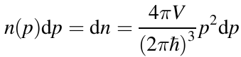

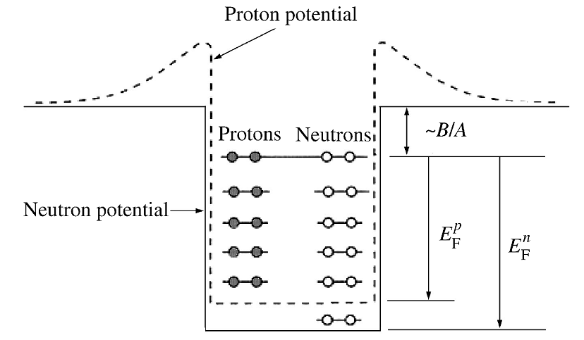

Figure (3-7): proton and neutron potentials and states in the fermi gas model.

Since every state can contain two fermions of the same species, we can have (using 

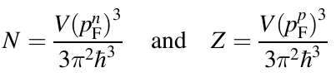

For neutrons and protons, respectively, with a nuclear volume

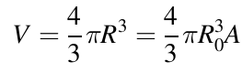

Where experimentally Ro=1.2fm, Assuming for the moment that the depths of the neutron and proton wells are the same, we find for a nucleus with Z=N=A/2, the Fermi momentum:

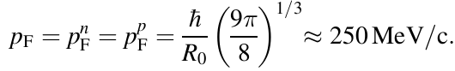

Thus the nucleons move freely within the nucleus with quite large momenta.

The Fermi energy is:

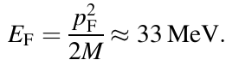

The difference between the top of the well and the Fermi level is constant for most heavy nuclei and is just the average binding energy per nucleon Bave=B/A=7–8 MeV. The depth of the potential and the Fermi energy are to a good approximation independent of the mass number A:

Vo=EF+Bave≈40MeV

Heavy nuclei generally have a surplus of neutrons. Since the Fermi levels of the protons and neutrons in a stable nucleus have to be equal (otherwise the nucleus can become more stable by β-decay) this implies that the depth of the potential well for the neutron gas has to be deeper than for the proton gas, as shown in Figure (3-7). Protons are therefore on average less tightly bound in nuclei than are neutrons.

**(3-5-4) Collective Model**

For each of the liquid drop model and shell model have a specific applications, all of them succeed in the interpretation of some phenomena and fails to explain other phenomena. So it became logical to consider each of these models is complementary to another in a single model called the collective model as a model that combines the two models. This model views the nucleus as having a hard core of nucleons in filled shells, as in the shell model, with outer valence nucleons that behave like the surface molecules of a liquid drop. In addition to the successes of each of the two models, this model has succeeded in formulating an equation to calculate the rotational energy levels to the even-even nuclei, i.e. the energy levels of deformed nuclei are very complicated, because there is often coupling between the various modes of excitation, but nevertheless many predictions of the collective model are confirmed experimentally.



Where, I is the moment of inertia to the nucleus.

J is the total angular momentum to the nucleus.

**(3-5-5) Optical Model**

The name comes from likening of the nucleus target as an optical lens, while the fallen particle represents the fallen optical wave. The most important achievements of the optical model are a description of the cross section for neutron absorption as a function of neutron's energy and of the mass number of the nucleus target. This model has been assumed that the total potential of the neutron and the nucleus target is a complex potential and can be written as:

V=Vo+iV1

Where Vo is the real part to the total potential which represents the effect of the nucleus on the neutron.

Vo=-42MeV for r≤R

=0 for r>R

While iV1 is the imaginary part to the potential which represents the probability to creates the compound nuclei.

**(3-5-6) Cluster Model (α-Particle Model)**

This model supposes that the alpha particle represent the building block of the nucleus, it's clear that this model explain the emitting of alpha particles from the heavy nucleus, for examples:



|  |  |  |
| --- | --- | --- |
| **Al-Mustansiriyah University**  **College of Science**  **Physics Department** |  | **Fourth Grade**  **Nuclear Structure**  **Dr. Ali Abdulwahab Ridha** |

**Chapter Four**

**(Nuclear Radiation)**

**(4-1) Nuclear Radiation**

Whenever a nucleus can attain a more stable (i.e., more tightly bound) configuration by emitting radiation, a spontaneous disintegration process known as radioactive decay or nuclear decay may occur. In practice, this "radiation" may be electromagnetic radiation, particles, or both.

Detailed studies of radioactive decay and nuclear reaction processes have led to the formulation of useful conservation principles. The four principles of most interest in this module are discussed below.

1. Conservation of electric charge implies that charges are neither created nor destroyed. Single positive and negative charges may, however, neutralize each other. It is also possible for a neutral particle to produce one charge of each sign.

2. Conservation of mass number does not allow a net change in the number of nucleons. However, the conversion of a proton to a neutron and vice versa is allowed.

3. Conservation of mass and energy implies that the total of the kinetic energy and the energy equivalent of the mass in a system must be conserved in all decays and reactions. Mass can be converted to energy and energy can be converted to mass, but the sum of mass and energy must be constant.

4. Conservation of momentum is responsible for the distribution of the available kinetic energy among product nuclei, particles, and/or radiation. The total amount is the same before and after the reaction even though it may be distributed differently among entirely different nuclides and/or particles.

**Alpha Decay (α)**

Alpha decay is the emission of alpha particles (helium nuclei) which may be represented as either. When an unstable nucleus ejects an alpha particle, the atomic number is reduced by 2 and the mass number decreased by 4. An example is Uranium-234 which decays by the ejection of an alpha particle accompanied by the emission of a 0.068 MeV gamma.



The combined kinetic energy of the daughter nucleus (Thorium-230) and the α particle is designated as KE. The sum of the KE and the gamma energy is equal to the difference in mass between the original nucleus (Uranium-234) and the final particles (equivalent to the binding energy released, since Δm=BE). The alpha particle will carry off as much as 98% of the kinetic energy and, in most cases, can be considered to carry off all the kinetic energy.

**Beta Decay (β)**

Beta decay is the emission of electrons of nuclear rather than orbital origin. These particles are electrons that have been expelled by excited nuclei and may have a charge of either sign.

If both energy and momentum are to be conserved, a third type of particle, the neutrino (ν) ­, must be involved. The neutrino is associated with positive electron emission, and its antiparticle, the antineutrino, is emitted with a negative electron. These uncharged particles have only the weakest interaction with matter, no mass, and travel at the speed of light. For all practical purposes, they pass through all materials with so few interactions that the energy they possess cannot be recovered. The neutrinos and antineutrinos are included here only because they carry a portion of the kinetic energy that would otherwise belong to the beta particle, and therefore, must be considered for energy and momentum to be conserved. They are normally ignored since they are not significant in the context of nuclear reactor applications.

Negative electron emission, represented as  or simply as e- or β-, effectively converts a neutron to a proton, thus increasing the atomic number by one and leaving the mass number unchanged. This is a common mode of decay for nuclei with an excess of neutrons, such as fission fragments below and to the right of the neutron-proton stability curve. An example of a typical beta minus-decay reaction is shown below.

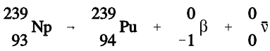

Positively charged electrons (beta-plus) are known as positrons. Except for sign, they are nearly identical to their negatively charged cousins. When a positron, represented as or simply as e+ or β+, is ejected from the nucleus, the atomic number is decreased by one and the mass number remains unchanged. A proton has been converted to a neutron. An example of a typical positron (beta-plus) decay is shown below.

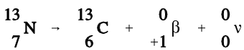

**Gamma Emission (γ)**

Gamma radiation is a high-energy electromagnetic radiation that originates in the nucleus. It is emitted in the form of photons, discrete bundles of energy that have both wave and particle properties. Often a daughter nuclide is left in an excited state after a radioactive parent nucleus undergoes a transformation by alpha decay, beta decay, or electron capture. The nucleus will drop to the ground state by the emission of gamma radiation.

**Electron Capture (EC, K-capture)**

Nuclei having an excess of protons may capture an electron from one of the inner orbits which immediately combines with a proton in the nucleus to form a neutron. This process is called electron capture (EC). The electron is normally captured from the innermost orbit (the K-shell), and consequently, this process is sometimes called K-capture. The following example depicts electron capture.

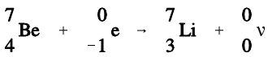

A neutrino is formed at the same time that the neutron is formed, and energy carried off by it serves to conserve momentum. Any energy that is available due to the atomic mass of the product being appreciably less than that of the parent will appear as gamma radiation. Also, there will always be characteristic x-rays given off when an electron from one of the higher energy shells moves in to fill the vacancy in the K-shell. Electron capture is shown graphically in Figure (4-1).

Electron capture and positron emission result in the production of the same daughter product, and they exist as competing processes. For positron emission to occur, however, the mass of the daughter product must be less than the mass of the parent by an amount equal to at least twice the mass of an electron. This mass difference between the parent and daughter is necessary to account for two items present in the parent but not in the daughter. One item is the positron ejected from the nucleus of the parent. The other item is that the daughter product has one less orbital electron than the parent. If this requirement is not met, then orbital electron capture takes place exclusively.

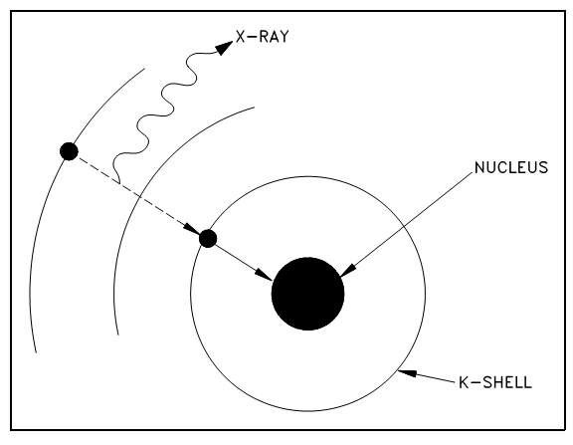

Figure (4-1): Orbital electron capture.

**Internal Conversion**

The usual method for an excited nucleus to go from the excited state to the ground state is by emission of gamma radiation. However, in some cases the gamma ray (photon) emerges from the nucleus only to interact with one of the innermost orbital electrons and, as a result, the energy of the photon is transferred to the electron. The gamma ray is then said to have undergone internal conversion. The conversion electron is ejected from the atom with kinetic energy equal to the gamma energy minus the binding energy of the orbital electron. An orbital electron then drops to a lower energy state to fill the vacancy, and this is accompanied by the emission of characteristic x-rays.

**Isomers and Isomeric Transition**

Isomeric transition commonly occurs immediately after particle emission; however, the nucleus may remain in an excited state for a measurable period of time before dropping to the ground state at its own characteristic rate. A nucleus that remains in such an excited state is known as a nuclear isomer because it differs in energy and behavior from other nuclei with the same atomic number and mass number. The decay of an excited nuclear isomer to a lower energy level is called an isomeric transition. It is also possible for the excited isomer to decay by some alternate means, for example, by beta emission.

An example of gamma emission accompanying particle emission is illustrated by the decay of nitrogen-16 below.

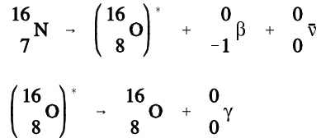

Another example of this type of decay is that of technetium-99m , which by the way is the most common radioisotope used for diagnostic purposes today in medicine. The reaction can be expressed as:



Here a nucleus of technetium-99 is in an excited state that is it has excess energy. The excited state in this case is called a metastable state and the nucleus is therefore called technetium-99m (m for metastable). The excited nucleus loses its excess energy by emitting a gamma-ray to become technetium-99.

**Spontaneous Fission**

This is a very destructive process which occurs in some heavy nuclei which split into 2 or 3 fragments plus some neutrons. These fragments form new nuclei which are usually radioactive. Nuclear reactors exploit this phenomenon for the production of radioisotopes. It's also used for nuclear power generation and in nuclear weaponry. The process is not of great interest to us here and we will say no more about it for the time being.

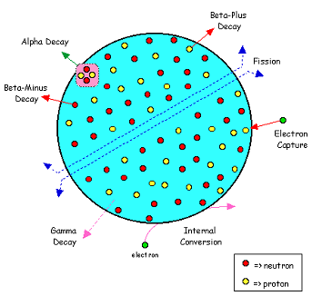

**Decay Schemes**

Decay schemes are widely used to give a visual representation of radioactive decay. The general method used for decay schemes is illustrated in the diagram below:

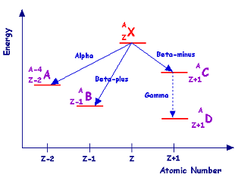

The energy is plotted on the vertical axis and atomic number on the horizontal axis-although these axes are rarely displayed in actual schemes. The isotope from which the scheme originates is displayed at the top - X in the case above. This isotope is referred to as the parent. The parent loses energy when it decays and hence the products of the decay referred to as daughters are plotted at a lower energy level.

The diagram illustrates the situation for common forms of radioactive decay. Alpha-decay is illustrated on the left where the mass number is reduced by 4 and the atomic number is reduced by 2 to produce daughter A. To its right the scheme for beta-plus decay is shown to produce daughter B. The situation for beta-minus decay followed by gamma-decay is shown on the right side of the diagram where daughters C and D respectively are produced.

For example, a scheme for a more complicated decay is that of caesium-137: This isotope can decay through two beta-minus processes. In one which occurs in 5% of disintegrations a beta-minus particle is emitted with energy of 1.17MeV to produce barium-137. In the second, which occurs more frequently (in the remaining 95% of disintegrations) a beta-minus particle of energy 0.51MeV is emitted to produce barium-137m, in other words a barium-137 nucleus in a metastable state. The barium-137m then decays via isomeric transition with the emission of a gamma-ray of energy 0.662MeV.

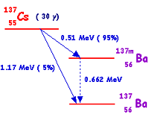

**Decay Chains**

When an unstable nucleus decays, the resulting daughter nucleus is not necessarily stable. The nucleus resulting from the decay of a parent is often itself unstable, and will undergo an additional decay. This is especially common among the larger nuclides.

It is possible to trace the steps of an unstable atom as it goes through multiple decays trying to achieve stability. The list of the original unstable nuclide, the nuclides that are involved as intermediate steps in the decay, and the final stable nuclide is known as the decay chain. One common method for stating the decay chain is to state each of the nuclides involved in the standard format. Arrows are used between nuclides to indicate where decays occur, with the type of decay indicated above the arrow and the half-life below the arrow. The half-life for decay will be discussed in the next chapter.

**Example:**

Write the decay chains for rubidium-91 and actinium-215. Continue the chains until a stable nuclide or a nuclide with a half-life greater than 1x106 years is reached.

**Solution:**

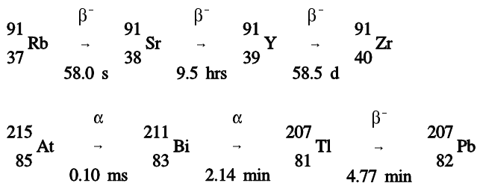

|  |  |  |
| --- | --- | --- |
| **Al-Mustansiriyah University**  **College of Science**  **Physics Department** |  | **Fourth Grade**  **Nuclear Structure**  **Dr. Ali Abdulwahab Ridha** |

**Chapter Five**

**(Interaction of Radiation with Matter)**

Different types of radiation interact with matter in widely different ways. A large, massive, charged alpha particle cannot penetrate a piece of paper and even has a limited range in dry air. A neutrino, at the other extreme, has a low probability of interacting with any matter, even if it passed through the diameter of the earth.

Radiation can be classified into two general groups, charged and uncharged; therefore, it may be expected that interactions with matter fall into two general types. Charged particles directly ionize the media through which they pass, while uncharged particles and photons can cause ionization only indirectly or by secondary radiation.

A moving charged particle has an electrical field surrounding it, which interacts with the atomic structure of the medium through which it is passing. This interaction decelerates the particle and accelerates electrons in the atoms of the medium. The accelerated electrons may acquire enough energy to escape from the parent atom, this process is called ionization. Uncharged moving particles have no electrical field, so they can only lose energy and cause ionization by such means as collisions or scattering. A photon can lose energy by the photoelectric effect, Compton Effect, or pair production. Because ionizing radiation creates ions in pairs, the intensity of ionization or the specific ionization is defined as the number of ion-pairs formed per centimeter of travel in a given material. The amount of ionization produced by a charged particle per unit path length, which is a measure of its ionizing power, is roughly proportional to the particle's mass and the square of its charge as illustrated in the equation below.



Where: I is the ionizing power, m is the mass of the particle, z is the number of unit charges it carries and K.E. is its kinetic energy

Since m for an alpha particle is about 7300 times as large as m for a beta particle, and z is twice as great, an alpha will produce much more ionization per unit path length than a beta particle of the same energy. This phenomenon occurs because the larger alpha particle moves slower for a given energy and thus acts on a given electron for a longer time.

**Alpha Radiation:**

Alpha radiation is normally produced from the radioactive decay of heavy nuclides and from certain nuclear reactions. The alpha particle consists of 2 neutrons and 2 protons, so it is essentially the same as the nucleus of a helium atom. Because it has no electrons, the alpha particle has a charge of +2. This positive charge causes the alpha particle to strip electrons from the orbits of the target atoms. As the alpha particle passes through material, it removes electrons from the orbits of atoms it passes near. Energy is required to remove electrons and the energy of the alpha particle is reduced by each reaction. Eventually the particle will expend its kinetic energy, gain 2 electrons in orbit, and become a helium atom. Because of its strong positive charge and large mass, the alpha particle deposits a large amount of energy in a short distance of travel. This rapid, large deposition of energy limits the penetration of alpha particles. The most energetic alpha particles are stopped by a few centimeters of air or a sheet of paper.

**Beta-Minus Radiation:**

A beta-minus particle is an electron that has been ejected at a high velocity from an unstable nucleus. An electron has a small mass and an electrical charge of -1. Beta particles cause ionization by displacing electrons from atom orbits. The ionization occurs from collisions with orbiting electrons. Each collision removes kinetic energy from the beta particle, causing it to slow down. Eventually the beta particle will be slowed enough to allow it to be captured as an orbiting electron in an atom. Although more penetrating than the alpha, the beta is relatively easy to stop and has a low power of penetration. Even the most energetic beta radiation can be stopped by a few millimeters of metal.

**Positron Radiation:**

Positively charged electrons are called positrons. Except for the positive charge, they are identical to beta-minus particles and interact with matter in a similar manner. Positrons are very short-lived, however, and quickly are annihilated by interaction with a negatively charged electron, producing two gammas with a combined energy (calculated below) equal to the rest mass of the positive and negative electrons.



**Bremsstrahlung:**

Small charged particles such as electrons or positrons may be deflected by nuclei as they pass through matter, which may be due to the positive charge of the atomic nuclei. This type of interaction generates x-radiation known as bremsstrahlung (Fig. below), which in German means “braking radiation.”

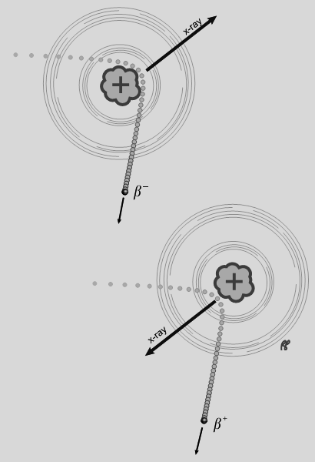

Figure (5-1): Bremsstrahlung. Beta particles (β−) and positrons (β+) that travel near the nucleus will be attracted or repelled by the positive charge of the nucleus, generating x-rays in the process.

**Neutron Radiation:**

Neutrons have no electrical charge. They have nearly the same mass as a proton (a hydrogen atom nucleus). A neutron has hundreds of times more mass than an electron, but 1/4 the mass of an alpha particle. The source of neutrons is primarily nuclear reactions, such as fission, but they may also be produced from the decay of radioactive nuclides. Because of its lack of charge, the neutron is difficult to stop and has a high penetrating power. Neutrons are attenuated (reduced in energy and numbers) by three major interactions, elastic scatter, inelastic scatter, and absorption. In elastic scatter, a neutron collides with a nucleus and bounces off. This reaction transmits some of the kinetic energy of the neutron to the nucleus of the atom, resulting in the neutron being slowed, and the atom receives some kinetic energy (motion). As the mass of the nucleus approaches the mass of the neutron, this reaction becomes more effective in slowing the neutron. Hydrogenous material attenuates neutrons most effectively. In the inelastic scatter reaction, the same neutron/nucleus collision occurs as in elastic scatter. However, in this reaction, the nucleus receives some internal energy as well as kinetic energy. This slows the neutron, but leaves the nucleus in an excited state. When the nucleus decays to its original energy level, it normally emits a gamma ray. In the absorption reaction, the neutron is actually absorbed into the nucleus of an atom. The neutron is captured, but the atom is left in an excited state. If the nucleus emits one or more gamma rays to reach a stable level, the process is called radiative capture. This reaction occurs at most neutron energy levels, but is more probable at lower energy levels.

**Electromagnetic (Gamma) Radiation:**

Gamma radiation is electromagnetic radiation. It is commonly referred to as a gamma ray and is very similar to an x-ray. The difference is that gamma rays are emitted from the nucleus of an atom, and x-rays are produced by orbiting electrons. The x-ray is produced when orbiting electrons move to a lower energy orbit or when fast-moving electrons approaching an atom are deflected and decelerated as they react with the atom's electrical field (called Bremsstrahlung).

The gamma ray is produced by the decay of excited nuclei and by nuclear reactions. Because the gamma ray has no mass and no charge, it is difficult to stop and has a very high penetrating power. A small fraction of the original gamma stream will pass through several feet of concrete or several meters of water. There are three methods of attenuating gamma rays. ***The first method is referred to as the photoelectric effect.*** When a low energy gamma strikes an atom, the total energy of the gamma is expended in ejecting an electron from orbit (generally inner shell). The result is ionization of the atom and expulsion of a high energy electron. This reaction is most predominant with low energy gammas interacting in materials with high atomic weight and rarely occurs with gammas having energy above 1MeV. Any gamma energy in excess of the binding energy of the electron is carried off by the electron in the form of kinetic energy.

***The second method of attenuation of gammas is called Compton scattering.*** The gamma interacts with an orbital (outer shell) or free electron; however, in this case, the photon loses only a fraction of its energy. The actual energy loss depending on the scattering angle of the gamma (scattering angle can range from nearly 0o to 180o). The gamma continues on at lower energy, and the energy difference is absorbed by the electron. This reaction becomes important for gamma energies of about 0.1 MeV and higher.

In Compton scattering, a photon scatters from an electron, resulting in a scattered electron (Compton electron) and a less energetic photon. If we regard the stuck electron as free and at rest (good approx.), we can use relativistic conservation to find a formula for:

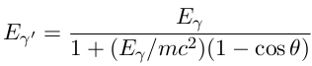

***At higher energy levels, a third method of attenuation is predominant. This method is pair-production.*** When a high energy gamma passes close enough to a heavy nucleus, the gamma completely disappears, and an electron and a positron are formed. For this reaction to take place, the original gamma must have at least 1.02MeV energy. Any energy greater than 1.02 MeV becomes kinetic energy shared between the electron and positron. The probability of pair-production increases significantly for higher energy gammas. ***The forth method is the Coherent Scattering (unmodified scattering).*** The interaction in which radiation undergo a change in direction without a change in wavelength. There are two types: 1. Thomson Scattering, a single electron is involved in the interaction. 2. Rayleigh Scattering, results from a cooperative interaction with all electrons of an atom. ***While the fifth on is Photodisintegration.*** In this method, part of nucleus of an atom is ejected by a high energy photon. The ejected portion may be neutron, a proton, an alpha particle, or cluster of particles. The photon energy must be in order of 7-15 MeV.

If we consider a beam of photons on a slab of thickness x, we have μ as a "total linear attenuation coefficient", where simply μ=τ+σ+κ (for photoelectric absorption, Compton scattering, and pair production losses, respectively). The fractional loss in intensity is:

dI/I=-μdx so that I=Ioe-μx

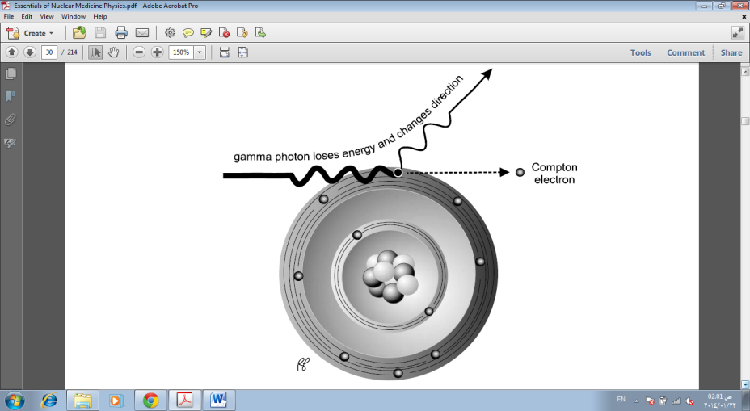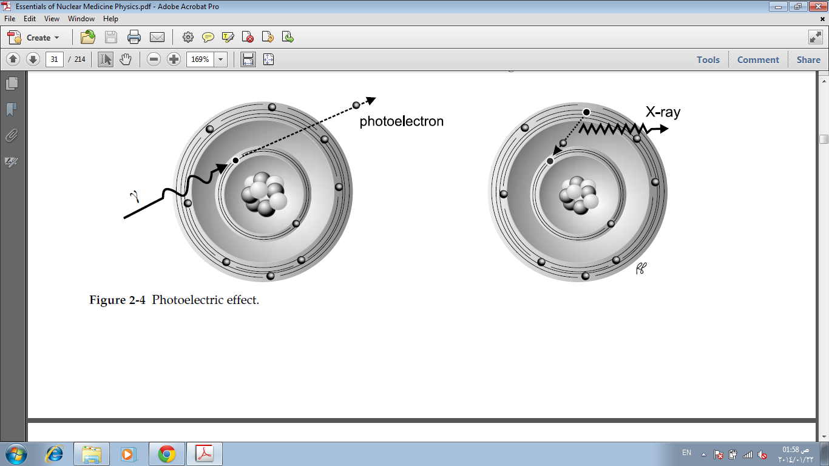

Figure (5-2): (a) Photoelectric effect, (b) Compton scattering.

**Shielding**

Alpha particles can be shielded by a piece of paper.

Beta particles can be shielded by a thin sheet of metal.

Gamma rays require thicker metal, often of high Z such as lead.

Neutrons moderated (slowed down) by low Z materials, captured by boron, cadmium.