**Lec(1) Serology 1/ 4/2018**

**Assistant Prof. Dr. Ekhlass N. Ali**

**Serology:** is the scientific study of [serum](https://en.wikipedia.org/wiki/Serum_(blood)) and other bodily fluids. In practice, the term usually refers to the [diagnostic](https://en.wikipedia.org/wiki/Medical_diagnosis) identification of [antibodies](https://en.wikipedia.org/wiki/Antibody) in the serum. Such antibodies are typically formed in response to an infection (against a given [microorganism](https://en.wikipedia.org/wiki/Microorganism)), against other foreign proteins (in response, for example, to a [mismatched](https://en.wikipedia.org/wiki/Acute_hemolytic_transfusion_reaction) [blood transfusion](https://en.wikipedia.org/wiki/Blood_transfusion)), or to one's own proteins (in instances of [autoimmune disease](https://en.wikipedia.org/wiki/Autoimmune_disease)).

Measuring antibody in serum or secretions and identifying antigens in blood, tissue or secretions using immunochemical techniques.

**USES and APPLICATIONS :**

• Immunity/past infection

• Screening blood /tissue donors

• Recent/Congenital infection

• Epidemiological studies.

• Where organism cannot be cultured

• To confirm an isolation

• To measure vaccine response

• Where disease is equelae of infection

• To confirm PCR.

Human beings have progressed too much in every field of life. They have advanced in the field of science and technology. There are many fields in which the advancement of science has a lot and is very beneficial to human beings. One of these fields is the field of medical. The advancement in the field of medical is warmly welcomed as it is of great advantage for the people and it has found the cure of the diseases which were thought to be substitute of death. Now this advancement has reduced the death rate to a great and is helping a lot in securing important human lives.

**Monoclonal Ab. And Polyclonal Ab:**

**Production of Monoclonal Antibodies**

Highly specific antibodies can be obtained by fusing immune splenic B cells from the spleen with tumor cells to produce **hybridomas,** each of which will then secrete a single antibody. The desired antibody-producing hybridoma can be identified by a screening process. If this hybridoma is subjected to a cloning step in which clones are selected, such that all progeny are derived from a single cloned parental cell, a monoclonal antibody is obtained. Monoclonal antibodies have high specificity and can be produced in large quantities. Thus, these biological reagents have been used extensively as probes in a wide range of systems including the characterization of novel cell-surface and soluble

proteins and carbohydrates, as enzyme catalysts, and for targeting in immunotherapy

protocols for immunization and cell fusion and selection . provided for screening primary hybridoma supernatants for antibodies of desired specificity establishment of stable hybridoma lines cloning of these B cell lines by limiting

dilution to obtain monoclonal lines and preparation of cloning/ expansion medium (thymocyte-conditioned medium.

The monoclonal antibody may be an extremely valuable reagent that will be

available in large quantities.

**IMMUNIZATION TO PRODUCE MONOCLONAL ANTIBODIES**

A wide variety of antigen preparations have been used successfully to produce monoclonal antibodies preparation).

protocol provides an immunization schedule for the production of most antibodies,although several different schedules can be used. In this protocol, emulsified antigen is injected intraperitoneally into the species of choice. A booster injection is administered 10 to 14 days after the primary immunization. Three days after the booster injection, the animals’ spleens are ready for cell fusion ***.***

**Materials**

**Antigen:**

Complete Freund’s adjuvant Animal: pathogen-free mouse, rat, or hamster

Incomplete Freund’s adjuvant .

1- to 2-ml glass syringes with Luer-Lok tips, sterile

3-way stopcock

20- and 22-G needles, sterile

*CAUTION:* CFA is an extremely potent inflammatory agent, and is hazardous to the investigator, particularly if introduced intradermally or into the eyes. Profound sloughing of skin or loss of sight may occur. Self-injection can cause a positive TB skin test and lead to a granulomatous reaction. Use gloves and protective eyewear when handling CFA.

1. Prepare antigen using 2 . 106 to 5 . 107 cells or 1 to 50 μg protein or peptide per animal to be immunized in normal saline. The antigen may be in any of several different forms depending on the desired property of the MAb and the method of screening preparation and screening assays). If cells are the immunogen, wash three times in serum-free medium before immunization. Plan the immunization of several animals(enough for several fusions) so that primed and boosted animals will be ready 3 days before fusion To minimize the risk of introducing a pathogen into the rodent colony, screen cells for

pathogens by antibody-production assay

2. Draw up antigen into a sterile 1- to 2-ml glass syringe with .

syringe to a 3-way stopcock.

3. Completely resuspend CFA to disperse the Mycobacterium tuberculosis bacilli which settle to the bottom of the container with time. Draw up a volume of CFA equal to the antigen volume in a syringe and connect to the antigen-containing syringe.

4. Emulsify antigen and CFA by discharging antigen into CFA, then discharging back and forth until a thickened mixture results. Test whether the emulsion is stable—a stable emulsion will not disperse when a drop of it is placed in water.

5. Transfer all of the CFA/antigen emulsion to one syringe and remove the other syringe and stopcock. Attach a sterile 20-G needle to the syringe containing the emulsion.

6. Inject emulsion intraperitoneally into the animal using <0.2 ml per mouse, 0.5 to 1ml per rat, or 0.2 to 0.4 ml per hamster.

Be careful not to force the syringe plunger since excessive pressure may dislodge the needle and spray the emulsion. Introduce the needle through the skin and tunnel the needle

between the skin and peritoneal wall before entering the peritoneal cavity at a site distant

from the dermal puncture site. Twirl needle before withdrawal to minimize leakage.

Rats are generally anesthetized whereas mice and hamsters can be manipulated with one hand and do not require anesthetic.

7. Boost animal after 10 to 14 days with approximately the same dose of antigen as in step 5. If cell fusion is planned for 3 days after boosting, immunize with antigen alone in aqueous solution, or intact cells in suspension. If a fusion is not immediately planned, boost the animal with antigen emulsified in IFA (which does not contain Mycobacterium tuberculosis bacilli).

Do not use CFA for the booster immunizations as this will cause intense inflammation and increased anti-TB antibody response.

If desired, antibody titers can be assayed by ELISA or immunoprecipitation .to 10 days after the primary and booster immunizations.

**Monoclonal Antibodies**

[Monoclonal antibodies](http://www.randox-lifesciences.com/Monoclonal-Antibodies-c-3) represent a single B lymphocyte generating antibodies to one specific epitope. B-cells can be isolated easily from the spleen and lymph nodes of immunised animals; however, these cells have a limited life span, and can only divide a limited number of times, coined the 'Hayflick limit'. This prohibits the culture of B-cells directly. For an antibody to be useful in research or industry, it must be readily available in large quantities. Due to the Hayflick limit, this would not be possible using B-cells cultured *in vitro* as they would eventually stop dividing and the population would die out.

Consequently, in 1975 Kohler and Milstein developed a technology to fuse immortal heteromyleoma cells with lymphocytes, using poly ethylglycol (PEG) to break down cell membranes and allow mixing of the genetic material from both cell types. The resulting cell type is called a hybridoma. This hybridoma takes on the characteristics of both the lymphocyte and heteromyeloma cell, creating an immortal cell with the ability to produce antibody. As the new cell line hybridoma is a product of the fusion of one heteromyeloma cell with one B-cell, the culture only ever has one antibody within the supernatant which, when purified, is called a [Monoclonal antibody](http://www.randox-lifesciences.com/Monoclonal-Antibodies-c-3). This technology allows scientists to extract and purify one antibody from the complex mixture of antibodies present in the *in vivo*polyclonal response. This cell line, once stabilised via single cell cloning, can be frozen and stored indefinitely under liquid nitrogen, allowing the antibody to be produced *in vitro,*in large quantities when required.

[Monoclonal antibodies](http://www.randox-lifesciences.com/Monoclonal-Antibodies-c-3) can be raised against many targets. Specific antibody characteristics can be identified and selected e.g. sensitivity requirements and cross reactivity levels can be specified and monoclonal antibodies screened to identify any cell lines exhibiting the required characteristics.

[Monoclonals](http://www.randox-lifesciences.com/Monoclonal-Antibodies-c-3) can also be generated to cross react with a group of molecules, for example the tricyclic anti-depressants have a similar overall structure with substitutions of differing atoms into the cyclic structure. This is very useful in drug detection when many possible combinations of the drug are to be tested in a patient.

**Monoclonal antibodies**

**​Facts:**

* High specificity. detect only one epitope on the antigen.
* Consist of only one antibody subtype (eg IgG1, IgG2, IgG3). When a secondary antibody is required for detection an antibody against the correct subclass should be chosen.  
  **Antibody production:**
* High technology required.
* Training is required for the technology used.
* Long timeframe for hybridoma production.

**Advantages:** Hybridomas are a constant and renewable source once created, and all batches will be identical, increasing consistency and standardization of experimental procedures and results.

Monoclonals detect one epitope per antigen. This has the following advantages:

* Less background from staining of sections and cells. Specifically detecting one target epitope means they are less likely to cross-react with other proteins.
* Due to their high specificity, monoclonal antibodies are excellent as the primary antibody in an assay and will often give significantly less background staining than polyclonal antibodies.
* Homogeneity of monoclonal antibodies is very high relative to polyclonals. If experimental conditions are kept constant, results from monoclonal antibodies will be highly reproducible between experiments.
* High specificity makes them extremely efficient for the binding of an antigen within a mixture of related molecules, such as during affinity purification.

**Disadvantages:**

* May be too specific to detect across a range of species.

More vulnerable to the loss of epitope through chemical treatment of the antigen than polyclonal antibodies. This can be offset by pooling two or more monoclonal antibodies to the same antigen (eg cocktail antibodies).

**Polyclonal Antibodies**

The immune response to an antigen generally involves the activation of multiple B-cells all of which target a specific epitope on that antigen. As a result a large number of antibodies are produced with different specificities and epitope affinities these are known as [polyclonal antibodies](http://www.randox-lifesciences.com/Polyclonal-Antibodies-c-2).

For production purposes these antibodies are generally purified from the serum of immunised animals were the antigen of interest stimulates the B-lymphocytes to produce a diverse range of immunoglobulin's specific to that antigen.

The aim is to produce high titre, high affinity antibodies. Today these polyclonal antibodies are used extensively for research purposes in many areas of biology, such as immune precipitation, histochemistry, enzyme linked immunosorbent assays (ELISA), [diagnosis of disease](http://www.randox.com/), immunoturbidimetric methods, western blots and Biochip technology. Polyclonal antibodies are ideally suited for use in sandwich assays as second stage antigen detectors.

Often [polyclonal antibodies](http://www.randox-lifesciences.com/Polyclonal-Antibodies-c-2) will be tagged with reporter molecules such as horseradish peroxidase (HRP) or alkaline phosphatase (AP) so that under specific conditions the antibodies presence can be detected by light or colour changes.

**Polyclonal antibodies**

**Facts:**

* Recognize multiple epitopes on any one antigen. Serum obtained will contain a heterogenous complex mixture of antibodies of different affinity.
* Polyclonals are made up mainly of IgG subclass.
* Peptide immunogens are often used to generate polyclonal antibodies that target unique epitopes, especially for protein families of high homology.  
  ​**Antibody production:**
* Inexpensive and relatively quick to produce.
* Production is less complex compared with monoclonal antibodies.

**Advantages:**

Polyclonal antibodies recognize multiple epitopes on any one antigen. This has the following advantages:

* High affinity: polyclonals amplify signal from a target protein with low expression level, as the target protein will bind more than one antibody molecule on the multiple epitopes. However, this is disadvantageous for quantification experiments (eg in flow cytometry) as it generates inaccurate results.
* Recognize multiple epitopes to give better results in immunoprecipitation (IP) and chromatin immunoprecipitation (ChIP).
* More tolerant of minor antigen changes (eg polymorphism, heterogeneity of glycosylation or slight denaturation) than monoclonals.
* Can identify proteins of high homology to the immunogen protein, and can be used to screen for the target protein in species other than that of the immunogen.
* Often the preferred choice for detecting denatured proteins.
* Multiple epitopes generally provide more robust detection.

**Disadvantages:**

* Prone to batch-to-batch variability.
* Produce large amounts of non-specific antibodies, which can create background signal in some applications.
* Multiple epitopes make it important to check immunogen sequence for cross-reactivity.
* Not useful for probing specific domains of antigen because antiserum will usually recognize many domains.

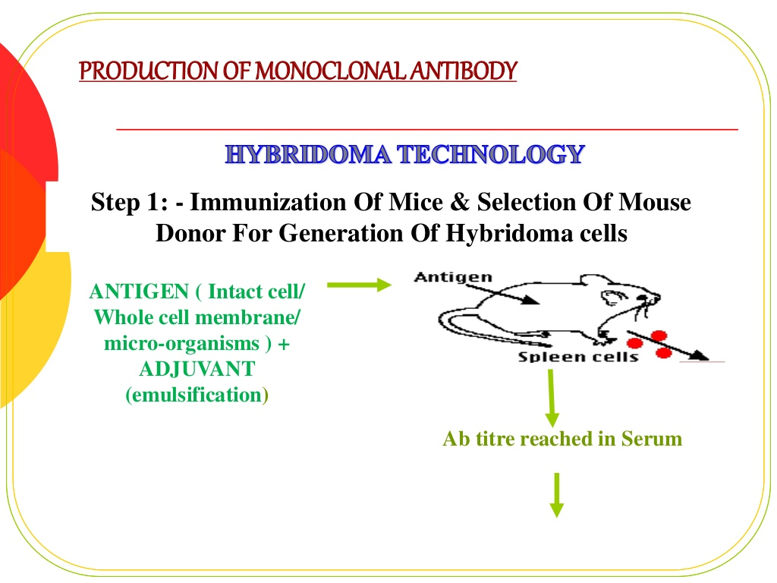

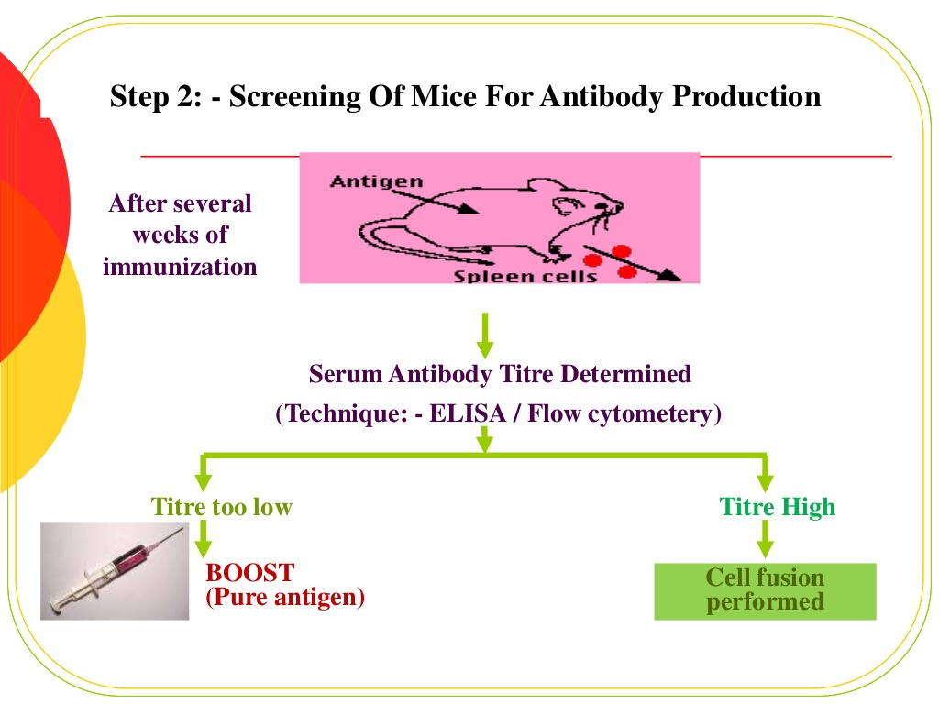

Description: http://image.slidesharecdn.com/monoclonalantibodiesandgenetherpy-140930003941-phpapp01/95/monoclonal-antibodies-and-gene-therpy-11-1024.jpg?cb=1412055601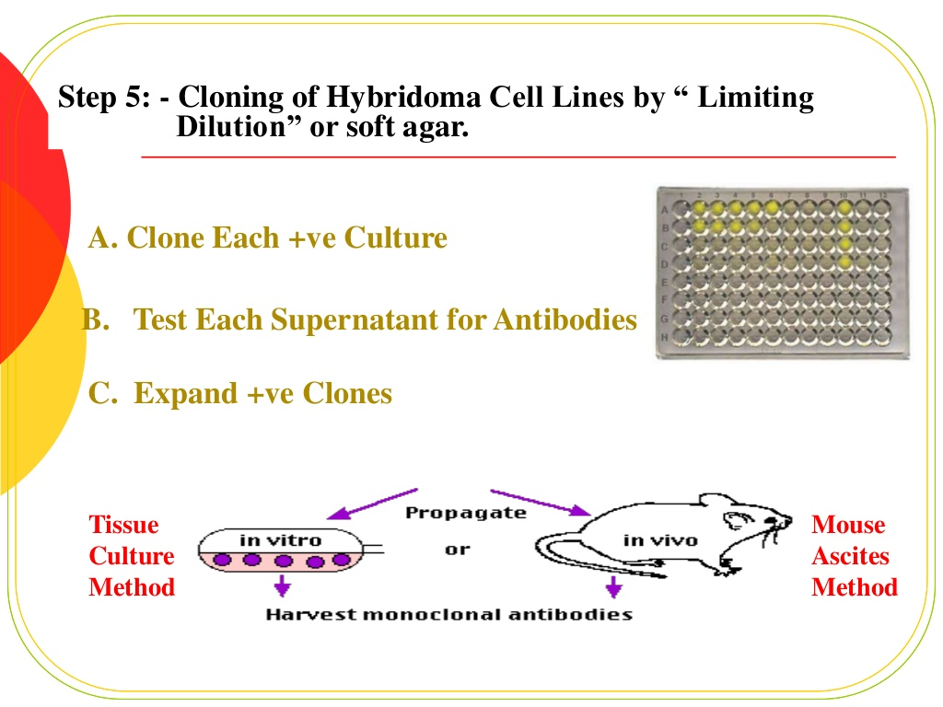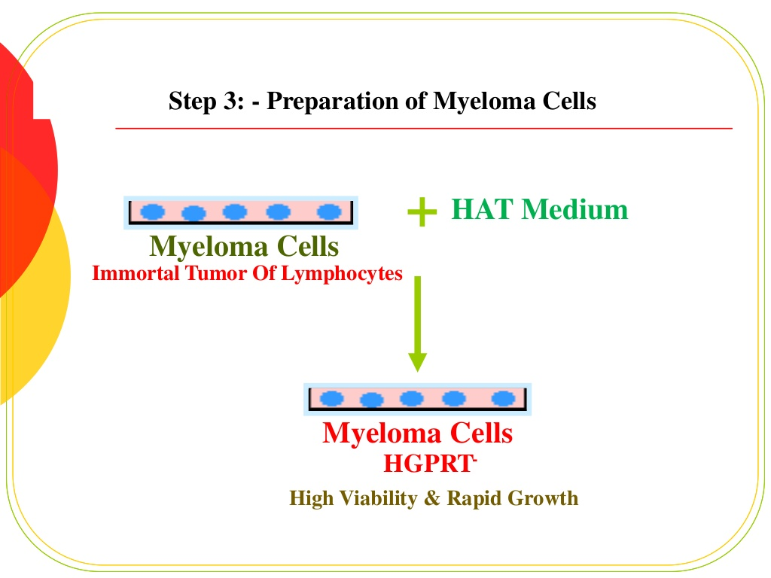

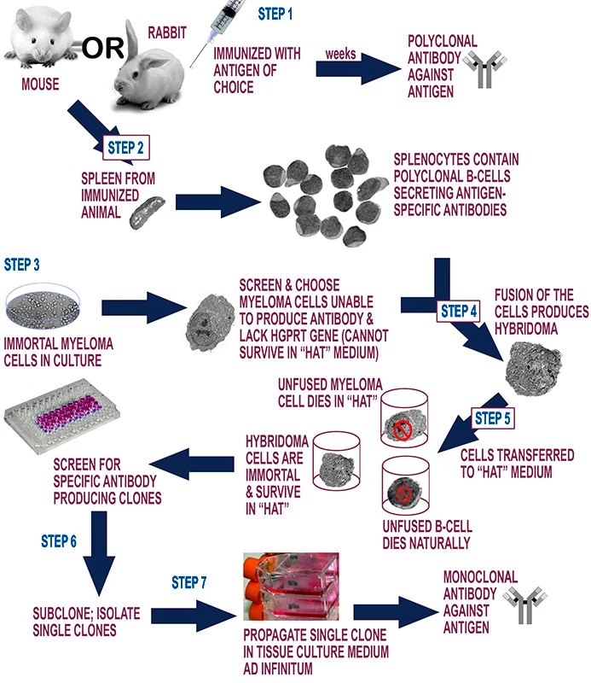

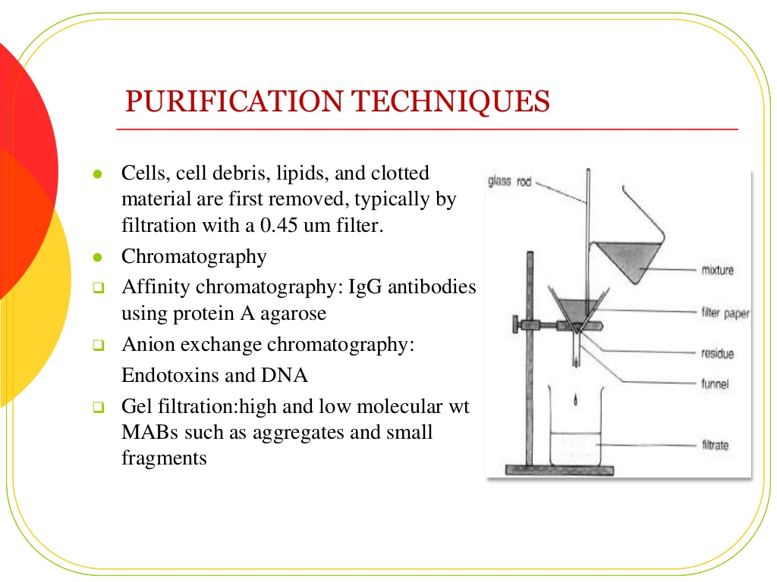

|  |  |
| --- | --- |
| **Polyclonal antibodies** | **Monoclonal antibodies** |
| Inexpensive to produce | Expensive to produce |
| Skills required for production are low | Training is required for the technology used |
| Relatively quick to produce | Hybridomas take a relatively long time to produce​ |
| Generate large amounts of non-specific antibodies | Generate large amounts of specific antibodies |
| Recognize multiple epitopes on any one antigen | Recognize only one epitope on an antigen |
| Can have batch-to-batch variability | Once a hybridoma is made, it is a constant and renewable source |
|  | No or low batch-to-batch variability |