Physical methods
Physical methods have also been used for soil-borne pest control, including steaming and solarization:

1-Steaming, which provides a wide spectrum of pest control, does not leave
any harmful residues in the soil, and no waiting period is required for
planting. However, this method is of low selectivity, creating a “biological vacuum”; it requires high initial investment for its implementation,consumes a high quantity of energy.

2-Solarization is a recent development for soil disinfection, which has been used in some countries for the last five-six years. Research on this method started in 1998 in the country. It consists of the use of plastic transparent sheets covering clean and moist soil to enable sunrays to pass through and to be absorbed, thus creating a heating system in soil that will later control several weeds and other pathogens present in soil. This method is effective when the soil is deeply prepared and is initially irrigated at field capacity. Heat leakage should be avoided by making sure that the plastic sheet edges are buried well. Air gaps between the plastic and soil should be minimized as they inhibit heat transfer into the soil.

Biological control agents:
1- Predators
2- Parasitoid insects
3- Micro-organisms (bacteria , fungy ,viruses ,Protozoa, Nematode)
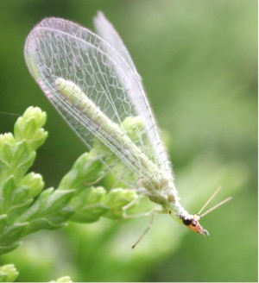
1- Predators
Predators are mainly free-living species that directly consume a large number of prey during their whole lifetime.
Ladybugs, and in particular their larvae which are active between May and July in the northern hemisphere, are voracious predators of aphids, and will also consume mites, scale insects and small caterpillars.
The larvae of many hoverfly species principally feed upon greenfly, one larva devouring up to fifty a day, or 1000 in its lifetime. They also eat fruit tree spider mites and small caterpillars. Adults feed on nectar and pollen, which they require for egg production.
Other useful garden predators include lacewings, pirate bugs, rove and ground beetles, aphid midge, centipedes, spiders, predatory mites, as well as larger fauna such as frogs, toads, lizards, hedgehogs, slow-worms and birds. Cats and rat terriers kill field mice, rats, June bugs, and birds. Dachshunds are bred specifically to fit inside tunnels underground to kill badgers.
Dragonflies are important predators of mosquitoes, both in the water, where the dragonfly naiads eat mosquito larvae, and in the air, where adult dragonflies capture and eat adult mosquitoes. Community-wide mosquito control programs that spray adult mosquitoes also kill dragonflies, thus reducing an important biocontrol agent.
More examples:
- Phytoseiulus persimilis (against spider mites)
- Amblyseius californicus (against spider mites)
- Amblyseius cucumeris (against spider mites)

2- Parasitoid insects
Parasitoids lay their eggs on or in the body of an insect host, which is then used as a food for developing larvae. The host is ultimately killed. Most insect parasitoids are wasps or flies, and usually have a very narrow host range.
Four of the most important groups are:
- Ichneumonid wasps: (5–10 mm). Prey mainly on caterpillars of butterflies and moths.
- Braconid wasps: Tiny wasps (up to 5 mm) attack caterpillars and a wide range of other insects including greenfly. A common parasite of the cabbage white caterpillar- seen as clusters of sulphur yellow cocoons bursting from collapsed caterpillar skin.
- Chalcid wasps: Among the smallest of insects (<3 mm). Parasitize eggs/larvae of greenfly, whitefly, cabbage caterpillars, scale insects and Strawberry Tortrix Moth (Acleris comariana).
- Tachinid flies: Parasitize a wide range of insects including caterpillars, adult and larval beetles, true bugs, and others.

Examples of parasitoids:

Encarsia formosa was one of the first biological control agents developed.
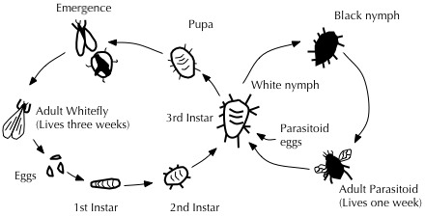
Diagram illustrating the life cycles of Greenhouse whitefly and its parasitoid wasp Encarsia formosa
- Encarsia formosa A small predatory chalcid wasp which is a parasitoid of whitefly, a sap-feeding insect which can cause wilting and black sooty moulds. It is most effective when dealing with low level infestations, giving protection over a long period of time. The wasp lays its eggs in young whitefly 'scales', turning them black as the parasite larvae pupates.
- Eretmocerus spp. (against white flies).

