Chapter one

  - Sun Sheets:
The Sun is a G2 type star, one of the hundred billion stars of this type in our galaxy (one of the hundred billion galaxies in the known universe).
- Diameter: 1,390,000 km (the Earth: 12,742 km or 100 times smaller)
- Mass: 1.1989 x 10³⁰ kg (333,000 times the mass of the Earth)
- Temperature: 5800 K (at the surface) 15,600,000 K (at the core) .
- The Sun contains 99.8% of the total mass of the Solar System (Jupiter contains nearly all the rest).
- Chemical composition:
Hydrogen 92.1%
Helium 7.8%
Other elements: 0.1%
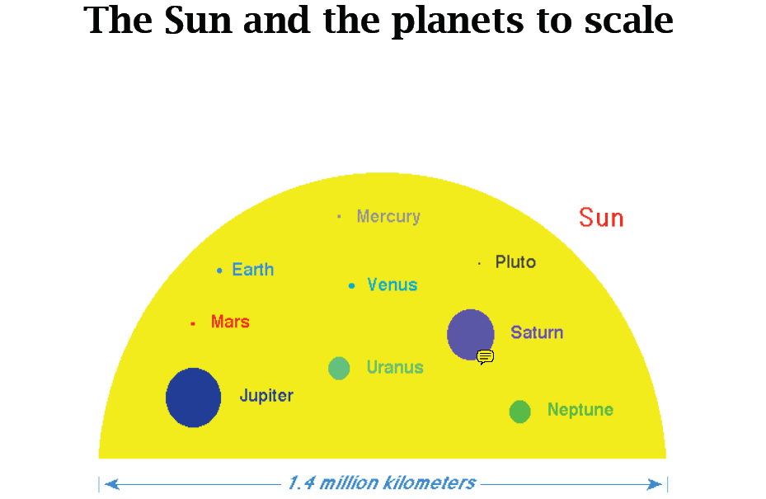

1.2 The internal structure of the Sun:
The Sun’s energy is created in the core by fusing hydrogen into helium. This
Energy is irradiated through the radiative layer, then transmitted by convection
Through the convective layer, and, finally, radiated through the photosphere,
Which is the part of the Sun that we see.
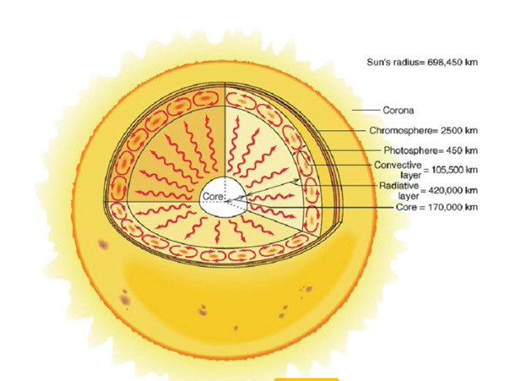
Radiation flux is regular up to a point. In reality it reveals variations. Spots appear as dark spots on the surface of the Sun and they have a temperature of 3,700 K (to be compared to the 5,800 K of the surrounding photosphere). A solar spot can last for may days, the most persistent lasting for many weeks. Solar radiation is subject to fluctuations, some of which are localized in restricted areas, while others are more global and follow an 11-year cycle. Every 11 years the sun goes from a limited number of solar spots and flares to a maximum, and vice versa. During this cycle the Sun’s magnetic poles switch orientation. The last solar minimum was in 2006.
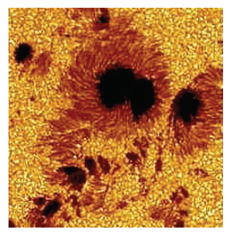
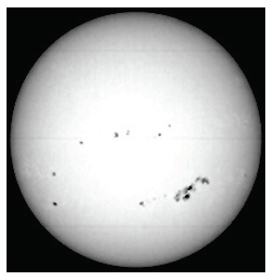

1-3 Solar radiation:
The sun irradiates approximately at the solar constant rate, which is, on the average, on the top of the atmosphere,
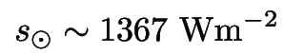
In its orbit around the Sun, the Earth keeps its north-south rotational axis unvaried, causing a different angle between the Sun’s rays and the surface of the Earth. The Earth is 5 million kilometers closer to the Sun during the northern winter: a clear indication that temperature is controlled more by orientation than by distance.
The Earth’s orbit around the Sun is an ellipse. The shape of the ellipse is determined by its eccentricity, which varies in time, changing the distances of the aphelion and perihelion

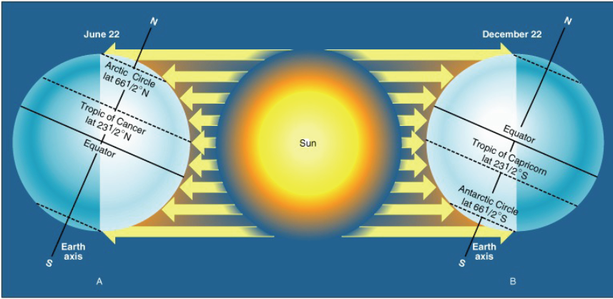
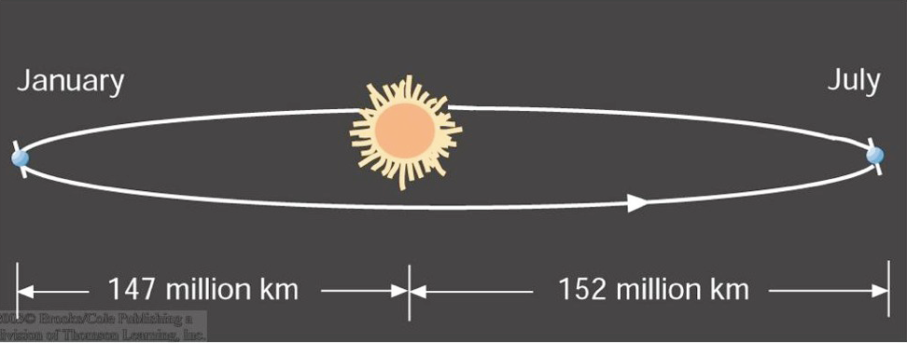

1-4 Radiation received from the Sun:
Solar intensity governs seasonal climatic changes and the local climatic niches
which are linked to the apparent height of the Sun. Incoming solar radiation is not evenly distributed across all lines of latitude, creating a heating imbalance.
For example, the complete energy balance is greater at the equator but the greatest amount of insolation is in the subtropical deserts Average annual radiation is
< 80 W/m2 in the cloudy parts of the arctic and the antarctic
>280 W/m2 in the subtropical deserts
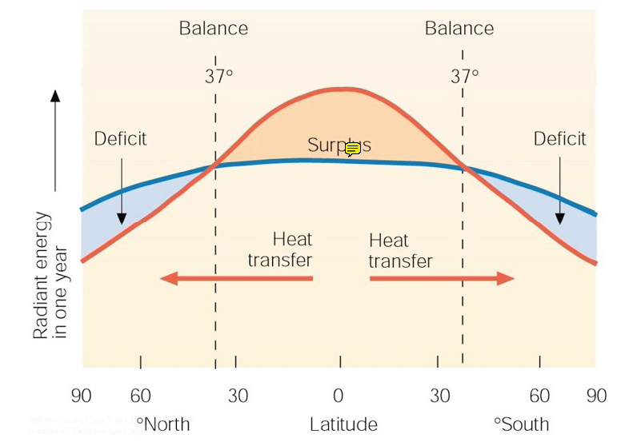
The tilt of the earth’s axis and atmospheric effects together affect the amount of radiation that reaches the ground.
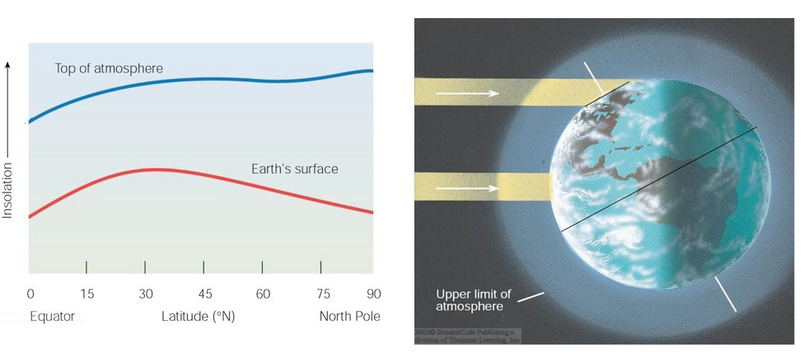

Particle Aspect of Electromagnetic Radiation.
In addition to its wave nature, electromagnetic radiation also seems to come in discrete bundles of energy called ‘photons.’ The energy of a photon depends on the frequency of the radiation via Planck’s law:
ε = hν = hc/λ.
This relation connects the wave-particle dual characteristics of EM radiation. The particle aspect is most relevant at high energies, or very low light levels, i.e., where there are few photons.
The Doppler Effect
Often explained by analogy to sound or water waves. See squeezed wave
diagram below.
Full special relativistic expression for wavelength of light from a moving source
is,
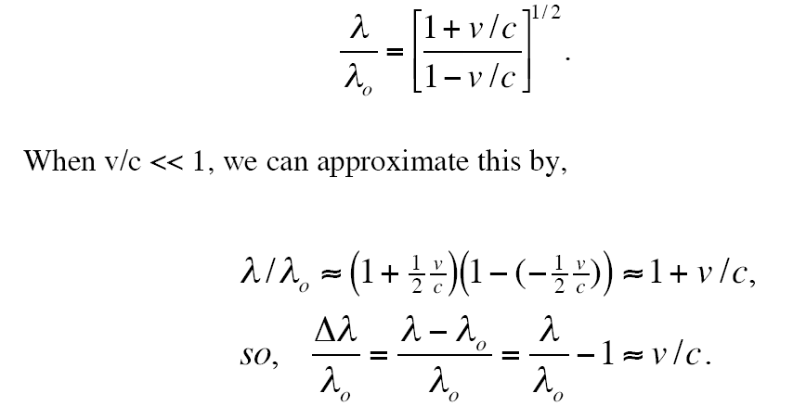
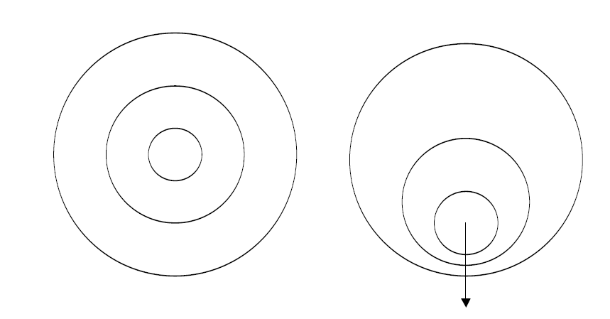
Intensity and Flux
To describe the flow (and scattering) of radiation we need the definitions of
intensity and flux, which quantify the idea of a directed, density of radiation.
Monochromatic intensity - is the amount of energy in the frequency interval (ν,
ν+Δν) flowing through a unit area, per unit time, into a cone of unit solid angle,
in a given direction.
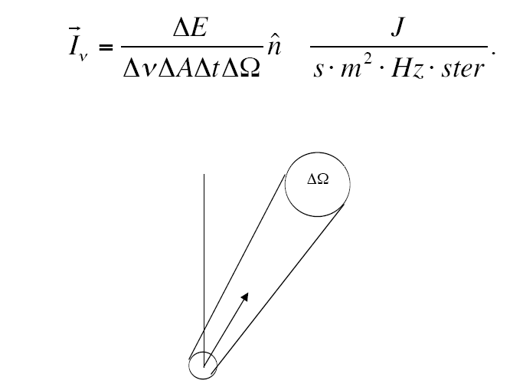
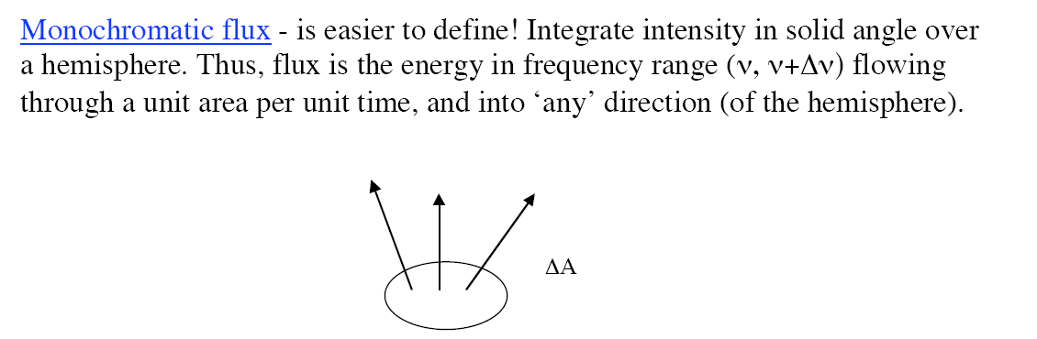
Alternately, the flux received at a detector is the total incoming energy per unit time, etc., from any angle (though often from a single point source).

1-5 The geometry of radiation:
Calculations of the incident radiation onto the surface of the Earth need to take account of the geometry of the interaction between the Sun’s rays and the surface of the Earth, which is curved and therefore variably exposed with respect to the direction of the Sun in function of latitude, time of day (longitude) and, naturally, day of the year. Moreover the Earth rotation is inclined with respect to its orbit around the Sun , and this causes seasons to happen.
To calculate the aforementioned quantities it is usual to use a topocentric coordinate system that is, with the origin in the geographic position of the observer, which is right-handed and positioned on the plane tangent to the Earth’s surface in
the considered point. The X-axis is, therefore, tangent to the earth and positive in a West-East direction. The Y-axis is tangent in the North-South direction and is directed towards the South. The Z-axis lies on the segment joining the centre of the Earth with the point being considered on the surface. It is assumed that the Sun lies in the ZY plane at the solar noon.
to determine the position of the Sun one needs to know the latitude, the hour angle, a n d t h e s o l a r declination.
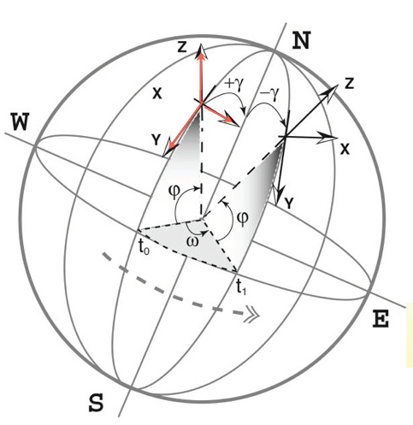

if t is the solar hour
Solar declination
The solar declination is a function of the day of the year (and the era). It
requires complex calculations that take account of the precession movements
of the Earth. There are, however, various approximations. The one that is
presented here is due to Bourges, 1985:
where is the day of the year
39
Copying with Earth surface
Is the angular height of Sun from the horizon at equator at noon*
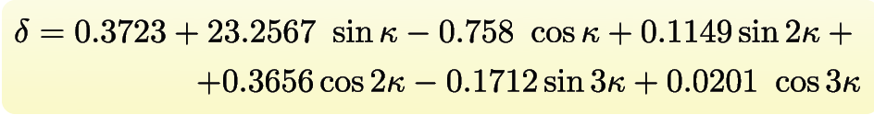

1-6 Shortwave Radiation budget:
It should not be forgot that the radiation budget is an energy budget, for which the incoming radiation equals the reflected one plus the absorbed plus the transmitted
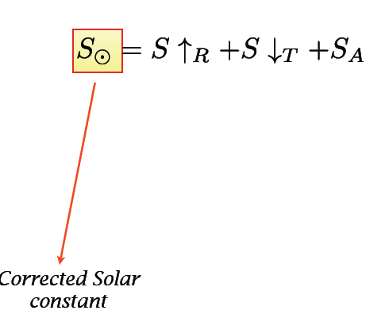
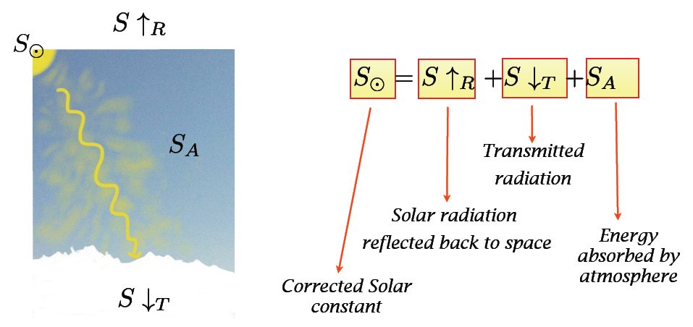
This budget can be apply to any slice of the atmosphere

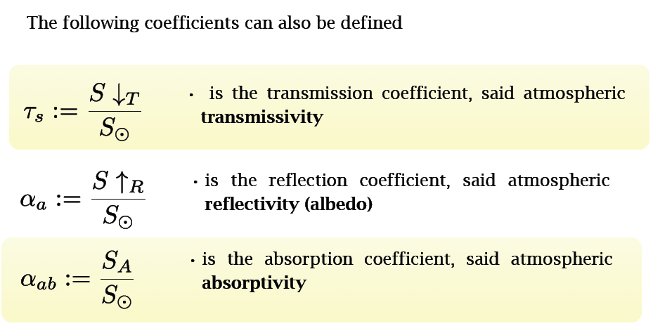
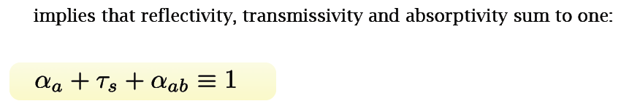

Incident solar radiation strikes gas molecules, dust particles, and pollutants, ice, cloud drops and the radiation is scattered. Scattering causes diffused radiation. Two types of light diffusion can be distinguished:
Mie scattering
Rayleigh scattering
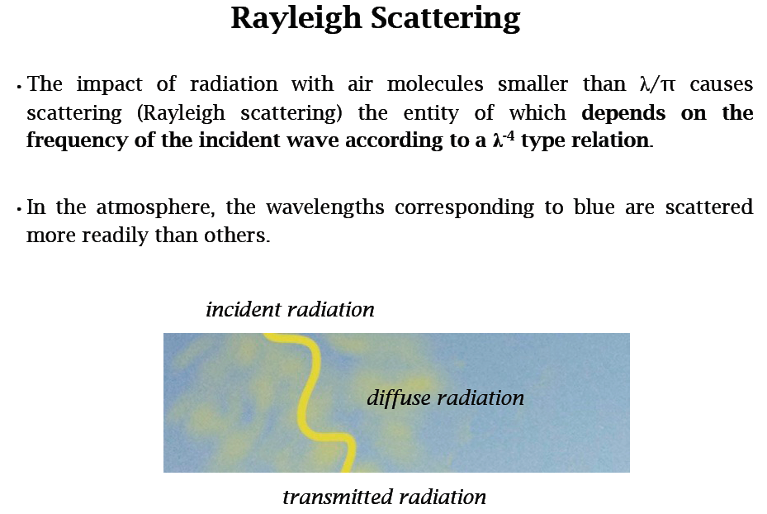
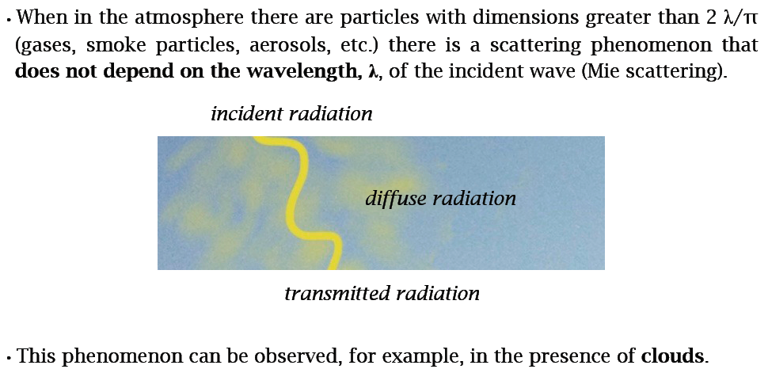
Scattering selectively eliminates the shorter visible wavelengths, leaving the longer wavelengths to pass. When the Sun is on the horizon, the distance travelled by a ray within the atmosphere is five or six times greater than when the Sun is at the Zenith and the blue light has practically been completely eliminated.

1-7 solar radiation transmitted to the ground under
Clear sky conditions:

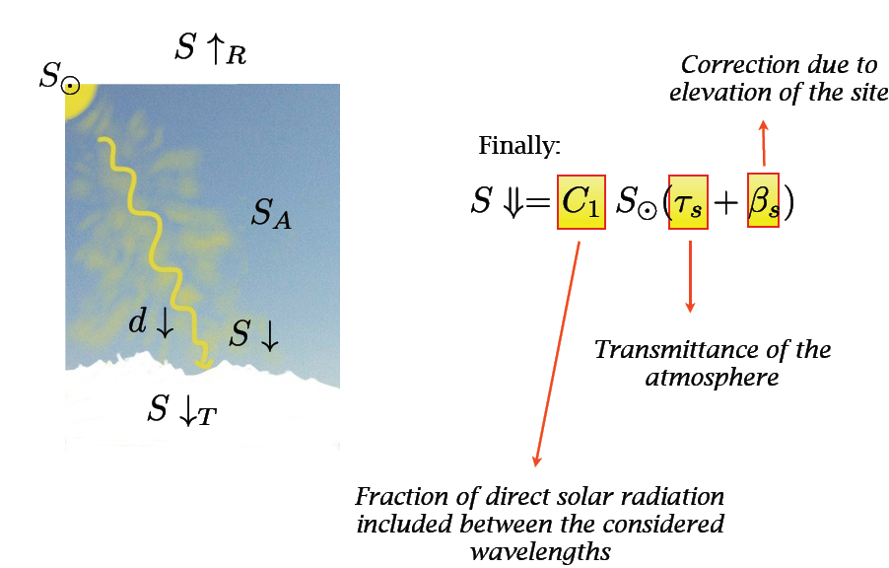
We do not enter in the details of how and are determined. Please look, for instance, at Formetta et al., 2012 It is assumed that the effects of clouds is an attenuation of the transmitted solar radiation
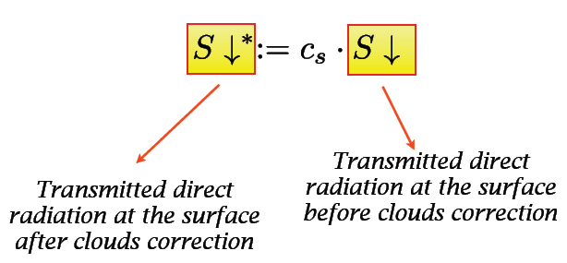
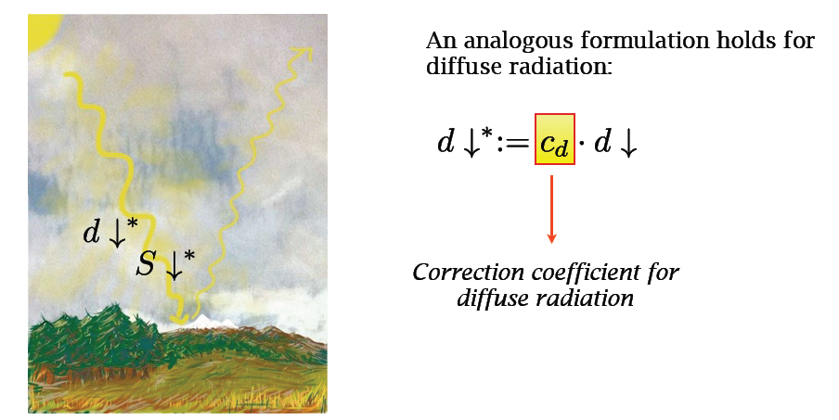

1-8 Estimation of the reduction coefficients
(Decomposition model):

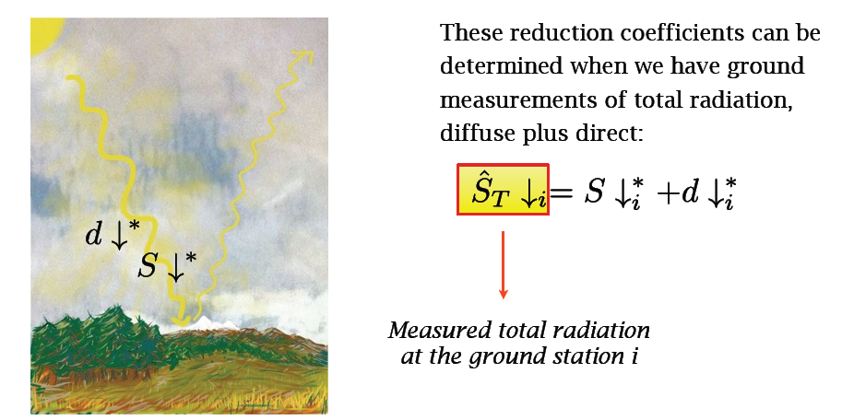
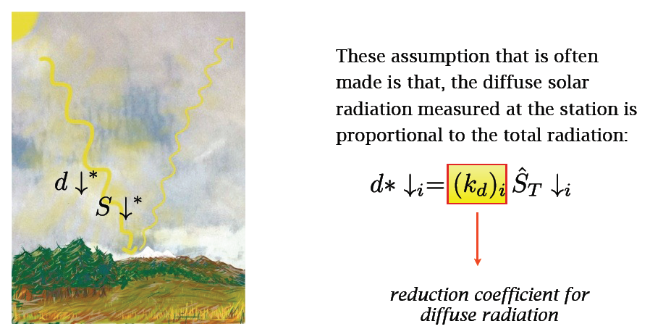
Therefore when substituting this diffuse radiation expression in the total radiation equation of previous slides, it results at stations:

