LECTURE-9&10

Serological testes
A serology blood test is performed to detect and measure the levels of antibodies as a result of exposure to a particular bacteria or viruses (antigens), the immune system produces specific antibodies against these organism. Antibody levels (antibody titer) help physicians determine whether an infection occurred recently (Acute) or years ago (chronic).
Serological testing is particularly helpful in the diagnosis of rickettsial and viral diseases such as Rocky Mountain spotted fever, influenza, measles, poliomyelitis, and yellow fever, as well as of infectious mononucleosis and rheumatoid arthritis. As a practical mass-screening diagnostic tool, it has proved valuable in the detection of such conditions as syphilis.
Submitting specimens
- Whole blood: Refrigerated specimens must be received within 24 hours of the time of collection.
- Serum separated from clot: Refrigerated specimens must be received within 48 hours of the time of collection. Frozen specimens must be received within six months of collection.
- CSF: Refrigerated specimens must be received within 48 hours from the time of collection. Frozen specimens must be received within six months of collection.

Rose Bengal plate test (RBT) for Brucella
The Rose Bengal test (RBT) is a simple, rapid slide-type agglutination assay performed with a stained Brucella abortus suspension at pH 3.6–3.7 and plain serum.

Although the overall sensitivity reported for RBT varies widely, with the use of good quality antigens made by experienced or reference laboratories, the sensitivity of RBT can increased.
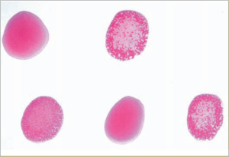

It is often used as a screening test in human brucellosis and would be optimal for small laboratories with limited means. False-negative reactions occur especially in the early stages of acute infection.

Procedure of Rose Bengal Plate Test:
• Test Serum (0.03 ml) is mixed with an equal volume of antigen on a white tile or enamel plate to produce a zone approximately 2 cm in diameter.
• The mixture is agitated gently for four minutes at ambient temperature, and then observed for agglutination.
• Any visible reaction is considered to be positive.

Widal Test
- Widal Test is an agglutination test which detects the presence of serum agglutinins (H and O) in patients serum with typhoid and paratyphoid fever.
- When facilities for culturing are not available, the Widal test is the reliable and can be of value in the diagnosis of typhoid fevers in endemic areas.
- It was developed by Georges Ferdinand Widal in 1896.
- The patient’s serum is tested for O and H antibodies (agglutinins) against the following antigen (Usually stained suspentions).
S. Typhi 0 antigen suspension
S. Typhi H antigen suspension
S. Paratyphi A 0 antigen suspension
S. Paratyphi A H antigen suspension
S. Paratyphi B 0 antigen suspension
S. Paratyphi B H antigen suspension
S. Paratyphi C 0 antigen suspension
S.Paratyphi C H antigen suspension

- Salmonella antibody starts appearing in serum at the end of first week and rise sharply during the 3rd week of endemic fever. In acute typhoid fever, O agglutinins can usually be detected 6–8 days after the onset of fever and H agglutinins after 10–12 days.
- It is preferable to test two specimens of sera at an interval of 7 to 10 days to demonstrate a rising antibody titer.
- Salmonella antigen suspensions can be used as slide and tube techniques.

Principle of Widal Test
Bacterial suspension which carry antigen will agglutinate on exposure to antibodies to Salmonella organisms. Patients’ suffering from enteric fever would possess antibodies in their sera which can react and agglutinate serial doubling dilutions of killed, coloured Salmonella antigens in an agglutination test. The main principle of widal test is that if homologous antibody is present in patients serum, it will react with respective antigen in the reagent and gives visible clumping on the test card and agglutination in the tube. The antigens used in the test are “H” and “O” antigens of Salmonella typhi and “H” antigen of S. paratyphi. “O” antigen is a somatic antigen and “H” antigen is flagellar antigen.

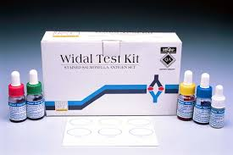

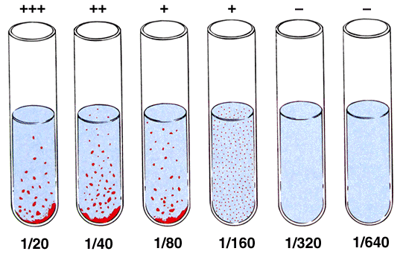

VDRL Test

What is a VDRL Test?
The venereal disease research laboratory (VDRL) test is designed to assess whether or not you have syphilis, a sexually transmitted infection (STI). Syphilis is caused by the bacteria Treponema pallidum. The bacteria infects by penetrating into the lining of the mouth or genital area.The VDRL test doesn’t look for the bacteria that causes syphilis. Instead, it checks for the antibodies your body makes in response to antigens produced by cells damaged by the bacteria. Antibodies are a type of protein produced by your immune system to fight off invaders like bacteria or toxins. Testing for these antibodies can let doctors know whether you have syphilis, because it checks for antibodies produced as a result of a syphilis infection, the VDRL test can be used whether or not have any symptoms.
The VDRL test isn’t always accurate. For example, it may give false-negative results if syphilis test was done less than three months, as the body might take this long time to make antibodies. The test is also unreliable in late-stage syphilis.On the other hand, the following can cause false-positive results:
- HIV
- Lyme disease
- malaria
- pneumonia (certain types only)
- systemic lupus erythematosus
- IV drug use
- tuberculosis
In some cases, the body may not produce antibodies even if it has been infected with syphilis. This means the VDRL test will be inaccurate.
The antibodies produced as a result of a syphilis infection can stay in the body even after syphilis has been treated. This means you might always have positive results on this test.

Rheumatoid arthritis
Rheumatoid arthritis can be difficult to diagnose because many conditions cause joint stiffness and inflammation and there is no definitive test for the condition.
There is no singular test for diagnosing rheumatoid arthritis. The diagnosis is based on the clinical presentation. Ultimately, rheumatoid arthritis is diagnosed based on a combination of the presentation of the joints involved, characteristic joint swelling and stiffness in the morning, the presence of blood rheumatoid factor and citrulline antibody, as well as findings of rheumatoid nodules and radiographic changes (X-ray testing). It is important to understand that there are many forms of joint disease that can mimic rheumatoid arthritis.
Abnormal antibodies can be found in the blood of people with rheumatoid arthritis with simple blood testing. An antibody called "rheumatoid factor" (RF) can be found in 80% of patients with rheumatoid arthritis. Patients who are felt to have rheumatoid arthritis and do not have positive rheumatoid factor testing are referred to as having "seronegative rheumatoid arthritis." Citrulline antibody (also referred to as anticitrulline antibody, anticyclic citrullinated peptide antibody, and anti-CCP antibody) is present in 50%-75% people with rheumatoid arthritis.

C-Reactive Protein Test
C-reactive protein (CRP) is a substance produced by the liver in response to inflammation. Other names for CRP are high-sensitivity C-reactive protein (HS-CRP), or ultra-sensitive C-reactive protein (US-CRP).
A high level of CRP in the blood is a sign that there may be an inflammatory process occurring in the body. Inflammation itself isn’t typically a problem, but it can indicate a host of other health concerns, including infection, arthritis, kidney failure, and pancreatitis. High CRP levels may put patients at increased risk for coronary artery disease, which can cause a heart attack.
A CRP test is a blood test designed to measure the amount of CRP in the blood. A CRP test only needs a blood sample. Your doctor can administer a CRP test along with a cholesterol screening or other routine blood work.
Usually, doctors order the test to determine a person’s risk for heart disease or stroke. Doctors may also order a CRP test after surgery to check for signs of postsurgical infection. They also might use it to monitor inflammatory diseases, including:
- pelvic inflammatory disease
- inflammatory bowel disease
- arthritis
- autoimmune diseases, such as lupus
C-reactive protein is measured in milligrams of CRP per liter of blood (mg/L). In general, a low C-reactive protein level is better than a high one, because it indicates less inflammation in the body.
A reading of less than 1 mg/L indicates you’re at low risk of cardiovascular disease. A reading between 1 and 2.9 mg/L means you’re at intermediate risk. A reading greater than 3 mg/L means you’re at high risk for cardiovascular disease. A reading above 10 mg/L may indicate a need for further testing to determine the cause of severe inflammation in your body.
An especially high CRP reading (greater than 10 mg/L) may indicate:
- a bone infection, or osteomyelitis
- an arthritis flare-up
- inflammatory bowel disease
- tuberculosis
- lupus or another connective tissue disease or autoimmune disease
- cancer, especially lymphoma
- pneumonia

Hepatitis

What is hepatitis?
Hepatitis is an inflammation of the liver that is most commonly caused by viruses but may also be due to chemicals, drugs, alcohol, inherited diseases, or autoimmune disease. The inflammation can be acute, flaring up and then resolving within a few weeks to months, or chronic, enduring over many years. Chronic hepatitis may persist for 20 years or more before causing significant symptoms related to progressive liver damage such as cirrhosis, liver cancer, or death.
The liver is a vital organ located in the upper right-hand side of the abdomen. It performs many functions in the body, including processing the body's nutrients, manufacturing bile to help digest fats, synthesizing many important proteins, regulating blood clotting, and breaking down potentially toxic substances into harmless ones that the body can use or excrete. Inflammation may (in severe cases) interfere with these processes and allow potentially toxic substances to accumulate.

Signs and Symptoms
The signs and symptoms of hepatitis are the same, regardless of the cause, but vary from person to person and may vary over time. Most people with chronic hepatitis have no symptoms at all. Some people with acute hepatitis have not symptoms, but many have mild and/or vague symptoms that may be mistaken for the flu. Some of the more common signs and symptoms include:
- Fatigue
- Nausea
- Abdominal pain
- Joint aches
- Itching
- Yellowing of the eyes and skin (jaundice, the one symptom strongly suggesting liver damage as the cause of other symptoms).

Liver function tests (LFTs)
Liver function tests measure various chemicals in the blood made by the liver. An abnormal result may indicate a problem with your liver and may help to identify the cause. Further tests may be needed to clarify the cause of your liver problem.

What does the liver do?
The liver is in the upper right part of your tummy (abdomen). The functions of your liver include:
- Storing fuel for your body (called glycogen) which is made from sugars.
- Helping to process fats and proteins from digested food.
- Making proteins that are essential for your blood to clot (clotting factors).
- Processing many medicines which you may take.
- Helping to remove poisons and toxins from your body.

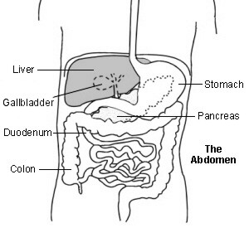
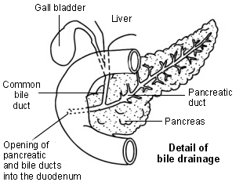

The liver also makes bile. This is a greenish-yellow fluid that contains bile acids, bile pigments and waste products such as bilirubin. Liver cells pass bile into bile ducts inside the liver. The bile flows down these ducts into larger and larger ducts, eventually leading to the common bile duct. The gallbladder is like a 'cul-de-sac' reservoir of bile which comes off the common bile duct. After you eat, the gallbladder squeezes bile back into the common bile duct and down into the the first part of the gut, known as the duodenum. Bile in the gut helps to digest fats.

Liver function tests (LFTs)
As the liver performs its various functions, it makes chemicals that pass into the bloodstream. Various liver disorders alter the blood level of these chemicals. Some of these chemicals can be measured in a blood sample.
LFTs are some tests that are commonly done on a blood sample. These usually measure the following:

- Alanine transaminase (ALT). This is an enzyme that helps to process proteins. (An enzyme is a protein that helps to speed up chemical reactions). Large amounts of ALT occur in liver cells. When your liver is injured or inflamed (as in hepatitis), the blood level of ALT usually rises.
- Aspartate aminotransferase (AST). This is another enzyme usually found inside liver cells. When a blood test detects high levels of this enzyme in your blood it usually means your liver is injured in some way. However, AST can also be released if heart or skeletal muscle is damaged. For this reason, ALT is usually considered to be more specifically related to liver problems.
- Alkaline phosphatase (ALP). This enzyme occurs mainly in liver cells next to bile ducts, and in bone. The blood level is raised in some types of liver and bone disease.
- Albumin. This is the main protein made by your liver and it circulates in your bloodstream. The ability to make albumin (and other proteins) is affected in some types of liver disorder. A low level of blood albumin occurs in some liver disorders. It can also occur in people who are malnourished.
- Total protein. This measures albumin and all other proteins in blood.

  - Bilirubin. This chemical gives bile its yellow/green colour. A high level of bilirubin in your blood will make you appear 'yellow' (jaundiced). Bilirubin is made from haemoglobin. Haemoglobin is a chemical in red blood cells that is released when your red blood cells break down.
  - A raised blood level of 'conjugated' bilirubin occurs in various liver and bile duct conditions. It is particularly high if the flow of bile is blocked. For example, by a gallstone stuck in the common bile duct, or by a tumour in the pancreas. It can also be raised with hepatitis, liver injury, or long-term alcohol abuse.
  - A raised level of 'unconjugated' bilirubin occurs when there is excessive breakdown of red blood cells - for example, in haemolytic anaemia. It can also occur in people with Gilbert's syndrome which is a common, harmless condition.

Other tests of the liver
- LFTs are useful and are often the first marker of disease in your liver. However, other tests of your liver may also be done to confirm the diagnosis of a particular disorder and/or to monitor the activity of the disorder and response to treatment.
Other blood tests
Which may be done include:
- Blood clotting tests. The liver makes many of the proteins needed to make blood clot. In certain liver disorders your liver cannot make enough of these proteins and so blood does not clot so well. Therefore, blood clotting tests may be used as a marker of the severity of certain liver disorders.
- Gamma-glutamyl transferase (GGT, or 'gamma GT'). This is another enzyme that occurs in liver cells. A high level of this enzyme is particularly associated with heavy alcohol drinking. (The liver breaks down and clears alcohol from the body and this enzyme is involved in the process.)
- Immunology. Blood tests may be done to detect:
- Viruses and antibodies to viruses. Various viral infections can cause inflammation of the liver (hepatitis) - for example, hepatitis A virus, hepatitis B virus, etc.
- Auto-antibodies. These are antibodies which attack a part of your own body and occur in autoimmune disorders.

Kidney function test

Serum Creatinine
Creatinine is a waste product that comes from meat protein in the diet and also comes from the normal wear and tear on muscles of the body. Creatinine levels in the blood can vary, and each laboratory has its own normal range. In many labs the normal range is 0.6 to 1.2 mg/dl. Higher levels may be a sign that the kidneys are not working properly. As kidney disease progresses, the level of creatinine in the blood increases.

Blood Urea Nitrogen (BUN)
Urea nitrogen is produced from the breakdown of food protein. A normal BUN level is between 7 and 20 mg/dl. As kidney function decreases, the BUN level increases.

