Lec.1

**Introduction**

Phycology or algology is the study of the algae. The word **phycology** is derived from the Greek word *phykos*, which means “seaweed.” Phycology is the study of the cells, structure, function, life cycles, ecology and other properties of algae. It is also called algology.

The algae are **thallophytes** (plants lacking roots, stems, and leaves) that have chlorophyll *a* as their primary photosynthetic pigment and lack a sterile covering of cells around the reproductive cells. This definition encompasses a number of plant forms that are not necessarily closely related, for example, the cyanobacteria which are closer in evolution to the bacteria than to the rest of the algae. Algae most commonly occur in water, be it fresh water, marine, or brackish. However, they can also be found in almost every other environment on earth, from the algae growing in the snow of some American mountains to algae living in lichen associations on bare rocks, to unicellular algae in desert soils, to algae living in hot springs. In most habitats they function as the primary producers in the food chain, producing organic material from sun light, carbon dioxide, and water. Besides forming the basic food source for these food chains, they also form the oxygen necessary for the metabolism of the consumer organisms. In such cases humans rarely directly consume the algae as such, but harvest organ isms higher up in the food chain (i.e., fish, crustaceans, and shellfish). Some algae, particularly the reds and browns, are harvested and eaten as a vegetable, or the mucilage are extracted from the phallus for use as gelling and thick agents.

**Distribution and abundance**

Based on their habitat three types of algae can be recognized: 1. Aerial and terrestrial algae; 2.Aquatic algae—(*a*) freshwater algae; *(b)* marine algae; 3. Algae of unusual habitat.

**Algal ecology**

**Planktonic algae**

The term ‘planktonic algae’ refers to the forms found floating or freely swimming in water. Among the freshwater planktonic algae, forms such as *Chlorella, Scenedesmus, , Spirulina, , Navicula, Fragilaria*

**Benthic algae**

The term ‘benthic algae’ refers to aquatic algae found attached to one or the other substratum. Among the freshwater forms, *Cladophora, Pithophora, Chara, Nitella* etc., and among marine forms most members of Phaeophyceae and Rhodophyceae are the common examples. *Cladophora, Enteromorpha, Porphyra, Polysiphonia,*

**Thermal algae**

Some algae tolerate a very high temperature and these are often called thermal algae. Such forms are known to grow up to 85°C, nearly boiling water.

**Soil algae**

Such forms of algae that grow on or in soil are called soil or terrestrial algae or edaphophytes. *Vaucheria, Botrydium, Zygnema, Oedogonium, Nostoc, Oscillatoria* etc. occur on soils.

**Crybophytes**

Certain algae are found growing on snow covered peaks of high mountains imparting attractive colors to snow. Common examples are *Haematococcus nivalis, Chlamydornonas yellowstonensis, Raphidonema, Cylindrocystis, Protoderma,* imparts brownish to purple color to snow.

**Lithophytes**

The algae growing attached to stones and rocky surfaces are called lithophytes. These may be of two types:

(i) **Epilithic.** These include algae living on surface of rocks, e.g., *Calothrix, Rivularia, Gloeocapsa, Pleurocapsa, Ectocarpus, Polysiphonia* etc.

(ii) **Endolithic.** These include algae which live inside the rocks, e.g., *Dalmatella* and *Podocapsa.*

**Epiphytes**

Some algae grow attached on the other plants and are called epiphytes. Such algae do not obtain the food from the plants on which they grow rather require support only. *Oedogonium, Ulothrix* etc., grow on other larger algae, besides, *Coleochaete* in association with *Chara* and *Nitella, Chaetophora* on leaves of *Vallisnaria* and *Nelumbo* and *Oedogonium* on *Hydrilla.*

**Halophytes**

Certain algae inhabit in water with high percentage of salt, as *Dunaliella* and *Stephanophora.* However, *Chlamydomonas ehrenbergii* and *Ulothrix flacca* have also been reported to grow in salt water.

**Symbionts**

large number of algae live in association with dissimilar organisms for their mutual advantage and are called symbiotic algae. *Nostoc* in *Anthoceros, Anabaena cycadae* in the coralloid root of *Cycas, Anabaena* species in *Azolla* etc. However, lichens are the best examples of symbiosis where the association lies in between algae and fungi. *Trebauxia, Calothrix, Chlorella, Gloeocapsa, Nostoc* etc.

**Endozoic algae**

Endozoic algae inhabit the protoplasm of other organisms, e.g., *Euglenomorpha, Zoochlorellae, Zooxanthellae, Carteria* etc. *Chlorella* like algae is found living within *Paramecium, Hydra* and certain molluscs and sponges . *Zooxanthellae* live in intimate association with coral community.

**Parasitic algae**

Some algae, for their food, are dependent on other plants and are termed as parasitic forms. The common intercellular parasite *Cephaleuros* (Chlorophyceae) grows on the leaves of angiosperms like *Magnolia, Rhododendron. Polysiphonia fastigata* is a semiparasite occurring on another algae *Ascophyllum nodosum* (Phaeophyceae). Some blue green algae *Anabaeniolum, Oscillatoria* and *Simonosiella* are found as parasite on man and in the intestines of animals.

**Range of thallus structure in algae**

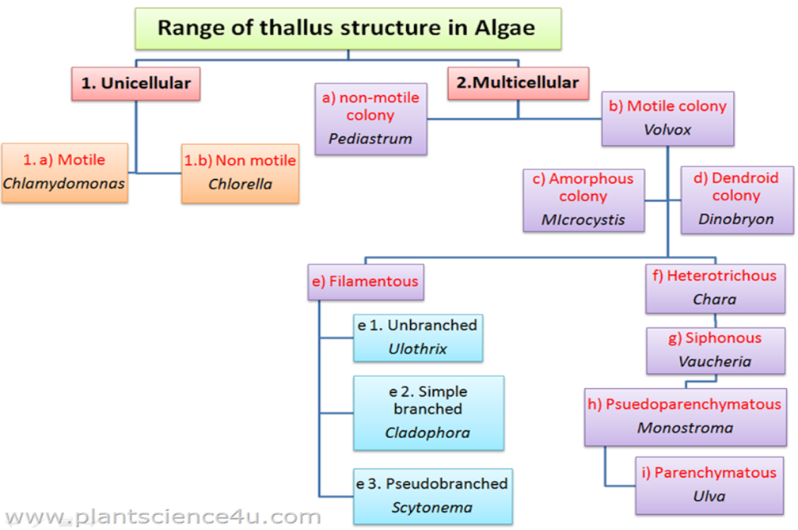

**Colonial algae**: Algae may exist as aggregates of several single cells held together loosely or in a highly organized fashion, the colony. In these types of aggregates, the cell number is indefinite, growth occurs by cell division of its components and each cell can survive on its own.

• palmelloid: term describing a colony of an indefinite number of single, non-motile cells in a mucilaginous matrix e.g. Hydrurus (Heterokontophyta) 

• trichome: a row (chain) of cells in the cyanobacteria. When the trichome is surrounded by a sheath, it is called a filament,Colonial algae can be

– non-motile colonies with cells evenly distributed throughout a gelatinous matrix, e.g. Hydrurus (Heterokontophyta)– free swimming colonies composed of cells held together by their elongated posterior ends e.g. Synura (Heterokontophyta)

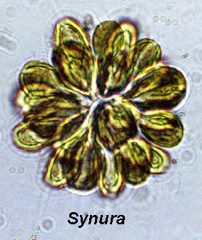

**Coenobium colonial algae**

Colony with constant (fixed) number of cells, which cannot survive alone where specific "tasks" among groups of cells is common. The number and arrangement of cells are determined at the time of origin and remain constant during the life span of the individual colony.

• *Volvox* (Chlorophyta) with its spherical colonies composed of

up to 50,000 cells is an example of motile coenobium, and *Pediastrum* (Chlorophyta) with its flat colonies of cells characterized by spiny protuberances is an example of non-motile coenobium.



**Filamentous algae**

Filaments can be simple or branched

• **Simple** Just a single row of cells firmly attached to one another, and with no branching. It represents the most basic form of multicellular algal thallus.

• In the Cyanophyceae the simple filament is the trichome.found in *Oscillatoria* (Cyanophyta),*Spirogyra* (Chlorophyta), or *Ulothrix*



**Branched filaments**

In the Cyanophyceae, two modes of branching occur false and true Branching – False branching are breakage of a trichome through a sheath, commonly in the area of a large heterocyst, giving the appearance of a branch. False branching results in • one false branch protruding through the sheath • two false branches protruding through the sheath

 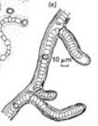

One False branched filaments Two False branched filaments

• One false branch **Branched filaments**

This is due to the occurrence of weak points (e.g. dead cell ) normally

next to a heterocyst and which eventually result in a break of the trichome, with one of the broken ends of the trichome protruding through the sheath as a false branch.

• two false branches. Here a loop is formed that protrudes through the sheath. The loop breaks in the middle as cell division continues, resulting in two false branches. It is probable that the large heterocysts lodging in the sheath cause the immovability of the trichome in the sheath

–**True branching**. True branches are outgrowing from cells that changed andcontinued their division to second plane of division (usually at right angles to that of the main filament axis).

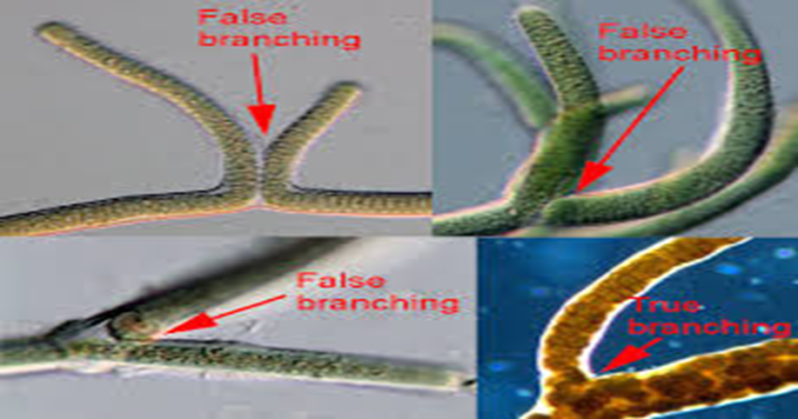

True branched filament can be

􀂾**Uniseriate** filaments : consists of a single layer of cells,􀂾**Multiseriate** filaments : made up of multiple layers of cells.



• **PSEUDOPARENCHYMATOUS**

Pseudoparenchymatous algae are made up of a loose or close aggregation of numerous, intertwined, branched **filaments** that collectively form the thallus, held together by mucilages, especially in red algae.

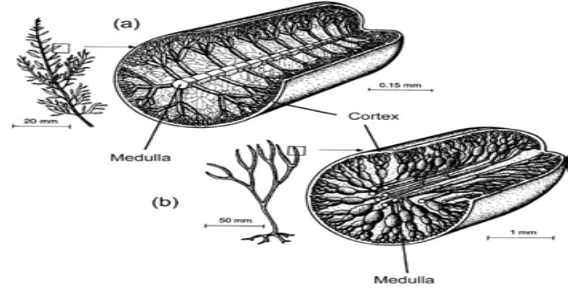

Diagrams of pseudoparenchymatous organization of red algae. (a)Uniaxial thallus. (b) Multiaxial thallus

– *Palmaria* (Rhodophyta) is a red alga with a complex pseudoparenchymatous structure. – In some brown algae (Phaeophyceae), branched filaments of one or several axial filaments are cohered by mucilages, forming pseudoparenchymatic thalli called haplostichous.

• **PARENCHYMATOUS**

In this case, cells of the primary filament divide in all directions and any essential filamentous structure is lost.

• Some parenchymatous algae have simple laminar thalli, consisting of cells similarly arranged in a single layer, as in some species of the genus *Porphyra*, or in two layers, as in *Ulva*. These thalli are caused by the division of its cells into two planes.

• In some phaeophyceans parenchymatous thalli are formed by cells that undergo division into two or more planes, originating polystichous thalli.

• Parenchymatous organization reaches its greatest complexity in Phaeophyceae, as in *Nereocystis* or *Laminaria*, which already have conducting cells with functions similar to those of phloem.

 

Nereocystis Laminaria,

**Siphonous algae**

• These algae are characterized by a siphonous or coenocytic construction, consisting of tubular filaments lacking transverse cell walls. These algae undergo repeated nuclear division without forming cell walls, such as Vaucheria

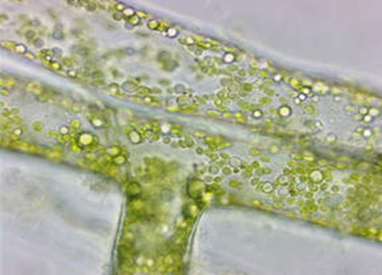

**Reproduction in algae**

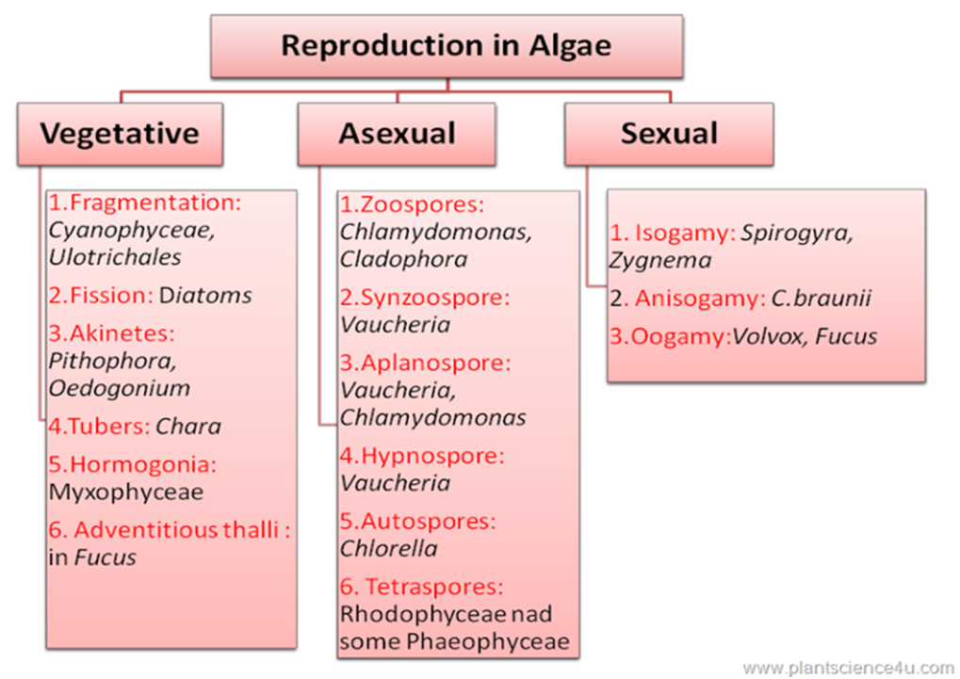

There are three type of reproduction in algae:

1-Vegetative reproduction 2-Asexual reproduction 3-Sexual reproduction

**1-Vegetative reproduction**

Takes place in different methods:

**(i) Cell division or Binary Fission**: It is the simplest form of reproduction; the parent Organism divides into two equal parts, each having the same hereditary information as the parent. In unicellular algae, cell division may be longitudinal as in Euglena

cell division
 

**(ii) Fragmentation;** the plant body brakes in to several part or ferments and each such fragment develops in to an individual. This type of vegetative reproduction is commonly met within filamentous forms, e.g., *Ulothrix,* Spirogyra, etc. • the fragmentation of colonies also takes place in several blue green algae, e.g. *Aphanothece, Nostoc*, etc.

Fragmentation
 

**(iii) Hormogone formation**: When the trichome's break in small pieces of two or more cells, such pieces are called ‘hormogones’ , Each hormogone develops into a new plant, e.g., *Oscillatoria, Nostoc*, etc

**(iv) Hormospores or hormocysts**: • Such multicellular spore-like structure function as perennating bodies called “ hormospores “ or “ hormocyasts “ . • They are thick-walled hormogones, and produced in some drier conditions.

**(vi) Tubers**: • usually these bodies are rounded and filled up with abundance of starch. • Each body may give rise to a new plant, e.g., Chara.

## (v) Adventitious thalli: • certain special structures of thalli are formed which help in vegetative reproduction. • The well-known propagula of Bryopsis, Sphacelaria are good examples.

**(vii) Bulbils**: • Small bud-like structures. Usually develop on the rhizoids of Chara are called bulbils. • Each such bulbil may develop into a new plant.

(Bulbils
 

**(viii) Akinetes**: • It is the types of reproduction very common in the blue green as well as green algae. • These akinetes are a type vegetative cell which is thick walled and will overcome the unfavourable condition. • Sometimes they are formed in chain. • Each akinete may develop into a new plant. • This type of reproduction is found in Oedogonium, Ulothrix, etc.

â¢ Each akinete may develop into a new plant.
â¢ This type of reproduction is found in
Oedogonium, Ulothrix, etc.
 

 Each akinete may develop into a new plant. • This type of reproduction is found in Oedogonium, Ulothrix, etc

**(ix) Adventitious Branches** • Adventitious Branches are formed in some large thalloid forms of algae. • These branch when get detached from the parent thallus develops into new plant . • Adventitious branch like protonema formed on the internodes of chara . • E.g Dictyota , Fucus .

2.Asexual Reproduction
â¢ Asexual reproduction is a mode of reproduction
by which offspring arise from a single organism,
a...

**Lec. 2**

**2. Asexual Reproduction**

Asexual reproduction take place by a variety of spore formed in different Algae. They include……

**(i) Zoospores**: • The zoospores are formed from certain older cells of the filaments. • The cytoplasm divides to form zoospores which are escaped from the mother cell. • They are always formed in favorable conditions. • The zoospores are always motile.

â¢ The zoospore are naked protoplasmic bodies
which move by mean flagella or cillia .
â¢ They may be (i) biflagellate, (ii) ...

• The zoospore are naked protoplasmic bodies which move by mean flagella or cilia

They may be (i) biflagellate, (ii) tetraflagellate, • e.g. Oedogoniales

**(ii) Aplanospores**: • When motile phase of zoospores is eliminated, the bodies are called aplanospores. • The aplanospore are produce when there is a lack of sufficient water. • These are covered by a thin wall but do not possess flagella like the zoospores. • The also germinate directly to give rise to new plant.

ï¶ (iii) By hypnospores :
â¢ Actually they are very thick-walled aplanospores
and develop only in adverse conditions.
â¢ In c...

**(iii) hypnospores** : • Actually they are very thick-walled aplanospores and develop only in adverse conditions. • In comparatively drier situation the content of mother cell round off and secrete a thick wall around them , to tide over the unfavourable condition. • These thick walled structure called resting spore or hypnospores .

â¢ Sometime the entire cell as such become
thick-walled to form an akinete .
â¢ They are usually produced at the approach of...

**(iv) Palmella stage**: • The approach of dryness as when the plants are left on the moist bank by receding water of the ponds the cells of many algae continue to divide but their contents are not liberated. • The mother wall becomes gelations thus forming a mass or colony of rounded cells which lie embedded in a jelly like substance formed from the cell walls.

â¢ On the return of favourable condition the cell
come out either as zoospore or as
aplanospores.
â¢ The germination to prod...

• On the return of favourable condition the cell come out either as zoospore or as aplanospores. • The germination to produce normal plant . • e.g Ulothrix etc

**(v) Autospores**: • They are just like aplanospores except that they are smaller in size. • They resemble in shape to mother cell except in size. • Each autospore gives rise to a new plant. • Such autospores are reported from many Chlorococcales. • E.g ,Scenedemus etc.

ï¶ (vi) Endospores:
â¢ In many blue green algae and Bacillariophyceae,
the endospores are formed within the cells.
â¢ The end...

(**vi) Endospores**: • In many blue green algae and Bacillariophyceae, the endospores are formed within the cells. • The endospore forming cell behaves as a Sporangium . • On the approach of favourable conditions, each endospore develops in a new individual.

ï¶ (vii) Cysts :
â¢ These are thick walled spores formed during
unfavourable conditions or even when food
supply is abundant...

**(vii) Cysts**: these are thick walled spores formed during unfavourable conditions or even when food supply is abundant. • During their formation as in vacheria the thallus becomes many septate and each chamber thus formed produce a thick walled cysts.

â¢ sometime the cysts many be formed in
rhizoides as in botrydium when they are called
rhizocysts .
â¢ Sometime a cyst may d...

• sometime the cysts many be formed in rhizoides as in botrydium when they are called rhizocysts . • Sometime a cyst may divide further to form a number of microcyst

**3. Sexual reproduction** ¬

why sexual reproduction developed and why it is maintained ? • The first fossilized evidence of sexual reproduction in eukaryotes is from the Stenian period, about 1 to 1.2 billion years ago. • These reasons include fighting the accumulation of deleterious mutations, increasing rate of adaptation to changing environments, dealing with competition or as an adaptation for repairing DNA damage and masking deleterious mutations. •It is greatly advanced method of reproduction

**Conditions for sexual reproduction:**

(a) The sexual reproduction takes place after considerable accumulation of food material and the climax of vegetative activity is over. (b) The bright light is the major factor for the production of the gametes. (c) A suitable pH value is required. (d) The optimum temperature is necessary.

Sexual reproduction are three main types, • (i) isogamy • (ii) heterogamy • (iii) Aplanogamy or conjugation

**(i) Isogamy**: • The fusion of similar motile gametes is found in many species. • Usually the gametes taking part in fusion come from two different individuals or filaments, sometimes these gametes come from two different cells of the same filament. Fertilization occurs when gametes of two different mating types fuse to form a zygote.

â¢ although in some species there are more than
two mating types .
â¢ Fertilization occurs when gametes of two
different mat...

(**ii) Heterogamy**: • The fusion of dissimilar gametes is called heterogamy. • There are two main types, (a) Anisogamy: (b) Oogamy:

**(a) Anisogamy**: • the fusing gametes are similar in appearance and are motile but are different physiologically or in size. • The smaller gamete is considered to be male (sperm cell), whereas the larger gamete is regarded as female (egg cell).

â¢ There are several types of anisogamy. Both
gametes may be flagellated and thus motile.
â¢ Alternatively, neither of the g...

There are several types of anisogamy. Both gametes may be flagellated and thus motile. • • In the red alga Polysiphonia, large non-motile egg cells are fertilized by small, non-motile spermatia.

(**b) Oogamy** : • In this case, the male antherozoid ( male gamete) fuses with the female egg. • The fusing gametes are different in size and behaviour . • One of the gamete is small and motile while the other is large and non-motile.

â¢ This types of sexual reproduction is termed as
fertilization or oogamyus reproduction and
the product is called an oospo...

• This types of sexual reproduction is termed as fertilization or oogamyus reproduction and the product is called an oospore. • This is usually found in higher types of green and brown algae. e.g :Vaucharia , Chara etc.

**(iii) Aplanogamy or conjugation**: • the fusion of two non-flagellate amoeboid gametes (aplanogametes). • They are morphologically similar but physiologically dissimilar, e.g., order Conjugales. • In fresh water algae, the sexual reproduction is best means because it is followed by the formation of thick-walled zygote or Oospore.

ï¶Reference
ï A Textbook of Algae
- A.V.S.S. Sambamurty
ï Cryptogamic botany , Algae & fungi
- Gilbert M.Smith
ï Introducti...

**Life-Cycle Patterns found in the Algae**

Algae exhibit three different life cycles (haplontic, diplontic and haplodiplontic reproductive cycle) with variation within different groups. The main difference is:

* The point where meiosis occurs
* The type of cells it produces,
* Whether there is more than one free-living stage in the life cycle.

**The primary classification of algae is based on the following five criteria:**

* Photosynthetic pigments
* Nature of food reserves
* Nature of cell wall components
* Type, number and attachment of flagella
* Cell structure

**Photosynthetic pigments**

**1-chlorophylls**

Chl. a present in all algae, Chl. b is found in Chlorophyta &Euglenophyta, Chl. c is found in Bacillariophyta ,Cryptophyta and phaeophyta , Chl. d is present only in the Rhodophyta , Chl. e only in two genera Xanthophyceae

**2-Carotenoids:**

Group of yellow, orange, red and brown protective pigments. ♦ Acts as screen to light and pass light energy to chlorophyll. ♦ Soluble in alcohol , acetone , benzene, insoluble in water. There are two types:

a- CAROTENES :- 6 types ( α,β ,γ ,ε , Flavicine and lycopene ) ♦ In most of algae β carotene is present . ♦ In Bacilleriophyceae and some member of cryptophyceae ε carotene is present. ♦ In Chlorophyceae α carotene is present .

b- XANTHOPHYLL :- ♦ Fucoxanthin - Present in Chrysophyceae , Bacilleriophyceae ,Phaeophyceae . ♦ Peridinin - Found only in Dinophyceae. ♦ Myxoxanthin and Myxoxanthophyll - Found in cyanophyceae ♦ Taraxanthin - Found in Rhodophyceae ♦ Antheraxanthin - Found in Euglenophyceae .

**3-PHYCOBILINS**

Water soluble blue or red pigments , Tetrapyrrolic compounds joined to globin proteins , Present in Cyanophyceae, Rhodophyceae,Cryptophyceae

3 types on the basis of absorption spectra:

¬ Phycocyanin :- Found in Cyanophyceae

¬ Phycoerythrin :- Found in Rhodophyceae

¬ Allophycocyanin :- Found in Cyanophyceae and Rhodophyceae

**Reserves foods**

Polysaccharides in which glucose subunits joined with α - 1,4 linkages are :- A. Starch ( Chlorophyceae and Charophyceae )

B. Floridean starch ( Rhodophyceae )

C. Myxophycean starch ( Cyanophyceae)

Polysaccharides with β -1,3 linkages are :- A. Laminarin (Phaeophyceae ) B. Chrysolaminarin (Chrysophyceae & Bacillariophyceae) C. Paramylon ( Euglinophyceae )

**Type, number and attachment of flagella**

Type and number of flagella

The type, number and position of flagella are important basis for primary classification of algae.

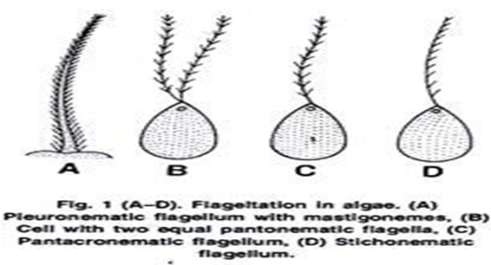

In Cyanophyta and Rhodophyta :flagella are completely absent in vegetative and reproductive structures.

In all other classes the basic flagella structure is similar. The flagella have 9 + 2 pattern of component fibrils

In Chlorophyta flagella are 2,4 or indefinite in number, apical or sub-apical in position and acronematic type i.e., isokontic

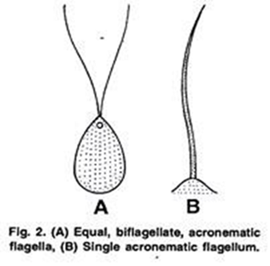

In Xanthophyceae flagella are two, unequal apical one acronematic and one pantonematic i.e., heterokontic.

In Phaeophyceae flagella are two lateral, one acronematic and one pantonematic and unequal in size.

In Prasinophyceae, prasionate type flagella are found. These are pantonematic and covered by minute hairs

**Chloroplast**

Cyanophyceae - Double membrane bound chloroplast absent. Thylakoids are free.

♦ Chlorophyceae- Bound by double membrane of chloroplast. Thylakoids occur in bands of 2-6.

♦ Charophyceae - Bound by double membrane of chloroplast

. ♦ Rhodophyceae- Bound by double membrane and thylakoids are free.

♦ Euglenophyceae - Chloroplast envelope is surrounded by one membrane of chloroplast endoplasmic reticulum (CER).

♦ Xanthophyceae - Chloroplast envelope is surrounded by two membranes of CER. Thylakoids are grouped in bands of three.

♦ Phaeophyceae - Chloroplast envelope is surrounded by two membranes of CER. Thylakoids are grouped in bands of three.

♦ Bacillariophyceae- Chloroplast envelope is surrounded by two membranes of CER.

♦ Chrysophyceae- Chloroplast envelope surrounded by two membrane of CER.

**Eyes spot**

Eye spot are not found in Cyanophyceae, Bacillariophyceae and Rhodophyceae . They are 3 types

¬ Eye spot is a part of chloroplast but not associated with flagella : Chlorophyceae and Chrysophyceae .

¬ Eye spot is a part of chloroplast but associated with flagella : Cryptophyceae , Xanthophyceae and Pheaophyceae.

¬ Eye spot is independent of chloroplast but adjacent to flagella: Eugelenophyceae and some Xanthophyceae .

In Dinophyceae eye spot range from collections of lipid globules containing carotenoids and lacking membrane to more complex arrays of lipid containing globules.