**3)Neurotoxins:**

*Neurotoxins* – The neuro toxins are alkaloids (nitrogen-containing compounds of low molecular weight) that block transmission of the signal from neuron to neuron and neuron to muscle in animals and man. Symptoms include staggering, muscle twitching, gasping and convulsions. The neuro toxins can be fatal at high concentrations due to respiratory arrest caused by failure of the muscular diaphragm. The two neurotoxins produced by cyanobacteria are anatoxin and saxitoxin . Anatoxins are synthesized by species of *Anabaena* , *Aphanizomenon* , *Oscillatoria* and *Trichodesmium*

Three families of cyanobacterial neurotoxins are known:

• anatoxin-a and homoanatoxin-a, which mimic the effect of acetyl choline,

• anatoxin-a(S), which is an anticholinesterase, and

• saxitoxins, also known as paralytic shellfish poisons (PSPs) which block nerve cell sodium channels.

**Anatoxin:** Anatoxins are neurotoxins and can be divided into anatoxin-a, homoanatoxin-a, and anatoxina(s). Anatoxin-a(s) is a natural Organophosporous(OP).

Anatoxin-a, also known as Very Fast Death Factor (VFDF), is a secondary, bicyclic amine alkaloid and cyanotoxin with acute neurotoxicity. It was first discovered in the early 1960s in Canada, and was isolated in 1972. Clinical effects of poisoning may appear within minutes to hours after exposure and may include loss of muscle coordination, muscle tremors and fasciculations, convulsions, and respiratory distress. The principal lethal effect is respiratory failure after loss of control over respiratory muscles.

Two mechanisms of action are used by this toxin. First, it acts as an through the nicotinic acetylcholine receptor (nAchR) where it the binding of the receptor's natural ligand, acetylcholine. stimulating muscle contraction however, anatoxin-a is not released from the receptor, which results in continuous contraction of the affected muscle. Second, it inhibits acetylcholinesterase, which leads to an increase of the neurotransmitter . The combined effect causes paralysis, resulting in death if respiratory muscles are affected.

Figure shows the presence of an additional methyl group (CH) on carbon atom 11 (C11) differentiates anatoxin-a from its analog homoanatoxin-a. Both molecules share almost identical toxicological properties

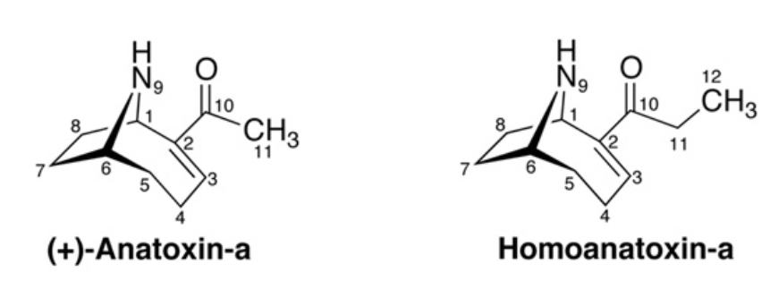

**Structures of Anatoxin-a and Homoanatoxin-a**

Anatoxin-a is unstable in water and other natural conditions, and in the presence of UV light undergoes photodegradation, being converted to the non-toxic products dihydroanatoxin-a and epoxyanatoxin-a. The photodegradation of anatoxin-a is dependent on pH and sunlight intensity but independent of oxygen. ATX-a is produced by various genera of cyanobacteria including *Anabaena, Planktothrix and Aphanizomenon*.

***Anatoxin-a(s):*** Anatoxin-a(S) "Salivary"[a] is a naturally occurring cyanotoxin commonly isolated from cyanobacteria (specifically of the genus Anabaena) also by other genera, such as Plantkothrix, Oscillatoria, Microcystis, Aphanizomenon, Cylindorspermum, and Phormidium and causes excess salivation in mammals via inhibition of acetylcholinesterase. Anatoxin-a(S) a natural OP, is structurally a cyclic N-hydroxyguanine organophosphate with a phosphate ester moiety.

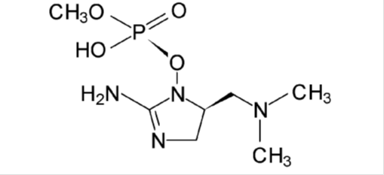

Chemical structure of Anatoxin-a(s)

The main mechanism of action for anatoxin-a(S) is by irreversible inhibiting the active site of acetylcholinesterase leading to excess acetylcholine in the parasympathetic and peripheral nervous systems, inducing poisoning via nicotinic receptor stimulation.

Its high affinity for the human erythrocyte acethylcholinesterase indicates that this toxin may represent a possible risk for human health. The ATX-a(s) shows high instability: it is inactivated at temperature higher than 40ᵒC and at pH>7.

**Saxitoxins (STXs):** Saxitoxins are also known as paralytic shellfish poisons (PSPs). Is a tetrahydropurine toxin, are a family of potent neurotoxins with a chemical structure which share tricyclic backbone with different chemical side-chains.

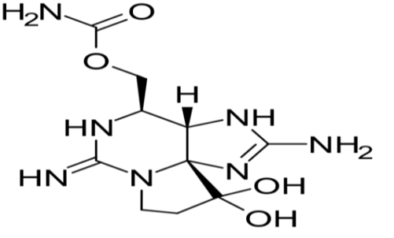

Chemical structure of Saxitoxins (STXs).

These molecules have been identified and characterised in both freshwater cyanobacteria genera (Anabaena, Aphanizomenon, Planktothrix, Cylindrospermopsis, Lyngbya, and Scytonema )and marine dinoflagellates from the genera (Alexandrium, Pyrodinium, and Gymnodinium). Harmful algal blooms of these species (named “red tides”) produce accumulation of saxitoxins through seafood consumption such as shellfish, fishes, and other organisms as the toxin accumulates in the food chain. Ingestion of contaminated tissues may lead to paralytic shellfish poison intoxications in humans and deaths by muscle paralysis and cardiorespiratory failure.

**Mechanism of action** , This molecule binds to the voltage sodium channel in neuronal cells with great potency blocking the nervous transmission and causing nerve dysfunction with death occurring from paralysis of respiratory muscles. It can also inhibit calcium and potassium channels in excitable cells thereby affecting the production of action potentials which can cause fatal cardiac arrhythmias.

**Mechanism of action**

Saxitoxins are selective, reversible voltage-gated sodium channel blockers. Saxitoxins cross the blood–brain barrier, and sodium channel blockade in the central nervous system therefore contributes to its paralytic effects .

In the environment, Saxitoxins are heat stable and water soluble. They are tasteless and odorless, and are not destroyed by cooking, and able to accumulate in freshwater environments for 9 to 28 days, depending on its variant. The Lethal Dose 50 (LD50) of STXs is 10 μg/kg after injection.

**β-N-methylamino-L-alanine (BMAA) :** β-Methylamino-L-alanine, or BMAA is a neurotoxic non-protein amino acid whose occurrence has been reported in a wide variety of cyanobacterial strains. Its potential role in various neurodegenerative disorders. BMAA is a derivative of the amino acid alanine with a methylamino group on the side chain. This non-proteinogenic amino acid is classified as a polar base.

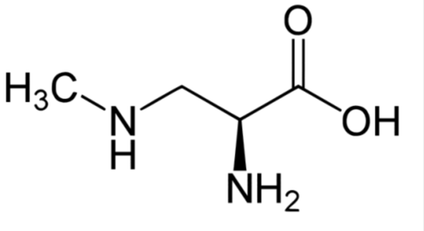

Chemical structure of β-N-methylamino-L-alanine (BMAA).

BMAA acts on motor neurons by fixation on glutamate receptor and it is involved in mechanisms inducing oxidative stress. This toxin has been proposed to contribute to neurodegenerative diseases such as Parkinson’s and Alzheimer’s.

**4) Dermatoxins**

Fresh water and marine cyanobacteria such as Lyngbya, Oscillatoria and Schizothrix may produce toxins causing severe dermatitis among swimmers in contact with the filaments.

**Irritant toxins Lypopolysaccharide (LPS)**: In general, LPS consists of three essential structural parts: (1) a glycan with an O-specific polysaccharide, which is attached to (2) a glycolipid anchor lipid A, through (3) a connecting polysaccharide Core region. is the main molecular component of the outer membrane layer of Gram-negative bacteria where it can act as a first line defence barrier.

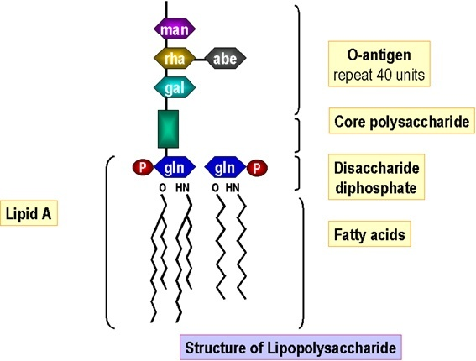

When a pathogen infect the host, the binding between the Gram-negative LPS and the Toll-like Receptor 4 (TLR4) which is present on the surface of many immune cells, is responsible for eliciting an immune response characterised by the release of cytokines and the activation of various cells like monocytes and macrophages. in addition to the studies suggesting an involvement of this molecule in causing allergy or respiratory and skin diseases, the LPS isolated from the *Oscillatoria planktothrix* has shown an antagonist effect on the TLR4- mediated immune activation.

**Lyngbyatoxin (LT) swimmer itch** :is an indole alkaloid first isolated in 1912 in Hawaii from the benthic cyanobacterium *Lyngbya majuscula* . This cyanotoxin is slightly lipophilic and its penetration as a percentage dose in guinea pig and human skin was respectively 23% and 6.2% after one hour of topical exposure. This observation indicates that during bathing activity, the body’s exposure to the water contaminated with Lyngbya majuscula might cause serious concerns.

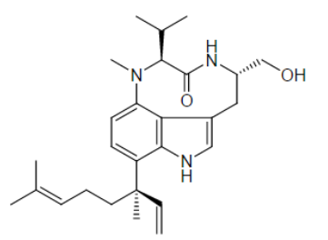

Chemical structure of Lyngbyatoxin A (LTA)

**Aplysiatoxin** :Aplysiatoxin (APX) is a phenolic bislactone ,Lethal Dose (LD50) value in mice has been reported as 100-120 μg/kg bw. It was identified in strains of Lyngbya majuscula, Aplysiatoxin, as with Lyngbyatoxin (LT), is the causative agent of severe contact dermatitis and is a potent tumor promoter which exerts its effects through the activation of protein kinase enzymes.

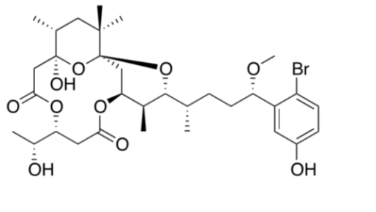

Chemical structure of Aplysiatoxin (APX).

**Principal groups of organisms generating Algal Blooms**

Harmful algal blooms consist of micro-algae that range in size from less than 10 μm to over 100μm. Worldwide there are around 300 algal species that cause destructive or harmful effects. For about 80 species, their produced toxins can reach to higher trophic levels (including humans) via the food web . Harmful algal blooms mostly comprise dinoflagellates, diatoms, cyanobacteria (freshwater). Dinoflagellates and diatoms in the marine environment and cyanobacteria in fresh and brackish water are the main groups that produce toxins. At the present time there are over 3000 dinoflagellates and diatoms identified, however; only 60-80 of these species are proven to be toxic. These species cause for 60000 intoxications of humans per year.

**Potentially toxic cyanobacteria**

Cyanobacteria blooms look like green paint . The texture is smooth. Some cyanobacteria blooms can be toxic. Some common types of potentially toxic cyanobacteria are Microcystis, Anabaena, Planktothrix and Lyngbya.

***Microcystis***

• Globular colonies that can adjust their buoyancy to move up and down through the water column • Cannot fix nitrogen from the atmosphere

•Blooms are green, thick and paint‐like, sometimes with a granular texture.

• At their onset individual colonies can be sometimes seen with the naked eye

 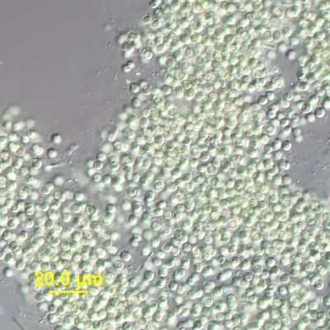

**Anabaena**.

• Colonies of hair-like filaments that can be planktonic or form mats along the bottom • contain specialized cells that convert nitrogen gas directly to ammonia by the process of nitrogen fixation.

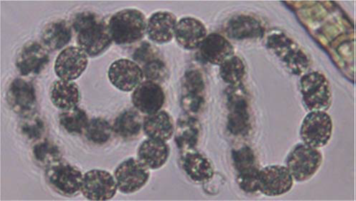 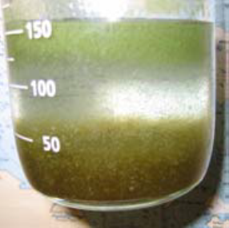

**Planktothrix**. This organism forms long, slender, straight filaments that will form dense suspensions both in the water column and on sediments, and can be found in high abundances in agriculturally impacted bodies of water.

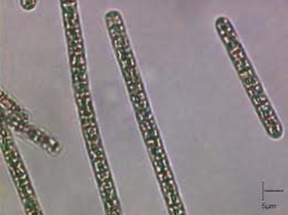 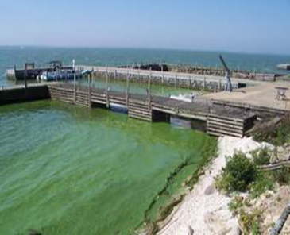

**Lyngbya**. This horse‐hair like cyanobacterium can form large dense mats on the bottom of water bodies, sometimes washing up on shore to create unsightly mounds of algae.

 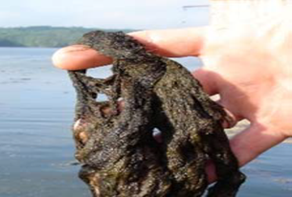

**Oscillatoria**, genus of blue-green algae common in freshwater environments, including hot springs. This unbranched filamentous alga, occurring singly or in tangled mats, derives its name from its slow, rhythmic oscillating motion,

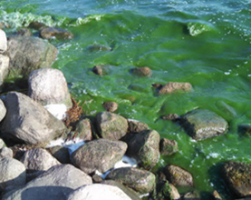 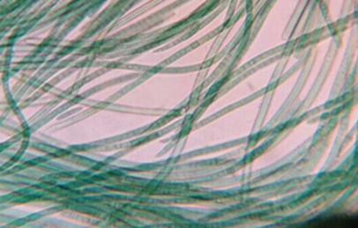

***Aphanizomenon***

• Colonies of planktonic filaments that often bundle together • Can fix nitrogen from the atmosphere using specialized cells • Sometimes sold as a dietary supplement. Consuming could be dangerous because this supplement is not regulated and may contain cyanobacterial toxins. *Consumers beware!*

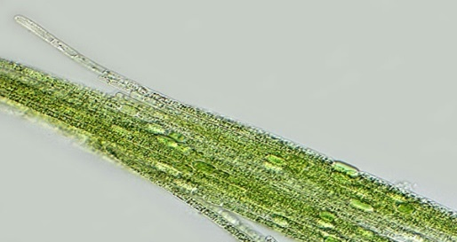

***Cylindrospermopsis***

• Colonies of planktonic filaments that distribute through the water

• Can fix nitrogen from the atmosphere using specialized, teardrop-shaped cells

***Nostoc***

• Colonies of filaments that usually clump into a green, gelatinous, “marble-like” ball • Can fix nitrogen from the atmosphere using specialized cells • Sold as a dietary supplement. Consuming could be dangerous because this supplement is not regulated and may contain cyanobacterial toxins. *Consumers beware!*

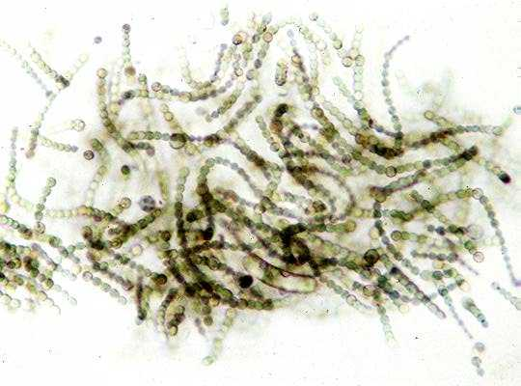 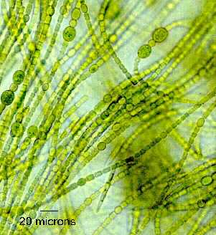

**Cyanotoxins: effects on human health**

When toxins are released in water during harmful algal blooms (HABs), their toxic effects in humans to occur through different routes: consumption of contaminated seafood, inhalation via aerosols or wind dispersed particles of dried algal material, ingestion of water or scum and direct contact with skin. The main illnesses caused by marine toxins in humans include the above mentioned Amnesic Shellfish Poisoning (ASP), Paralytic Shellfish Poisoning (PSP), Diarrhetic Shellfish Poisoning (DSP), Neurotoxic Shellfish Poisoning (NSP) and Ciguatera Fish Poisoning (CFP). Sometimes these exposures have resulted in severe headache, fever, pneumonia, vertigo and myalgia.

Cyanotoxins require additional attention also because of the high levels of Microcystins (MCs) reported in Blue Green Algae Supplements (BGAS), food supplements containing blue-green algae and generally used as natural products for their beneficial effects such as losing weight during hypocaloric diets or elevating mood for people with depression. These BGAS are mainly obtained from *Spirulina* spp. and *Aphanizomenon flos-aquae*, usually collected from the natural environment or artificial ponds where potentially toxic cyanobacteria can be present and cause BGAS contamination.

Humans can also be exposed to cyanobacteria through the consumption of aquatic organisms which can bioaccumulate the toxins in their tissues and transfer them through the food web to wildlife and humans. Microcystins are mainly accumulated in the hepatopancreas of the shellfish and molluscs while, in fish, they can be predominantly detected in viscera. The maximum concentration of MCs in the edible parts of fish, crustaceans and mussels has been reported to reach levels of 300, 2700 and 16,000 μg/kg, respectively. The limit value for STX has been set at 800 μg/kg.

Many cases of intoxication and deaths in humans have been attributed to the ingestion of marine organisms infected with STXs, a neurotoxin associated with the disease known as Paralytic Shellfish Poisoning (PSP). Every year, more than 2000 cases of human poisoning through fish or shellfish consumption are reported worldwide with a mortality rate of 15%

Saxitoxin is one of the most potent marine biotoxin and when ingested in high concentration this toxin can induce rapid symptoms ranging from tingling of the extremities to respiratory paralysis and death. The disease outcome depends on the timeliness of medical cares including artificial respiration, gastric lavage and fluid therapy. When an individual survive 12 hours post-ingestion, all symptoms resolve rapidly although it generally takes 24 hours to completely depurate the blood from the chemical.

Consumption of meat could represent an additional way of exposure to cyanotoxins, however, data on the accumulation of MCs in livestock (sheep, cow etc.) after ingestion of contaminated water reveal that no trace of cyanotoxins are present into milk or meat. Instead, with regard to vegetables, studies conducted with water infested with blooms or scums and used to water rice, rape and lettuce have showed the presence of cyanotoxins in plant extracts. It is important to point out that cyanobacterial cells can be removed from vegetables following the washing procedures and that when broccoli were irrigated with water containing MCs at a concentration of 1-10 μg/L, corresponding to levels typically found in surface water, the toxins were detected only in the roots, not therefore endangering human health.