Lab 2
The Lymphoid System
The lymphatic system is a network of tissues and organs that primarily consists of lymph vessels, lymph nodes and lymph. The tonsils, adenoids, spleen and thymus are all part of the lymphatic system.
The primary function of the lymphatic system is to
- transport lymph, a clear, colorless fluid containing white blood cells that helps rid the body of toxins, waste and other unwanted materials.
- removal of interstitial fluid, the extracellular fluid that bathes most tissue.
- It also acts as a highway, transporting white blood cells to and from the lymph nodes into the bones, and antigen-presenting cells to the lymph nodes.
Primary Lymphoid Organs
It is called central, lymphoid organs are the thymus and bone marrow. The function of the primary lymphoid organs is for PRODUCTION and MATURATION of the white blood cells in order to defend the body from disease.
1- Bone Marrow : Red bone marrow is a hematopoietic tissue containing many stem cells that produce blood cells and platelets. All of the leukocytes, or white blood cells, of the immune system are produced by red bone marrow. Leukocytes can be further broken down into 2 groups based upon the type of stem cells that produces them: myeloid stem cells and lymphoid stem cells. Myeloid stem cells produce monocytes and the granular leukocytes—eosinophils, basophils, and neutrophils. The lymphocytes which complete their maturation and education in BONE MARROW called B-lymphocyte and others migrate to the THYMUS to mature and education called T-lymphocyte.
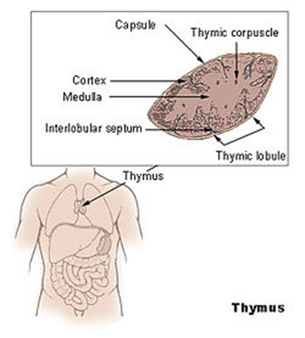
2-Thymus Gland : Thymus is composed of two identical lobes and is located anatomically in front of the heart and behind the sternum .Histologically, each lobe of the thymus can be divided into a central medulla and a peripheral cortex which is surrounded by an outer capsule. The cortex and medulla play different roles in the development of T-cells and one of the most important roles of the thymus is the induction of central tolerance(self- tolerance) are the organs or regions where the mature and immuno competent lymphocytes

Secondary Lymphoid Organs:
are also known as peripheral lymphoid organs. These colonize and interact with foreign agents to induce immune response to antigenic stimuli. These organs include :
1-Spleen; is an organ in the upper far left part of the abdomen, to the left of the stomach. It plays multiple supporting roles in the body. It acts as a filter for blood as part of the immune system. Old red blood cells are recycled in the spleen, and platelets and white blood cells are stored there. The spleen also helps fight certain kinds of bacteria that cause pneumonia and meningitis.
The spleen is composed of the red and white pulp. The white pulp produces and grows immune cell as well as blood cells. On the other hand, the red pulp is responsible for purifying the blood and removing dead or old blood cells . Because of its function in the immune and circulatory systems, the spleen is surrounded by a multitude of blood and lymph vessels.
Germinal centers in the white pulp serve as the sites of lymphocyte production. Similar to the lymph nodes, the spleen reacts to microorganisms and other antigens that reach the bloodstream by releasing special phagocytic cells. These cells reside in both red and white pulp, and they serve to remove foreign material from the blood .
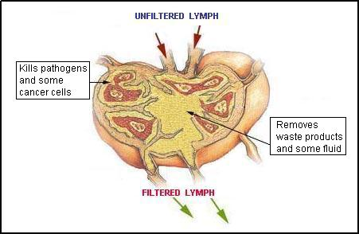
2- Lymph Node: are small, kidney-shaped organs of the lymphatic system There are 600 to 700 lymph nodes found mostly throughout the thorax and abdomen of the body with the highest concentrations in the axillary (armpit) and inguinal (groin) regions in the human body.
Each lymph node is divided into two general regions, the capsule and the cortex. The capsule is an outer layer of connective tissue. Underlying the capsule is the cortex, a region containing mostly inactivated B and T lymphocytes plus numerous accessory cells such as dendritic cells and macrophages. The cortex is further divided into two functional areas: the outer cortex and inner cortex. These regions surround an inner medulla, which consists primarily of activated antibody-secreting plasma cells.
The lymph nodes function as filters of lymph that enters from several afferent lymph vessels. The reticular fibers of the lymph node act as a net to catch any debris or cells that are present in the lymph. Macrophages and lymphocytes attack and kill any microbes caught in the reticular fibers. Efferent lymph vessels then carry the filtered lymph out of the lymph node and towards the lymphatic ducts.

Accessory Lymphoid Tissues
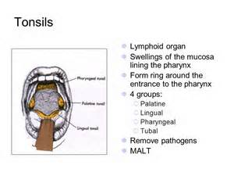
Also called mucosa- associate lymphoid tissues are associated with the mucosa membrane of a number of organs like respiratory and digestive system which protect the body against the foreign invaders. It include ;
1-Tonsils : There are 5 tonsils in the body (2 lingual, 2 palatine, and 1 pharyngeal). The lingual tonsils are located at the posterior root of the tongue near the pharynx. The palatine tonsils are in the posterior region of the mouth near the pharynx. The pharyngeal pharynx, is found in the nasopharynx at the posterior end of the nasal cavity. The tonsils contain many T and B cells to protect the body from inhaled or ingested substances. The tonsils often become inflamed in response to an infection.

2-Peyer’s patches. Peyer’s patches are small masses of lymphatic tissue found in the ileum of the small intestine. Peyer’s patches contain T and B cells that monitor the contents of the intestinal lumen for pathogens. Once the antigens of a pathogen are detected, the T and B cells spread and prepare the body to fight a possible infection.
3-Skin : the largest lymphatic organ . contain specialized phagocytic cells called Langerhans cells

