Lab 5

Antigen-antibody interactions

Antigen-antibody interaction, or antigen-antibody reaction, is a specific chemical interaction between antibodies produced by B- lymphocytes and antigens forming what called immune complex during immune response. It is the fundamental reaction in the body by which the body is protected from complex foreign molecules, such as pathogens and their chemical toxins. In the blood, the antigens are specifically bound by antibodies to form an antigen-antibody complex. The immune complex is then transported to cellular immune systems where it can be destroyed or deactivated.

There are several types of antibodies and antigens, and each antibody is capable of binding only to a specific antigen. The specificity of the binding is due to specific chemical constitution of each antibody. The antigenic determinant or epitope of antigens is recognized by the variable region of the Antibody .

Antigens are bound to antibodies through weak and noncovalent bonds such as electrostatic interactions, hydrogen bonds, Van der Waals forces, and hydrophobic interactions. as these bondings are very weak so large number of such bondings are required. The strength of antigen-antibody interaction is expressed in terms of avidity and affinity.

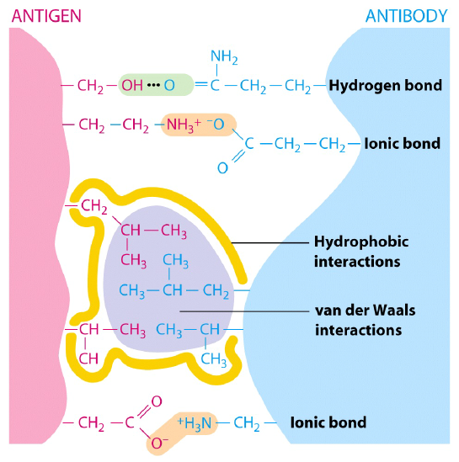

Factors affect Ag-Ab reaction

- Antibody Affinity

Measures the strength of interaction between an epitope and an antibody’s antigen binding site (Fab). High-affinity antibodies will bind a greater amount of antigen in a shorter period of time than low-affinity antibodies and that can be be influenced by factors including pH, temperature and buffer composition.

- Antibody Avidity

Gives a measure of the overall strength of an antibody-antigen complex. It is dependent on three major parameters:
- Affinity of the antibody for the epitope.
- Valency of both the antibody and antigen.
- Structural arrangement of the parts that interact.

All antibodies are multivalent e.g. IgGs are bivalent and and IgMs are decavalent. The greater an immunoglobulin’s valency (number of antigen binding sites), the greater the amount of antigen it can bind. Similarly, antigens can demonstrate multivalency because they can bind to more than one antibody. Multimeric interactions between an antibody and an antigen help their stabilization.
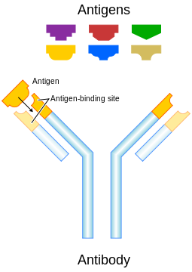
- Antibody Specificity

An antibody has distinct specificity for a certain antigen. The antibody is even capable of distinguishing tiny differences in antigen structure such as isomers, which are small changes in chemical bonds.

Cross reactivity refers to the ability of an individual antibody combining site to react with more than one antigenic determinant or the ability of a population of antibody molecules to react with more than one antigen. Cross reactions arise because the cross reacting antigen shares an epitope in common with the immunizing antigen or because it has an epitope which is structurally similar to one on the immunizing antigen (multispecificity).

- Physical form of the antigen
The physical form of the antigen influences how one detects its reaction with an antibody. If the antigen is a particulate, one generally looks for agglutination of the antigen by the antibody. If the antigen is soluble one generally looks for the precipitation of the antigen after the production of large insoluble antigen-antibody complexes.

- Antigen to antibody ratio: it is very effective in detecting immunocomplexes .

Prozone : is a possible cause of False-Negative antigen-antibody reaction caused by Excessive amout of antibody

Postzone : refers to the Excess of antigen resulting in no lattice formation in an agglutination reaction

equivalence zone:
a variable ratio of antigen and antibody which results in precipitation in which there is no unbound antibody or antigen.





