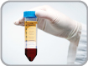
Lymphocytes Isolation from Peripheral Blood
Lab. 10
(Ficoll Method)
Lymphocytes (B, T and NK cells) belong to the White Blood Cells (WBC or leukocytes) together with monocytes and granulocytes. Lymphocytes are found in the blood, bone marrow (where they are produced) and lymphoid tissues. They play a central role in the immune system and their blood rate might be affected during infections, genetic diseases, cancers… High quality isolation of lymphocytes is thus a key step in many in vitro research programs covering immunology, infectious diseases and oncology.
Lymphoprep (Ficoll-Hypaque)
The Lymphocytes Separation Medium is a sterile-filtered solution of a sucrose polymer and diatrizoate salts at a specific gravity of 1.077-1.080 g/mL at 20°C. It is formulated for isolation of mononuclear cells from de-fribinated or heparinized whole human blood without any loss of cell viability. One-step centrifugation permits separation of mononuclear lymphocytes from erythrocytes, polynuclear lymphocytes and most platelets.

Procedure:
- Place fresh heparinized vein blood into 15- or 50-ml conical centrifuge tubes. Using a sterile pipet, add an equal volume of room-temperature PBS (phosphate buffer saline). Mix well.
- Slowly layer the Ficoll-Hypaque solution underneath the blood/PBS mixture by placing the tip of the pipet containing the Ficoll-Hypaque at the bottom of the sample tube. Use 3 ml Ficoll-Hypaque per 10 ml blood/PBS mixture.
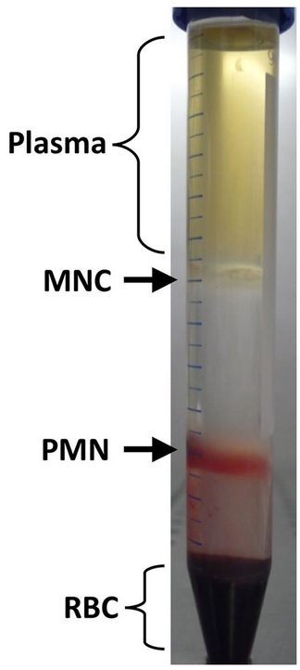
* To maintain the Ficoll-Hypaque/blood interface, it is helpful to hold the centrifuge tube at a 45° angle.
* Alternatively, the blood/PBS mixture may be slowly layered over the Ficoll-Hypaque solution.
- Centrifuge 30 min in a GH-3.7 rotor at 2000 rpm (900 × g), 18° to 20°C, with no brake.
- Using a sterile pipet, remove the upper layer that contains the plasma and most of the platelets ,using another pipet, transfer the mononuclear cell layer to another centrifuge tube. Wash cells by adding excess HBSS (∼3 times the volume of the mononuclear cell layer) and centrifuging 10 min at 1300 rpm (400 × g), 18° to 20°C. Remove supernatant, resuspend cells in HBSS, and repeat the wash once to remove most of the platelets. Resuspend mononuclear cells in complete RPMI-10.
- determine viability by trypan blue method ( mix a drop of both trypan blue and isolated lymphocytes suspention on a slide and cover with cover slip, examine under microscope, count 200 lymphocytes, if the cell is stained then it is dead and if not then it’s a live .Viability should be 90%.
- Finally count with haemocytometer.

HBSS - Hank's Balanced Salt Solution
The essential function of a balanced salt solution is to maintain pH and osmotic balance as well as provide your cells with water and essential inorganic ions. Hanks’ balanced salt solution (HBSS) can be used as a temporary diluting, washing, irrigating or transporting solution for cell or tissue culture. It provides a buffering system to maintain the physiological pH range and osmotic balance of the culture media, and provides cells with a source of water and essential inorganic ions, and a carbohydrate as an energy source.
Hank's Buffered Salt Solution (HBSS) composition
0.137 M NaCl
5.4 mM KCl
0.25 mM Na₂HPO₄
0.1g glucose
0.44 mM KH₂PO₄
1.3 mM CaCl₂
1.0 mM MgSO₄
4.2 mM NaHCO₃
RPMI-1640
Roswell Park Memorial Institute medium, commonly referred to as RPMI, is a form of nutritional medium used in cell culture and tissue culture. It has traditionally been used for growth of Human lymphoid cells. This medium contains a great deal of phosphate and is formulated for use in a 5% carbon dioxide atmosphere. RPMI 1640 has traditionally been used for the serum-free expansion of human lymphoid cells.

