Lab 5 Monoclonal Antibody Production
Serology and Vaccines

What are monoclonal antibodies?
There are two features of the antibody-epitope relationship are key to the use of monoclonal antibodies as a molecular tool.
- specificity -- the antibody binds only to its particular epitope
- sufficiency -- the epitope can bind to the antibody on its own, i.e. the presence of the whole antigen molecule is not necessary
Each B cell in an organism synthesizes only one kind of antibody. In an organism, there is an entire population of different types of B cells and their respective antibodies that were produced in response to the various antigens that the organism had been exposed to. However to be useful as a tool, molecular biologists need substantial amounts of a single antibody (and that antibody alone). Therefore we need a method to culture a population of B cells derived from a single ancestral B cell,s so that this population of B cells would allow us to harvest a single kind of antibody. This population of cells would be correctly described as monoclonal, and the antibodies produced by this population of B cells are called monoclonal antibodies. In contrast, antibodies obtained from the blood of an immunized animal are called polyclonal antibodies.

Production of monoclonal antibodies
The production of monoclonal antibodies was pioneered by Georges Kohler and Cesar Milstein in 1975.
FIRST In order to isolate a B lymphocyte producing a certain antibody, we first have to induce the production of such a B cell in an organism. For example, if we need an antibody for avian SERCA2 protein, we would inject the protein into a mouse. This is typically done in two doses, an initial "priming" dose and a second "booster" dose 10 days laters. Since the protein is of foreign origin, the mouse immune system recognizes it as such and soon some of the B cells in the mouse would begin production of the antibody to avian SERCA2.
SECOND A sample of B cells is extracted from the spleen of the mouse and added to a culture of myeloma cells (cancer cells). The intended result is the formation of hybridomas, cells formed by the fusion of a B cell and a myeloma cell. The fusion is done by using polyethylene glycol (PEG) .
THERD The next step is to select for the hybridomas and get rid of both B cells and myeloma cells. The myeloma cells are HGPRT-ve and the B cells are HGPRT+ve. HGPRT is hypoxanthine-guanine phosphoribosyl transferase , an enzyme involved in the synthesis of nucleotides from hypoxanthine, an amino acid . The culture is grown in HAT (hypoxanthine-aminopterin-thymine) medium, which can sustain only HGPRT+ cells.The myeloma cells that fuse with another myeloma cell or do not fuse at all die in the HAT medium since they are HGPRT-. The B cells that fuse with another B cell or do not fuse at all die because they do not have the capacity to divide indefinitely. Only hybridomas between B cells and myeloma cells survive, being both HGPRT+ and cancerous.
Fourth The initial collection of B cells used is heterogenous, i.e. they do not all produce the same antibody. Therefore the hybridoma population too does not produce a single antibody. There is also another complication. A hybridoma cell is initially tetraploid, having been formed by the fusion of two diploid cells. However the extra chromosomes are somehow lost in subsequent divisions in a random manner . This means that we cannot be certain that the hybridomas will all produce the desired antibody or even any antibody at all. Screening is required to decide which hybridoma cells are actually producing the desired antibody.
Each hybridoma is cultured and screened after doing SDS-PAGE (sodium dodecyl sulfate - polyacrylamide gel electrophoresis) and Western blots. The probe used is the epitope of the antibody that is desired, which may be labeled by radioactivity or immunofluorescence. Once we are sure that a certain hybridoma is producing the right antibody, we can culture that hybridoma indefinitely and harvest monoclonal antibodies from it.
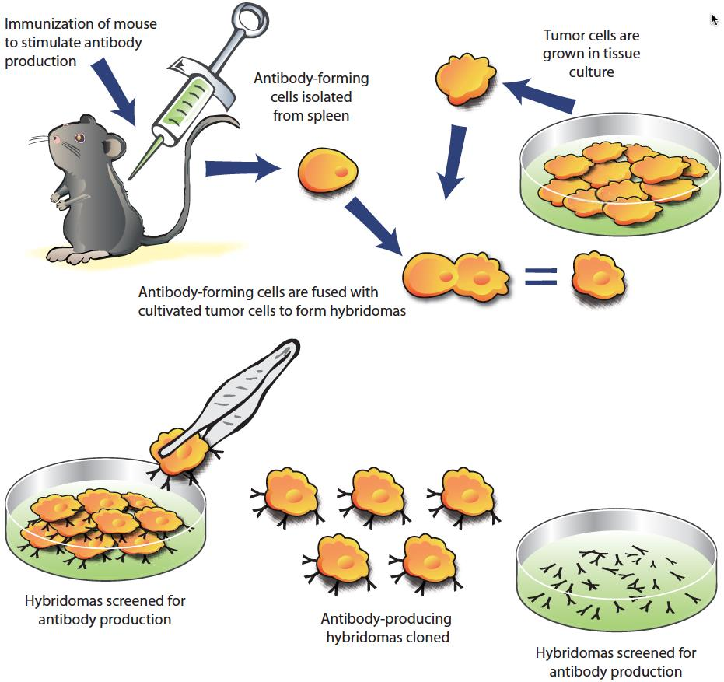

Uses of monoclonal antibodies
Monoclonal bodies have a variety of academic, medical and commercial uses. It would be impossible to list all of these here.
- Antibodies are used in several diagnostic tests to detect small amounts of drugs, toxins or hormones, e.g. monoclonal antibodies to human chorionic gonadotropin (HCG) are used in pregnancy test kits . Another diagnostic uses of antibodies is the diagnosis of AIDS by the ELISA test.
- Antibodies are used in the radioimmunodetection and radioimmunotherapy of cancer, and some new methods can even target only the cell membranes of cancerous cells . A new cancer drug based on monoclonal antibody technology is Ritoxin, approved by the FDA in November 1997.
- Monoclonal antibodies can be used to treat viral diseases, traditionally considered "untreatable". In fact, there is some evidence to suggest that antibodies may lead to a cure for AIDS.
- Monoclonal antibodies can be used to classify strains of a single pathogen, e.g. Neisseria gonorrhoeae can be typed using monoclonal antibodies .
- Researchers use monoclonal antibodies to identify and to trace specific cells or molecules in an organism, e.g. developmental biologists at the University of Oregon use monoclonal antibodies to find out which proteins are responsible for cell differentiation in the respiratory system.
- OKT3, an antibody to the T3 antigen of T cells, is used to alleviate the problem of organ rejection in patients who have had organ transplants.

Isotype, Allotype, Idiotype Antibodies
Isotypes
Antibody isotypes are the same thing as antibody classes. There are 5 major isotypes: IgM, IgD, IgG, IgE, and IgA. The difference between these isotypes lies in the heavy chain (Mu, Delta, Gamma, Epsilon, or Alpha). You can have either kappa or lambda light chains with any of these isotypes. In humans, the most plentiful isotype is IgG; the least plentiful one is IgE. They all have different functions, which, come to think of it, is a good topic for another post.
Allotypes
Allotypes represent the genetically determined differences in antibodies between people. So you and I both have IgG, but unless we’re closely related, my IgGs are very slightly different than yours – maybe just by a couple amino acids in the constant region of the heavy or light chains. Allotypes are used for paternity testing.
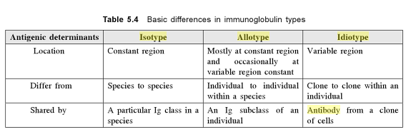
Idiotypes
Idiotypes are antibodies that recognize different specific epitopes. The thing that determines the idiotype is way at the end of the variable region; it’s composed of a bunch of different idiotopes (or combining sites).

