Breast Anatomy

The diagrams to the right shows some basic anatomical structures of the breast.
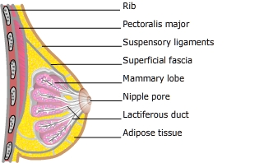

Macroscopic structures:-
- Normally, there are two mammary glands, one on either side of the sternum but breast tissue or nipples may occur anywhere along the embryonic milk lines.
- The adult female breast normally extends from the second rib superiorly to the 6th or 7th rib inferiorly and from the sternal border to the midaxillary line laterally. Rarely breast tissue may extend well beyond those landmarks
- The breast develops within the superficial fascia and is retained in place by suspensory ligaments (Cooper's ligaments)
- The breast rests on the major chest muscle, the pectoralis major
- Fat surrounds and permeates the gland. Fat contributes to the size and shape of the breast.

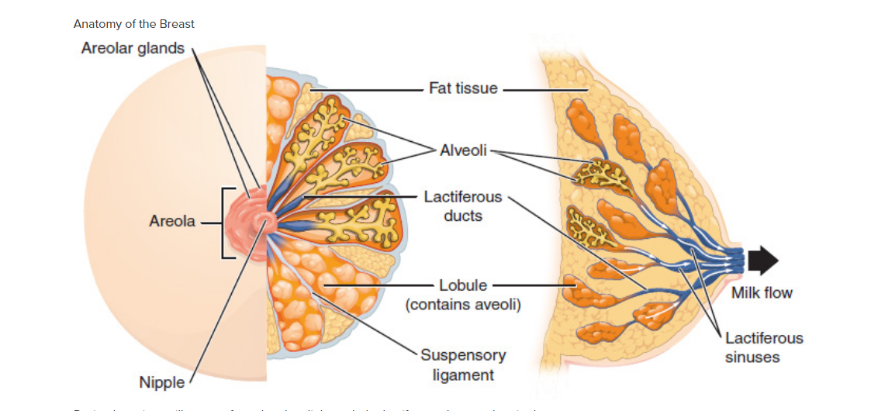

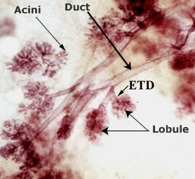
Microscopic
- Each breast, or mammary gland, contains 15-20 lobes and each lobe is comprised of 20-40 terminal ductal lobular units (TDLU). The TDLU is the functional unit of the breast.
- TDLUs consists of:
  - extralobular terminal duct (ETD) which attaches the lobule to the ductal system
  - intralobular terminal duct (ITD) continues the duct system into the lobule
  - clusters of 10-100 sac-like acini that open into the ITD.
- Acini and the terminal duct are the source of milk production.
  - "The epithelium throughout the ductal-lobular system is bilayered, consisting of an inner (luminal) epithelial cell layer and an outer ( basal ) myoepithelial cell layer".
  - Visual, auditory and areola stimulation trigger a neuroendocrine reflex which releases oxytocin from the posterior pituitary. Oxytocin travels in the blood to the mammary gland where it stimulates specific receptors on myoepithelial cells, causing them to contract and expel milk into the ducts and on toward the nipple.
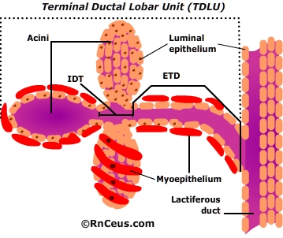
- Each lobe empties into a lactiferous duct.
- Lactiferous ducts merge into 5-10 main lactiferous ducts that open at the nipple.
- The majority of pathologic changes in the breast, including Ductal carcinoma in situ (DCIS), also known as intraductal carcinoma,DCIS and invasive carcinomas, are believed to arise from the TDLU.

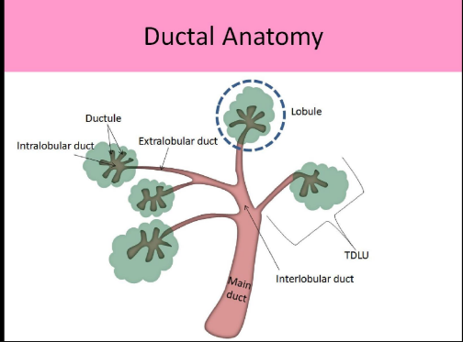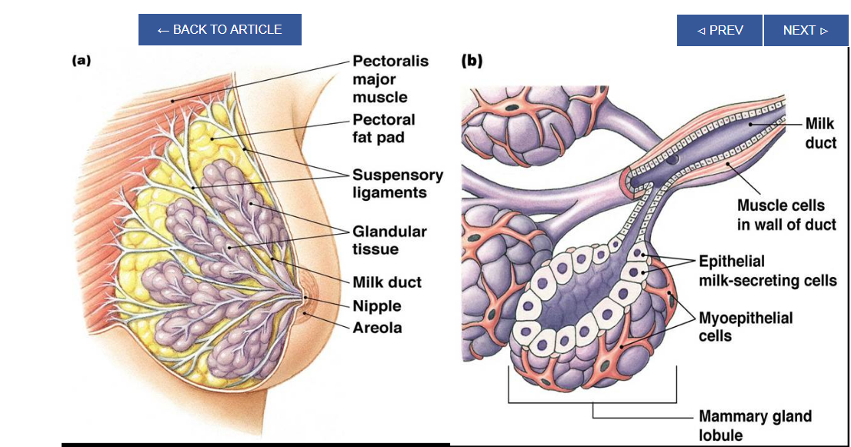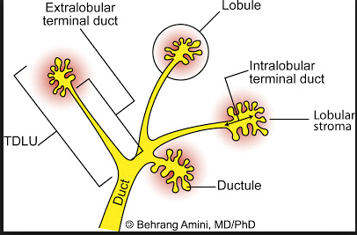

Biochemistry[edit]
Estrogen and growth hormone (GH) are essential for the ductal component of mammary gland development, and act synergistically to mediate it.^{[13][14][15][16][17]} Neither estrogen nor GH are capable of inducing ductal development without the other.^{[14][15][16][17]} The role of GH in ductal development has been found to be mostly mediated by its induction of the secretion of insulin-like growth factor 1 (IGF-1), which occurs both systemically (mainly originating from the liver) and locally in the mammary fat pad through activation of the growth hormone receptor (GHR).^{[14][15][16][17][18]} However, GH itself also acts independently of IGF-1 to stimulate ductal development by upregulating estrogen receptor (ER) expression in mammary gland tissue, which is a downstream effect of mammary gland GHR activation.^{[17]} In any case, unlike IGF-1, GH itself is not essential for mammary gland development, and IGF-1 in conjunction with estrogen can induce normal mammary gland development without the presence of GH.^{[17]} In addition to IGF-1, other paracrine growth factors such as epidermal growth factor (EGF) , transforming growth factor beta (TGF-β),^{[19]} amphiregulin,^{[ 20]} fibroblast growth factor (FGF), and hepatocyte growth factor (HGF)^{[21]} are involved in breast development as mediators downstream to sex hormones and GH/IGF-1.^{[22][23][24]} During embryonic development, IGF-1 levels are low, and gradually increase from birth to puberty.^{[25]} At puberty, the levels of GH and IGF-1 reach their highest levels in life and estrogen begins to be secreted in high amounts in females, which is when ductal development mostly takes place.^{[25]} Under the influence of estrogen, stromal and fat tissue surrounding the ductal system in the mammary glands also grows.^{[26]} After puberty, GH and IGF-1 levels progressively decrease, which limits further development until pregnancy, if it occurs.^{[25]} During pregnancy, progesterone and prolactin are essential for mediating lobuloalveolar development in estrogen-primed mammary gland tissue, which occurs in preparation of lactation and nursing.^{[13][27]}
Androgens such as testosterone inhibit estrogen-mediated mammary gland development (e.g., by reducing local ER expression) through activation of androgen receptors expressed in mammary gland tissue,^{[27][28]} and in conjunction with relatively low estrogen levels, are the cause of the lack of developed mammary glands in males.^{[29]}

Physiology[edit]

Hormonal control[edit]
Lactiferous duct development occurs in females in response to circulating hormones. First development is frequently seen during pre- and postnatal stages, and later during puberty.
- Estrogen promotes branching differentiation,^{[34]} whereas in males testosterone inhibits it. A mature duct tree reaching the limit of the fat pad of the mammary gland comes into being by bifurcation of duct terminal end buds (TEB), secondary branches sprouting(نمو) from primary ducts^{[5][35]} and proper duct lumen formation. These processes are tightly modulated by components of mammary epithelial Extracellular matrix,ECM interacting with systemic hormones and local secreting factors. However, for each mechanism the epithelial cells' "niche" can be delicately unique with different membrane receptor profiles and basement membrane thickness from specific branching area to area, so as to regulate cell growth or differentiation sub-locally.^{[36]}
2- Important players include beta-1integrin, epidermal growth factor receptor (EGFR), laminin-1/5, collagen-IV, matrix metalloproteinase (MMPs), heparan sulfate proteoglycans, and others.
3- Elevated circulating level of growth hormone and estrogen get to multipotent cap cells on Terminal end buds ,TEB tips through a thin, leaky layer of basement membrane. These hormones promote specific gene expression. Hence cap cells can differentiate into myoepithelial and luminal (duct) epithelial cells, and the increased amount of activated MMPs can degrade surrounding ECM helping duct buds to reach further in the fat pads.^{[37][38]} On the other hand, basement membrane along the mature mammary ducts is thicker, with strong adhesion to epithelial cells via binding to integrin
Integrins are transmembrane receptors that facilitate cell-extracellular matrix (ECM) adhesion and non-integrin receptors. When side branches develop, it is a much more “pushing-forward” working process including extending through myoepithelial cells, degrading basement membrane and then invading into a periductal layer of fibrous stromal tissue.^{[5]} Degraded basement membrane fragments (laminin-5) roles to lead the way of mammary epithelial cells migration.^{[39]} Whereas, laminin-1 interacts with non-integrin receptor dystroglycan negatively regulates this side branching process in case of cancer.^{[40]} These complex "Yin-yang" balancing crosstalks between mammary ECM and epithelial cells "instruct" healthy mammary gland development until adult.There is preliminary evidence that soybean intake mildly stimulates the breast glands in pre- and postmenopausal women

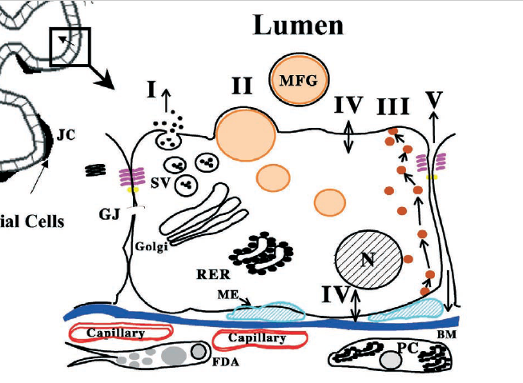

Fig. 1. Diagram of mammary alveolus and alveolar epithelial cell showing pathways for milk secretion. Milk is secreted by alveolar epithelial cells into the lumen (arrows). It is then expressed through the ducts by contraction of myoepitheilal cells that surround alveolar and ductal epithelial cells. The alveolus is surrounded by a well-developed vasculature and a stroma comprising extracellular matrix components,
fibroblasts and adipocytes. The region indicated by the box is expanded to show key structural and transport properties of alveolar cells.Pathway I depicts exocytotic secretion of milk proteins, lactose, calcium and other components of the aqueous phase of milk. Pathway II depicts milk fat secretion with formation of cytoplasmic lipid droplets (CLDs) that move to the apical membrane to be secreted as a membrane bound milk fat globule (MFG). Pathway III depicts vesicular transcytosis of proteins such as immunoglobulins from the interstitial space. Pathway IV depicts transporters for the direct movement of monovalent ions, water and glucose across the apical and basal membranes of the cell. Pathway V depicts transport through the paracellular pathway for plasma components and leukocytes. Pathway V is open only during pregnancy, involution and in inflammatory states such as mastitis. Abbreviations: SV, secretory vesicle; RER, rough endoplasmic reticulum; BM, basement membrane; N, nucleus; PC, plasma cell; FDA, fat depleted adipocyte; JC, junctional complex containing the tight and adherens junctions; GJ, gap junction; ME, myoepithelial cell. Redrawn from Ref. [82] with permission.

Mammary physiology and milk secretion
James L. McManaman*, Margaret C. Neville, Advanced Drug Delivery Reviews 55 (2003) 629–641

