Jet stream

A fast flowing current of air located above the surface of the earth, blowing from west to east. Wind speeds can exceed (200 mph) but we don’t see or feel this at ground level. Instead, this part of the atmosphere helps develop and steer weather around the globe, sometimes bringing storms, sometimes bringing very calm and settled days.
Jet streams usually sit at the boundary between the troposphere and the stratosphere at a level called the tropopause. This means most jet streams are about (9 to 16) Km off the ground. Figure (1) is a cross section of a jet stream.

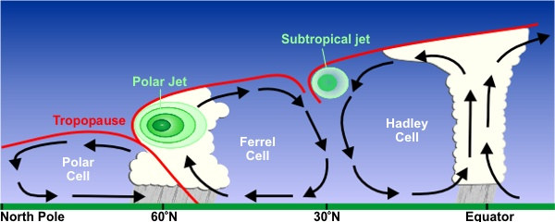

Fig(1): a cross section of a jet stream

Jet streams in the real atmosphere look very much like the thin ribbons of fast-moving air, as sketched in (2) Jet vertical thickness (order of 5 to 10 km) is much smaller than their horizontal width (order of 1000 to 2000 km).
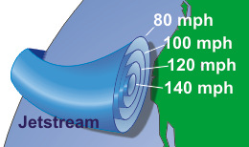

fig (2):shape of jet stream.

***jet stream form at the boundaries of adjacent air masses with significant differences in temperature, such as of the polar region and the warmer air to the south.
***Because of Earth's rotation the streams flow west to east in both the Northern Hemisphere and the Southern Hemisphere due to the Coriolis effect.
*** polar jet stream at 300mb map
*** subtropical jet stream at 200 mb map

The dynamics of jet streams
The dynamics of jet streams are actually quite complicated, so this is a very simplified version of what creates jets. The basic idea that drives jet formation is this: a strong horizontal temperature contrast, like the one between the North Pole and the equator, causes a dramatic increase in horizontal wind speed with height. Therefore, a jet stream forms directly over the center of the strongest area of horizontal temperature difference, or the front. As a general rule, a strong front has a jet stream directly above it that is parallel to it. Figure (1) shows that jet streams are positioned just below the tropopause (the red lines) and above the fronts, in this case, the boundaries between two circulation cells carrying air of different temperatures.

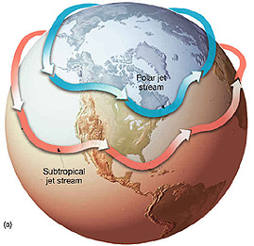
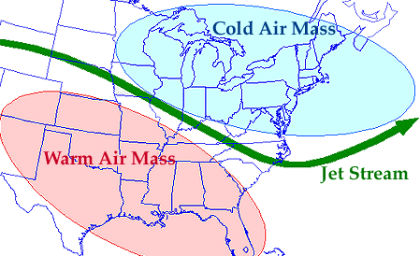

Figure 3: Typical Locations of Jet Streams Across North America (Image from NASA)

The two jet streams that directly affect our weather in the continental US are the polar jet and the subtropical jet. They are responsible for transporting the weather systems that affect us. The polar front is the boundary between the cold North Pole air and the warm equatorial air. The polar jet sits at roughly 60°N latitude because this is generally where the polar front sits. The subtropical jet is at roughly 30°N latitude. The subtropical jet is located at 30°N because of the temperature differences between air at mid-latitudes and the warmer equatorial air. The polar and subtropical jets are both westerly, meaning they come from the west and blow toward the east. Both jets move north and south with the seasons as the horizontal temperature fields across the globe shift with the areas of strongest sunlight.
the seasonal location of jet stream
In the winter the polar jet moves south and becomes stronger because the North Pole gets colder but the equator stays about the same temperature. This increases the temperature contrast and moves the strengthened polar front jet farther south. As you probably have noticed, jet streams are not just straight across, but have a wavy pattern. The jets follow the contours of low and high pressure areas (troughs and ridges, respectively), which move like waves in the atmosphere across the earth. In winter when the polar jet dips into the US, the troughs and ridges affect what kind of weather an area will have. Figure (4) is a comparison of the strength and position of the polar jet in summer versus winter. If a trough is sitting over you, it is generally very cold and snowy or rainy. If a ridge is sitting over you, it is generally warm and dry. So if it’s winter and the jet stream looks like it does in the picture, Utah would be warmer than average and Tennessee would be colder than average, possibly experiencing some snow.
The subtropical jet also moves and evolves over time. The strongest effect of the subtropical jet in the southeastern US is in winters during years when El Niño is occurring in the eastern Pacific Ocean. The subtropical jet is then positioned in such a way that southern Georgia and Florida are right underneath the main jet, and experience colder and wetter conditions than years when there is no El Niño.

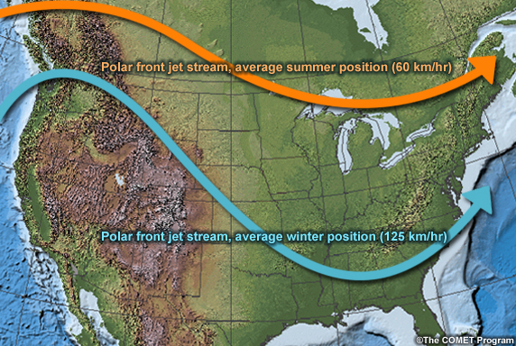
Figure4: Typical Locations of Polar Jet Stream Throughout Summer and Winter

