|  |
| --- |
| **By: Dr.Neihaya Heikmat** |

**Quorum sensing**

It is a system of stimulus and response correlated to population density. Many species of [bacteria](http://en.wikipedia.org/wiki/Bacteria) use quorum sensing to coordinate [gene expression](http://en.wikipedia.org/wiki/Gene_expression) according to the density of their local population. In addition to its function in biological systems, quorum sensing has several useful applications for computing and robotics. Quorum sensing can function as a decision-making process in any decentralized system, as long as individual components have: (a) a means of assessing the number of other components they interact with and (b) a standard response once a threshold number of components is detected.

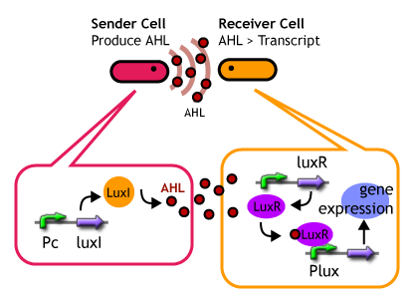

luxR: encodes an autoinducer-responsive transcriptional activator.

luxI: encodes a protein required for autoinducer synthesis.

## Bacteria

Some of the best-known examples of quorum sensing come from studies of [bacteria](http://en.wikipedia.org/wiki/Bacteria). Bacteria use quorum sensing to coordinate certain behaviors based on the local density of the bacterial population. Quorum sensing can occur within a single bacterial [species](http://en.wikipedia.org/wiki/Species) as well as between diverse species, and can regulate a host of different processes, in essence, serving as a simple communication network. A variety of different [molecules](http://en.wikipedia.org/wiki/Molecules) can be used as [signals](http://en.wikipedia.org/wiki/Cell_signaling). Common classes of signaling molecules are [oligopeptides](http://en.wikipedia.org/wiki/Oligopeptides) in [Gram-positive bacteria](http://en.wikipedia.org/wiki/Gram-positive_bacteria), [N-Acyl Homoserine Lactones](http://en.wikipedia.org/wiki/N-Acyl_Homoserine_Lactone) (AHL) in [Gram-negative bacteria](http://en.wikipedia.org/wiki/Gram-negative_bacteria), and a family of [autoinducers](http://en.wikipedia.org/wiki/Autoinducer) known as [autoinducer-2](http://en.wikipedia.org/wiki/Autoinducer-2) (AI-2) in both Gram-negative and Gram-positive bacteria.

**Gram-negative bacteria use homoserine lactones as words**

Communication via LuxI/LuxR **(HSL/transcriptional activator)** signaling circuits appears to be the standard mechanism by which Gram-negative bacteria talk to each other, as quorum sensing systems resembling the canonical *V. fischeri* circuit have been shown to control gene expression in over 25 species of Gram-negative bacteria. In every case, an acylated HSL is the signal molecule whose synthesis is dependent on a LuxI-like protein. A cognate LuxR-like protein is responsible for recognition of the HSL autoinducer and subsequent transcriptional activation of downstream target genes. A general model showing the fundamental components of a Gram-negative quorum sensing circuit is presented in Figure 1. Many physiological processes are regulated by these cell–cell communication systems, including virulence, biofilm formation, antibiotic production, and conjugation.

**AHL molecule**

**Fig.1: Gram-negative quorum sensing**

**Gram-positive bacteria speak with oligopeptides**

Quorum sensing in Gram-positive bacteria is also responsible for the control of a wide variety of functions. However, Gram-positive bacteria have evolved a basic communication mechanism that is different from that used by Gram-negative bacteria. In this case, the

signals are modified oligopeptides that are secreted into the medium and accumulate at high cell density.

The detectors for the oligopeptide signals are two-component adaptive response proteins. Bacteria use two-component proteins to detect fluctuations in environmental stimuli and relay the information regarding these changes into the cell. The mechanism of signal transduction is via a conserved phosphorylation / dephosphorylation mechanism. Analogous to Gram-negative quorum sensing bacteria, Gram-positive bacteria employ a conserved signal– response mechanism as the foundation of the quorum sensing process, and the addition of diverse regulatory components fine-tunes each circuit to the individualized needs of the species.

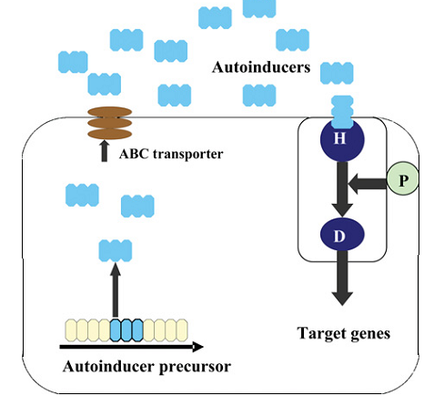

**Fig.2:Gram-positive** **quorum sensing**

**Multilingual bacteria: the universal LuxS language**

All of the quorum sensing systems we have described so far rely on the precise recognition of an autoinducer by its cognate detector. The tight specificity inherent in these communication systems is presumably required to prevent the bacteria from being confused by noise. Further, it allows them to keep their conversations private, i.e., within their own species. However, recent studies suggest that bacteria may have evolved multiple languages that serve different purposes.

It appears that many bacteria possess a species-specific language as well as a species-nonspecific language. These findings imply that bacteria can assess their own population numbers and also the population density of other species of bacteria in the vicinity. Furthermore, distinct responses to the intraspecies and interspecies signals allow a particular species of bacteria to properly modulate its behavior depending on whether it makes up a majority or a minority of any given consortium.

**LuxS :** Shared by Gram-positives & Gram-negatives

• Present in > 50 bacterial species.

• Involved in production of autoinducer 2 (AI-2).

• LuxS also functions as a component of the Activated Methyl Cycle.



### Fig.3: The universal LuxS language

### Mechanism

Bacteria that use quorum sensing constitutively produce and secrete certain [signaling molecules](http://en.wikipedia.org/wiki/Signaling_molecules) (called [*autoinducers*](http://en.wikipedia.org/wiki/Autoinducer) or [*pheromones*](http://en.wikipedia.org/wiki/Pheromones)). These bacteria also have a [receptor](http://en.wikipedia.org/wiki/Receptor_(biochemistry)) that can specifically detect the signaling molecule ([inducer](http://en.wikipedia.org/wiki/Inducer)). When the inducer binds the receptor, it activates [transcription](http://en.wikipedia.org/wiki/Transcription_(genetics)) of certain [genes](http://en.wikipedia.org/wiki/Genes), including those for inducer synthesis. There is a low likelihood of a bacterium detecting its own secreted inducer. Thus, in order for gene transcription to be activated, the [cell](http://en.wikipedia.org/wiki/Quorum_sensing) must encounter signaling molecules secreted by other cells in its environment.

When only a few other bacteria of the same kind are in the vicinity, [diffusion](http://en.wikipedia.org/wiki/Diffusion) reduces the concentration of the inducer in the surrounding medium to almost zero, so the bacteria produce little inducer. However, as the population grows, the concentration of the inducer passes a threshold, causing more inducer to be synthesized. This forms a [positive feedback](http://en.wikipedia.org/wiki/Positive_feedback) loop, and the receptor becomes fully activated. Activation of the receptor induces the up-[regulation](http://en.wikipedia.org/wiki/Regulation_of_gene_expression) of other specific genes, causing all of the cells to begin transcription at approximately the same time.

#### *Vibrio fischeri*

Quorum sensing was first observed in [*Vibrio fischeri*](http://en.wikipedia.org/wiki/Aliivibrio_fischeri), a bioluminescent bacterium that lives as a [mutualistic](http://en.wikipedia.org/wiki/Mutualism_(biology)) [symbiont](http://en.wikipedia.org/wiki/Symbiont) in the [photophore](http://en.wikipedia.org/wiki/Photophore) (or light-producing organ) of the [Hawaiian bobtail squid](http://en.wikipedia.org/wiki/Hawaiian_bobtail_squid). When *V. fischeri* cells are free-living (or [planktonic](http://en.wikipedia.org/wiki/Plankton)), the autoinducer is at low concentration, and, thus, cells do not luminesce. However, when they are highly concentrated in the photophore (about 1011 cells/ml), transcription of [luciferase](http://en.wikipedia.org/wiki/Luciferase) is induced, leading to [bioluminescence](http://en.wikipedia.org/wiki/Bioluminescence).

#### *Escherichia coli*

In the Gram-negative bacteria [*Escherichia coli*](http://en.wikipedia.org/wiki/Escherichia_coli) (*E. coli*), cell division may be partially regulated by [AI-2](http://en.wikipedia.org/wiki/AI-2)-mediated quorum sensing. This explains why, when grown with [glucose](http://en.wikipedia.org/wiki/Glucose), *E. coli* will lose the ability to internalize AI-2 (because of [catabolite repression](http://en.wikipedia.org/wiki/Catabolite_repression)). When grown normally, [AI-2](http://en.wikipedia.org/wiki/AI-2) presence is transient. *E. coli* and *Salmonella enterica* do not produce AHL signals commonly found in other Gram-negative bacteria. However, they have a receptor that detects AHLs from other bacteria and change their gene expression in accordance with the presence of other "quorate" populations of Gram-negative bacteria.

#### *Salmonella enterica*

[*Salmonella*](http://en.wikipedia.org/wiki/Salmonella) encodes a LuxR homolog, SdiA, but does not encode an AHL synthase. SdiA detects AHLs produced by other species of bacteria including *Aeromonas hydrophila*, *Hafnia alvei*, and *Yersinia enterocolitica*. *Salmonella* does not detect AHL when passing through the gastrointestinal tracts of several animal species, suggesting that the normal microbiota does not produce AHLs. Therefore, *Salmonella* appears to use SdiA to detect the AHL production of other pathogens rather than the normal gut flora.

#### *Pseudomonas aeruginosa*

The opportunistic pathogen [*Pseudomonas aeruginosa*](http://en.wikipedia.org/wiki/Pseudomonas_aeruginosa) uses quorum sensing to coordinate the formation of [biofilms](http://en.wikipedia.org/wiki/Biofilms), [swarming motility](http://en.wikipedia.org/wiki/Swarming_motility), [exopolysaccharide](http://en.wikipedia.org/wiki/Exopolysaccharide) production, and cell aggregation. These bacteria can grow within a host without harming it, until they reach a certain concentration. Then they become aggressive, develop to the point at which their numbers become sufficient to overcome the host's [immune system](http://en.wikipedia.org/wiki/Immune_system), and form a [biofilm](http://en.wikipedia.org/wiki/Biofilm), leading to [disease](http://en.wikipedia.org/wiki/Disease) within the host.

#### *Acinetobacter* sp.

It has recently been found that [*Acinetobacter*](http://en.wikipedia.org/wiki/Acinetobacter) sp. also show quorum sensing activity. This bacterium, an emerging pathogen, produces AHLs. Interestingly, *Acinetobacter* sp. shows both quorum sensing and **quorum quenching** activity. It produces AHLs and also, it can degrade the AHL molecules as well.

#### *Aeromonas* sp.

This bacterium used to be considered a fish pathogen, but it has recently emerged as a human pathogen. [*Aeromonas*](http://en.wikipedia.org/wiki/Aeromonas) sp. have been isolated from various infected sites from patients (bile, blood, peritoneal fluid, pus, stool and urine). All isolates produced the two principal AHLs, N-butanoyl homoserine lactone (C4-HSL) and N-hexanoyl homoserine lactone (C6-HSL). It has been documented that *Aeromonas sobria* has produced C6-HSL and two additional AHLs with N-acyl side chain longer than C6.

#### *Yersinia enterocolitica*

The YenR and YenI proteins produced by the [gamma proteobacterium](http://en.wikipedia.org/wiki/Gammaproteobacterium) [*Yersinia enterocolitica*](http://en.wikipedia.org/wiki/Yersinia_enterocolitica) are similar to *Vibrio fischeri* LuxR and LuxI. YenR activates the expression of a [small non-coding RNA](http://en.wikipedia.org/wiki/Bacterial_small_RNA), YenS. YenS inhibits YenI expression and acyl homoserine lactone production. YenR / YenI / YenS are involved in the control of swimming and swarming motility.

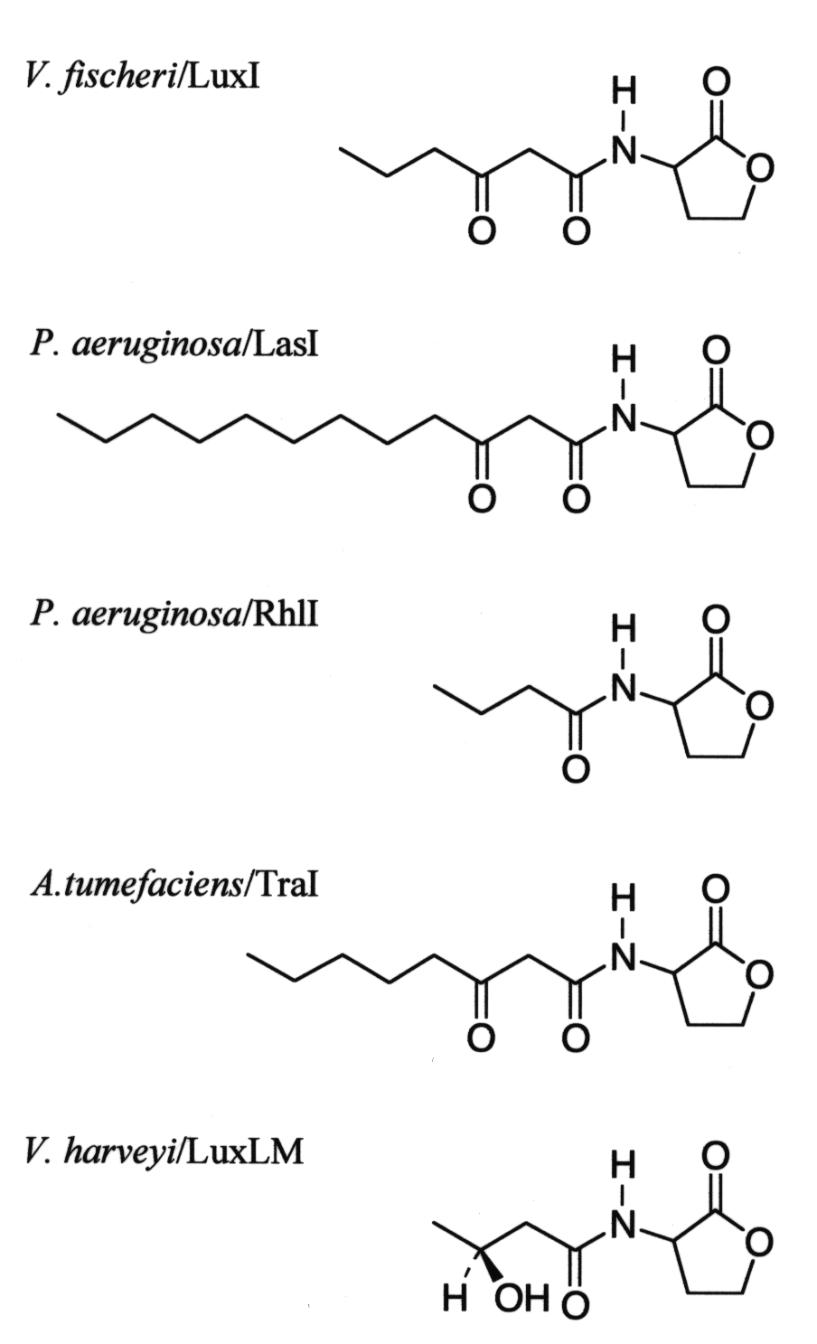

**Acyl-Homoserine Lactone Autoinducers**

**Staphylococcus aureus**

The gram-positive human pathogen Staphylococcus aureus also has a quorum sensing system. However, it does not use an AHSL as an autoinducer. The S. aureus autoinducers are [peptides that contain an unusual thiolactone structure](http://www.pnas.org/content/96/4/1218.long) (i.e., a thol ester-linked cyclic structure). The S. aureus quorum sensing system controls the synthesis of virulence factors responsible for the pathogenicity of this organism in vivo.

**Quarum sensing, Resistance and Pathogenicity**

bacterial physiology for drug discovery focused on two related areas–virulence factors and quorum sensing. Virulence factors are not expressed by a strain of pathogenic bacteria in vitro, but are expressed only when the bacteria infect a host. Once expressed, they enable the bacteria to colonize the host and cause disease. Examples of such virulence factors include secretion systems that deliver bacterial effector proteins into host cells. These effector proteins may, for example, kill host cells, inhibit cytokine production or phagocytosis, or may mediate bacterial entry into the host cells.



**Ouarum sensing and biofilm**

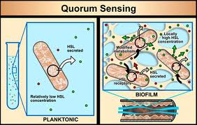

Recent studies have linked quorum sensing and biofilm maturation. This is a particularly gratifying finding because quorum sensing functions to control gene expression in groups of bacteria, and biofilms are just that, organized groups of bacteria.

### 

## [Developing resistance-free antibiotics by targeting quorum sensing](http://biopharmconsortium.com/blog/2012/06/11/developing-resistance-free-antibiotics-by-targeting-quorum-sensing/)

The biology-driven drug discovery strategy involved a combination of

1. Building on the quorum sensing studies of targeting the quorum sensing system in order to discover agents that would have the possibility of not triggering resistance, a 2. Targeting a critical, bacterial-specific pathway enzyme that is upstream of the recognition of AHSLs by quorum sensing receptors (the usual target of most researchers in this area).

Biology-driven drug discovery strategies, often coupled with innovative approaches to chemistry (in the case of small-molecule drug discovery) are applicable to very many different targets involved in a whole range of human diseases.

## Quorum quenching

Quorum quenching is the process of preventing quorum sensing by disrupting the signalling. This may be achieved by degrading the signalling molecule. **QS molecules can be degraded by:**

* Increasing pH (>7): as at higher pH AHL molecules undergo lactonolysis

in which its biological activity is lost.

* At higher temperature AHL undergoes lactonolysis.
* Some plants infected by pathogenic bacteria *E. carotovora*, increase the

pH at the site of infection, resulting in lactonolysis of AHL molecules.

* Some bacteria produces lactonolysing enzymes, such as AiiA. eg: *Bacillus cereus, B. thuriengiensis*.

