CHAPTER THREE
Absorption and transmission
3-1 Flux
A flux density, F, called a flux, its define as the transfer of a quantity per unit area per unit time. The area is taken perpendicular (normal) to the direction of flux movement. Examples with metric (SI) units are mass flux (kg· m^{–2}·s^{–1}) and heat flux, (J·m⁻²s^{–1}). Using the definition of a watt (1 W = 1 J·s^{–1}), the heat flux can also be given in units of (W·m^{–2}). A flux is a measure of the amount of inflow or outflow such as through the side of a fixed volume, and thus is frequently used in Eulerian frameworks (Fig. 3.1). Because flow is associated with a direction, so is flux associated with a direction.
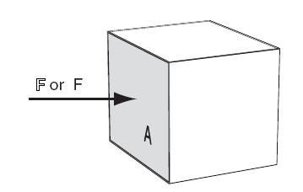
Figure 3.1: Flux F through an area A into one side of a volume.
You must account for fluxes $F_{x}, F_{y}, and F_{z}$ in the x, y, and z directions, respectively. A flux in the positive x-direction (eastward) is written with a positive value of $F_{x}$, while a flux towards the opposite direction (westward) is negative. The total amount of heat or mass flowing through a plane of area $A$during time interval $∆t$ is given by:
$$amount=F . A. ∆t……………………………….3.1$$
$$F=any amount such as heat or mass$$
For heat, $Amount ≡ ∆Q_{H}$ by definition. Fluxes are sometimes written in kinematic form, F, by dividing on air density, $ρ_{air}$ :
$$F=\frac{F}{ρ_{air}}……………………………………….3.2$$
Kinematic mass flux equals the wind speed, M. Kinematic fluxes can also be in the 3 Cartesian directions: $F_{x}, F_{y}, and F_{z}$.
Heat fluxes $F_{H}$ can be put into kinematic form by dividing by both air density $ρ_{air}$ and the specific heat for air $C_{p}$, which yields a quantity having the same units as temperature times wind speed (K·m·s^{–1}).
$$F_{H}= \frac{F}{ρ_{air} C_{p}} …………………………..3.3 ( heat only)$$

For dry air (subscript “d”) at sea level:
$$ρ_{air} C_{p}=1231\frac{ \left(w.m^{2}\right)}{km.s^{-1}}$$
$=12.31 mb.K^{-1} = 1.231 kpa.K^{-1}$

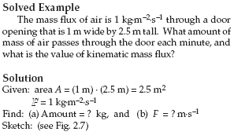

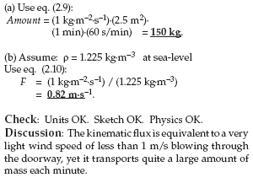
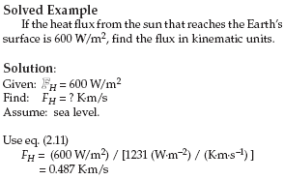

The reason for sometimes expressing fluxes in kinematic form is that the result is given in terms of easily measured quantities. For example, while most people do not have “Watt” meters to measure the normal “dynamic” heat flux, they do have thermometers and anemometers. The resulting temperature times wind speed has units of a kinematic heat flux (K·m·s^{–1}). Similarly, for mass flux it is easier to measure wind speed than kilograms of air per area per time. Heat fluxes can be caused by a variety of processes. Radiative fluxes are radiant energy (electromagnetic waves or photons) per unit area per unit time. This flux can travel through a vacuum. Advective flux is caused by wind blowing through an area, and carrying with it warmer or colder temperatures. For example a warm wind blowing toward the east causes a positive heat-flux component $F_{Hx}$ in the x-direction. A cold wind blowing toward the west also gives positive$F_{Hx}$. Turbulent fluxes are caused by eddy motions in the air, while conductive fluxes are caused by molecules bouncing into each other.

3-2 propagation:
Radiation can be modeled as electromagnetic waves or as photons. Radiation propagates through a vacuum at a constant speed: c_{o} = 299,792,458 m·s^{–1}. For practical purposes, you can approximate this speed of light as c_{o} ≈ 3x10⁸ m·s^{–1}. Light travels slightly slower through air, at roughly c = 299,710,000 m·s^{–1} at standard sea-level pressure and temperature, but the speed varies slightly with thermodynamic state of the air). Using the wave model of radiation, the wavelength λ (m·cycle^{–1}) is related to the frequency, ν (Hz = cycles·s^{–1}) by:
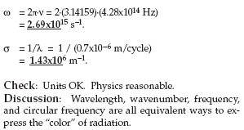
Wavelength units are sometimes abbreviated as (m). Because the wavelengths of light are so short, they are often expressed in units of micrometers (µm). Wavenumber is the number of waves per meter: σ (cycles·m^{–1}) = 1/λ. Its units are sometimes abbreviated as (m^{–1}). Circular frequency or angular frequency is ω (radians/s) = 2π·ν. Its units are sometimes abbreviated as (s^{–1}).
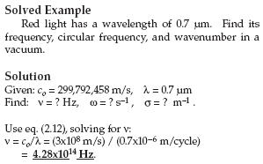

3-3 emission
Objects warmer than absolute zero can emit radiation. An object that emits the maximum possible radiation for its temperature is called a blackbody. Planck’s law gives the amount of blackbody monochromatic (single wavelength or color) radiant flux leaving an area, called emittance or radiant emittance, E_{λ}*:

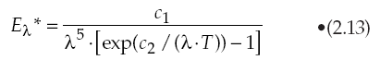

Where T is absolute temperature, and the asterisk indicates Blackbody. The two constants are:
c₁ = 3.74 x 108 W·m^{–2} · µm⁴, and
c₂ = 1.44 x 104 µm·K .
Eq. (2.13) and constant c₁ already include all directions of exiting radiation from the area. E_{λ}* has units of W·m⁻²/µm; namely, flux per unit wavelength. For radiation approaching an area rather than leaving it, the radiant flux is called irradiance. Actual objects can emit less than the theoretical blackbody value:
E_{λ} = e_{λ}·E_{λ}* , where 0 ≤ e_{λ} ≤ 1 is emissivity,
a measure of emission efficiency. The Planck curve (eq. 2.13) for emission from a blackbody the same temperature as the sun (T = 5780 K) is plotted in Fig. 2.8. Peak emissions from the sun are in the visible range of wavelengths (0.38 – 0.74 µm, see Table 2-3). Radiation from the sun is called solar radiation or short-wave radiation. The Planck curve for emission from a blackbody that is approximately the same temperature as the whole Earth-atmosphere system (T ≈ 255 K) is plotted in Fig. 2.9. Peak emissions from this idealized average Earth system are in the infrared range 8 to 18 µm. This radiation is called terrestrial radiation, long-wave radiation, or infrared (IR) radiation. The wavelength of the peak emission is given by Wien’s law:
Where a = 2897 µm·K.

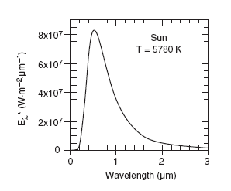
Figure ( ) : Planck radiant exitance, Eλ*, from a blackbody approximately
the same temperature as the sun.

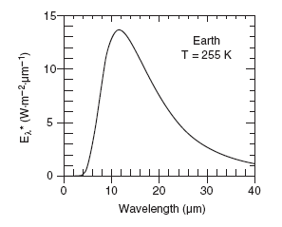
Figure 2.9 :Planck radiant exitance, Eλ*, from a blackbody approximately
the same temperature as the Earth.

The total amount of emission (= area under Planck curve = total emittance) is given by the Stefan- Boltzmann law:
where σ_{SB} = 5.67x10^{–8} W·m^{–2}·K^{–4} is the Stefan- Boltzmann constant, and E* has units of W·m^{–2}.

