Eukaryotic
Eukaryotic cells are cells that contain a nucleus and organelles, and are enclosed by a plasma membrane. Organisms that have eukaryotic cells include protozoa, fungi, plants and animals. Eukaryotic cells are larger than those of prokaryotes having a volume of around 10,000 times and more complex than prokaryotic cells, which are found in Archaea and Bacteria. Eukaryotic cells contain a variety of structures called organelles, which perform various functions within the cell. Examples of organelles are ribosomes, which make proteins, the endoplasmic reticulum, which sorts and packages the proteins, and mitochondria, which produce the energy molecule adenosine triphosphate (ATP). They also have a true nucleus, which contains the genetic material DNA and is surrounded by a nuclear envelope. All of the organelles are stabilized and given physical support through the cytoskeleton,

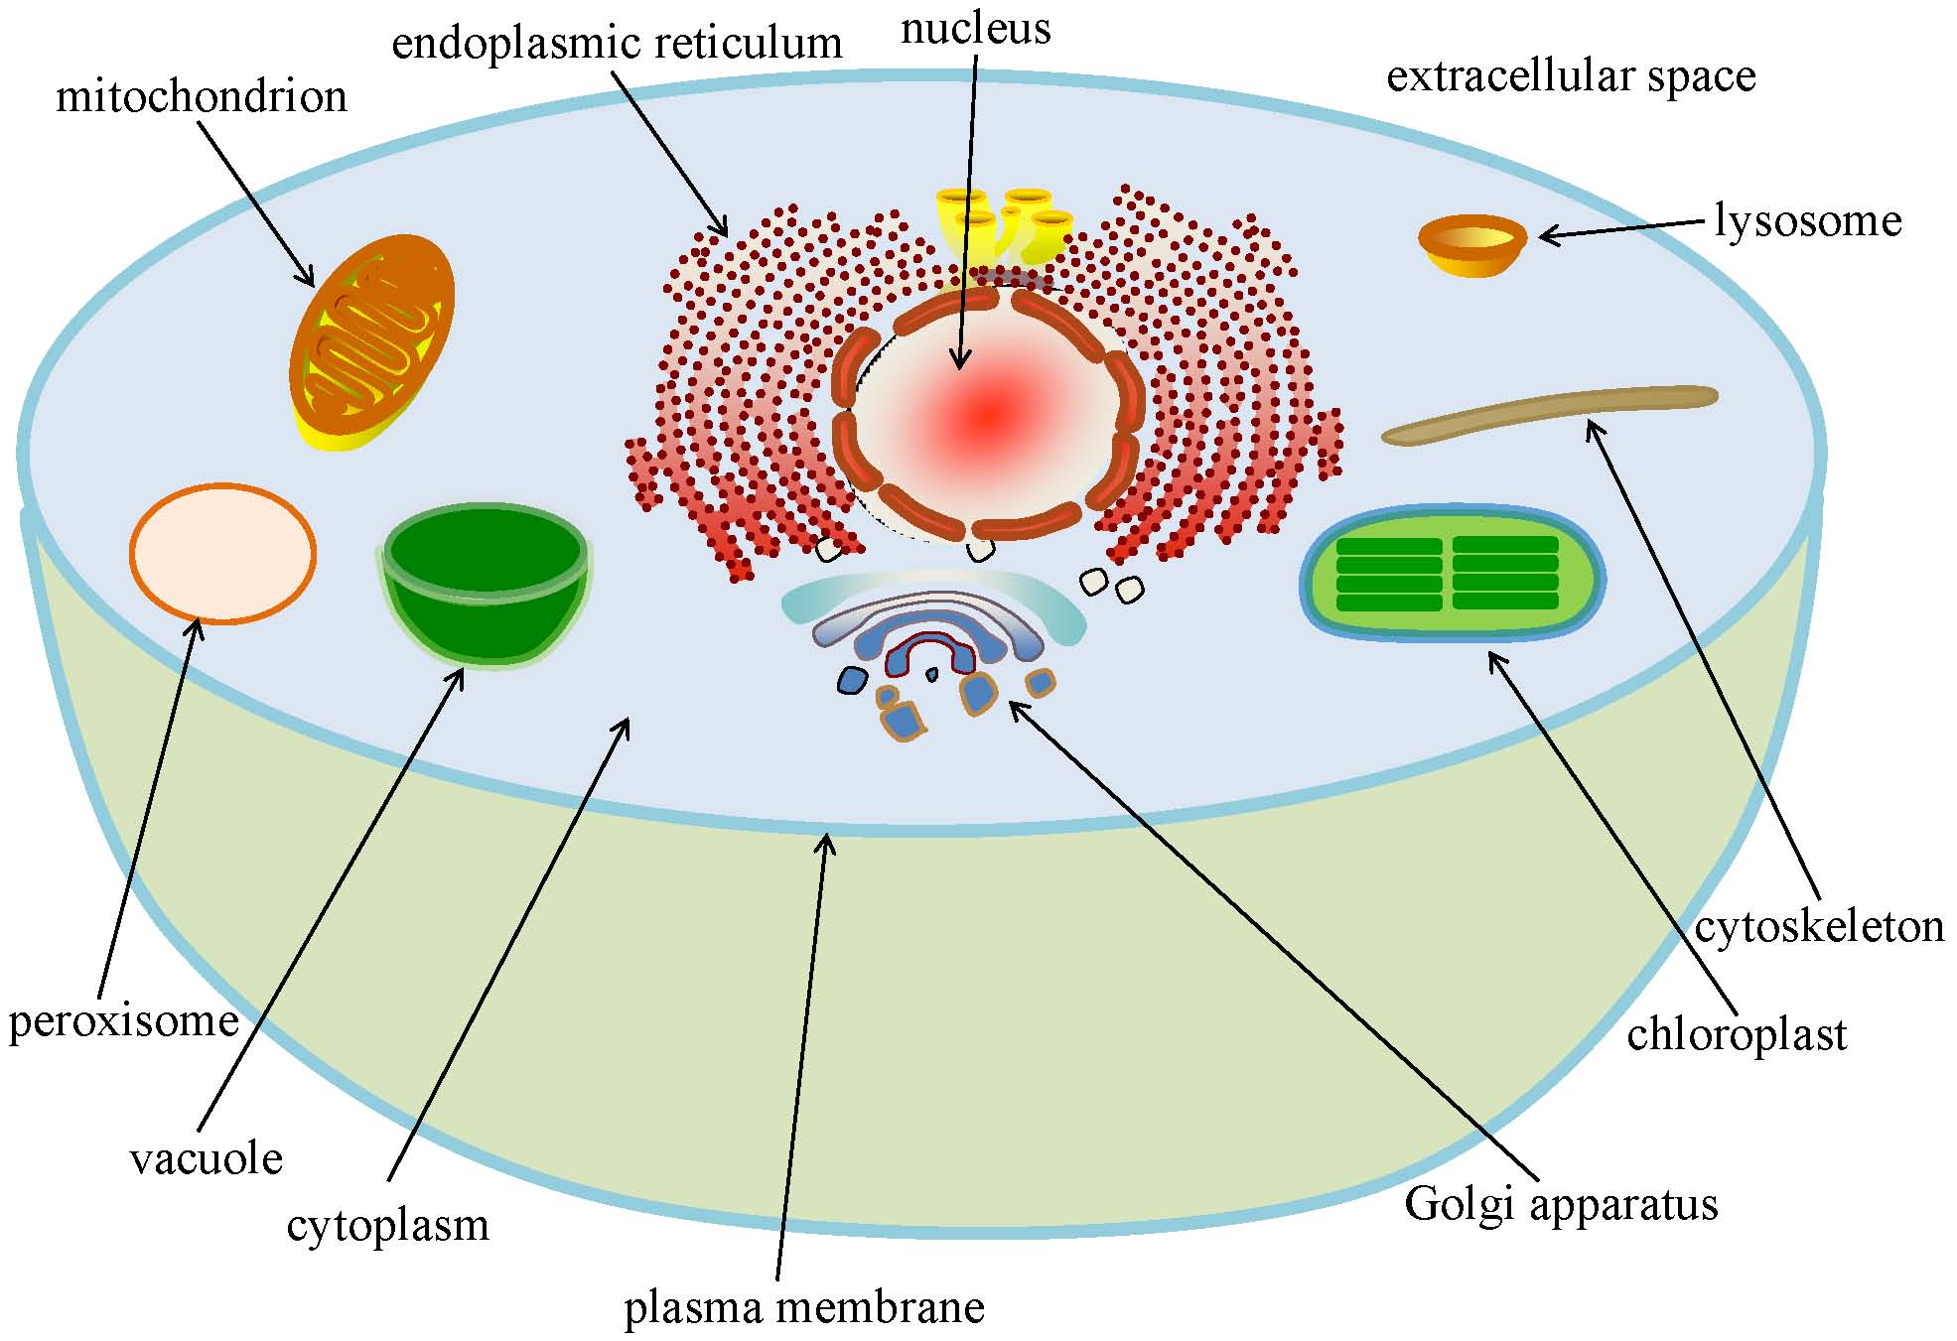

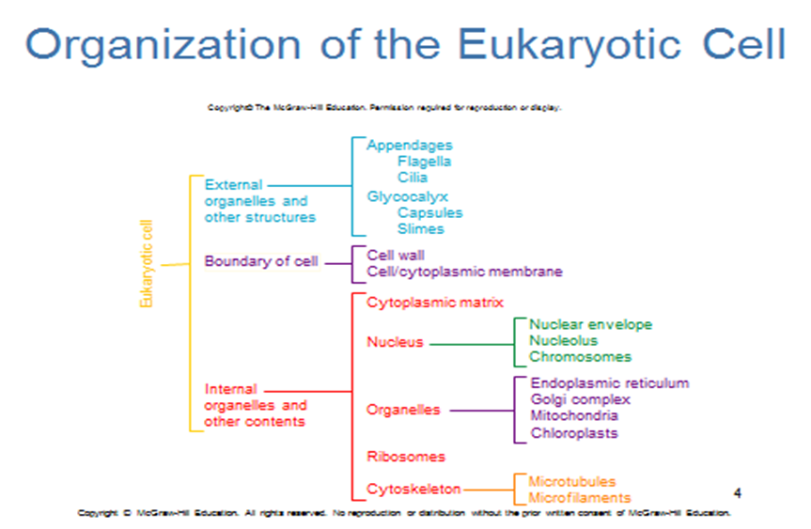

External structurs
1- cilia and flagella are remarkably similar in their organization, ,Cilia and flagella are microscopic hair or thread like motile structures present extra-cellularly . They originate intra-cellularly from the basal body and help in locomotion, feeding and circulation. Cilia are small hair like structures which causes the movement of either the cell or the surrounding fluid. Flagella are longer than cilia and are responsible for cell movement. Prokaryotic flagella are structurally different from that of eukaryotic flagella.
-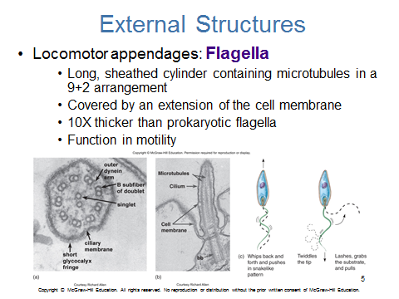

2-
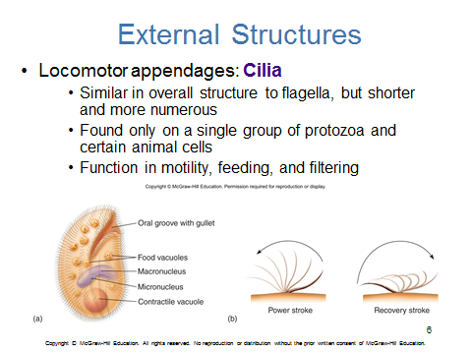

3 - glycocalyx
The glycocalyx, is a glycoprotein and glycolipid covering that surrounds the cell membranes of some bacteria, epithelia, and other cells. his coating consists of several carbohydrate moieties of membrane glycolipids and glycoproteins, which serve as backbone molecules for support. Generally, the carbohydrate portion of the glycolipids found on the surface of plasma membranes helps these molecules contribute to cell–cell recognition, communication, and intercellular adhesion.

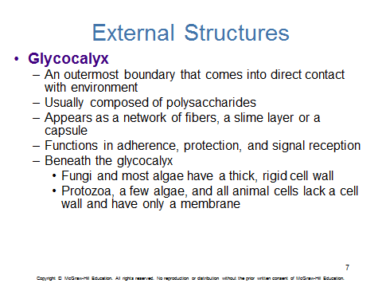

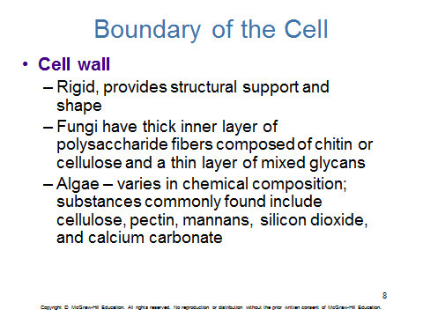

Cytoplasmic ( cell ) membrane
The cell membrane is a phospholipid bilayer that completely surrounds a bacterial cell. The word 'completely' is important here because any break in the bilayer will lead to the death of the bacteria. In fact, some of our favorite antibacterial cleaning products kill bacterial cells by destroying or making holes in the cell membrane, allowing the bacterial cell contents to spill out.
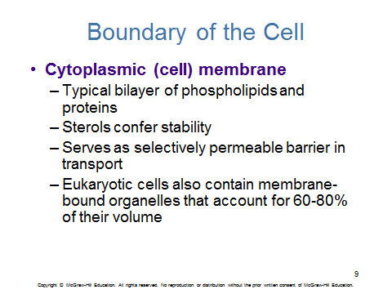

The Nucleus
Eukaryotic cells have a true nucleus, which means the cell’s DNA is surrounded by a membrane. Therefore, the nucleus houses the cell’s DNA and directs the synthesis of proteins and ribosomes, The nuclear envelope is a double-membrane structure that constitutes the outermost portion of the nucleus. Both the inner and outer membranes of the nuclear envelope are phospholipid bilayers. The nuclear envelope is punctuated with pores that control the passage of ions, molecules, and RNA between the nucleoplasm and cytoplasm. In prokaryotes, DNA is organized into a single circular chromosome. In eukaryotes, chromosomes are linear structures
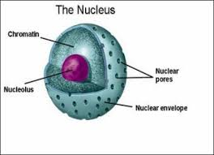
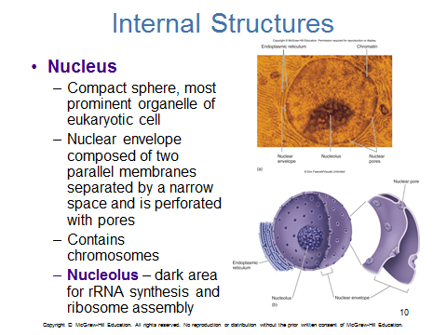
Internal structures
The endoplasmic reticulum found in most types of eukaryotic cells. There are two types of endoplasmic reticulum: rough (granular) and smooth (agranular). The rough endoplasmic reticulum is studded with ribosomes that are the sites of protein synthesis. The smooth endoplasmic reticulum lacks ribosomes and functions in lipid manufacture and metabolism, the production of steroid hormones, and detoxification

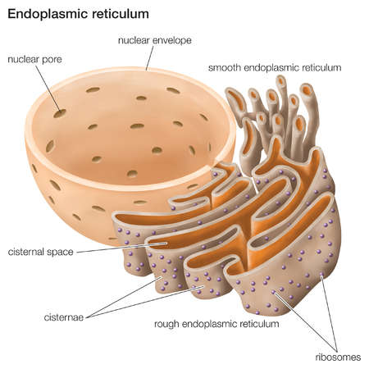
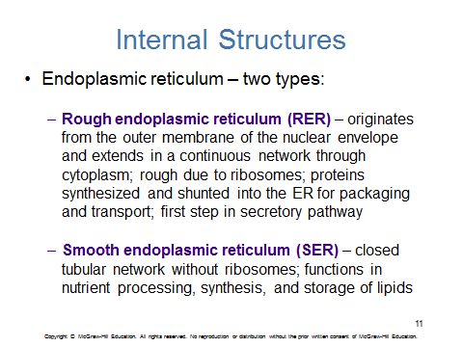
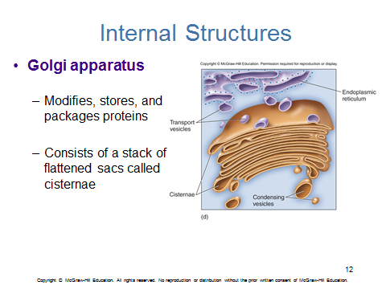

Golgi apparatus
Golgi apparatus, membrane-bound organelle of eukaryotic cells (cells with clearly defined nuclei) that is made up of a series of flattened, stacked pouches called cisternae. The Golgi apparatus is responsible for transporting, modifying, and packaging proteins and lipids into vesicles for delivery to targeted destinations. It is located in the cytoplasm next to the endoplasmic reticulum and near the cell nucleus.
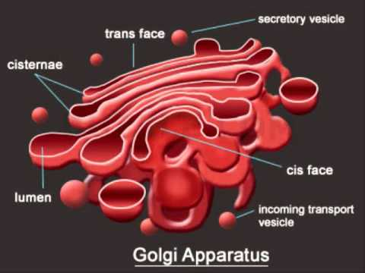

Lysosomes
Lysosomes are membrane-enclosed organelles that help eukaryotic cells obtain nourishment from macromolecular nutrients. The lysosomes contain many hydrolytic enzymes such as proteases, nucleases, and lipases)
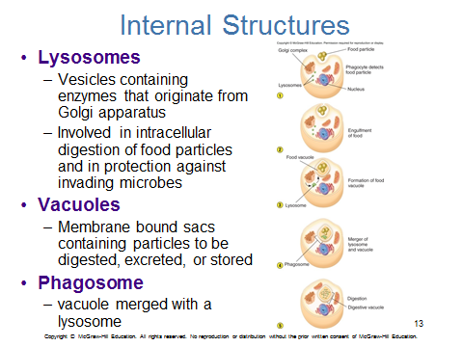

Mitochondria
organelles within eukaryotic cells that produce adenosine triphosphate (ATP), the main energy molecule used by the cell. For this reason, the mitochondrion is sometimes referred to as “the powerhouse of the cell”. Mitochondria are found in all eukaryotes. They are made of two membranes. The outer membrane covers the organelle and contains it like a skin. The inner membrane folds over many times and creates layered structures called cristae. The fluid contained in the mitochondria is called the matrix.

+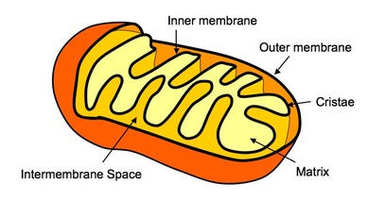
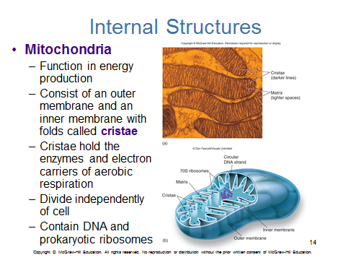

Chloroplasts
Chloroplasts are plant cell organelles that carry out photosynthesis. Photosynthesis is the series of reactions that use carbon dioxide, water, and light energy to make glucose and oxygen. This is a major difference between plants and animals,plants (autotrophs) are able to make their own food, like sugars, while animals (heterotrophs) must ingest their food
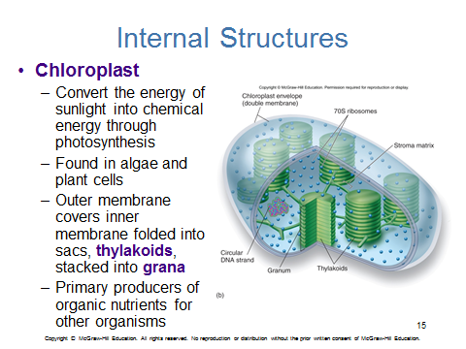

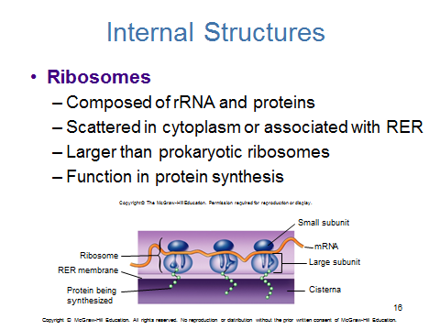
Ribosomes are cellular organelles that assemble enzymes and other proteins according to the directions found in the DNA code. Structurally, ribosomes consist of two major subunits. The smaller subunit reads mRNA, and the larger subunit assembles amino acids into a peptide chain that will be folded into a protein. The ribosomes and associated molecules are also known as the translational apparatus.
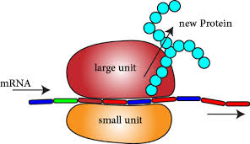

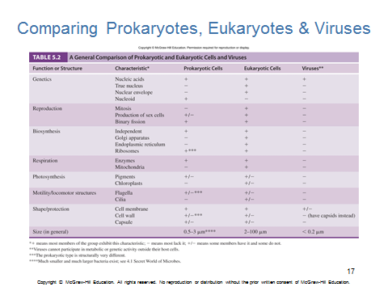
Survey of Eukaryotic Microbes (Fungi Algae Protozoa)

Fungal Cells
Like plant cells, fungal cells also have a cell wall, but their cell wall is made of chitin. Some fungi have septa, which are holes that allow organelles and cytoplasm to pass between them. This makes the boundaries between different cells less clear.
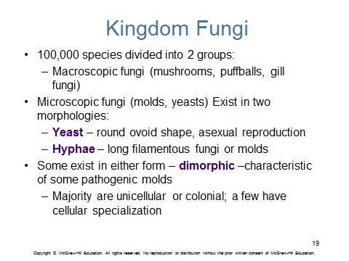

Algae

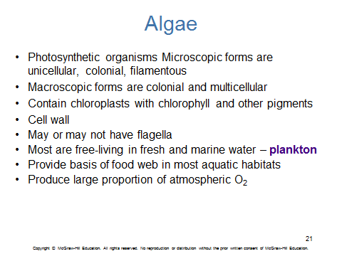

Protozoa
Protozoa are eukaryotic organisms that consist of a single cell. They can move around and eat, and they digest food in vacuoles. Some protozoa have many cilia, which are small “arms” that allow them to move around. Some also have a thin layer called a pellicle, which provides support to the cell membrane
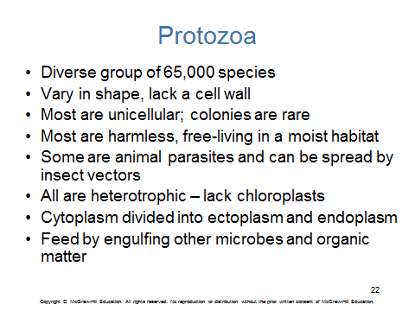

Protists
eukaryotic organisms that are unicellular and sometimes colonial or less often multicellular and that typically include the protozoans, most algae, and often some fungi (such as slime molds)

