Republic of Iraq

Ministry of Higher Education and Scientific

Research

Al-Mustansiriyah University

Collage of Science

Department of Chemistry

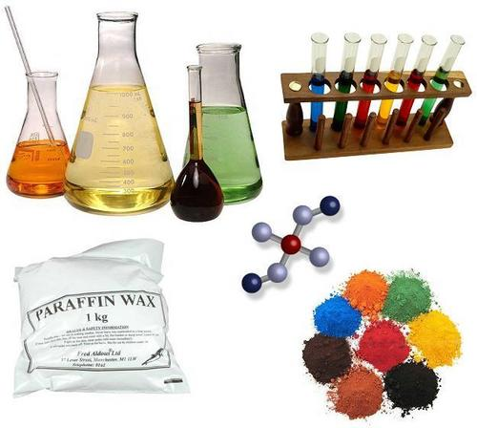

**Practice Qualitative Chemical Analysis**

First class

Edited by

**Alaa Abullwahid Jasim Ruba Fahmi Abass**

**Ali Amer Waheb Neda Ibrahim Mahdi**

Assistant lecturer

**Supervised by**

**Khitam Jaber Nabhan**  Dr. Amer **Saleh Mahdi Dr.**

Lecturer Lecturer

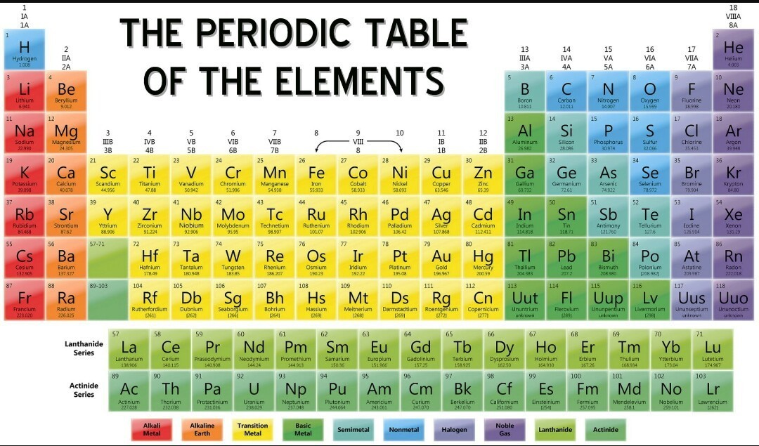

***Analytical Chemistry* &its importance**

The science seeks ever improved means of measuring the chemical composition of natural and artificial materials by using techniques to identify the substances which may be present in a material and to determine the exact amounts of the identified substance. Analytical chemistry involves the analysis of matter to determine its composition and the quantity of each kind of matter that is present. Analytical chemists detect traces of toxic chemicals in water and air. They also develop meth­ods to analyze human body fluids for drugs, poisons, and levels of medication.

***Analytical chemistry consists of:***

**(A) Qualitative analysis** which deals with the identification of elements, ions, or compounds present in a sample (tells us what chemicals are present in a sample).

**(B) Quantitative analysis** which is dealing with the determination of how much of one or more constituents is present (tells how much amounts of chemicals are present in a sample). This analysis can be divided into three branches:

**(1) Volumetric analysis (Titrimetric analysis)**: The analyte reacts with a measured volume of reagent of known concentration, in a process called titration. **(1st grade)**

**(2) Gravimetric analysis**: usually involves the selective separation of the analyte by precipitation, followed by the very non-selective measurement of mass (of the precipitate). **(2nd grade)**

**(3) Instrumental analysis:** They are based on the measurement of a physical property of the sample, for example, an electrical property or the absorption of electromagnetic radiation. Examples are spectrophotometry (ultraviolet, visible, or infrared), fluorimetry, atomic spectroscopy (absorption, emission), mass spectrometry, nuclear magnetic resonance spectrometry (NMR), X-ray spectroscopy (absorption, fluorescence). **(4th grade)**

**ارشادات مختبرية مهمة**

على الطالب قراءة هذه التعليمات والقواعد بدقة والالتزام بها ضمانا ً لسلامته وسلامة زملائه الطلبة والعاملين معه في المختبر بغية التوصل الى الهدف الاساسي من دخوله المختبر وحصوله على افضل النتائج وأعلى الدرجات وتحقق الاستفادة الفعلية من وقت الحصة المختبرية راجين من طلبتنا الاعزاء عدم مخالفتها أو الاستهانة بها.

1– الالتزام بارتداء الصدرية وذلك حفاظا ً على نظافة ملابسك وعدم تلفها وتلوثها بالمحاليل والمواد الكيميائية وارتدائها بداية دخول المختبر.

2– وضع الحقائب و الكتب والسجلات التي تخصك في الاماكن المخصصة لها بعيدا ً عن موقع عملك ولا يكون امامك سوى الملزمة المختبرية ودفتر خاص لتسجيل النتائج والملاحظات الخاصة بالتجربة.

3– عدم العبث بالاجهزة والادوات التي لا تحتاجها.

4– العناية بالنظافة من الصفات الي يجب أن يتحلى بها كل محلل كيميائي.

5- تجنب لمس الجلد أو الانف أو الفم أو العين اثناء العمل الا بعد غسل اليدين بالماء والصابون.

6– عند فتح غطاء لقنينة مادة كيميائية يجب ان يوضع الغطاء بشكل مقلوب على المنضدة لضمان عدم تلوثه وتلوث المنضدة.

7- عدم استعمال ملعقة مادة أو قطارة محلول وادخالها في محلول اخر تجنبا ً لحدوث تلوث المادة أو المحلول الاخر.

8- عند سحب محلول من قنينة أو اخذ مادة صلبة لا يجوز ارجاع الفائض الى نفس القنينة الاصلية انما تخزن في قنينة اخرى أو تهمل.

9- عند الوزن يجب استعمال قنينة وزن أو دورق صغير نظيف وجاف واحرص على أن يكون الميزان افقياً.

10- عدم استعمال اي اداة زجاجية قبل تنظيفها جيداً وغسلها بالماء المقطر وتجفيفها.

11 – عند سقوط مواد كيميائية على اليد او الملابس يجب غسلها بأكبر كمية من الماء.

**Some glassware that used in laboratory:**

**أنبوبة اختبار (Test tube)**

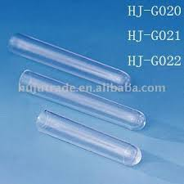 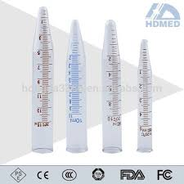

**حامل انابيب اختبار (test tube rack) ماسك انابيب اختبار (holder)**

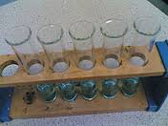

**السحاحة( Burette):** **الدورق المخروطي (Conical flask)**

[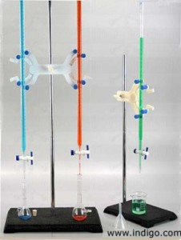](http://arabian-chemistry.com/wp-content/uploads/2015/01/%D8%A7%D9%84%D8%B3%D8%AD%D8%A7%D8%AD%D8%A9.jpg) 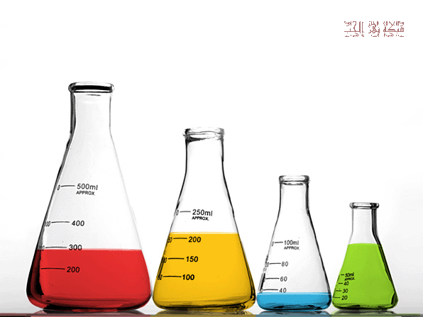

**قدح زجاجي Beaker)**) **الاسطوانة المدرجة ( (Graduated Cylinder**

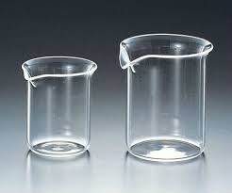 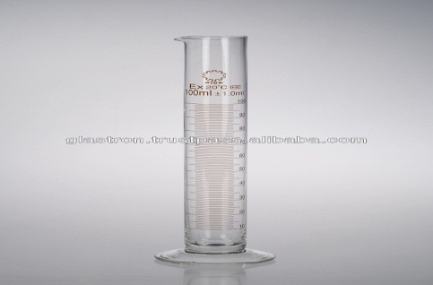

**زجاجة ساعة  (Watch glass)  ورق الترشيح (Filter paper)**

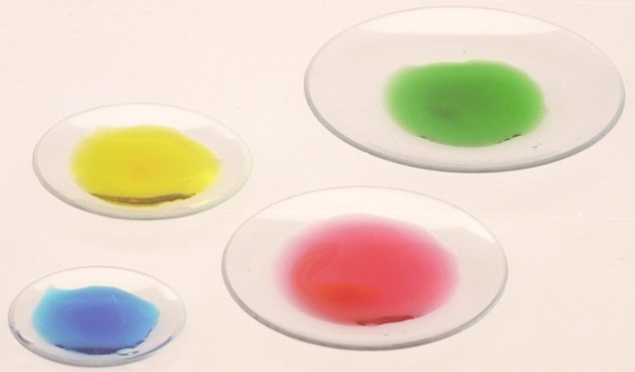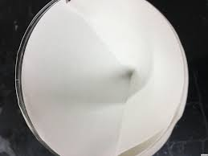

**القنينة الحجمية (Volumetric flask)**

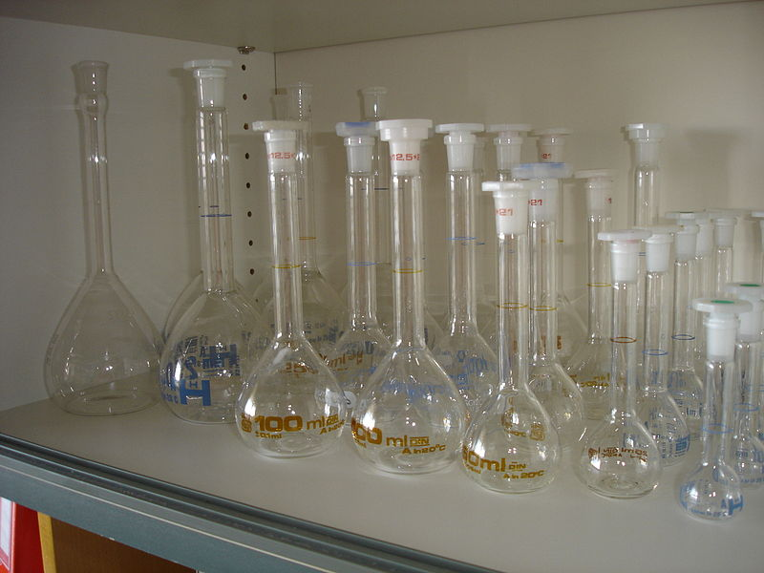

**الملعقة الوزنية spatula)) الماصة  (Pipette)**

 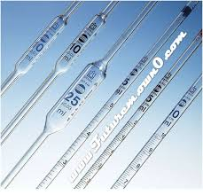

**قنينة غسيل washing bottle)) فرشاة brush))**

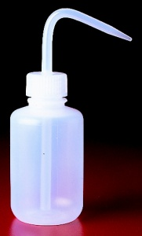 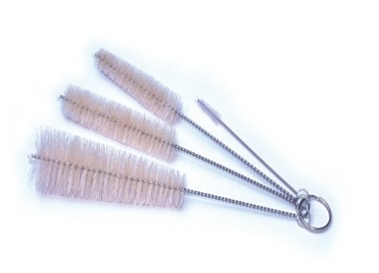

قمع زجاجي ((funnel قطارة dropper))

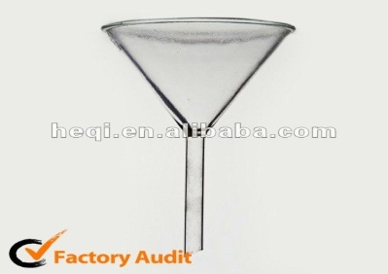 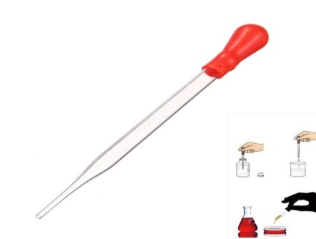

الجفنة الخزفية (crucible)

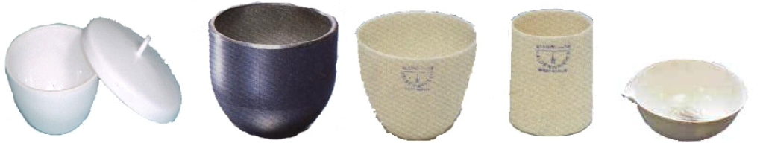

المحرك الزجاجي ((glass rod حامل (stand) + ماسك ( (clamp

 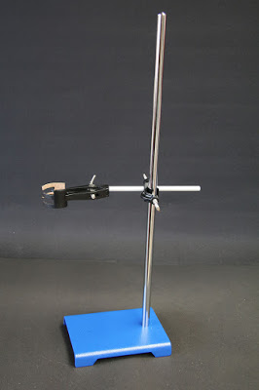

**Qualitative Analysis**

**Separation of ions to groups and identification**

Identification steps at first time to groups by certain reagents and then detection each ion in group:

1. Identification of groups by certain reagent.
2. Identification of each ion in group by special reagent.

Properties of reagents used in the detection and separation of ions of different groups from each other:

1. Abilities to precipitate ions of group which belong to it from mixture.
2. Reagent must form pure precipitate with ions of element belong to its group without ions from other group.

2- The reagent must be a pure precipitate with the element ions belonging to its group without ions from another group.

1. The precipitate must be easily to separate from each other.

3- The resulting precipitate must be easily separated from the other ions in solution

1. Reagent must be stable, doesn't decomposed and easily to have it, low cost.

**Analysis Of Cations**

Several methods for the analysis of cations for metals were used descriptively.

The cations covered in this course will be restricted to those of silver, lead, mercury, copper, bismuth, cadmium, arsenic, tin, antimony, iron, manganese, cobalt, nickel, zinc, aluminum, chromium, barium, calcium, strontium, magnesium, sodium, potassium, and ammonium.

The outline will describe the method of precipitating and .analyzing each group. To analyze a general unknown, it is necessary only that the solution left from the Group I precipitation be used as the unknown for the Group II analysis, the solution from the Group II precipitation for the Group III unknown, etc. For the usual analysis, no more than 1 ml. of unknown should be taken. More will make the analysis difficult.

|  |  |  |  |
| --- | --- | --- | --- |
| **Groups** | **Ions** | **Precipitation agent** | **Precipitates of group** |
| Group I | Ag+1 , Pb+2, Hg  مجموعة الفضة | 3M HCl | AgCl, Hg2Cl2, PbCl2 |
| Group II | IIA= (Cu+2, Hg+2 , Pb+2, Bi+3, Cd+2)  مجموعة النحاس  IIB =( As+3 , Sb+3, Sn+2, Sn+4)  مجموعة الزرنيخ | H2S + 0.3M HCl | HgS, pbS, Bi2S3, CuS, CdS  As2S3, Sb2S3, SnS2, SnS |
| Group III | IIIA=( Fe+3, Cr+3,Al+3)  مجموعة الحديد  IIIB =( Zn+2, Mn+2, Ni+2, Co+2)  مجموعة الزنك | NH3+ NH4+1  H2S+NH3+ NH4+1 | Cr(OH)3, Al(OH)3, Fe(OH)3  MnS, ZnS, NiS, CoS |
| Group IV | Ba+2, Sr+2, Mg+2 Ca+2,  مجموعة الكالسيوم | (NH4)2HPO4 | Ba(PO4)2, Sr3(PO4)2 , Ca3(PO4)2, Mg(NH4)PO4 |
| Group V | Na+2, K+1, NH+1  مجموعة العناصر القلوية | لا يوجد كاشف مرسب خاص بهذه المجموعة حيث أن لكل ايون كاشفه الخاص به | |

**Experiment no (1)**

**Separation and Analysis of First Group**

**(, Pb+2 Ag+1, Hg)**

Group I are consists of Silver Ag+ 1, Lead Pb+ 2, and Mercurous Hg 2+2 and these ions are common of this group.

The chemical characteristics of the metals to be considered in this course shows that the chlorides of the three ions, **Ag+1, Hg**and Pb+2 are insoluble whereas those of the other cations are soluble. It is possible, therefore, to separate these three metals from the others in a general unknown by adding CI- to the solution to precipitate the chlorides of lead, silver, and mercurous.

These ions precipitated by the use of an acid solution of hydrochloric acid at a concentration (3 M) these precipitations (AgCl, PbCl2, and Hg2Cl2) formed as shown in the equations below:

Ag+1  + HCl → AgCl

Pb+2  + HCl → PbCl2

Hg + HCl → Hg2Cl2

**Procedure:**

1- transfer 1 ml of mix. to test tube then add 3 drops of dil. HCl (3M).

2- stir the mix and put it in the centrifuge (2 min) then separate .

3- add to the filtrate 1 drop of dil. HCl .

4- the precipitate contain AgCl , PbCl2 , Hg2Cl2 which are white precipitate .

5- add 1 ml of hot dist. water then transfer to water bath (1-2 min.) .

6- transfer the test tube to centrifuge while its hot , separate the filtrated from the precipitate .

7- each ion will be identify by adding the specific reagent:

A: add K2Cr2O7 to hot filtrated while contains Pb+2 , Cl- ( yellow ppt. ) .

B: add (NH4OH) to ppt. then dissolve AgCl ( black ppt. ) .

C: add dil. HNO3 the precipitate AgCl .

D: dissolve the ppt. of Hg2Cl2 in the ( aqua regia ) then add SnCl2 (white ppt. ) then change to gray after add excess of SnCl2 .



**1-3 drops**

**3M HCl**

**MIXTURE**



**Filt**.

Hg2Cl2,AgCl,PbCl2

**Group 2,3,4,5**

**White ppt.**

**and heating in water bathe 1-2 min**



PbCrO4

**K2CrO4**

**Filt.**

Hg2Cl2,AgCl

PbCl2

**Separation**

**SnCl2**

**5-10 drops**

**Hgo**

**White ppt.**

**White ppt.**

**AgCl**

**Hg2Cl2**

**1-3 drops**

**And whait 1-2 min**

**SnCl2**

**HgCl2**

**with heating**

**1-3 drops**

**HCl : HNO3**

**3:1**

**1-3 drops**

**HNO3**

**PPT.**

**Hg0**

**+**

**HgNH2Cl3**

**Ag(NH3)2Cl**

**Separation**

**Filt.**

**1-3 drops**

**NH4OH**

**White ppt.**

**Yellow ppt.**

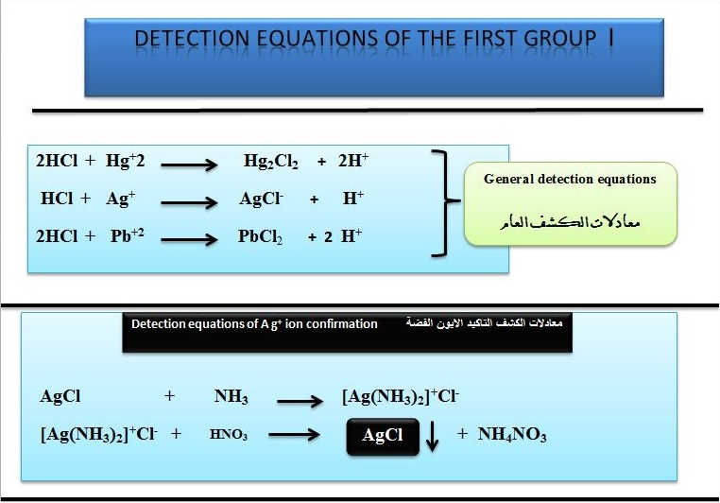

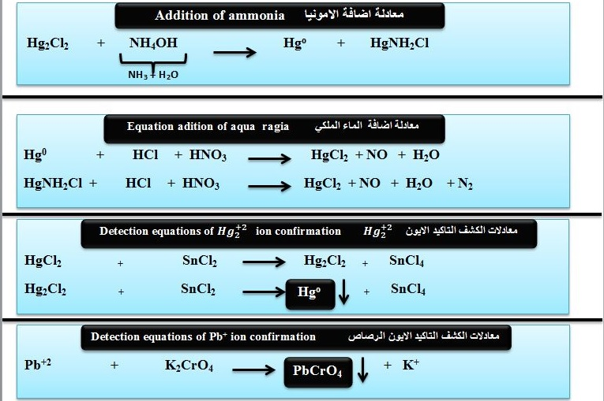

**Experiment no (2)**

***Separation and analysis of group 2 cations (arsenic- copper group)***

*Copper group* **(Cu+2, Cd+2, Hg+2, Pb+2, Bi+3 ) IIA**

*Arsenic group* **( Sb+3, As+3, Sn+4 ) IIB**

**Theoretical bases**

Ions of this group share the possibility of precipitation and separation on the form of sulphides from a solution of 0.3 M for HCl. The H2S gas is used as a precipitation agent or Aqueous Solution of thioacetamide (CH3CSNH3) It will be a source of H2S gas release. Thioacetamide it dissolves easily with water and then aqueous analysis especially when the temperature is higher than the room temperature and according to the equation

CH3CSNH2 +H2O CH3CONH2 +H2S

There is another way to generate H2S gas continuously using HCl concentrated in a kipp device where the reaction can be easily controlled starting or stopping the reaction as soon as the gas faucet is opened and closed, and according to the equation

FeS + 2HCl FeCl2 + H2S

Precipitation using a thioacetamide solution is much easier and better than using a very toxic H2S gas. The use of H2S gas in the precipitation requires the entry of gas in the solution inside the gas cabinet and pay attention to the gas in the solution in order not to lose part of the precipitate solution. Using the thioacetamide solution requires adding enough drops of this solution to (the group or ion) solution to be precipitate and then heating the solution produced inside the test tube in a water bath until the complete precipitate phase. It is important to note here that not only are the group 2 sulfides are not dissolved in water, but a number of heavy element ions that are precipitate as sulfides, which fall within the five groups in the qualitative analysis . The second group of positive ions (copper-arsenic group) includes eight ions that are precipitate and separated as Sulfides form. Of the HCl acid solution H3O+ concentration in it ranges from 0.2-0.3 M The precipitation factor used is either H2S or solution thioacetamide (TA) After the precipitation of this group in the above conditions will be easily isolated from the rest of the subsequent groups (Third, fourth and fifth). Here is a large difference in the solubility product of the large difference between the values of water-constrained constants in the table below. Two groups of sulphides are precipitate in the acidic solution (group 2 ions sulfides) and the other is precipitate from a basic solution.

The following table shows the insoluble sulphides of some positive ions of the second and third groups with the values of the solubility product constants.

|  |  |  |  |
| --- | --- | --- | --- |
| The sulphide | Ks.p | The sulphide | Ks.p |
| CdS | 3.6 **×**10 -29 | MnS | 1.4 **×**10 -15 |
| CuS | **8.5×**10-45 | FeS | 3.7 **×**10 -19 |
| HgS | 3.0 **×**10 -55 | CoS | 7.0 **×**10 -23 |
| Bi2S3 | 1.6 **×**10 -72 | ZnS | 1.2 **×**10 -23 |
| Sb2S3 | 1.9 **×**10 -85 | NiS | 1.4 **×**10 -24 |

**Procedure:**

1. We have a mix of group 2 cations (arsenic- copper group) add 3 drops thioacetamide (TA) solution and 3 drops HNO3.
2. Preheat in water bath About a quarter of an hour a black Precipitate (I) appears convert to a brown color by heating.
3. separate the filtrate (I) from the Precipitate (I).
4. Precipitate (I) Consists of (HgS (Add (Aqua regia) And heated in a water bath with stirring The precipitate dissolves and we obtain the Hg+2 ion. After that, add drops of SnCl2 solution (reduced agent) until it turns into a black precipitate from Hgo and stop adding it Thus we have detected the presence of mercury ion (Hg+2) in the mix.
5. The filtrate (I) contains of this ions (Cu+2, Cd+2, Pb+2, Bi+3) add (3-5) drops of ammonia solution. A white precipitate appears a consist of Bi (OH) 3 and Pb (OH) 2.
6. Separate the filtrate (II) from the Precipitate (II).
7. Add 2 drops of NaOH solution with stirring to the *Precipitate* (II) and place it in the centrifuge to obtain a precipitate (III) and filtrate (III).
8. The white precipitate (III) is Bi (OH) 3 added to its sodium stannite reagent and turns into a black color indicating the presence Bi+ 3 ion.
9. **Preparation of sodium stannite reagent** from the reaction of 3 drops of NaOH solution with an increase of SnCl2 solution until a white precipitator is formed to indicate the formation of sodium stannite reagent.
10. The filtrate (III) Consists of Na2PbO4 add K2CrO4 potassium chromate solution to turn into PbCrO4 yellow color indicating the presence Pb+2 ion.
11. The filtrate (II) contains Cu [NH3] 4] +2 , [Cd (NH3) 4] +2 divided it into two parts (AII) and (BII).
12. Add 3 drops from KCN solution to The filtrate )AII (to turn into solution contain of [Cu(CN)4]+2 and [Cd(CN)4]+2 add to it 3 drops of thioacetamide (TA) solution and then heat in water bath until a yellow precipitate is formed from CdS compound indicating the presence Cd+2 ion
13. Add 3 drops from acetic acid CH3COOH solution and 3 drops from Potassium ferrocyanide K4[Fe(CN)6] solution to The filtrate (BII) to turn into red solution due to formation of Cu2[Fe(CN)6] complex indicating the presence Cu+2 ion

separation and analysis of the second group װ



***MIXTURE***

**HgS,CdS,Bi2S3,CuS,pbS ,As2S3,SnS2,Sn2S3,Sb2S3**

Filt.

**Filt.**

**Bi(OH)3**

**Bi**

**CdS**

**Hg0**

**[Cu(CN)4]-2**

**Hg2Cl2**

**Cu2Fe(CN)6**

**[Cd(NH3)4]+2**

**[Cu(NH3)4]+2**

**HgS**

**HgCl2**

**Black ppt.**

**CuS,CdS,Bi2S3,pbS**

**Filt.**

**HgS,CdS,Bi2S3,CuS,pbS**

**As+3,Sn+2,Sn+4,Sb+3**

**Filt.**

