Chapter 2: The Integumentary system
Skin is the first line defense covering the whole body. It consists of 2layers: dermis originating from ectoderm, epidermis originating from mesoderm. skin connects the body directly to the external environment .
Function of skin:
1-Body support: The skin supports the body and keeps its shape with the help of endoskeleton bones.
2- Protection: The outer surface of skin consist of a horny layer that act as a strong defense line against microbes and harmful materials, also it protects the internal organs against external shocks. For example the fish scales, feather and hair play an important role in protection.
3- Excretion: Skin helps in regulating osmotic pressure by excreting sweat which is also beneficial in regulating constant body temperature and getting rid of body toxins.
4-Regulating body temperature: Every biological body process gives heat which is distributed among different organs by blood and the body get rids of it in urine, feces and sweat through excretory system or lungs or skin.
- How does the body keep its temperature in cold and hot weather?
In cold weather, the skin keeps its temperature by; decreasing sweating, storing the heat in fat under skin or fur or hair or feather.
In hot weather, dilated blood vessels helps eliminating the heat outside the body along with the evaporated sweat excreted from sweat glands in skin.
5-Storing fat: Skin has 3 main functions; a- it’s an insulator against losing heat .
b-it stores extra food in birds and animals who do hibernation as amphibians, reptiles and bears who consume it during immigration and long sleeping time .
c- Fat is distributed differently between different animals and between males and females so it defines the external shape of the body.
6- Breathing: Amphibians uses the skin in respiration by exchanging gases between blood and external environment through skin
7- Sensation: Skin receives many external stimuli as; heat , cold , pressure and pain.
Skin of cartilaginous fish as dog fish:
The skin of cartilaginous fish consist of epidermis that secrets a mucus material and dermis consisting of connective tissue containing pigmented cells under basement membrane.
They have scales on their surface called protective scales , each scale contains a central hallow containing blood vessels and nerves and covered from outside by a thin mina layer 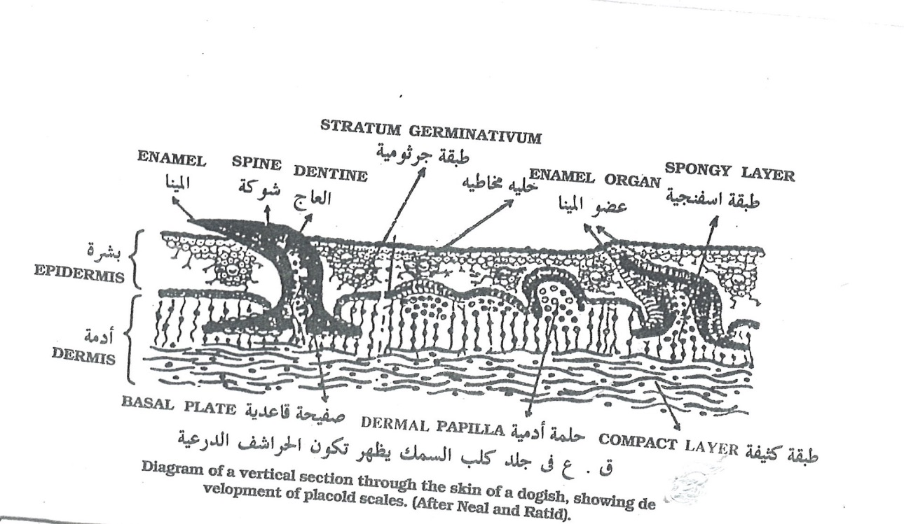
Skin of bony fish:
The epidermis consist of scaly epithelial arranged cells containing mucus cells , the superficial layer has hard cycloid scales while the dermis consist of connective tissue containing pigmented cells and from it originate the flat cycloid scales also it precipitate bone to form annular successive rings in different seasons , age could be determined by these rings which grows fast during spring and summer and stops during winter .

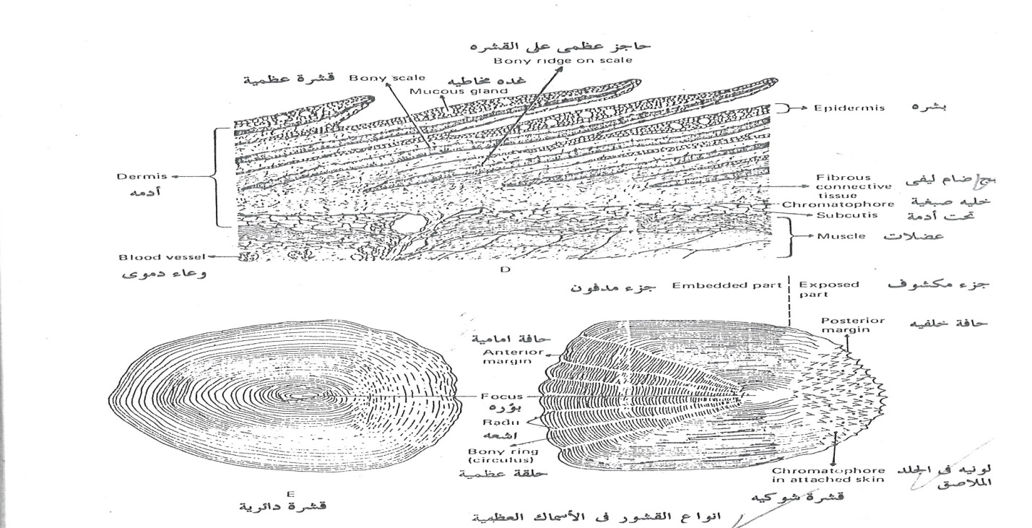

Skin of amphibians:
The amphibians have soft slippery skin containing 2 layers like other vertebrates animals in general; epidermis and dermis separated by basement membrane.
A-Epidermis:
It consist of malpigian layer of columnar cells which divides constantly to give multiple layers of spongy cells that gradually decrease in size as going upward to the body surface and they expand to form a renewable horny layer.
B- Dermis:
Consists of:
- Loose connective with many blood vessels, nerve fibers and melanophores which gives the frog its color. Its color change according to heat, humidity and light.
- Mucus glands .these glands are formed by cuboid cells to secret mucus that accumulate in the follicular glands to be excreted to the outside.
Function of mucus:
a- This mucus exchange gases through skin during hybridization
b-helps the frog to escape from enemies
- Toxic glands to secret toxic substance that kills microbes and fight against enemies, these glands are found excessively in parotid glands behind the eyes.

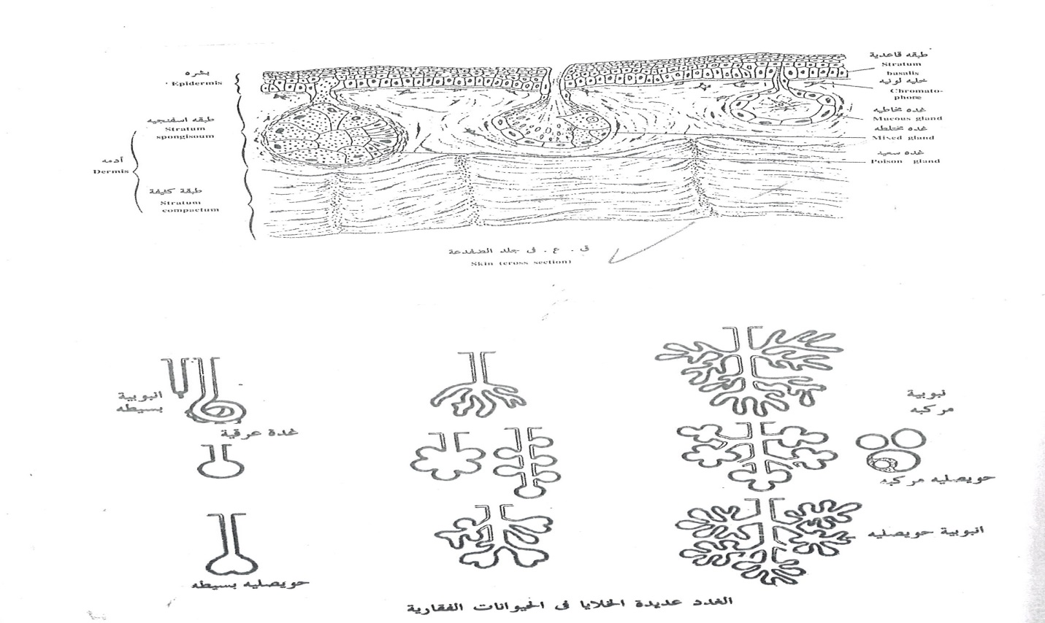

The color in frog’s skin:
The frog’s skin contains melanocytes distributed in its body and influenced by:
1 – Melatonin secreted by pineal body which causes constriction of melanocyte to lighten the skin.
2- Melatonin stimulating hormone (MSH) secreted by middle lobe of pituitary gland which cause wide distribution of melanocytes to darken the skin .
Light and heat also affect the color of frogs.
Skin of reptiles:
The skin of reptiles contains horny scales and they contain little glands located in certain sites as ; thigh pores in orchids.

Keratinized epidermal structures:
Formation: The reptiles epidermis rotate around itself around a small projection called papilla to form the keratinized scaly layer, these scales differs in shape from small projections in chameleon to thin horny sheet in snakes .
Different forms: These scales are flattened in turtles to cover the bony plates forming the carapace and plastron , also the scales connect with the horizontal abdominal muscles of snakes and move them up and down to help its movement.
These scales are also found in birds legs and the tail of some mammals as rats.

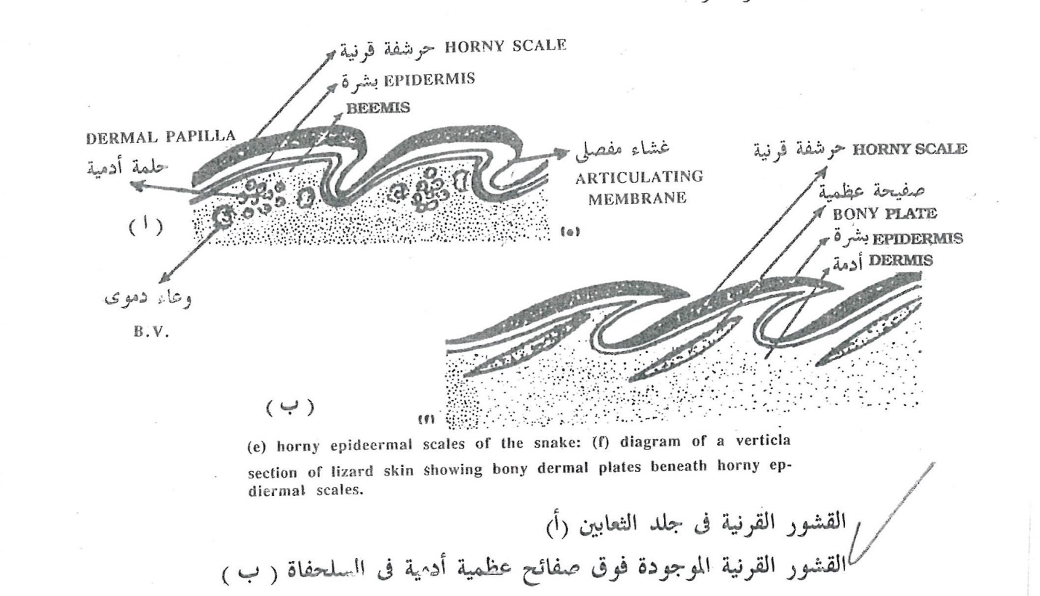

Claws, nails and hoofs:
The keratinized layer of amniotes gives claws that is modified into nails or hoofs in most mammals which resemble scales in reptiles and birds legs.
Nail composition: consists of
1- long strong claw plate with a soft pad underneath while in hoovers the hoof has a sole plate underneath. The hoof are formed from short plates united with each other by a sticky material.
2-Compact horn forming the nail and covering the nail bed , it’s covered from both sides by nail wall . The nail groove separate the nail bed from nail wall and cover the nail fold with a white lunular shaped part called”lanule”.
3-Nail fold has the same skin components , under nail fold there is nail matrix which produce the new nail.

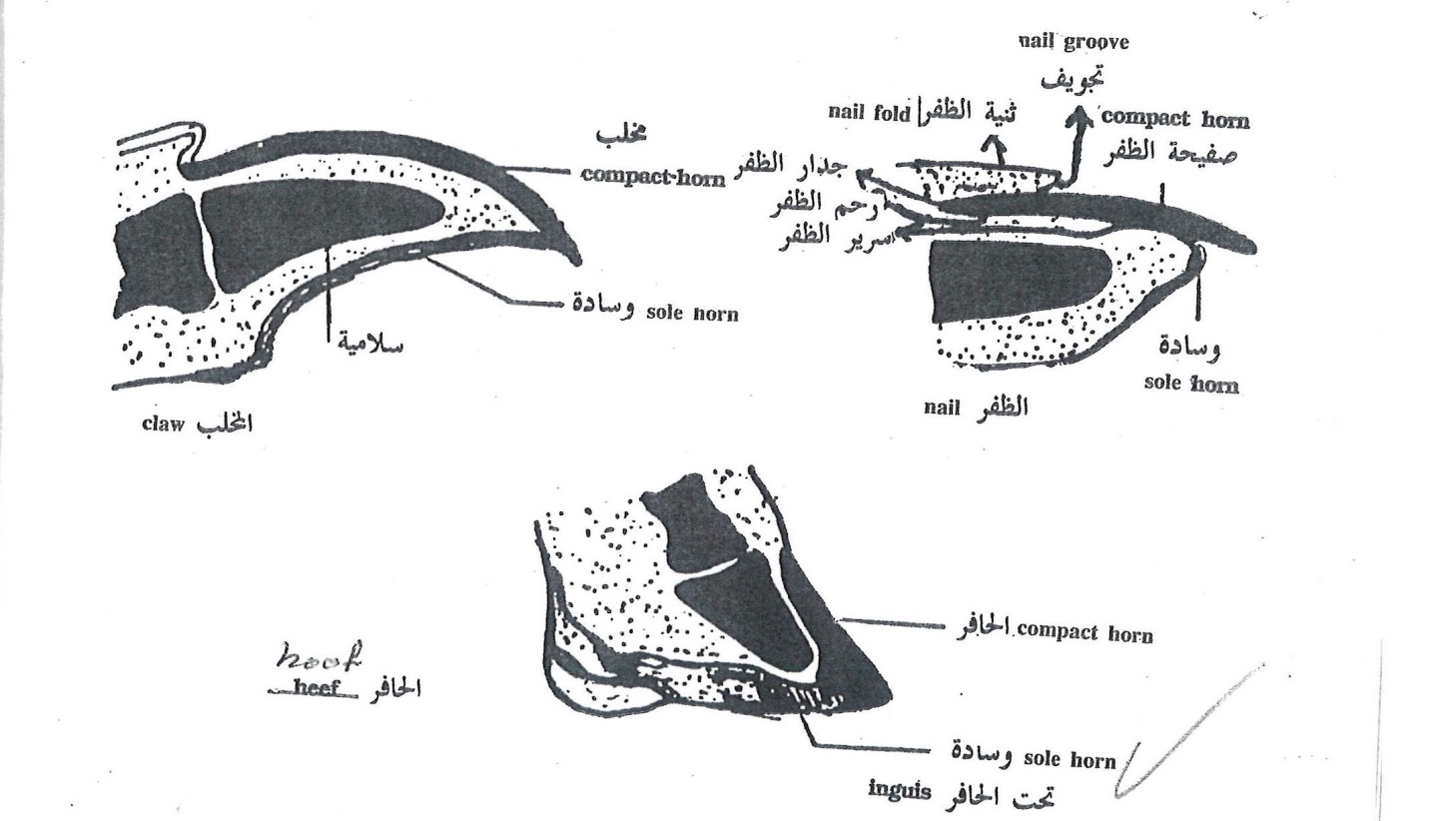

The skin of birds:
It is a thin layer covered with thick layer of feathers. The epidermis consists of thin keratinized arranged cells while the dermis is rich of oil producing cells.
The only pair of glands found in birds is uropygal glands the opens in a nipple like structure in the tail. These glands secrete an oily material to lubricate its peak and feathers. Birds also have keratinized scales on their claws, wings edges especially the young birds.
Feathers:
They are skin appendages described as modified scales, In pigeons the feathers originate from scales in their legs, in other birds as owls feathers and scales are found together on their legs.
Function: Feathers help in regulating body temperature and helps in flying.
Types: a- contour feathers
b- down feathers
c- Filoplumes
Feathers are arranged regularly all over the body but in some parts as under the wing or around the anus its distributed irregularly.

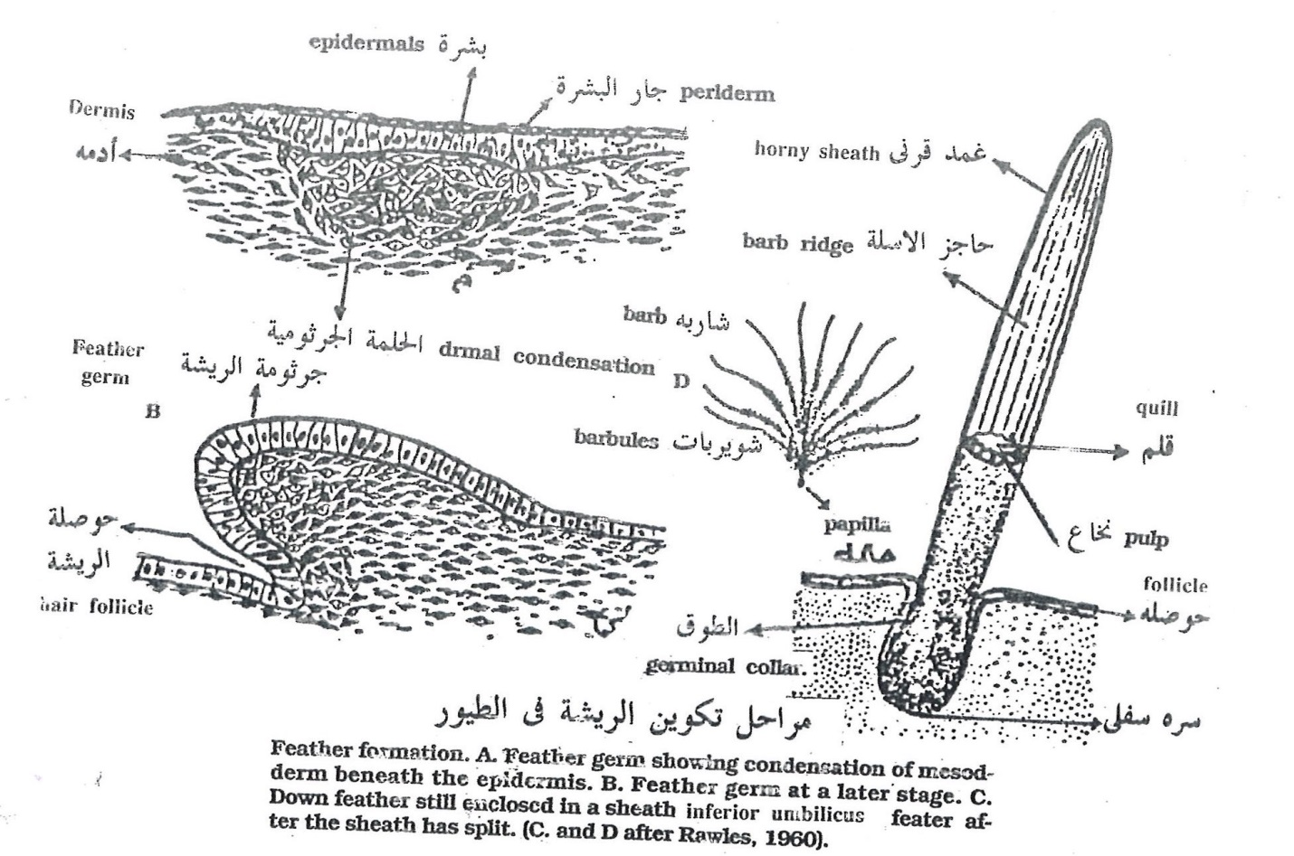
The skin of mammals:
Mammals skin consist mainly from 2 layers; the epidermis and dermis that originate from 2 sources
- Epidermis is a superficial from ectoderm
- Dermis is a deep layer from mesoderm
Hair formation
- The hair starts to appear as a proliferating budfrom epidermis to penetrate dermis and pushing the germinal layer.
- The deep part of this bud form the hair papilla.
- The middle part forms the shaft.
- The proliferating germinal layer at the hair bud pushes the hair upward to the body surface , its nourished from downward by dermal bud cells.
- Sebaceous gland buds from the wall of hair follicle , it is responsible for nourishing the hair.
At birth the hair is soft and weak called lungo hair that falls soon after birth to be replaced by our thickhair which consist of:
a- new hair bud ,b- the newborn’s body surface is covered by oily substance ( secreted from sebaceous gland) ,c- some degenerating epithelial cells, it is thought that these structures protect the embryo from the amniotic during pregnancy.
The buried part of hair inside the skin is called “the root”, while the apparent part is called “the shaft”.
The hair consists of 3layers:
1-The external layer called “hair cuticle”
2- The middle layer called “cortex”
3-The inner layer called hair medulla.
Melanocytes are located in the middle layer , the hair becomes weaker and start to fall also its color faint by increasing age then it is replaced by new weak hair.

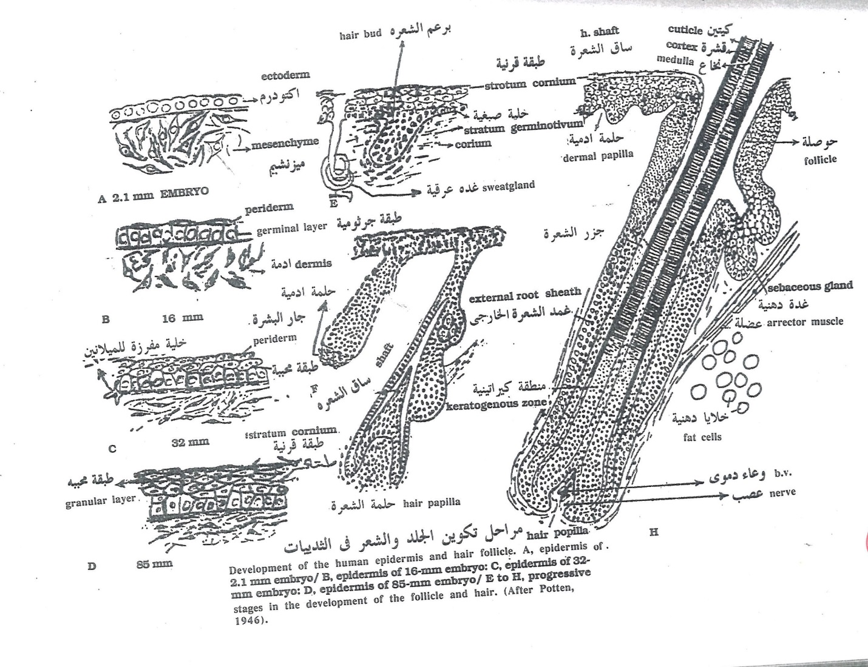

Development of human tooth:
- tooth formation starts by immersion of dermis along the edge of the jaw forming “the tooth bud, and it keeps the connection with the dental lamina.
- Papillae are extended from the tooth hollow called “tooth germ”, each tooth germ gives rise to enamel organ, and the dental lamina connects between the enamel organ and the tooth hollow.
- Some mesodermal cells accumulate at the opening of enamel organ to form “dental papillae “also at the same time another group f tooth germs are formed between the epithelial gums and primary tooth germs.
- The epithelial cells forming the enamel layer consists of columnar cells calls ameloblasts which induce the formation of odontoblasts in the neighboring dental papilla. The odontoblasts give a thin layer called predentine.
- By secreting the enama and odontoblasts the tooth appears at the surface of the gum to clinch the food and the central part of the tooth consist of dermis , blood vessels ,nerves and connective tissue .

