Chapter – Four: The respiratory system
Respiration gives energy, needed for metabolic activities, from cells by oxidation oxidizing food particles by oxygen.
Respiration could be external between blood and external environment or internal between blood and blood capillaries and tissue.
Respiration is done by special system called respiratory system. In vertebrates, there are 2 types of organs: gills and lungs. Gills are spindle like structures supplied with blood capillaries and covered with a thin epithelial layer. Gills are characterized by large surface area to facilate gas exchange. In addition to gills, bony fish have swim bladder lying at the dorsal side. Swim bladder is a sac like organ connected anteriorly to the esophagus through open canals in some types and closed in others. Swim bladder helps the fish to swim in different water layers.
When animals moved from water environment to land environment , lungs replaced gills, lung fish have a well-developed lungs through which gas exchange occur therefore gills is considered older than lungs in 4 limbs animals.
In cartilaginous fish:
There are 5 pairs of branchial chambers; the anterior four have branchial lamellae on both anterior and posterior sides so each one of them is called “holobranch” while the fifth chamber has only anterior branchial lamellae because its posterior side is attached directly to the trunk so it’s known as “hemibranch”. Behind the eye there is a gill slit known as “spiracle” or “pseudobranch” as it doesn’t have a respiratory function.

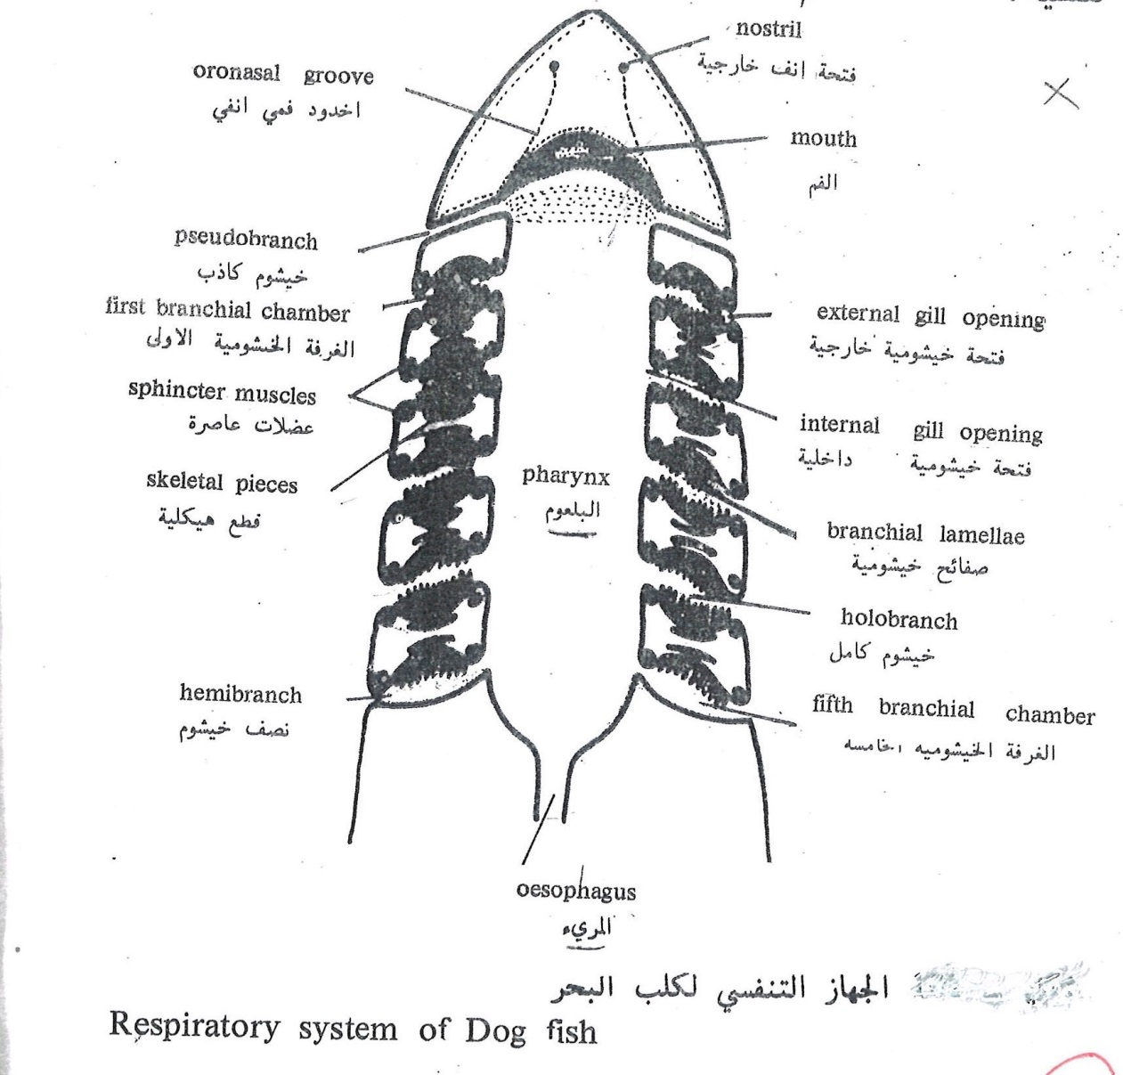
In bony fish:
There are 5 pairs of branchial chambers; the anterior four chambers are active while the fifth one is attached totally to the trunk, these chambers are separated by gill arches and all of them open in common branchial chamber, also its lined externally by operculum. This chamber opens into a branchial opening at the end of the pharynx.
The opening and closure of this opening is controlled by “branchiostigeal membrane”, each branchial arch carries externally 2 rows of branchial filaments and internally 2 rows of gill rackers to support the arches.

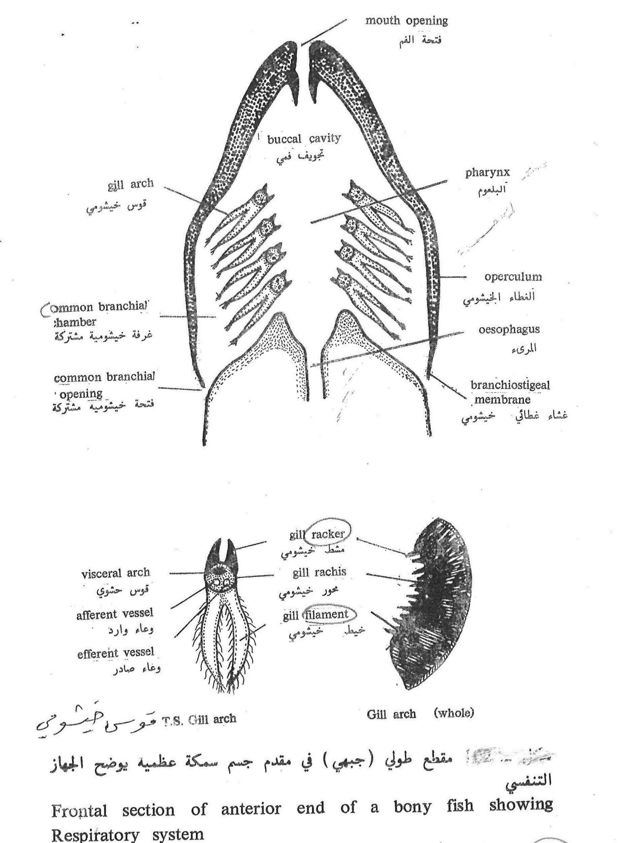
In lung fish:
In addition to the 5 branchial chambers there is a primitive lung which is a swimming bladder after modification, it exchange gases to oxygenate blood in to left atrium.
In amphibians:
They are considered the first animals to breath from the atmosphere.as the gills are modified to lungs during their transformation from larvae into adult. Amphibians have wide pharynx leading to primitive larynx supported by arytenoid cartilage and cricoid cartilage which forms the circumference of primitive larynx.
Frogs and toads have lean vocal cords and male frogs have vocal sacs which are filled with air to give the significant voice of frogs.
There is no trachea in amphibians the larynx opens directly into the lungs. Larynx is divide into 2 branches at its end to open into the adjacent lung , the lungs lies in the pleuroperitoneal cavity, the lungs is divide into alveoli that are separated by trabeculae. In amphibians that live most of their lives on land have lungs with larger surface areas to compensate respiration through skin in humidity.
In amphibians with tails as salamanders have no lungs or gills so they depend on respiration through skin.
Respiration takes place by breathing air in and out by opening the base of mouth to open and close nostrils then when the air reaches the lungs gases are exchanged between capillaries and blood capillaries.

In reptiles
The epiglottis leads to a primitive larynx supported by cricoid and arytenoid cartilage. Some reptiles have small vocal cords, then the larynx leads to the trachea which appears for the first time in reptiles. The trachea is short in lizards and tall in crocodiles and turtles that are supported by dorsally incomplete cartilaginous rings to allow the esophagus to expand during swallowing large food particles.
Trachea is divided into 2 divisions for each lung, the lung in reptiles is more modified than that of amphibians and its more likely to the lungs of mammals.
There are small simple hollow projections on the posterior surface of lungs, scientists considered that these projections descend from air sacs in birds.
Lungs of reptiles are located in pleural cavity that is separated from the visceral cavity by a fold or incomplete septum from body surface.

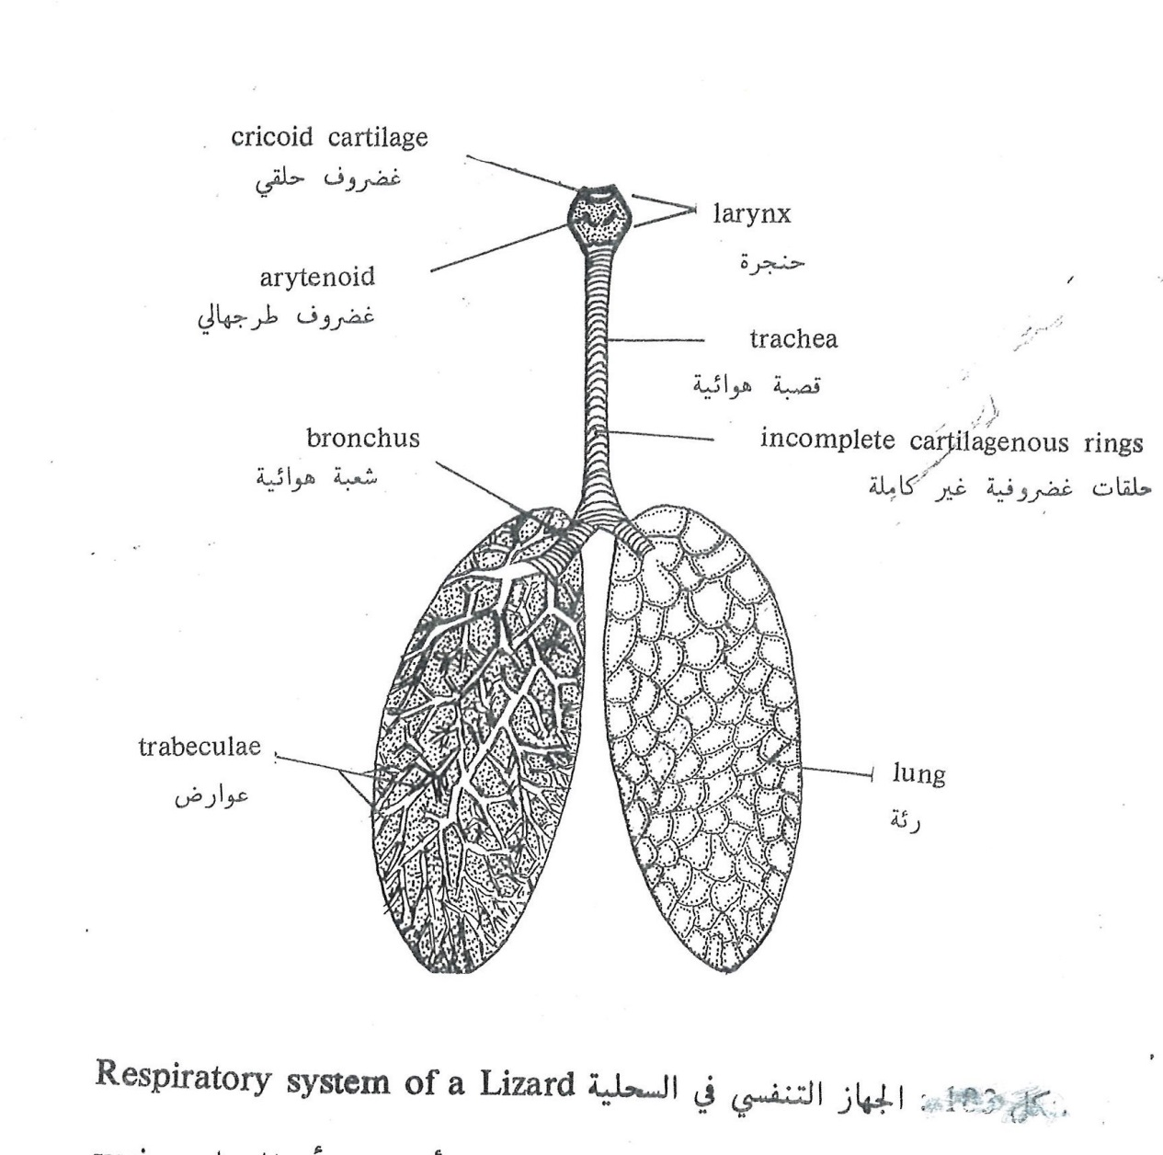
In birds:
The respiratory system starts with the epiglottis opening that looks like a slit and supported with 2 arytenoid cartilages, also the epiglottis lies at the posterior part of the mouth. The epiglottis opening leads to a chamber called the larynx that is supported by 2 arytenoid cartilages and 2cricoid cartilages.
Here the larynx doesn’t have vocal cords because it’s not the organ of voice as other animals and the voice organ is located in the posterior part of trachea that extend as long as the neck does. The larynx leads to the trachea which is along straight tube supported by complete bony rings then it’s divided into 2 branches to each adjacent lung. At the point of bifurcation of trachea there is the voice organ or syrinx. Syrinx is a bloated structure containing vertical sheets called “pessulus” connected anteriorly with a semilunar membrane. When air enters through the trachea the pessulus sheets vibrates so the semilunar membrane would vibrate producing the special sound of birds.
Q: HOW IS THE SOUND OF BIRDS PRODUCED
Each bronchus is divided into many bronchioles inside the lungs tissues, these bronchioles are small tubules to give the lungs its spongy texture. The bronchioles are attached to air sacs which are membranous elongations between the 2 alveoli, these sacs are found outside the lung area where it goes through the viscera and into the bone, also the wall of these sacs are so delicate and fills the cavity of the bird’s body.
In pigeons, there are 9 sacs; four of them are in pairs which are: the cervical air sacs, the anterior thoracic sacs, posterior thoracic sacs, abdominal sacs. While the remaining is a single interclavicular air sac. These sacs are used to store air that is pushed back into the lungs by muscles, movement, and abdominal pressure.
When the air goes into and out of these sacs gas exchange takes place so respiratory system in birds is highly qualified to provide enough oxygen for flying.
The air sacs have other function other than respiration which is decreasing body weight resembling swimming sac in fish. The 2 lungs are lying in the pleural cavity that is separated from the abdominal cavity by an oblique septum that is attached to respiratory muscles to control inspiration and expiration.
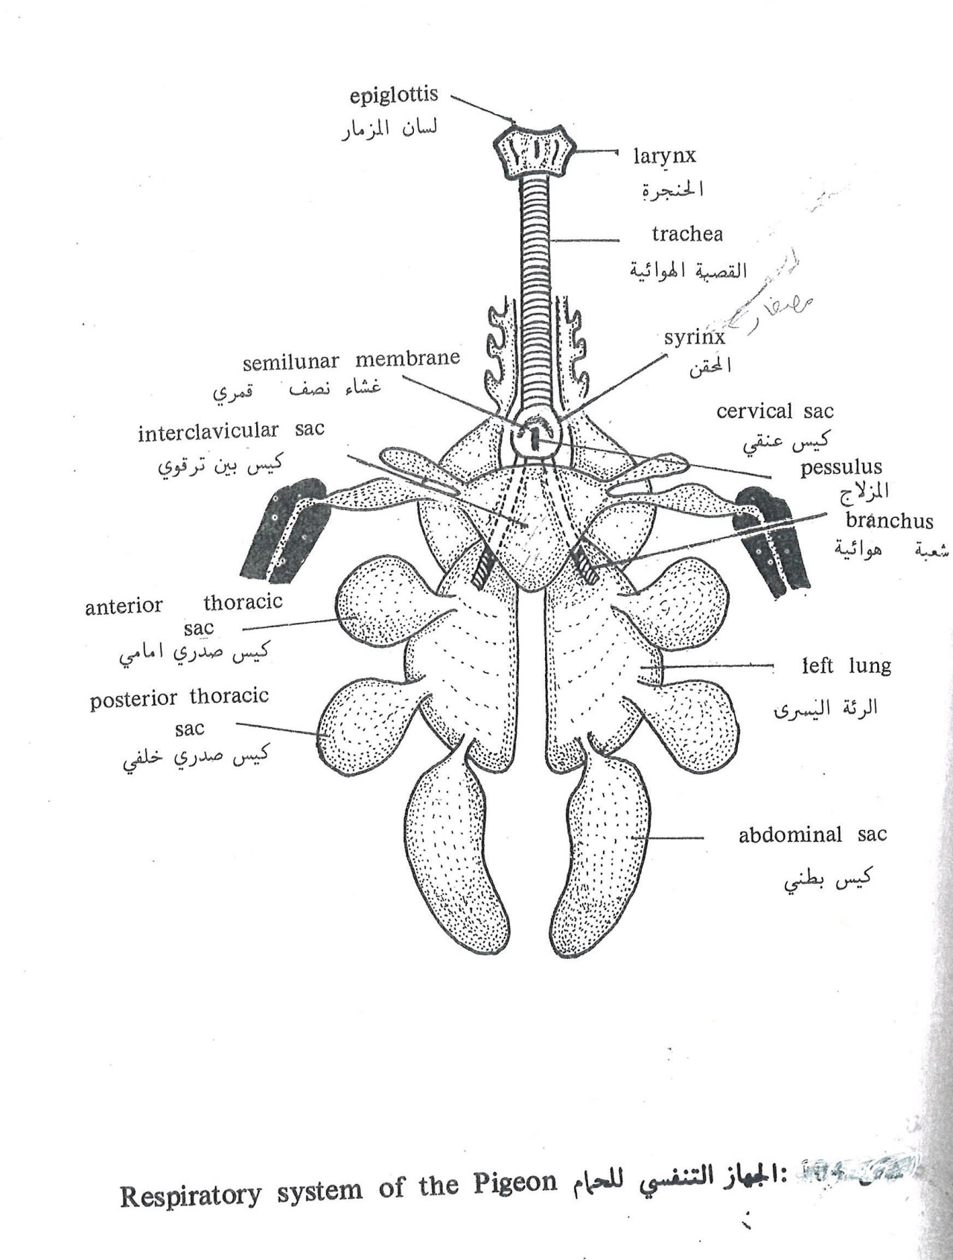
Q\ GIVE SHORT NOTES ABOUT AIR SACS (COMPOSITION AND FUNCTION)
In mammals:
The epiglottic opening is secured by a muscular organ called epiglottis then leads to the pharynx supported by 2 arytenoid cartilages posteriorly and cricoid cartilage and all these cartilages are covered anteriorly by another shield like cartilage called thyroid cartilage. There are skin folds along the thyroid and arytenoid cartilages forming the vocal cords the pharynx leads to the trachea whose length differs according to the length of the neck, it is supported by dorsally incomplete rings adjacent to the esophagus.
Each bronchus is divided in the lung into smaller branches till reaching the bronchioles that give rise to the alveoli through which gas exchange occur.
Lung in mammals is spongy, lobar and pink colored. The number of lobes differs in animals and the number of lobes in right lung is always more than the left one.
Lungs are located in the pleural cavity which surrounds the lung entirely and it’s separated from the peritoneal cavity by the diaphragm. The diaphragm goes up and down by contraction and relaxation to perform inspiration and expiration.

